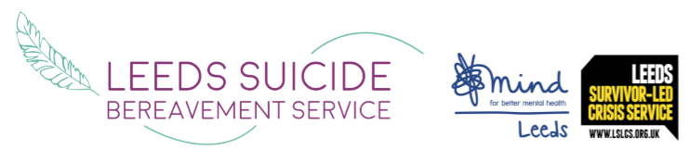
Leeds Mind
Clarence House
11 Clarence Road
Horsforth
Leeds, LS18 4LB

T: 0113 305 5800

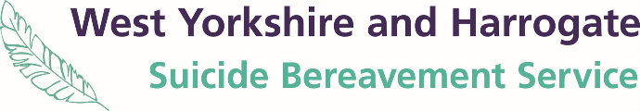

Suicide Bereavement Support across West Yorkshire

Across West Yorkshire there are two services that offer support after a bereavement by suicide. Both services are overseen by Leeds Mind.

The Leeds Suicide Bereavement Service – covers Leeds and is funded by Leeds City Council.
LSBS provides 1:1, peer support groups, family support and counselling.

The West Yorkshire and Harrogate Suicide Bereavement Service covers – Harrogate, Craven, Wakefield, Bradford, Calderdale and Kirklee’s and is funded by the ICS.
WYHSBS provides 1:1 and peer group support.

The services operate on a peer support model, meaning all staff and volunteer have lived experience of being bereaved by suicide. Support can be provided regardless of when the suicide occurred, with an emphasis on prioritising timely support to those recently bereaved. Support will be provided irrespective of the relationship – this may be a parent, child, partner, sibling, other relative, friend, client or work colleague. Support can be accessed as an individual, friends’ group, family or workplace.

The service can be used if individuals believe that someone, they care about has ended their own life, even if this has not been officially recognised or an inquest has not been held yet. We also support people who feel affected by a suicide but do not identify as bereaved, for example witnessing a death.

As we know those who are bereaved by suicide are at much higher risk of ending their own life than the general population. Therefore, both services provide timely and proactive support.
We would be extremely grateful if you can display our materials and recommend our services where appropriate.

Professional and self-referrals can be made by visiting our website.
If you require any more information or have any queries, please visit our website www.leedssbs.org.uk or wyhsbs.org.uk or call us on 0113 3055 800 (Leeds Mind Reception) and we will be happy to help.

Affiliated to National Mind
(the National Association for Mental Health)

Reg. Charity Number
1007625
Registered in England
Number 2193270

