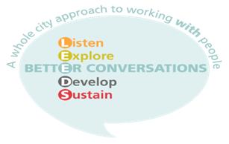

***Leeds Better Conversations***

***For Health and Social Care Staff***

**Now, more than ever, is the time for kind, compassionate conversations with one another. Behind the scenes we have been developing our eLearning and Virtual Interactive Sessions. These sessions will give you the opportunity to reflect on how you are feeling and what impact your conversations are having, whilst we stay connected with colleagues and the citizens of Leeds.**

***COMING SOON! FREE eLearning and Virtual Interactive Sessions***

**What is your style of learning? Please choose**

**1 2 3**

**Supporting people through kind conversations**

**Virtual Interactive session - 3 hours with up to 6 people dates available NOW!!**

**Supporting people through kind conversations**

**eLearning - 50 minute introductory session Available NOW!!**

**Better Conversations Skills Day**

**A one day session, which is on hold due to Covid-19**

**1**  **2** **3**

**To express an interest in accessing any of the above sessions**

**Please contact:**

**Email:** [**better.conversations@nhs.net**](mailto:better.conversations@nhs.net)

**Or visit[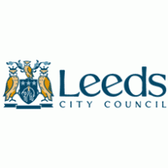](http://www.brandsoftheworld.com/logo/leeds-city-council?original=1):** <https://www.eventbrite.co.uk/o/better-conversations-24244548112>

T:@betterconvolds

**Twitter: @betterconvolds**

***If there is anything else we can do to support you during this time, please just get in touch.***

***#kindconversations***





