COVID19 vaccination for BAME communities – social media plan
Contents
(click links below to quickly jump to designated section)
COVID-19 vaccination: safety and dispelling myths (Videos English and translated)
Receiving your COVID19 vaccination (Translated Videos)
Receiving your Covid19 vaccination (English videos)
Importance of getting vaccinated
Vaccine safety
BAME susceptibility
Myths – Mandatory Vaccine
Myths – Inclusion of meat
Myths – Catching COVID from the vaccine
Vaccine aftercare/ continued care

Theme | Audience | Content |  | Media
COVID-19 vaccination: safety and dispelling myths (Videos)  ^Back to top of page | Public – Urdu speaking communities / Islamic communities | Twitter | Facebook | https://youtu.be/oYyJGjAkgL4
 |  | [In Urdu], Qari Asim, Imam at @LeedsMosque, dispels some myths and talks about the safety of the #COVID19Vaccine. The vaccine has been through rigorous checks and it is one of the best chances we have to protect ourselves against coronavirus https://youtu.be/5p8wZETbtTw | Speaking in Urdu, Qari Asim, Imam at Makkah Mosque in Leeds, dispels some myths and talks about the safety of the COVID19 vaccine. The vaccine has been through rigorous checks and it is one of the best chances we have to protect ourselves against coronavirus https://youtu.be/5p8wZETbtTw.  The NHS will let you know when it's your turn to have the vaccine. It's important not to contact the NHS for it before then.  Further information about the COVID-19 vaccine can be found on the NHS website https://www.nhs.uk/CovidVaccine
 | Public –Islamic communities | Twitter | Facebook | (English Long version)  https://www.nhs.uk/CovidVaccine
 |  | Qari Asim, Imam at @LeedsMosque, dispels some myths and talks about the safety of the #COVID19Vaccine The vaccine has been through rigorous checks and it is one of the best chances we have to protect ourselves against coronavirus https://youtu.be/H9KUkho62ok | Qari Asim, Imam at Makkah Mosque in Leeds, dispels some myths and talks about the safety of the COVID19 vaccine. The vaccine has been through rigorous checks and it is one of the best chances we have to protect ourselves against coronavirus https://youtu.be/H9KUkho62ok.  The NHS will let you know when it's your turn to have the vaccine. It's important not to contact the NHS for it before then.  Further information about the COVID-19 vaccine can be found on the NHS website https://www.nhs.uk/CovidVaccine.
 | Public – Islamic communities | Twitter | Facebook | (English short version)  https://youtu.be/viWlpSVSU6Q
 |  | Qari Asim, Imam at @LeedsMosque, dispels some myths and talks about the safety of the #COVID19Vaccine. The vaccine has been through rigorous checks and it is one of the best chances we have to protect ourselves against coronavirus https://youtu.be/viWlpSVSU6Q | Qari Asim, Imam at Makkah Mosque in Leeds, dispels some myths and talks about the safety of the COVID19 vaccine. The vaccine has been through rigorous checks and it is one of the best chances we have to protect ourselves against coronavirus https://youtu.be/viWlpSVSU6Q.  The NHS will let you know when it's your turn to have the vaccine. It's important not to contact the NHS for it before then.  Further information about the COVID-19 vaccine can be found on the NHS website https://www.nhs.uk/CovidVaccine
Receiving your COVID19 vaccination (Translated Videos)  ^Back to top of page | Public –British sign language users | Twitter | Facebook | https://youtu.be/5p8wZETbtTw
 |  | [BSL translated] Lead pharmacist for Central North Leeds PCN @fazilajumabhoy is encouraging people to attend their COVID-19 vaccine when invited. The vaccine has been through rigorous checks and it is one of the best chances we have to protect ourselves against coronavirus https://youtu.be/5p8wZETbtTw | [BSL translated] Lead pharmacist for Central North Leeds PCN, Fazila Jumabhoy, is encouraging people to attend their COVID-19 vaccine when invited. The vaccine has been through rigorous checks and it is one of the best chances we have to protect ourselves against coronavirus. https://youtu.be/5p8wZETbtTw  Further information about the COVID-19 vaccine can be found on the NHS website https://www.nhs.uk/CovidVaccine
 | Public – Bengali speaking communities | Twitter | Facebook | https://youtu.be/gIWC343BNkE
 |  | [In Bengali] Dr Amal Paul a GP at Roundhay Road Surgery is encouraging people to attend their COVID-19 vaccine when invited. The vaccine has been through rigorous checks and it is one of the best chances we have to protect ourselves against coronavirus https://youtu.be/gIWC343BNkE | [In Bengali] Dr Amal Paul a GP at Roundhay Road Surgery is encouraging people to attend their COVID-19 vaccine when invited. The vaccine has been through rigorous checks and it is one of the best chances we have to protect ourselves against coronavirus. https://youtu.be/gIWC343BNkE  Further information about the COVID-19 vaccine can be found on the NHS website https://www.nhs.uk/CovidVaccine
 | Public – Dutch speaking communities | Twitter | Facebook | (Short version)  https://youtu.be/NSjt2MhHi10
 |  | [In Dutch] Dr Esther Sterrenburg, GP at Leeds Student Medical Practice is encouraging people to attend their COVID-19 vaccine when invited. The vaccine has been through rigorous checks and it's one of the best chances we have to protect ourselves against coronavirus https://youtu.be/NSjt2MhHi10 | [In Dutch] Dr Esther Sterrenburg, GP at Leeds Student Medical Practice is encouraging people to attend their COVID-19 vaccine when invited. The vaccine has been through rigorous checks and it's one of the best chances we have to protect ourselves against coronavirus https://youtu.be/NSjt2MhHi10.  Further information about the COVID-19 vaccine can be found on the NHS website https://www.nhs.uk/CovidVaccine
 | Public – Dutch speaking communities | Twitter | Facebook | (Long version)  https://youtu.be/5YFagKnsI4M
 |  | [In Dutch] Dr Esther Sterrenburg, GP at Leeds Student Medical Practice is encouraging people to attend their COVID-19 vaccine when invited. The vaccine has been through rigorous checks and it's one of the best chances we have to protect ourselves against coronavirus https://youtu.be/5YFagKnsI4M | [In Dutch] Dr Esther Sterrenburg, GP at Leeds Student Medical Practice is encouraging people to attend their COVID-19 vaccine when invited. The vaccine has been through rigorous checks and it's one of the best chances we have to protect ourselves against coronavirus https://youtu.be/5YFagKnsI4M.  Further information about the COVID-19 vaccine can be found on the NHS website https://www.nhs.uk/CovidVaccine
 | Public –Urdu speaking communities | Twitter | Facebook | https://youtu.be/AeOs0zygU1s
 |  | [In Urdu] Dr Sarwar encourages people to attend their COVID-19 vaccine when invited. The vaccine is safe to have its been through all necessary checks & is one of the best chances we have to protect ourselves against coronavirus https://youtu.be/AeOs0zygU1s | [In Urdu] Dr Sarwar encourages people to attend their COVID-19 vaccine when invited. The vaccine is safe to have and it has been through all necessary checks and is one of the best chances we have to protect ourselves against coronavirus https://youtu.be/AeOs0zygU1s.  Further information about the COVID-19 vaccine can be found on the NHS website https://www.nhs.uk/CovidVaccine
 | Public – Arabic speaking communities | Twitter | Facebook | (Short version)  https://youtu.be/djKE4YMlWTw
 |  | [In Arabic] Ayat a Clinical Pharmacist is encouraging people to attend their COVID-19 vaccine when invited. The vaccine is safe to have it has been through all necessary checks & is one of the best chances we have to protect ourselves against coronavirus https://youtu.be/djKE4YMlWTw | [In Arabic] Ayat a Clinical Pharmacist is encouraging people to attend their COVID-19 vaccine when invited. The vaccine is safe to have, it has been through all necessary checks and is one of the best chances we have to protect ourselves against coronavirus https://youtu.be/djKE4YMlWTw.  Further information about the COVID-19 vaccine can be found on the NHS website https://www.nhs.uk/CovidVaccine
 | Public – Arabic speaking communities | Twitter | Facebook | (Long version)  https://youtu.be/1wm4gwmKnK8
 |  | [In Arabic] Ayat a Clinical Pharmacist is encouraging people to attend their COVID-19 vaccine when invited. The vaccine is safe to have it has been through all necessary checks & is one of the best chances we have to protect ourselves against coronavirus https://youtu.be/1wm4gwmKnK8 | [In Arabic] Ayat a Clinical Pharmacist is encouraging people to attend their COVID-19 vaccine when invited. The vaccine is safe to have, it has been through all necessary checks and is one of the best chances we have to protect ourselves against coronavirus https://youtu.be/1wm4gwmKnK8.  Further information about the COVID-19 vaccine can be found on the NHS website https://www.nhs.uk/CovidVaccine
Receiving your Covid19 vaccination (English videos)  ^Back to top of page | Public | Twitter | Facebook | (Short version)  https://youtu.be/Aqi9LT9fgq8
 |  | Dr Esther Sterrenburg, GP at Leeds Student Medical Practice is encouraging people to attend their COVID-19 vaccine when invited. The vaccine has been through rigorous checks and it's one of the best chances we have to protect ourselves against coronavirus https://youtu.be/Aqi9LT9fgq8 | Dr Esther Sterrenburg, GP at Leeds Student Medical Practice is encouraging people to attend their COVID-19 vaccine when invited. The vaccine has been through rigorous checks and it's one of the best chances we have to protect ourselves against coronavirus. https://youtu.be/Aqi9LT9fgq8  Further information about the COVID-19 vaccine can be found on the NHS website https://www.nhs.uk/CovidVaccine
 | Public | Dr Esther Sterrenburg, GP at Leeds Student Medical Practice is encouraging people to attend their COVID-19 vaccine when invited. The vaccine has been through rigorous checks and it's one of the best chances we have to protect ourselves against coronavirus https://youtu.be/SuWfkFnusEU | Dr Esther Sterrenburg, GP at Leeds Student Medical Practice is encouraging people to attend their COVID-19 vaccine when invited. The vaccine has been through rigorous checks and it's one of the best chances we have to protect ourselves against coronavirus https://youtu.be/SuWfkFnusEU.  Further information about the COVID-19 vaccine can be found on the NHS website https://www.nhs.uk/CovidVaccine | (Long version)  https://youtu.be/SuWfkFnusEU
 | Public | Twitter | Facebook | https://youtu.be/aU-zvkVHIl4
 |  | Dr Sarwar is encouraging people to attend their COVID-19 vaccine when invited. The vaccine is safe to have as it has been through all the necessary checks and is one of the best chances we have to protect ourselves against coronavirus https://youtu.be/aU-zvkVHIl4 | Dr Sarwar encourages people to attend their COVID-19 vaccine when invited. The vaccine is safe to have and it has been through all necessary checks and is one of the best chances we have to protect ourselves against coronavirus https://youtu.be/aU-zvkVHIl4.  Further information about the COVID-19 vaccine can be found on the NHS website https://www.nhs.uk/CovidVaccine
 | Public | Twitter | Facebook | https://youtu.be/Ppiv7JbGEWI
 |  | Ayat a Clinical Pharmacist is encouraging people to attend their COVID-19 vaccine when invited. The vaccine is safe to have it has been through all necessary checks & is one of the best chances we have to protect ourselves against coronavirus https://youtu.be/Ppiv7JbGEWI | Ayat a Clinical Pharmacist is encouraging people to attend their COVID-19 vaccine when invited. The vaccine is safe to have, it has been through all necessary checks and is one of the best chances we have to protect ourselves against coronavirus https://youtu.be/Ppiv7JbGEWI.  Further information about the COVID-19 vaccine can be found on the NHS website https://www.nhs.uk/CovidVaccine
Importance of getting vaccinated  ^Back to top of page | All | Grace Stewart-Hanson, named Nurse Safeguarding Adults at @LCHNHSTrust has shared her story on receiving the #COVID19Vaccine and the importance of doing so.  Read Grace’s #COVIDVaccination story here: https://www.leedsccg.nhs.uk/news/covid19-vaccination-graces-story/  #TeamLeeds #LeedsMakingHistory |  | 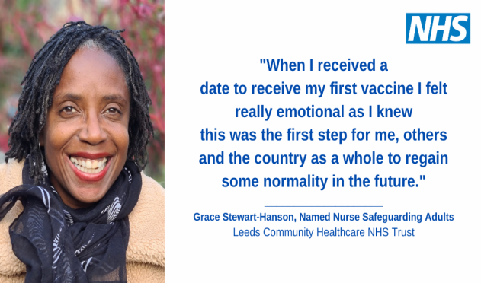  Link to full sized image
 | All | “Our NHS is committed to improving our lives by providing the best care. Having the vaccination would be helping them do just that.”  @Pastrymix is encouraging people to have their #COVID19vaccine to help our NHS. Read Grace’s vaccination story here: https://www.leedsccg.nhs.uk/news/covid19-vaccination-graces-story/ |  | 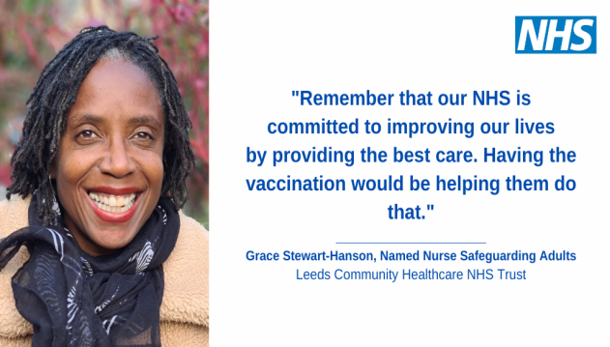  Link to full sized image
 | Public | Vaccination is the most important thing you can do to protect your community against serious illnesses. When enough people get vaccinated, it’s harder for a disease to spread to those who can’t have vaccines.  Learn more;  https://nhs.uk/conditions/vaccinations/why-vaccination-is-safe-and-important/ |  | 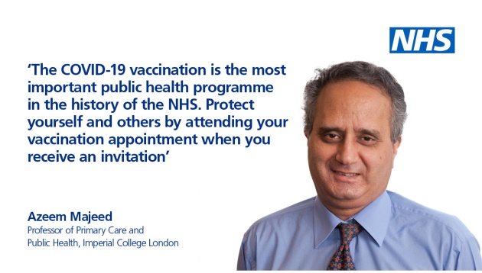  Link to full sized image
 | Frontline staff | The #COVIDvaccine is available to all our healthcare colleagues. Getting vaccinated means protecting yourself from the virus so you can be there for your family, friends and patients. Please take up your invite for your vaccine when you are sent this.  http://nhs.uk/CovidVaccine |  | 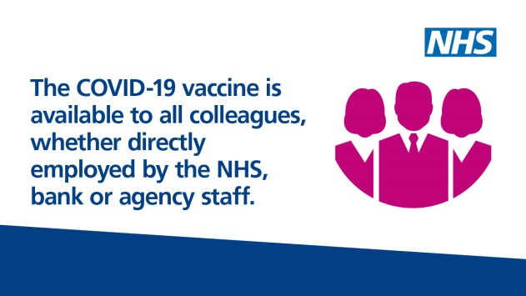  Link to full sized image
 | Frontline staff | If you’re a frontline worker in the NHS, you are more likely to be exposed to COVID-19 at work. Getting your #COVIDVaccination when you’re invited to will help protect you, your family and those you care for.  For everything you need to know about the vaccine visit http://nhs.uk/CovidVaccine |  | 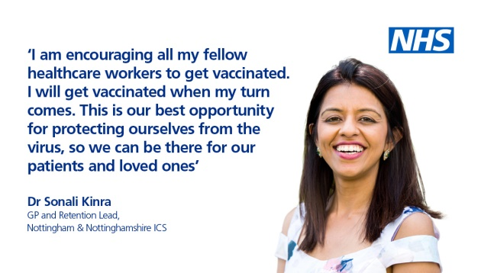  Link to full sized image
 | Frontline staff | *WATCH* NHS Chief People Officer @Prerana_Issar explains why vaccination is so important for health and social care colleagues #COVIDVaccine https://youtu.be/szGfb0SoP1c |  | Video link
 | Frontline staff | *WATCH* Dr @NikkiKF Professor Jonathan Van-Tam and  @25DavidPearson answer some important questions from health and care staff about the #COVIDVaccine https://youtu.be/-_r1-EHKcP8 |  | Video link
 | All | The #COVIDvaccine should help reduce the rates of serious illness and save lives and will therefore reduce pressure on the NHS and social care services.  The NHS will let you know when it's your turn to have the vaccine. It's important not to contact the NHS for it before then.  http://nhs.uk/CovidVaccine |  | 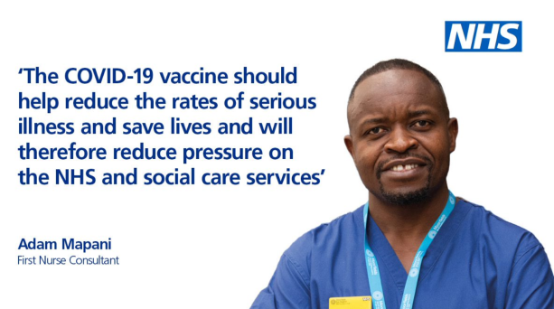  Link to full sized image
Vaccine safety  ^Back to top of page | Public | The Pfizer #COVIDVaccine has undergone a rigorous testing process across different age groups, gender groups and ethnic groups, leading to a 95% vaccine efficacy across these groups.  Learn more: http://nhs.uk/CovidVaccine |  | 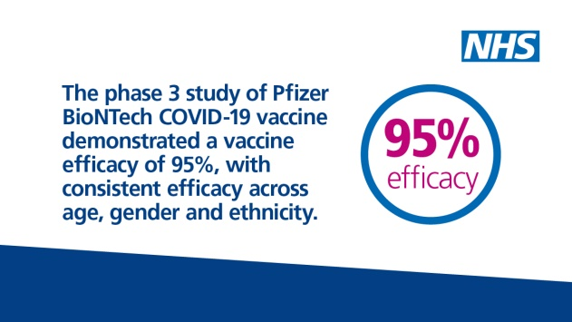  Link to full sized image
 | Frontline staff | The #COVIDVaccine has undergone months of rigorous testing & strict approval processes to ensure its safety and effectiveness. Taking up your vaccination invite will help protect yourself, your families and your communities.  Learn more: http://nhs.uk/CovidVaccine |  | 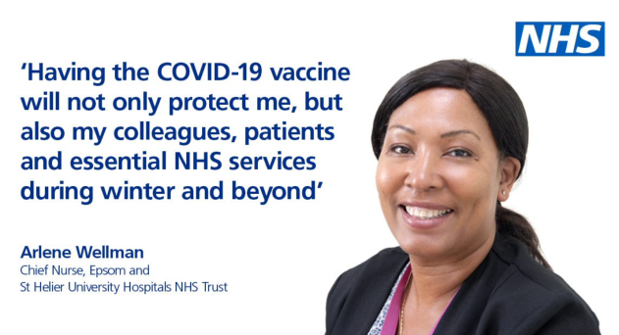  Link to full sized image
 | All | The #COVIDVaccine is safe. All steps in the usual vaccine development process have been rigorously followed, including clinical trial phases.  The NHS will let you know when it's your turn to have the vaccine. It's important not to contact the NHS for it before then.  http://nhs.uk/CovidVaccine |  | 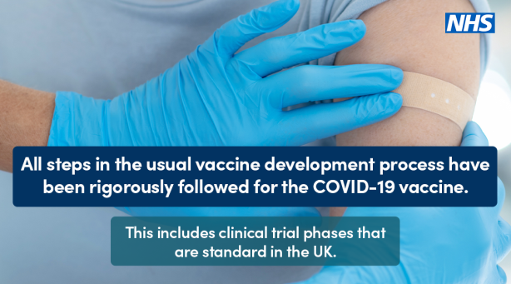  Link to full sized image
 | All | Vaccines are only made available to the public after meeting strict safety & effectiveness criteria. The #COVIDVaccines have been approved by MHRA, the official UK regulator, like all other medicines and devices.  Learn more about its safety at: https://t.co/0qdrm3mQDM?amp=1 |  | 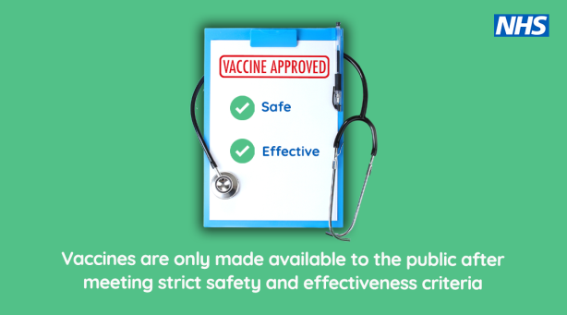  Link to full sized image
BAME susceptibility  ^Back to top of page | Public | BAME communities continue to be disproportionately impacted by COVID19, so it is important that these communities get necessary protection. Getting the #COVIDVaccine as soon as you can will help protect yourself, your families and your communities.  The NHS will let you know when it's your turn to have the vaccine. It's important not to contact the NHS for it before then.  http://nhs.uk/CovidVaccine |  | 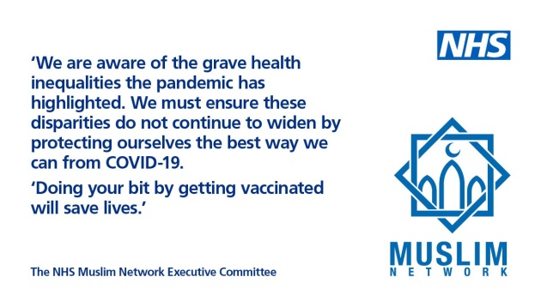  Link to full sized image
 | Frontline staff | If you’re a frontline worker in the NHS, you are more likely to be exposed to COVID-19 at work. Getting your #COVIDVaccination as soon as you can should protect you and may help to protect your family and those you care for.  The NHS will let you know when it's your turn to have the vaccine. It's important not to contact the NHS for it before then.  http://nhs.uk/CovidVaccine |  | 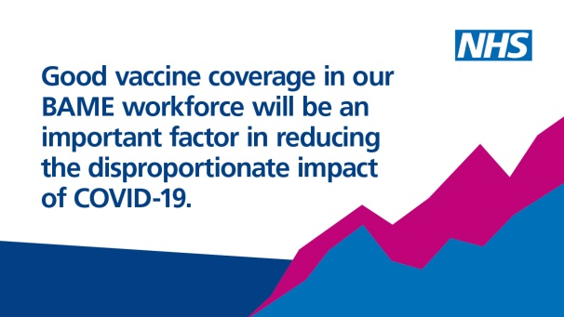  Link to full sized image
 | Frontline staff | To help reduce the disproportionate impact of COVID19 among BAME communities, the NHS will prioritise vaccines for frontline and BAME staff using local risk-assessments to identify the most vulnerable members of staff for vaccine priority.  Please take up your invite for your vaccine when you are sent this.  http://nhs.uk/CovidVaccine |  | 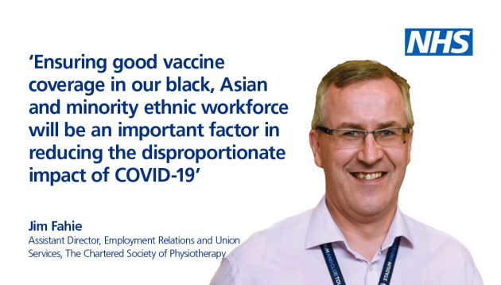  Link to full sized image
 | Frontline staff | There is evidence of a disproportionate impact of COVID19 on those from BAME communities. Getting vaccinated is therefore crucial in helping stop the spread of the virus and protect our loved ones and the patients we care for.  Please take up your invite for your vaccine when you are sent this.  Learn more: http://nhs.uk/CovidVaccine |  | 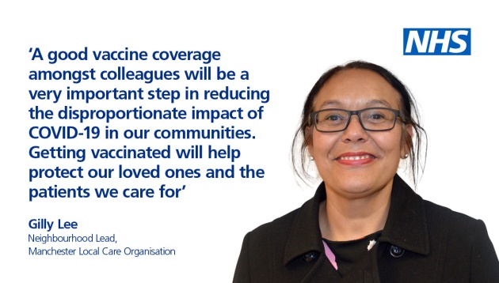  Link to full sized image
 | Frontline staff | COVID19 has impacted all of us, particularly those from BAME backgrounds. Getting your #COVIDVaccination as soon as you can will help protect you, your loved ones and your patients.  Please take up your invite for your vaccine when you are sent this.  Learn more: http://nhs.uk/CovidVaccine |  | 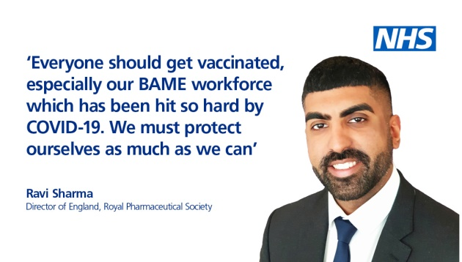  Link to full sized image
Myths – Mandatory Vaccine  ^Back to top of page | Public | While the #COVIDVaccine is not compulsory, getting vaccinated does ensure you protect yourself, your loved ones and others from the virus.  The NHS will let you know when it's your turn to have the vaccine. It's important not to contact the NHS for it before then.  Learn more: http://nhs.uk/CovidVaccine |  | 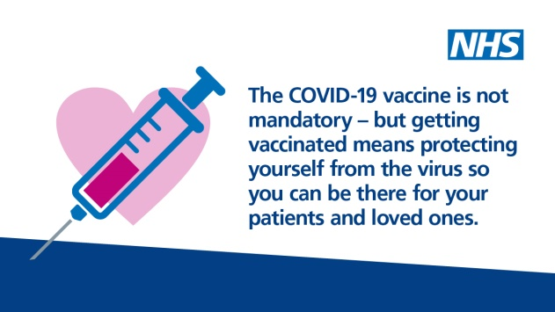  Link to full sized image
 | Frontline workers | There are no plans for a COVID-19 vaccine to be compulsory. Just as they do with the winter flu vaccine, your local NHS will be working hard to ensure staff are able to get vaccinated, and that any concerns that staff have are answered.  For more details visit: http://nhs.uk/CovidVaccine |  | 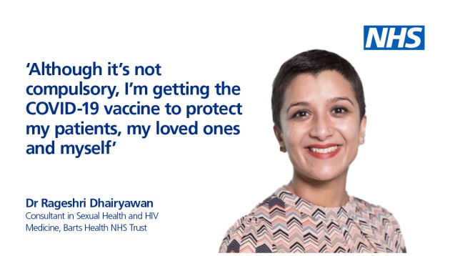  Link to full sized image
Myths – Inclusion of meat  ^Back to top of page | All | The approved #COVIDVaccines do not contain any meat derivatives or porcine products. This should assure staff and public with faith, allergies and dietary requirements which prohibit this that the vaccines are safe to receive.  Learn more at: http://nhs.uk/CovidVaccine |  | 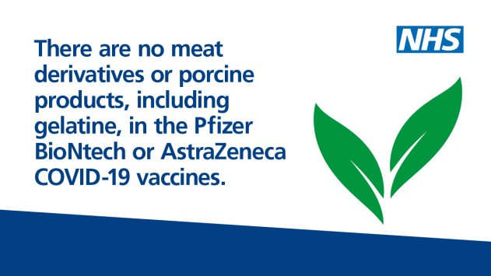  Link to full sized image
 | Frontline workers | The approved vaccines have undergone rigorous testing, ensuring that no meat derivatives or porcine products are present. Staff with faith, allergies or dietary requirements that prohibit meat consumption, can therefore be assured of the vaccines safety.  http://nhs.uk/CovidVaccine |  | 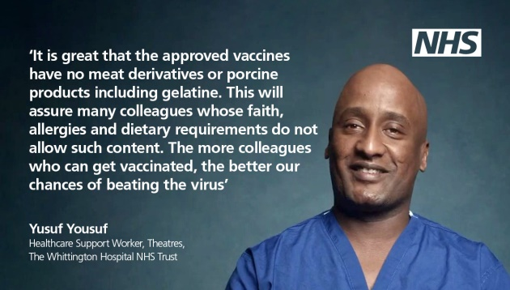  Link to full sized image
Myths – Catching COVID from the vaccine  ^Back to top of page | All | You cannot catch COVID-19 from the #COVIDVaccine but it is possible to have caught COVID-19 and not realise you have the symptoms until after your vaccination appointment. Having the COVID19 vaccine is the best way to protect yourself and others from the virus.  http://nhs.uk/CovidVaccine |  | 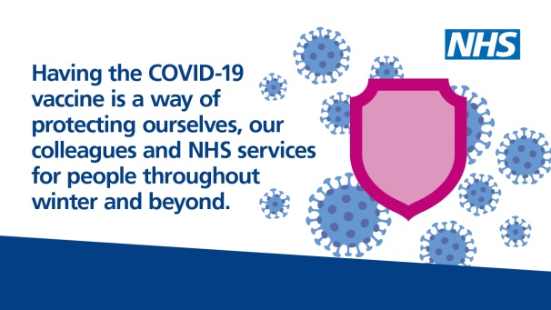  Link to full sized image
Vaccine aftercare/ continued care  ^Back to top of page | All | Despite the vaccine now being available, to continue to protect yourself, your family, friends and colleagues you still need to:  - practice social distancing  - wear a face covering  - wash your hands frequently  - follow the current guidance at www.gov.uk/coronavirus |  | 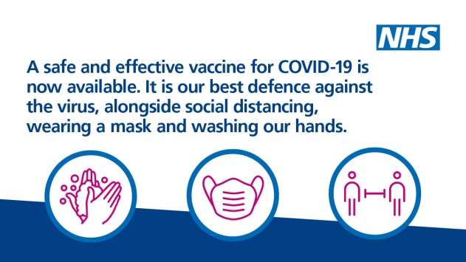  Link to full sized image
 | All | [Leaflet in English] Know the facts: What to expect after your COVID19 vaccination https://tinyurl.com/yx9nbngz  If you’re yet to have the vaccine, the NHS will let you know when it's your turn to have the vaccine. It's important not to contact the NHS for it before then. |  | 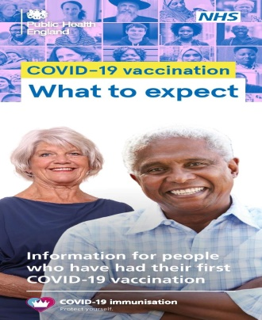  Link to full sized image
 | All | [Leaflet in Polish] Know the facts: What to expect after your COVID19 vaccination https://tinyurl.com/yxww8vhc  The NHS will let you know when it's your turn to have the vaccine. It's important not to contact the NHS for it before then. |  | 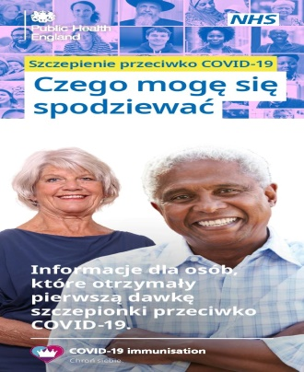  Link to full sized image
 | All | [Leaflet in Romanian] Know the facts: What to expect after your COVID19 vaccination https://tinyurl.com/yy85enf2  The NHS will let you know when it's your turn to have the vaccine. It's important not to contact the NHS for it before then. |  | 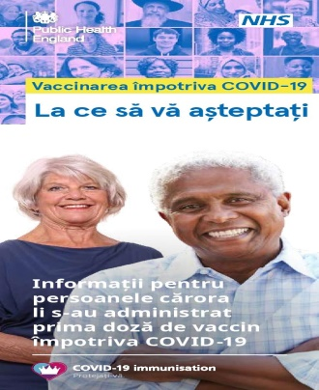  Link to full sized image
 | All | [Leaflet in Spanish] Know the facts: What to expect after your COVID19 vaccination https://tinyurl.com/y42yy8h3  The NHS will let you know when it's your turn to have the vaccine. It's important not to contact the NHS for it before then. |  | 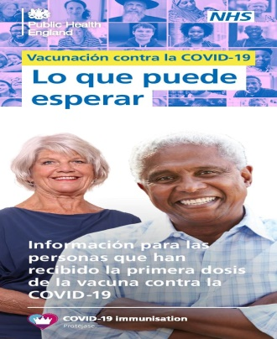  Link to full sized image
 | All | [Leaflet in Turkish] Know the facts: What to expect after your COVID19 vaccination https://tinyurl.com/y5gako6j  The NHS will let you know when it's your turn to have the vaccine. It's important not to contact the NHS for it before then. |  | 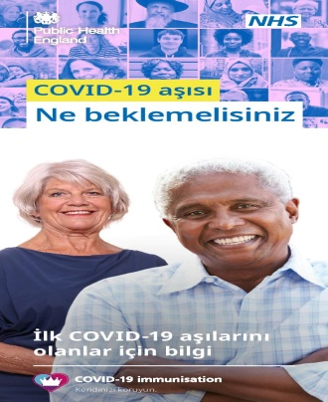  Link to full sized image

