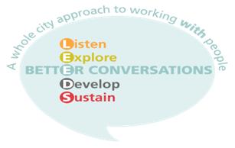

**Leeds Better Conversations**

**FREE eLearning and virtual interactive sessions**

**for health and social care staff**

“Join us to consider how we can create the space for more kind and compassionate conversations with each other. Our workshops allow the opportunity to reflect on how you are feeling and what impact your conversations are having, as well as your communication strengths and areas for development”.

**We are offering two sessions to suit your style of learning.**

**You can choose one or both!**

**1 2**

**Supporting people through kind conversations**

**eLearning - 60 minute introductory session**

**Avalible NOW!!**

**Supporting people through kind conversations**

**Virtual Interactive session - 3 hours with up to 14 people**

**Avalible Now!!**

**Dates available NOW!!**

**To express an interest in accessing any of the above sessions,**

**please email:** [**better.conversations@nhs.net**](mailto:better.conversations@nhs.net)

**Book eLearning:** <https://www.eventbrite.co.uk/e/117229882735>

**Book VIS [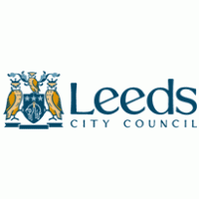](http://www.brandsoftheworld.com/logo/leeds-city-council?original=1):** <https://www.eventbrite.co.uk/o/betterconversations-30794835390>

T:@betterconvolds

**Twitter: @betterconvolds**

**Instgram: Leeds Better Converstaions**

**Facebook: Leeds Better Conversations**





