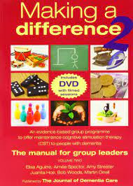
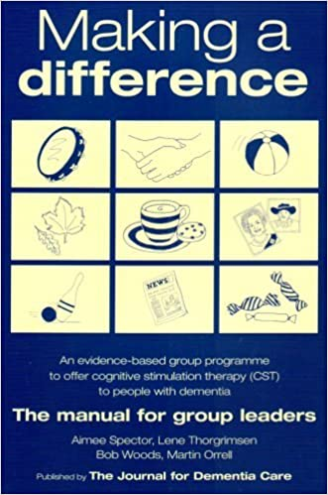

Scoping Survey:
Cognitive Stimulation Therapy (CST) &
Maintenance Cognitive Stimulation Therapy (mCST) Groups

Dear colleagues
We are a group of statutory and non-statutory/Third Sector organisations looking to develop a consistent offer of Cognitive Stimulation Therapy (CST) & Maintenance Cognitive Stimulation Therapy (mCST) to people living with dementia in Leeds. So far we consist of LCC Adults & Health, Age UK Leeds, NHS CCG, LYPFT, MAECare, OPAL, Touchstone & Young Dementia Leeds (Community Links) and we are keen to involve other groups in this ambition.
There have been previous groups running in the city and some continue to run. We are currently trying to scope out what provision exists in the city already so that we can see where there are good examples and models that we can learn from. We also want to see where there may be gaps and where new or additional provision would benefit the citizens of Leeds. This is entirely voluntary and we appreciate you taking the time to share your knowledge and experience:

- Please state what organisation you represent: __________________________

- Please give the name and contact details for someone within your organisation who can be contacted for further information about your responses: ________________________________________________________________

- Does your organisation currently run a Cognitive Stimulation Therapy (CST) or a Maintenance Cognitive Stimulation Therapy (mCST) group? (If yes, please provide details ___________________________________________________
_______________________________________________________________

If yes, does the group follow the “Making a Difference” CST or mCST manual? ________________________________________________________________
________________________________________________________________

If yes, has the group altered due to COVID?__________________ ________________________________________________________________

- Does your organisation currently run a group for people living with dementia that has some cognitive stimulation elements, but does not stick to the “Making a Difference” CST/mCST manual? (If yes, please provide details) ________________________________________________________________
________________________________________________________________

- Would your organisation be interested in starting to run a CST/mCST group in the future? __________________________________________________________

Please return to:
Jess Inglis, Operations Director (Partnerships & Service Development), Age UK Leeds jessica.inglis@ageukleeds.org.uk
OR
Lou Bergin, Clinical Lead for Older People’s Services,
(Leeds & York Partnership NHS Foundation Trust) louise.bergin@nhs.net

