

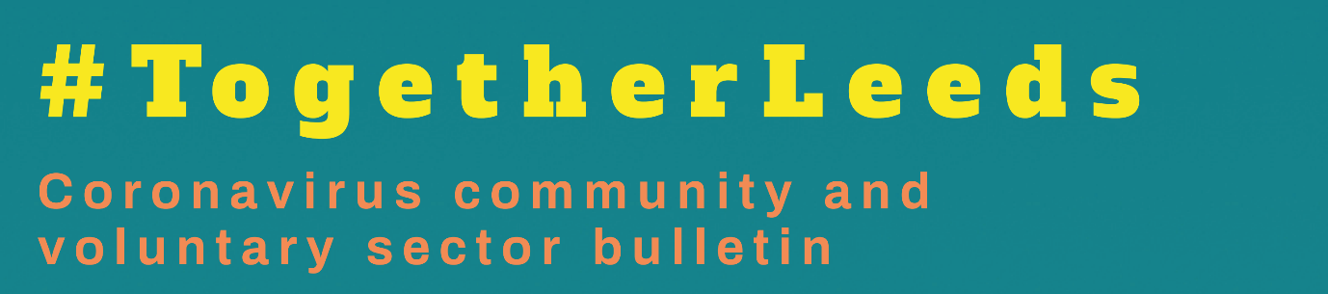**Coronavirus Third Sector Bulletin: Edition 49Coronavirus Third Sector Bulletin: Edition 50**

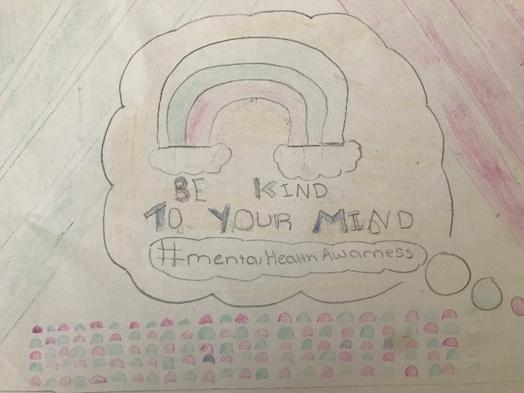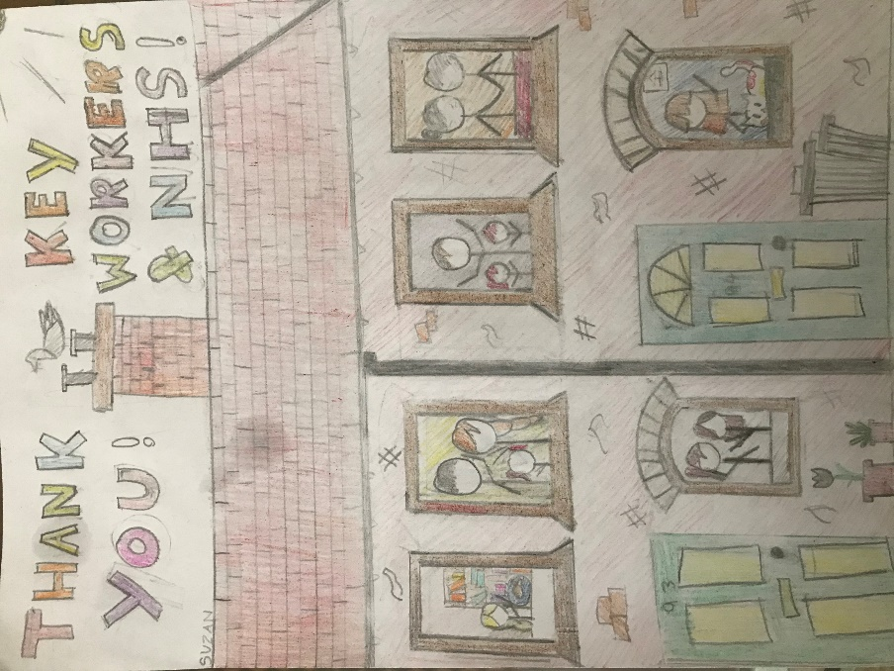

**Art by Eliza, age 10 and Suzanne, age 10**

**Introduction**

Welcome to the latest Together Leeds bulletin, created by local NHS and council partners to provide an overview of the key messages local people need to know. Please share these messages through your own communication networks. This week we have been a little bit short on capacity and Dex from Healthwatch has not been able to add his magic to the graphics, we hope that this will not stop you from using and sharing the information and messages. In this edition:

* Self-isolation rules
* Vaccines for 16/17-year-olds
* Student vaccinations
* World Alzheimer's Day
* World Suicide Prevention Day
* RSV in babies and children
* Upcoming Leeds Public Health training
* Every minute counts
* Building Bridges- Leeds digital festival
* Age Proud Leeds Festival – join us in a time to feel good about ageing!
* Domestic servitude
* Connecting Opportunities volunteer role
* CEV support routes
* Big Leeds Chat
* Trauma Informed Primary Care Workshop

**Self-isolation rules**

When do people need to self-isolate?

You will need to self-isolate for 10 days if you:

* Test positive for COVID-19 or start showing symptoms
* An adult who has not been fully vaccinated and you have been identified by contract tracers as a close contact of someone who has tested positive
* An adult who lives with someone who tests positive (or has Covid symptoms) and you are not fully vaccinated
* Arrive in the UK from a [red list country](https://www.gov.uk/guidance/red-amber-and-green-list-rules-for-entering-england#red-list) (including those people who are fully vaccinated)
* An adult who has not been fully vaccinated and you arrive in the UK from an [amber list country](https://www.gov.uk/guidance/red-amber-and-green-list-rules-for-entering-england#amber-list)

What do I need to do if I’m vaccinated?

Fully vaccinated adults in the UK do not have to self-isolate for 10 days if they have been told they have been in close contact with a person who has Covid. The second vaccine must have been received at least [14 days before contact with the infected person](https://www.gov.uk/government/news/self-isolation-removed-for-double-jabbed-close-contacts-from-16-august).

**Vaccines for 16/17-year-olds**

Sixteen and seventeen year olds in Leeds can now get their COVID-19 vaccine, dates and times are available at [www.leedsccg.nhs.uk/covid-19-vaccine-information/walk-in-clinics/](http://www.leedsccg.nhs.uk/covid-19-vaccine-information/walk-in-clinics/)

You do not need to be registered with a GP or have an NHS number.

**Vaccines for 16/17-year-olds**

Sixteen and seventeen year olds in Leeds can now get their COVID-19 vaccine. Dates and times of clinics are available at [www.leedsccg.nhs.uk/covid-19-vaccine-information/walk-in-clinics/](http://www.leedsccg.nhs.uk/covid-19-vaccine-information/walk-in-clinics/)

You do not need to be registered with a GP or have an NHS number.

**Student vaccinations**

Being up to date with vaccinations is important for students starting university who will be meeting, mixing, and living with lots of new people. Universities can present ideal conditions for infections to spread. These include measles, mumps, Covid-19 and meningococcal disease which although rare can be serious and potentially deadly. In addition to the Covid-19 vaccine Coronavirus (COVID-19) vaccines - NHS (www.nhs.uk), students are also strongly advised to have had:

* MenACWY vaccine (meningococcal disease) [MenACWY vaccine - NHS (www.nhs.uk)](https://www.nhs.uk/conditions/vaccinations/men-acwy-vaccine/)
* 2 doses of the MMR vaccine [MMR (measles, mumps and rubella) vaccine - NHS (www.nhs.uk)](https://www.nhs.uk/conditions/vaccinations/mmr-vaccine/)

Both these vaccines are offered as part of the school age vaccination programme. However, thousands of students start university every year having never had these vaccines. Students can check their vaccination status with their GP and can still access these vaccines if required.

Additional information is available in this blog: [Getting back together - Vaccination and students | Undergraduate | UCAS](https://www.ucas.com/connect/blogs/getting-back-together-vaccination-and-students)

**World Alzheimer's day**

World Alzheimer’s day is on 21st September. If you need help and advice about living with dementia, or are worried about dementia, the Alzheimer’s Society’s Dementia Connect support line is 0333 150 3456. It is open extended hours, and they can refer people through to a Leeds Memory Support Worker [www.alzheimers.org.uk/dementia-connect-support-line](http://www.alzheimers.org.uk/dementia-connect-support-line)

The Carers Leeds Dementia Hub offers 1:1 support, carers’ groups, and training for families and other unpaid carers call 0113 380 4300 or go to [www.carersleeds.org.uk/our-support-service/carers-of-people-with-dementia/](http://www.carersleeds.org.uk/our-support-service/carers-of-people-with-dementia/)

Advice for anyone who’s worried about their or someone else’s memory problems or confusion can go to [www.alzheimers.org.uk/memoryproblems](http://www.alzheimers.org.uk/memoryproblems).

Dementia-Friendly Crossgates Roadshow

Tuesday 21st September, 10am – 12

Cross Gates & District Good Neighbours’ Scheme, Newman Centre, Station Road, Leeds LS15 7JY

[www.carersleeds.org.uk/event/dementia-friendly-cross-gates-roadshow/](http://www.carersleeds.org.uk/event/dementia-friendly-cross-gates-roadshow/)

**World Suicide Prevention Day**

World Suicide Prevention Day took place on Friday, 10th September 2021. This year the international theme was ‘Creating Hope Through Action’.

The West Yorkshire and Harrogate & Care Partnership has launched a comprehensive [website](https://suicidepreventionwestyorkshire.co.uk/) dedicated to helping people who are struggling with suicidal thoughts and anyone else who would like support for their mental wellbeing. This is an information portal led by a group of organisations including voluntary, NHS, and local authorities looking to reduce deaths by suicide in the region. Here you can find information about organisations in Bradford, Leeds, Calderdale, Kirklees and Wakefield. Professional training and specialist support for men can also be located on the website.

**RSV in babies and children**

There has been an increase in severe respiratory illness (RSV) in children and babies recently, as restrictions ease and people mix more, with cases higher than usual for this time of year and further increases expected over the winter months.

Symptoms of severe respiratory infection in children include a high temperature of 37.8°C or above (fever), a dry and persistent cough, difficulty feeding/loss of appetite, rapid or noisy breathing (wheezing).

Most cases of respiratory illness are not serious and clear up within 2 to 3 weeks, but parents should contact their GP or call NHS 111 if:

* Their child struggles to breathe.
* Their child has taken less than half their usual amount during the last 2 or 3 feeds, or they have had a dry nappy for 12 hours or more.
* The child has a persistent high temperature of 37.8C or above.

Some children under 2, especially those born prematurely or with a heart condition, can suffer more serious consequences from these common respiratory infections.

Find out more about the symptoms and what to do [here](https://www.nhs.uk/conditions/bronchiolitis/causes/).

**Upcoming Leeds Public Health training**

The Leeds Public Health Training team has released tickets for a selection of webinars that will take place in September or October. The sessions include Smoking and Tobacco Control on the 16th September; Mental Health in an Unequal World on 8th October; and Autumn and Winter vaccinations for Covid-19 and Influenza on 28th October.

To find out more or book a place, visit <https://www.leeds.gov.uk/phrc/public-health-training/want-to-know-more-sessions>

To watch recordings of recent Leeds Public Health Training (LPHT) sessions that you were unable to attend in person, visit the [LPHT playlist on YouTube](https://www.youtube.com/playlist?list=PLggQFjpTLgpJehyjhnn7doqrDIEtCo_sf) to browse the selection.

**Every minute counts**

We've just launched our new Every Minute Counts campaign online and would love if you could help share the news with your network. Our campaign aims to raise awareness around the positive impacts of being active. It’s important to remember that being active doesn’t necessarily mean going to the gym, or spending time playing sport, it can simply be the small tasks we do throughout the day that add up.

Think about those times you are carrying your shopping bags, mowing the grass, or even getting up to put the kettle on, all those minutes count to improve our health and wellbeing.

To find out more go online at oneyouleeds.co.uk or call 0800 169 4219

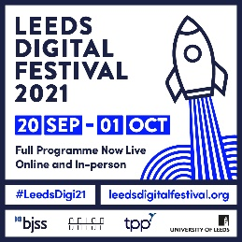

**Building Bridges- Leeds digital festival**

Recent insight provided by young people and parents in Leeds highlighted the growing divide between parents’ and young people’s digital literacy. This insight was gathered in relation to gambling-type activity as part of online gaming. Many parents/carers feel out of their depth in relation to account settings to control time, spend and security. The speed of digital innovation in the form of trading and streaming platforms and eSports leaves parents/carers feeling out of touch. This can become a great source of frustration and conflict.

Parent Zone, a national social enterprise, will provide an expert perspective on digital resilience and effective engagement with parents through the trusted professionals they turn to. They will outline how the Digital Resilience Framework can empower parents to be more confident in their conversations with their children, and the support they give them to manage their online world.

We will also share local and national tools and resources that are available to parents/carers to increase their knowledge and skills of online gaming and digital literacy, in order to achieve a healthier interface with the online world and better protect themselves and their children.

*Eventbrite booking* [Building Bridges – crossing the digital divide between parents and children Tickets, Tue 21 Sep 2021 at 12:30 | Eventbrite](https://www.eventbrite.co.uk/e/building-bridges-crossing-the-digital-divide-between-parents-and-children-tickets-167465302227)

**Age Proud Leeds Festival – join us in a time to feel good about ageing!**

Welcome to the first Age Proud Festival in Leeds! The festival will run continue to run until Friday 17th September at a range of venues across the city as well as lots of virtual events from the comfort of your own home.

* **Launch events** was held at the Leeds Playhouse on 6th September
* During the **ten days of the festival** there will be events taking place all over Leeds – check the website regularly for new events!
* Keeping people safe at the Age Proud Festival: read the COVID response statement on the [website here](https://www.ageproudfestivalleeds.org/).

[The festival website is the place to find out everything about the festival](https://www.ageproudfestivalleeds.org/), so make sure to visit regularly for new information.

**Domestic servitude**

The real-life story of a survivor of domestic servitude has become the inspiration behind a new [online animation](https://www.youtube.com/watch?v=mxQWjDNvs-Y) aimed at the communities of West Yorkshire. Launched to coincide with UN World Day Against Trafficking in Persons on 30 July 2021, it highlights the signs, raises awareness and encourages reporting of this hidden crime.

Domestic servitude typically involves victims working in a private family home where they are ill-treated, humiliated, subjected to unbearable conditions or working hours and made to work for little or no pay. Over the last two years, there has been a specific increase in reports of domestic servitude within West Yorkshire, indicating women from Pakistan and Bangladesh are being brought to the UK and exploited in domestic homes.

As well as English, the animation has been translated into Urdu, Punjabi and Bengali with subtitles. See the [dedicated webpage](https://www.westyorks-ca.gov.uk/policing-and-crime/domestic-servitude-animation/) for more information.

**Connecting Opportunities volunteer role**

Connecting Opportunities works with new migrants to develop their skills and opportunities to find work and be part of the local community.

Volunteers Mentors and Befrienders are matched to an individual refugee or migrant who has the right to work, and who has been referred by their Connecting Opportunities Keyworker. The aim is for the volunteer to support the person they are matched find out more in this [short film](https://www.youtube.com/watch?v=TKIWFm5U8AM).

**CEV support routes**

The Leeds Shielding Communications Toolkit contains a wide variety of advice and information on being clinically extremely vulnerable.

This includes information in different languages and formats as well as information being presented by video/ audio and presentation formats.

<http://bit.ly/leedsshieldingtoolkit>

**Big Leeds Chat**

The Big Leeds Chat is back, and we need your help – we are looking for people to volunteer as *chat makers.* The BLC is our ‘one health and care system’ listening event – an opportunity for us all to hear first-hand about what matters to local people, and what they need to live a healthier life.

Chat makers play a key role at the events – they will be buddied with a senior leader, and will support them in instigating chats with passers-by, and making notes of the conversation. It’s a great opportunity for you to meet a diverse range of people, with different stories and experiences to share.

This year, instead of hosting one big BLC event in Leeds city centre, we are focussing on hosting smaller BLC events in different communities across the city, and with priority populations. Events will take place over September and October – the first event took place on 4th September.

If you would like to take part in one of these events this year, please email [blcontour2021@gmail.com](mailto:blcontour2021@gmail.com) and a member of the Big Leeds Chat Team will keep you updated with the dates and venues of chats so that you can choose the one that is best for you.

We would advise chat makers and decision makers to attend an online BLC pre-briefing session prior to attending an event in September and October. These sessions are designed to inform all participants of what is expected, the aims of the BLC events and all safety measures (including precautions around covid19).

To book onto a pre-briefing session, please complete the [link](https://doodle.com/poll/mrhv5eierfhteqmi?utm_source=poll&utm_medium=link) provided. Once you have booked your pre-briefing session, you will just need to access the Zoom link below on the date and time chosen and one of the team will welcome you into the virtual session.

<https://us02web.zoom.us/j/2609081518>

**Trauma Informed Primary Care Workshop**

We’re excited to be inviting you to the first West Yorkshire and Harrogate Health and Care Partnership’s Trauma informed Primary Care Workshop, in partnership with West Yorkshire Violence Reduction Unit

Thursday 23rd September 2021, 7.00pm- 9.00pm (Virtual)

For further information about this event please contact Carrie Rae [carrie.rae1@nhs.net](mailto:carrie.rae1@nhs.net) or Emm Irving [emmerline.irving@nhs.net](mailto:emmerline.irving@nhs.net)

To register and book your place, please go to <https://www.eventbrite.co.uk/e/trauma-informed-primary-care-workshop-tickets-167039388307>