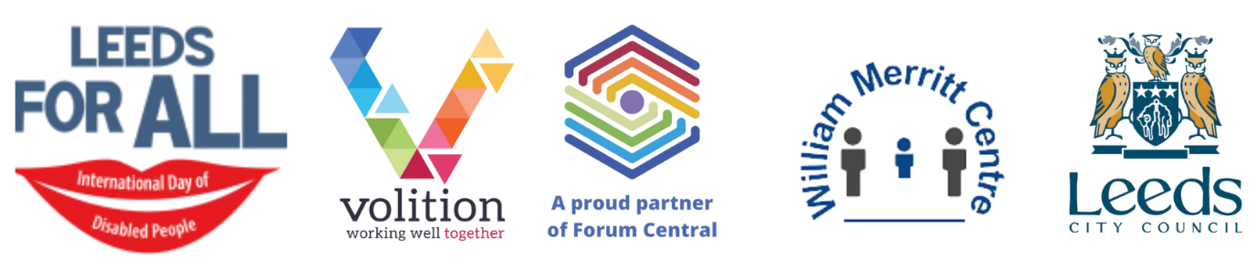
Venue change *** NOW ONLINE *** International Day of Disabled People 03 Dec 2021
10am – Online event opening – Zoom link
- Adam Douglas, Master of Ceremony
- Cllr Kevin Ritchie, Councillor for Bramley and Stanningley and Disability Champion, Leeds City Council
- Geoff Turnbull, Equality, Communities Housing and Environment, Leeds City Council
10am – 11am Change People, We are Out Spoken! – Zoom link
Join us for a workshop to find out more about the inclusion project involving LGBTQI+ people, who are also autistic and/or have a learning disability. Learn more about the barriers people face and how you can be an ally.
10.15am – 10.55am Online marketplace and discussion – Zoom link
Meet our virtual stallholders, hear about their services and who they work with.
11am – Official opening – Zoom link
- Lord Mayor of Leeds
- Cllr Kevin Ritchie, Councillor for Bramley and Stanningley and Disability Champion, Leeds City Council
- Geoff Turnbull, Equality, Communities Housing and Environment, Leeds City Council
- People In Action, Leeds Talent 2021 –
  - Olivia Quigley (singer)
  - Callum Kemp (singer/guitarist)
  - Catherine O’Donnell (Irish dancer)
  - Megan Nunns (singer)
11.30am – 11.40am ‘Beth & The Outsiders’ Video – Lippy People – Zoom link
How does it feel when someone close to us dies? What can help us when we are coping with loss? Watch a video story made by Aarron on Lippy People’s ‘Life, Loss, Learning, Legacy’ project – and hear his story.
11.45am – 12pm Ella Frances Sanderson – Zoom link
Ella’s poetry on her Asperger’s inspires people with the difficulty not to give up on life. We’ll show a video about Asperger’s followed by live poetry.
12pm – 1.15pm Online marketplace and discussion – Zoom link
Meet our virtual stallholders, hear about their services and who they work with.
12pm – 1pm Deaf Awareness & Everyday BSL signs, Deaf Women’s Society & Leeds Deaf Forum – Zoom link
Learn everyday basic BSL signs.
1pm – 2pm Climate Action Leeds, Highlighting the Climate Emergency – Zoom link
Join Climate Action Leeds and learn more about the climate emergency, how it’s affecting the world we live in, and what you can do to help. Creative learning activity, with a chance to ask questions about Climate Action Leeds.
1.15pm – 1.30pm Northern Ballet’s Ability – Performance – Zoom link
Short dance performed by members of Ability, Northern Ballet’s dance course for adults with learning disabilities.
1.40pm – 2pm Mircolink demonstration – Zoom link
2pm – 2.40pm Online marketplace and discussion – Zoom link
Meet our virtual stallholders, hear about their services and who they work with.
2.10pm – 2.30pm Sense, Drumming with Music – Booking link
Get moving to the upbeat music, and practice your drumming skills using wooden sticks! Suitable for people with complex disabilities, this class can be adapted for all individuals.
2.40pm – 2.55pm Leeds For All reflections and feedback – Zoom link
Join us for reflections on the day, share your feedback and see Tom Baileys visual representation of the day
3pm Close – Zoom link
Councillor James Lewis, Leader of Leeds City Council

