Local men’s network celebrates funding and national award nomination.
Photo call
Weds 19th Jan 12:30pm
W2 Barbers, 131 Easterly Rd, Roundhay, Leeds LS8 2TP
With W2 Barbers, local men and representatives of Men’s Health Unlocked
A photo of two men getting their haircuts with Richard at W2 Barbers. Richard is a local “Manbassador” – a local business talking to his regular clients and helping to direct them to local activities and support. The “Manbassador” project is part of the wider Men’s Health Unlocked programme.
Also present will be
- Damian Dawtry (Forum Central), Men’s Health Unlocked Coordinator
- Lawrence Glyn (Space2), Community Development Worker
- A senior figure from Leeds City Council / Local charity
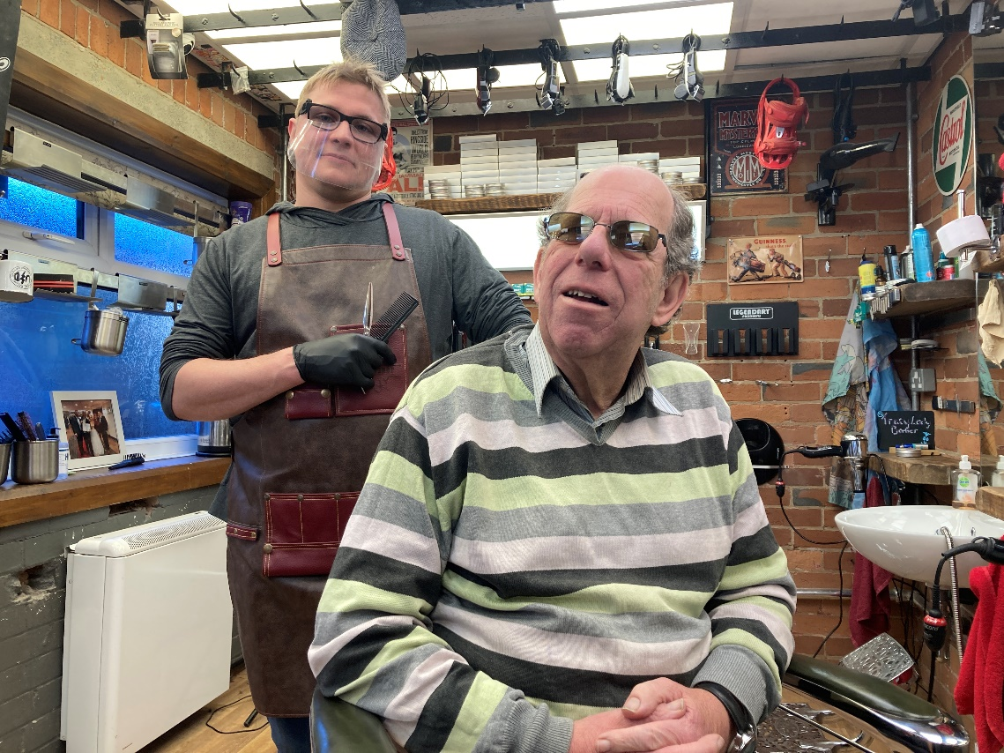
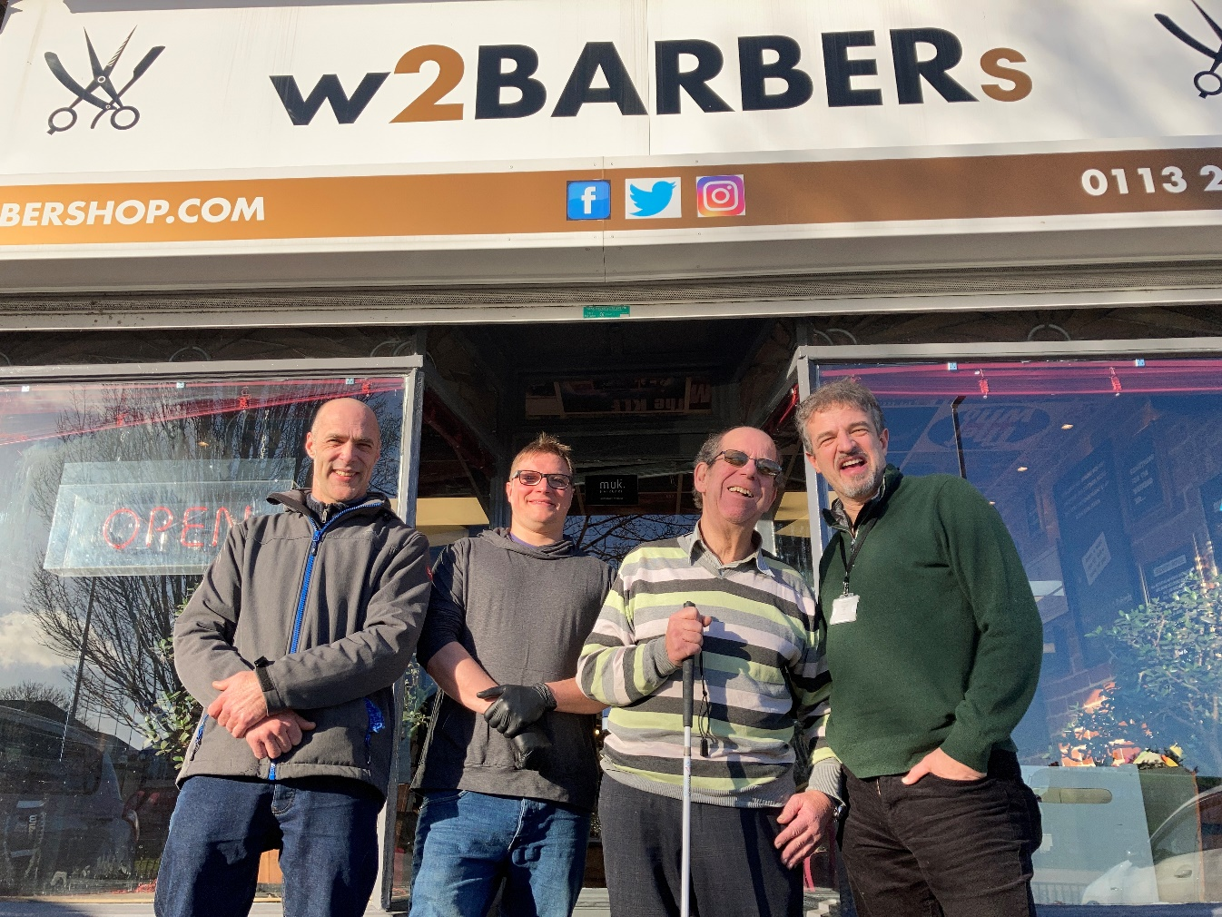
A local network supporting men’s health is celebrating this week having been awarded over £300,000 by the National Lottery, as well as being nominated for a national Project of the Year award.
Men’s Health Unlocked (MHU), a partnership between four local charitable bodies (Barca-Leeds, Forum Central, the Orion Partnership and Touchstone) and Leeds City Council, has received two years’ worth of funding from the National Lottery Reaching Communities Fund, to support the health and wellbeing of men across the Leeds area. It will feature free data-enabled tablets for isolated men, a city-wide men’s magazine, a directory of local activities, and, to mark Leeds City of Culture 2023, a Northern Man Festival, featuring both local and national organisations, artists and academics.
The boost for men’s health in the city comes after a successful first 12 months of the project, which has seen the network make waves at a local and national level. It has delivered 100 tablets to socially isolated and digitally excluded men across the city – half of which were men from ethnic minority backgrounds. It has also set up a men’s helpline and recruited “Manbassadors” in local shops, such as W2 Barbers on Easterly Road, who have regular chats with men to help point them towards activities and services.
In supporting the burgeoning men’s health work across the city, it has linked up groups to work together on projects, as well as providing academic and professional support to those who are looking to support and promote men’s health.

Joining together for Men’s health
Men’s Health Unlocked Coordinator, Damian Dawtry, said, “The continuation of this network is fantastic news for the city. It has come at a vital time as men, and men’s health, need support. They are dying 3.5 years earlier than women, they are more likely to suffer from Covid and from most of the major illnesses that affect all genders. Sadly, as many of us are aware, men are more likely to feel that this life has nothing to offer them any more, and are taking their own lives at an alarming rate.
“We need a joined-up approach to tackle these issues. This network involves key players both nationally and locally – leading groups such as our delivery partners Barca-Leeds, Touchstone and the Orion Partnership, as well as vital smaller organisations such as Leeds Dads and Circles of Life. We’re working alongside one of the world’s leading authorities on men’s health, Professor Alan White, as well as leading figures from the Public Health team and from the regional health authority. We’re on board with Women’s Lives Leeds and looking at some exciting joint work, and have received valuable support from national organisations such as the International Men’s Day and Mankind Initiative, to help address the nationally low uptake of domestic abuse victim services by men.

Key Support
Key figures from Public Health are also helping to drive this network forward, including Public Health Chief Officer, Carol Walker FFPH. “We have been delighted to work with and support MHU. Their invaluable work has been recognised locally, and now nationally through this additional funding from the National Lottery”, she says. “We look forward to continuing our work with MHU partners in this important work that focuses on men’s health which will support men in all communities across Leeds.”
Tim Taylor, Head of Public Health Localities and Primary Care Team, adds. “There is lots of great work going on across Leeds for men, which really makes a difference to their lives. This partnership brings together lots of this work and will allow it to be even more effective. The joint working with women’s organisations in the city is really important too and will lead to improved outcomes for all.”

A Leeds network with national acclaim and influence.
Men’s Health Unlocked was also a national finalist in the Project of the Year category in the Men and Boys Coalition Awards. “We were nominated for our innovative approach”, says Damian. “Ultimately, we lost out to Prostate Cancer UK, and there is no shame in that – to stand alongside a national charity was something that we are all very proud of.”
Professor White has also shown his enthusiasm for the network, saying, “Leeds has shown that by meeting the different health needs of men and women they can have a more efficient and effective service provision. This benefits everyone. Currently, there is a push for a national men’s health strategy and Leeds is a prime example of what can be achieved when the health of men is taken seriously.”

Giving men a say in their health.
The network is keen to keep men at the heart of what they are doing. “The support from funders such as the Lottery, and the combined vision, passion and dedication of a wide variety of organisations and bodies, has been absolutely vital, but it would mean nothing without the men themselves being on board, says Damian. “That’s why many of our activities are about including men in what we are doing, and giving them a voice. We will recruit some as volunteers to promote men’s health issues and develop campaigns. It’s men who will be designing the magazine, it’s them who will co-curate the festival, and it’s them who will be sharing health messages with other men online. Indeed, it’s them who will bring innovation and true connection to the work that we are doing.
“Taking a gendered approach to health is an excellent way to find really powerful solutions – solutions that work for men and solutions that work for women”, says Damian. “We’re keen to talk to men, to listen to them, and to help them take positive steps to making themselves, and consequently the loved ones around them, healthier and happier.”

Much of the work will begin in April, but in the meantime Men’s Health Unlocked continues to support local men’s groups, inform strategic meetings and promote collaborations, hold workshops, and support projects such as a men’s redundancy support package and a Men Supporting Women’s Safety project (with Women’s Lives Leeds and other partners).

Connecting isolated men to the internet
One of the strands beginning in April will be delivered by Barca-Leeds, who will be providing the tablets with free data attached. “We are proud to be partners in Men's Health Unlocked, a ground breaking men’s network here in Leeds”, says Bill Owen, Operations Director at Barca-Leeds. “We will be delivering the 'Unlock Online' strand, providing much-needed digital inclusion for men across the city. With the pandemic heightening issues of digital exclusion, as well as exacerbating social isolation and impacting metal health in men, the need for people to be digitally connected has never been greater.
Building on our successful pilot, we will, through the provision of free online access, connect men with other people and services and unlock the digital barriers that many face. Men will able to access vital connections such as men’s clubs, or services covering a wide range of areas including mental health services, addiction services and financial inclusion. Thanks to the support provided by the network, we hope that Unlock Online can have significant impact on the lives of the men involved in the project, including improving mental wellbeing & physical health, increasing social skills and enhancing financial literacy.’

To find out more about Men’s Health Unlocked, visit www.forumcentral.org.uk/mhu or contact Damian Dawtry at Forum Central on 07985 442630

Notes for Editor:

Forum Central
Forum Central is a network of health and social care third sector organisations in Leeds. It is delivered by the partnership of Leeds Older People’s Forum and Volition (the Mental Health, Physical and Sensory Impairment and Learning Disabilities Forum).
Our mission is to be a collective voice for the health and care third sector. Our combined membership stands at almost 300 third sector organisations working across Leeds – large and small with membership open to all third sector organisations working in health and care in Leeds.
Contact Damian Dawtry, Men’s Health Unlocked Coordinator
Leeds Older People's Forum, part of Forum Central
damian.dawtry@forumcentral.org.uk | 07985 442630
Follow us on Twitter: @LeedsOPF | @MyForumCentral
Men’s Health Unlocked Webpage: www.forumcentral.org.uk

Barca-Leeds
Barca-Leeds is an innovative multi-purpose charity in Leeds. Founded in 1994, we deliver transformational services to adults, children, young people & families. Our services help people overcome the barriers they may face by delivering advice, support and guidance.
This includes people who may have complex needs, issues with housing and finances, and people with physical and mental health problems.
We also provide services to children, young people and adults affected by domestic abuse, drug and alcohol issues, as well as people struggling with employment or education.
https://www.barca-leeds.org/our-services
https://www.barca-leeds.org/services/mhu

Contact Bill Owen, Operations Director (Employability and Community Health)
Unit 2a | Northside Exchange | Wyther Lane | Leeds | LS5 3BT
bill.owen@barca-leeds.org
m: 07745536616

Leeds City Council Public Health
Contact Tim Taylor, Head of Public Health (Localities & Primary Care)
Adults and Health Directorate, Leeds City Council
Adults and Health Directorate | Leeds City Council | Merrion House| 5th Floor West | 110 Merrion Centre | Leeds | LS2 8BB
Mob: 07891 278231
Email: tim.taylor@leeds.gov.uk

The Orion Partnership
The Orion Partnership is a consortium of four like-minded organisations: Feel Good Factor, Zest-Health for Life, Space2 and Shantona Women’s Centre based and working within East North East Leeds, sharing common values and organisational cultures with over 40 years direct experience in our communities. Their Well Man Programme has been providing health and wellbeing activities for men since 2014.
This project will be led by Space2 , working with Feel Good Factor and Zest
www.space2.org.uk/about-us/orion-partnership/
Contact Emma Tregidden, Joint CEO, Creative
Space2, The Old Fire Station , Gipton Approach, LEEDS, LS9 6NL
emmat@space2.org.uk

Touchstone
Touchstone provides mental health and wellbeing services to over 2000 people a year, whilst also working across communities to grow their confidence and capacity to demand the services and positive experiences they are entitled to.
https://touchstonesupport.org.uk/about-us/

Contact Joe Kemp, Senior Community Development Worker
Mentally Healthy Leeds, 41-47 Cromwell Mount, Leeds LS9 7ST
Joek@touchstonesupport.org.uk
07741 328786

Professor Alan White
Alan was the Founder and Co-director of the Centre for Men’s Health at Leeds Beckett University, he is now Emeritus Professor of Men's Health at the University having retired from his University post in 2017. He was a co-founder of the Men’s Health Forum Charity (www.menshealthforum.org.uk) and was the Chair of the Board of Trustees for 12 years, he is now its Patron. Alan lead the team writing the State of Men’s Health in Leeds Report and the State of Women’s Health in Leeds Report.
https://www.alanwhitemenshealth.co.uk

National Lottery Community Fund
The National Lottery Community Fund distributes over £600m a year to communities across the UK, raised by players of The National Lottery. The Reaching Communities Fund offers a larger amount of funding (over £10,000) for organisations that work with their community to help them thrive. They fund projects that work to make positive changes in their community – whether that is for people living in the same area, or people with similar interests or life experiences.

National Men’s Health Strategy
To view Professor White’s presentation to the All Party Parliamentary Committee on a national Men’s Health Strategy, in which MHU features as an example of policy creating positive action, please visit
https://www.youtube.com/watch?v=Ekm09M2U4ng

Please direct all press enquiries to:
Damian Dawtry, Forum Central. damian.dawtry@forumcentral.org.uk | 07985 442630

