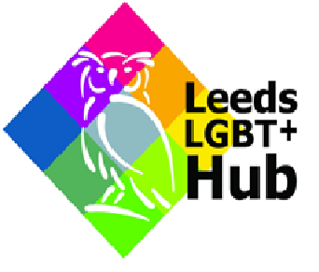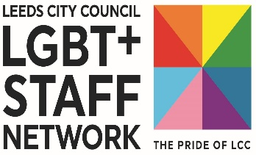

Leeds City Council LGBT+ community grant application form

We have grants available designed to support LGBT+ third sector organisations, grass roots organisations and organisations that work directly with the LGBT+ community in recovery from the Covid-19 pandemic. Please tell us about the events, activities and/or projects you are requesting funding for in the below sections of the application form.

Please complete all sections of this application form.

Please return the completed form and your cost breakdown by email to: LeedsLGBT@leeds.gov.uk by 5pm on Friday 10th June 2022.

Section 1 – about you and your organisation

Name of Applicant (lead contact):

E-mail address of applicant:

Organisation name:

Details of other organisations you will be working with:

Your organisations social media usernames and hashtags:

Section 2 – about your events, activities or projects.

- Please tell us the title/s of your events, activities, or projects

- Over what period will your events, activities or projects be held? (Date and time if available) Please be advised that all funding must be spent by 31st March 2023.

- Tell us what you want to do and what impact the funding will have? (300 words max)

- Tell us how this will contribute to improve the resilience of your organisation, promote equality of opportunity for LGBT+ communities, highlight barriers faced by LGBT+ people in society and provide positive outcomes for LGBT+ individuals in the wider community. (400 words max)

- Tell us up to 4 key things you are aiming to achieve through your events, activities, or projects.

- Tell us how you are going to be working with other LGBT+ organisations or community groups. (200 words max)

- Tell us how much your proposed events, activities or projects are likely to cost altogether and how much you want from us.
Please include (as a separate attachment) a full breakdown of your expected costs and show what the Leeds City Council LGBT+ community grant will be paying for.

- Will people have to pay to participate in your proposed events/projects/activities and if so, how much and will there be options to ensure lower-income groups are not excluded?

- Please briefly explain how you will monitor and evaluate your events, activities, or projects. You will be expected to provide a brief response at the end of the grant period expanding on this answer based on evidence gathered. (300 words max)

- If your application is success, how will you promote the support you have received from Leeds City Council?

Section 3 - Making your idea work

This part of the grant form aims to see whether there are any access, legal, safeguarding or health and safety issues that may need to be resolved to make sure your planned events, activities or projects can go ahead.
If you do not have polices, a venue or are not a constitutionalised charity this does not mean you will not receive a Leeds City Council LGBT+ community grant; it just means we will need to work with you to match you with an appropriate organisation or funder to make sure your idea does not run into any difficulties.
Please answer the following questions:
- Where will your activities be delivered in Leeds? If you already have planned areas or venues for delivery, please include the area or the address including postcode.

- What venue/s will or might you use? How do you know the venue/s will be safe for use by participants?

- Please tell us how you will make sure that your events, activities, or projects will be accessible, meet the needs of our diverse communities and be welcoming to everyone attending.

- Through the proposed events, activities, or projects, will you come into contact with children and young people under the age of 19 or vulnerable adults?

- How will you make sure you are able to respond to any complaints or safeguarding issues raised during your proposed events, activities, or projects?

- All funding must be spent in line with the Leeds City Council Equality and Diversity Policy. Please confirm that you have read the policy and will abide by this in the delivery of your works.

- Are you in receipt of any funding from Leeds City Council or the LGBT+ Hub? This may be taken into consideration when evaluating your submission.

