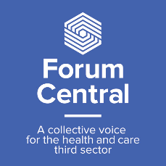

Health, well-being and safe relationships for learning disabled and neurodiverse communities
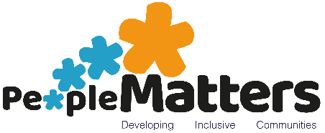
Expression of interest
Deadline: August 5th

People Matters, working with Forum Central, have been fortunate to have received an indicative grant allocation from NHS Leeds CCG, soon to become the Leeds Office of the Integrated Care System (LOICS), under their ‘Addressing Health Inequalities’ scheme. This grant allocation has come through submission in a competitive process and People Matters will be lead provider for the project ‘Health, well-being and safe relationships for learning disabled and neurodiverse communities’. The project will be looking to pilot 8 groups across the city over a period of approximately 6 months with a view to securing longer term sustainable provision in the future. (Please note this is not guaranteed at this point).
People Matters will be the lead grant holder and are looking to work with at least 3 other Forum Central member organisations as delivery partners. They will lead on setting and collating evidence towards KPI’s and will offer support for delivery partners on working with NHS partners, and linking the work to the outcomes framework of the newly formed Learning Disability and Neurodiversity Population and Care Board. This board holds devolved power for outcomes and financial spend for the ICS, formerly learning disability commissioning with the NHS Leeds CCG
Delivery partners will be expected to recruit attendees, deliver groups, and attend regular (no more than 6) delivery partner meetings to support collaborative working, record keeping and data collection. This group will also aim to collaborate with existing providers such as those funded via national charitable trusts throughout the period of funding in order to support development of a coherent offer across the city. Service level agreements will be put in place to ensure all partners funded by the project hold relevant insurance and adhere to policies covering areas such as safeguarding, health and safety, data protection and equality of opportunities. Information on funding allocations and timing will be shared with prospective partners after this is signed off by commissioners.
The project groups, of approx. 8 people, should aim to meet weekly (excluding holiday periods) from October onwards for a period 6 months. Places can be offered to people with learning disabilities and/or autistic people. Partners will be encouraged to give priority to NHS referrals. The focus of group activities should be led by group members across the broad theme of physical and mental health and well-being. (People Matters will focus on working across the area of safe relationships). Visits from NHS practitioners should be supported where appropriate to encourage partnership working between the third sector and the NHS.

Information from prospective partners
Contact name:
Organisation name:
Contact number:
Contact email:
Where is the organisation based:
Planned delivery location if different:

Please confirm you are willing to contribute to the project working group.
Yes/No/Maybe
Are you: (circle all that apply)
Looking to support an existing group
Looking to start a new group (you have already identified the need)
Looking to bring in ‘expertise’ to deliver one or several sessions with an existing group

Briefly expand on your answer(s) above (max 200 words)

What evidence have you used to identify a need to provide health/wellbeing focused groups/activities for existing groups?
What potential benefits would you expect for group members? (max 200 words)

What potential benefits would you expect for your organisation? (max 200 words)
What current relationships do you have with NHS health services including GP’s, LCPs, CCG, PCN, NHS trusts and social prescribing services? (If none then please state this. It will not affect your ability to be within the partnership) (max 120 words)

Is there anything else relevant to the project you would like to tell us? (max 120 words)

Please return the Expression of Interest form to Sally Jude: sally@peoplemattersleeds.co.uk

