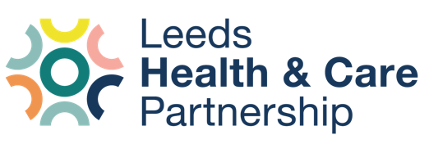
Partnership development work:
Update 3 – November 2023

- Background
- This note provides the third instalment of the regular updates on the Partnership Development work currently underway across the Leeds Health and Care Partnership.
- Previous communications have been shared outlining the aim, scope, objectives, and structure of this work. This update is intended as a build on these, so we recommend reviewing these earlier emails if you have not already done so. If you need a copy of the earlier communications, please request these via the contact details at the end of this note.
- Update – activity over the last two weeks
- A revised Memorandum of Understanding (MoU) and statement of the Leeds Health and Care Partnership’s purpose, scope and functions has been developed and shared with Stakeholders aligned to ‘Theme 1’. The document aims to set out what the functions of the partnership could be, and how/where they take place. The document also aims to describe the different types of relationships in the partnership and why this is so complex. A key diagram from this document is below (with the strong caveat, that we know this isn’t ‘right’ but a helpful starting point).
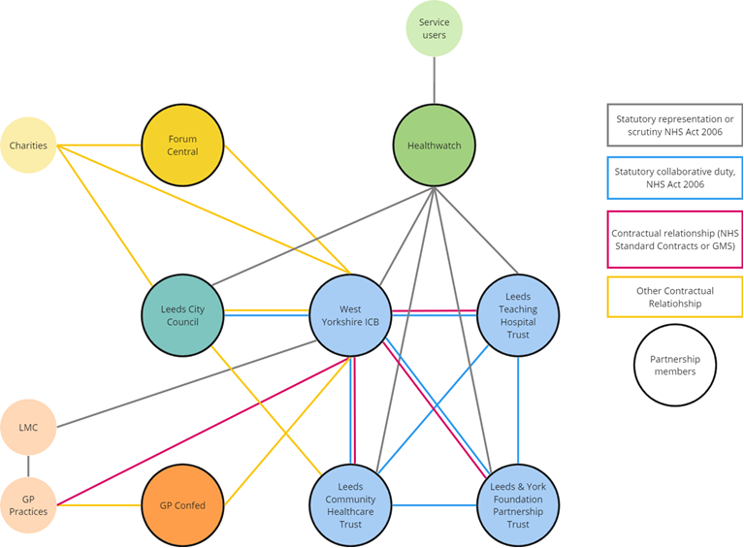
- If anyone would like to see the full working document for comment/review, then please contact Nick Grudgings (nick.grudgings@nhs.net)
- The Theme 1 stakeholders met last week to feedback on the document. The group noted this this was a really helpful start, but asked that we draw out more clearly the functions we must do (or are expected / legislated to do) and those that we should do (where we believe it adds value for us to do). Other comments were discussed in the meeting and will be incorporated into the next version.
- Aligned to the MoU, work has been underway to map current and potential ‘future state’ governance arrangements. This has started by taking our existing partnership governance diagrams and annotating it with the current challenges, gaps, and overlaps.
- Kirsten Walker from Newton Europe has recently started supporting the Partnership Development Work. She is a business psychologist and brings experience in the field of partnership working.
- Looking ahead –work under way the next two weeks
- PEG will meet face to face on 15th December for a facilitated session that will focus on partnership purpose, scope, and functions and to also plan a series of exec to exec team wider sessions.
- The next iteration of the MoU document will be developed and shared for further review.
- A series of wider partnership sessions for executive leaders across Leeds to come to together will be planned for with the aim for the first session to take place in January – dates TBD.
- A more detailed write up of the Staten Island next steps and actions is under development and will be shared with the Steering Group members, then wider partners, in December.

- Contact details
For further details on any of this work please contact manraj.khela@leeds.gov.uk, or emily.carr20@nhs.net, or contact your organisational representatives involved in the work. We’d also welcome feedback on our communications, so do let us know if there is anything you’d like to see more or less of.

