International Day of Disabled People 2023

Evaluation Report
February 2024
(Word document version with photos and appendix)

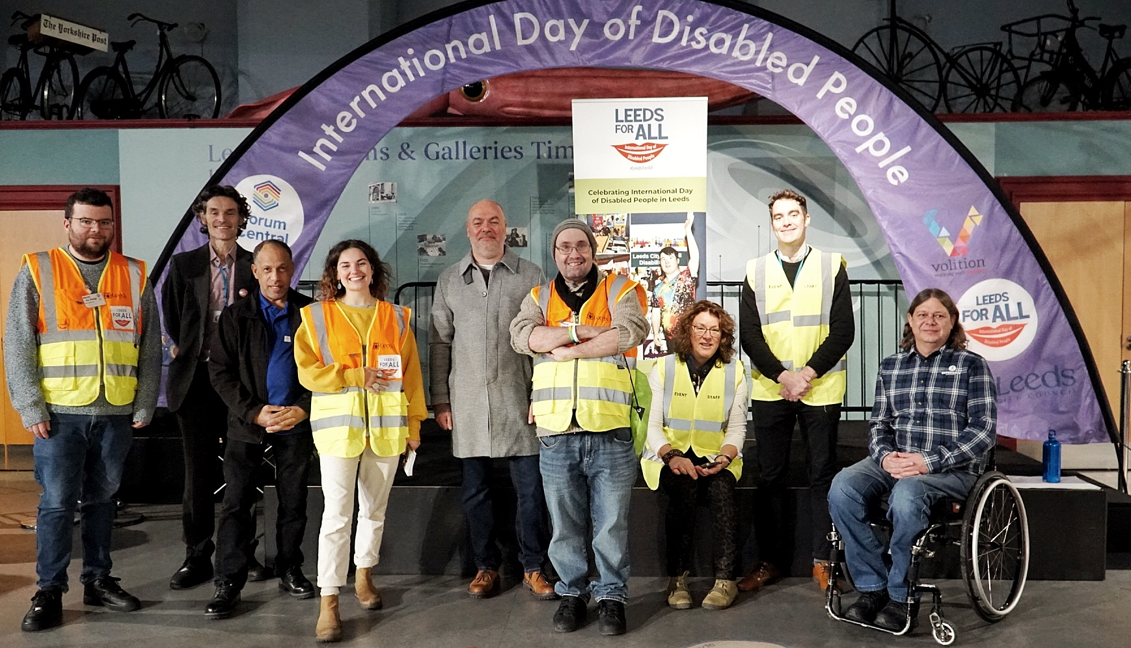
Photos credit: Cheryl Ferris-Stewart

Contents

Page 2 Background
Leeds for All History
Page 3 Executive Summary
Event Summary
Funding and Figures
Page 7 Event Activity and Delivery
Stallholder Information
Accessibility
Other considerations
Communications and Marketing
Page 12 The Marketplace
Stalls and Interactive Stalls
Guest Speakers
Page 17 The Small Grants Programme
Evaluation of Activites
Page 23 Feedback
Quantitative data
Qualitative data
Page 31 Conclusion
Recommendations
Reflexive Statements

Appendices
Page 33 Appendix 1 - Leeds for All logo
Page 34 Appendix 2 – Stallholder Information Pack
Page 41 Appendix 3 – Stallholder Summary
Page 46 Appendix 4 – Easy Read Programme
Page 47 Appendix 5 – Press Release, Selection of promo graphics
Page 51 Appendix 6 – Illustrations
Page 52 Appendix 7 – Summary Chart of Completed Activities
Page 55 Appendix 8 – Easy Read Feedback Form, Digital Feedback Form
Page 57 Appendix 9 – Email Feedback

Background

International Day of Disabled People (IDODP) is a Global Day of Recognition created by The United Nations which takes place every year on 3 December. The annual observance of this day aims to promote an understanding of disability issues and mobilise support for dignity, rights and wellbeing of disabled people.

It was launched in 2019 to coincide with the United Nations Disability Inclusion Strategy that came into being in June that year.

IDODP is recognised by the British Government as an important part of our UK Disability Policy. Our current Minister of State for Disabled People, Health and Work is Miriam Davies. The principles of IDODP are Celebration, Learning, Optimism and Action.

Since 2019, Forum Central have worked in partnership with The Disability Hub at Leeds City Council to host the ‘Leeds for All – International Day of Disabled People’. 2023 saw the event being hosted for its 5th year.

Leeds For All History

The Disability Hub at Leeds City Council worked in partnership with Forum Central to organise the first ever International Day of Disabled People Celebration Event, in Leeds, in December 2019 at Leeds City Museum. The brand name ‘Leeds for All’ and logo (Appendix 1) was created.

2019

The theme of 2019 was ‘The Future is Accessible’. The event focused on bringing people, organisations and communities together with the aim of celebrating the achievements of disabled people in Leeds.

2020
The team continued celebrations in 2020 during the COVID-19 Pandemic. The Leeds For All event became a week of accessible, online, live and at home activities to keep people with disabilities connected. It created, ‘A space for celebration, reflection, connection, acceptance and challenge.’

2021
In 2021 the week-long celebrations went hybrid and were live streamed from Leeds City Museum as there was a resurgence of COVID-19 at that time which meant people couldn't attend in-person events. The theme was ‘Leeds for All - Recovery from COVID-19.’

2022
This year saw the IDODP event being scaled down to a one-day event consisting of a Marketplace, mainly due to limited staffing and a need to bring it back to scope. The theme was ‘Making Invisible Disabilities Visible’, thus widening inclusivity to neurodivergent and/or autistic people.

Small Grants Activities - 2022: 2022 was the first year that the IDODP Small Grant Funded Activities ran. Micro grants were given to a selection of small community led organisations, to open up new avenues and attract fresh audiences. It helped organisations to achieve both these objectives successfully and the activities ran from December 2022 -January 2023. Eight organisations were involved, and each received £250 each to hold an activity or mini project that was additional to their normal work.

You can read about the highlights of each of the previous four events by scanning the IDODP Reports which are available to read here:
- 2022 Report: Leeds for All International Day of Disabled People
- 2021 Report: Leeds for All - Recovery from Covid -19
- 2020 Report: IDODP Goes Online
- 2019 Report: IDOPWD Leeds

Executive Summary

An overall figure of 380 people attended the IDODP Celebrations Day on November 30, 2023, which was a great success, not discounting the 28 stallholders and their volunteer helpers. It included a wide variety of people with lived experience from learning disability, sensory impairment and autism support organisations and as individuals, as participating and active citizens of Leeds.

The Small Grant Fund reached 511 people at community-based events that were held around Leeds. These were organised and run by 12 different organisations who were awarded a small grant to contribute to their IDODP celebration activity or event. Further information is in the Small Grants section with evaluation summary.

The two halves of the whole IDODP ‘23 project therefore influenced and allowed around 900 people to be included in its extended pan-disability scope which for a one-off annual project shows valuable and extensive results with collaborative and partnership building spinoffs that collaboration vs working in silos brings.

The far-reaching vision of IDODP combines fully with that of the Better Lives Strategy to ‘support every person to live in a place they call home with people and things they love, in communities that look out for one another, doing the things they love’

The IDODP Celebrations Day combined with the Small Grant Funded Activities supported organisations to reach new audiences, network, build new partnerships and strengthen old ones. It allowed people to:
- Access relevant information and services in one place
- Look at their current and future wellbeing and try new activities
- Connect in-person with ‘thriving communities’ and join in / join up

IDODP ‘23 not only provided a focus for community engagement but also supported getting people's voices heard and influencing change.

The Disability Hub
The annual IDODP Marketplace event has a large reach, and is an important place outside of The Disability Hub meetings where direct engagement can happen between Leeds City Council and disabled people. The Disability Hub works with organisations and speaks directly with disabled people to get their views on how the Council can make Leeds a more inclusive city across all aspects of their services. The Marketplace event also enabled colleagues from the Connecting Leeds team in Highways & Transportation at Leeds City Council to engage with members of the Public.

The support and promotion of third sector activities by enabling and facilitating such key annual events is a priority of the Equality team and something which they seek to do across all protected characteristics. As well as this, the IDODP Celebrations link into key strands of Leeds City Council strategies such as the Best City Ambition and Better Lives Strategy.

It also increases public awareness of the contributions the Council makes to the disabled infrastructure in Leeds.

It is a significant partnership event for the Equality team, Forum Central; its members and members of the IDODP Steering Group. The Disability Hub supports third sector partners in organising the IDODP Celebrations with input from the Leeds for All team.

The Leeds for All Team
The ethos of the Leeds for All team and steering group in 2023 was to be innovative, creative, and to foster a learning culture where co-production and co-design were central to project planning. For example, the two new Mini-Highlights videos that were produced extend the range of scope for post events engagement by allowing people to view and listen to summaries of IDODP ’23. Both videos are Audio Described to be accessible for blind and visually impaired people. This has been a learning curve and helps demonstrate best practice in the pursuit of accessibility for the Disability Hub and Forum Central going forwards.

Delivering to the theme of ‘Transformation, Inclusion, Innovation’ in turn allowed us all to work together to try new approaches and ideas, which are evident in the overall success and reach of 2023 and associated positive feedback.

Event Summary: IDODP 2023 ‘Transformation, Inclusion and Innovation’

This Leeds for All IDODP event happened for the 5th year in succession, giving it the feel of an established programme, again held at Leeds City Museum. The theme of 2023 was “Transformation, Inclusion and Innovation”. The main thrust of the event was for it to be larger in terms of more stallholders, more activities, greater public attendance and a greater cross sector Marketplace.

This event also had the addition of facilitated and accessible activities run by Yorkshire Cricket, Active Leeds, Yorkshire Dance and The Feel Good Circus. The activities gave the event a more holistic and vibrant feel as attendees could take part and interact with each other. The IDODP marketplace and activities were free to attend. Attendees did not have to go through a booking process.
People coming to the Celebrations Day came in and stayed for as long as they wanted, using the space for networking, socialising and learning about new organisations.

This year there was an intersectional approach to the organisation of the event under the theme of ‘Transformation, Inclusion and Innovation’.

Funding and Figures: Marketplace Event and Small Grants Fund

Leeds City Council Contributions

A generous contribution of £3450 MICE funding from Councillors representing wards across Leeds was provided for International Day of Disabled People (IDODP).

MICE provides an allocation of funds for locally determined projects to be used for qualifying proposals by Ward Members. The MICE funding for IDODP was provided with contributions from 24 councillors which supported the small grants scheme that funded 12 projects.

The Adults and Health Directorate at Leeds City Council contributed £1,000 for the IDODP marketplace event in the Museum which included support with costs for performances and interactive activities on the day.

The Children and Families Directorate contributed £350 towards speakers fees and performance activities. Both Directorates were keen to show their support for IDODP given their important work to support disabled people across Leeds through their services.

The Leeds City Council Equality team also contributed £1,000 towards the overall costs for the event including an ‘IDODP event arch’ for the stage area which will be used for the event in future years.

Thanks to the generous contributions of Elected Members the small grant funded model has also given participating organisations enough capacity to run additional and very successful community-based activities around IDODP in both 2022 and 2023.

Forum Central Contributions

Dedicated planning, administration, design, coordination of the IDODP event and grants was delivered by Forum Central. The Forum Central Partnership contract covers the staff team members responsible for the successful running of this event. Volition is the Forum Central Partner organisation and registered charity which is the employer of the four staff members whose involvement was worked out to be the equivalent to £3,500 in terms of staff resource.

The Disability Hub Contributions

The Disability Hub is one of the Council’s Equality Hubs. It supports Council engagement with a wide range of Leeds citizens so they can feed into the decisions it makes. Leeds City Council Equality team staff members contributed to the preparations and promotion of the event, as well offering support on the day.

Event Activity and Delivery

Steering Group

The Leeds for All team recruited a steering group, by inviting a range of organisations, each with a focus on a different impairment or condition, to volunteer. Steering group meetings took place once a month from June till November, for 1-2 hours.

The steering group had 10 members made up of third sector organisations and Leeds City Council representatives; ABA (Association of Blind Asians), LDPO (Leeds Disabled People’s Organisation), Leeds Involvement, Leeds City Council – Access, Equality, and Special Services Departments, Leeds Autism Services, LCIL (Leeds Centre for Integrated Living) and Volition, Forum Central.

Steering group members helped input on activities, layout, accessibility and with the promotion of the event. It illustrated a cross-sector and pan-disability approach with organisations representing support and activities, offered by and for, people with both visible and invisible disabilities, people with learning disabilities and/or autistic people.

The steering group did not partake in the grant panel for the Small Grants Fund. This was so that they could also apply for the funds if desired, and not be excluded by conflict of interest.

Stallholder Information

Stallholder Virtual Information Session

An information session for stall holders was held 14 days before the event so that room layout, arrival/departure times and other necessary information could be given to the people hosting stalls on the day. It included a Q&A session where stallholders could clarify anything they needed to, this resulted in a problem free set up and smooth running of the marketplace on the day. 16 stallholders attended the briefing session.

Stallholder Information Pack (Appendix 2)

This was emailed out to all stallholders after the information session. It included the following documents:

- IDODP poster and social media flyer,
- Broderick Hall Stalls layout
- Programme
- Event Access Guide
- YouTube Access Video
- Stallholder Summary (Appendix 3)

Stallholders were asked to contribute to promotion in the run up to the event.

Accessibility

Venue Access Tour Video

Our learning disability team made a visit to the museum to create an accessibility video, with subtitles. This showed where the various entry/exit points were to the building, where activities were located, how to use the lift, and where accessible and changing places toilets were located too. The video can be viewed on YouTube: IDODP 2023 Access Tour of Leeds City Museum (QR code on page 33 in Appendix). It received 120 views and 4 likes (as of January 2024). It proved to be a very positive aid according to attendee feedback. Feedback from Kenneth at Asking You!:

“I think that video is amazing, great idea to show everybody where the lifts are before they get there, where the ramp is and how to access everything before they get there, I think that’s brilliant!”

Sight Guides

Forum Central held a training session prior to the event so that on the day there were 4 Sight Guides present at the marketplace to be on hand if needed. Staff also wore Hi-Viz gilets to make them visible to anyone who wanted help or information during the day. All volunteers had attended an in-house information session and a health and safety talk at Forum Central as part of their training.

BSL Interpreters

This year because we had both a marketplace event and activities, we had 2 interpreters from Leeds City Council who provided adequate support for the Opening Speeches, the Well-being Session for the Deaf community and for any individual requests in support for networking. The BSL Interpreters were identified to people at the start of the event and were visible throughout the day to support both the marketplace and the Adapted Activities.

Easy Read Programme and Welcome Table

An Easy Read programme was produced and shared to explain what was happening at the event, including who the speakers were, and where and when activities were taking place. Hardcopies of the easy read programme (Appendix 4) were available for attendees who needed them at the Forum Central/Leeds Disability Hub welcome table. The welcome table also provided handouts/leaflets from disability led organisations on health, transport, and employment initiatives.

Further considerations

Risk Assessment

A thorough listing of all activities and stall holders was compiled which clarified to organisers details of the space in the main hall and illustrated what stallholders were intending to do on the day.

Room Layout – Map

There were 3 large scale A3 printouts of the Broderick Hall layout (see Stallholder Pack, Appendix 2) showing where each organisation’s stall was located for people to refer to.

Feedback Post box

A red and gold post box (cardboard) was positioned by the Broderick Hall main doors and the welcome desk and captured valuable feedback from attendees. We asked how the content of the day and their interactions with organisations and activities had inspired them or influenced them to connect with new organisations. And if it had inspired or enabled them to try something new to add to their daily routines or changed their outlook on improving their wellbeing and social connections.

Further information about event feedback can be found in the data analysis section of this report.

Signage

The museum is a multi-level venue with many steps and every attempt was made to make accessing the different activities in the museum as easy as possible. Large arrows and directions were posted at strategic points and museum Visitor Assistants and Forum Central Volunteer Staff (wearing hi-vis jackets) were placed along corridors, at entry and exit points, downstairs and in the main hall.

Communications and Marketing

Brand Development

This year the branding of IDODP was developed to give it a more up to date look and feel. Introduction of the teal colour was done as a combination of the Forum Central specialism colours of cyan for Learning Disability and green for Physical Sensory Impairment (PSI) to reflect the cross-specialism approach of this event. It is also part of Leeds City Council’s colour palette.

Promotion

The event and small grants fund was promoted widely by Forum Central and Leeds Disability Hub through direct email, online via social media (Facebook and Twitter) and on the websites of Forum Central, Doing Good Leeds, Eventbrite, Leeds Inspired and Leeds City Museum. Posters were displayed at venues and workplaces around the city centre. The Forum Central team shared it by word of mouth at Network meetings and with contacts. Stall holder organisations were also encouraged to promote the event to their service users and people they support.

The guest speakers and activities were a fantastic promotional tool and were highlighted as key reasons to come along. As was the fact that it is a free event with Quiet sensory room and BSL interpreters.

This event brings organisations, partners, commissioners and funders together as a leading community event and was promoted as such.

The following was produced and shared as part of a communications plan:
- Press release (Appendix 5a) circulated to local and regional media contacts.
- A4 poster (Appendix 2) taken to some locations, and available for organisations to download for display in their offices and venues.
- Social media graphics (Appendix 5b) shared on Forum Central and Disability Hub accounts and available for organisations to download for use.
- Email signature (Appendix 5b) added to all of the Forum Central staff members' email signatures to ensure the event's recognition by member and partner organisations.

Facebook Activity

Several posts were shared on facebook in the run up to the event. A small-scale targeted ad with a budget of £8.00 was used to boost the event post on Facebook. This was useful because the organic reach of Facebook is limited. It reached 706 people, 25 people responded that they were interested and 10 people said ‘going’.

X (formerly Twitter) Activity

X (formerly Twitter) is Forum Central’s main social media channel. Our audience consists of mainly third sector organisations and employees. 16 posts were made on the Forum Central account in November to promote the event which generated a lot of interest. The Disability Hub and Stallholder organisations were also actively posting on X about the IDODP event in the run up.

Three Forum Central posts on the day totalled 1968 impressions and 163 engagements. The highest achieving post was of a quote and photo of Jodie Boyd-Ward speaking at the event, which was seen by 950 people (impressions) and received 62 engagements; 8 of which were retweets and 32 were likes. It read:

“Leeds is my city, this is my home now… It doesn’t matter what barriers you think are in the way - there is a right outlet for you and Leeds has been amazing in helping me find mine”
Great to hear from Jodie Boyd Ward - her story and how sport has been her saviour #IDODP2023

Activity Alliance, the provider of the table ping pong activity, posted:

“It’s great to be a part of today’s International Day of Disabled People event in Leeds.
We’re here alongside organisations from across West Yorkshire sharing the work we do to close the activity fairness gap. #LeedsForAll”

The Marketplace

Councillor Kevin Ritchie “I thought the day was excellent, the programme varied and interesting. The joy of the participants downstairs during the various activities was a pleasure to see. The range of stalls and quality of information was first class too”.
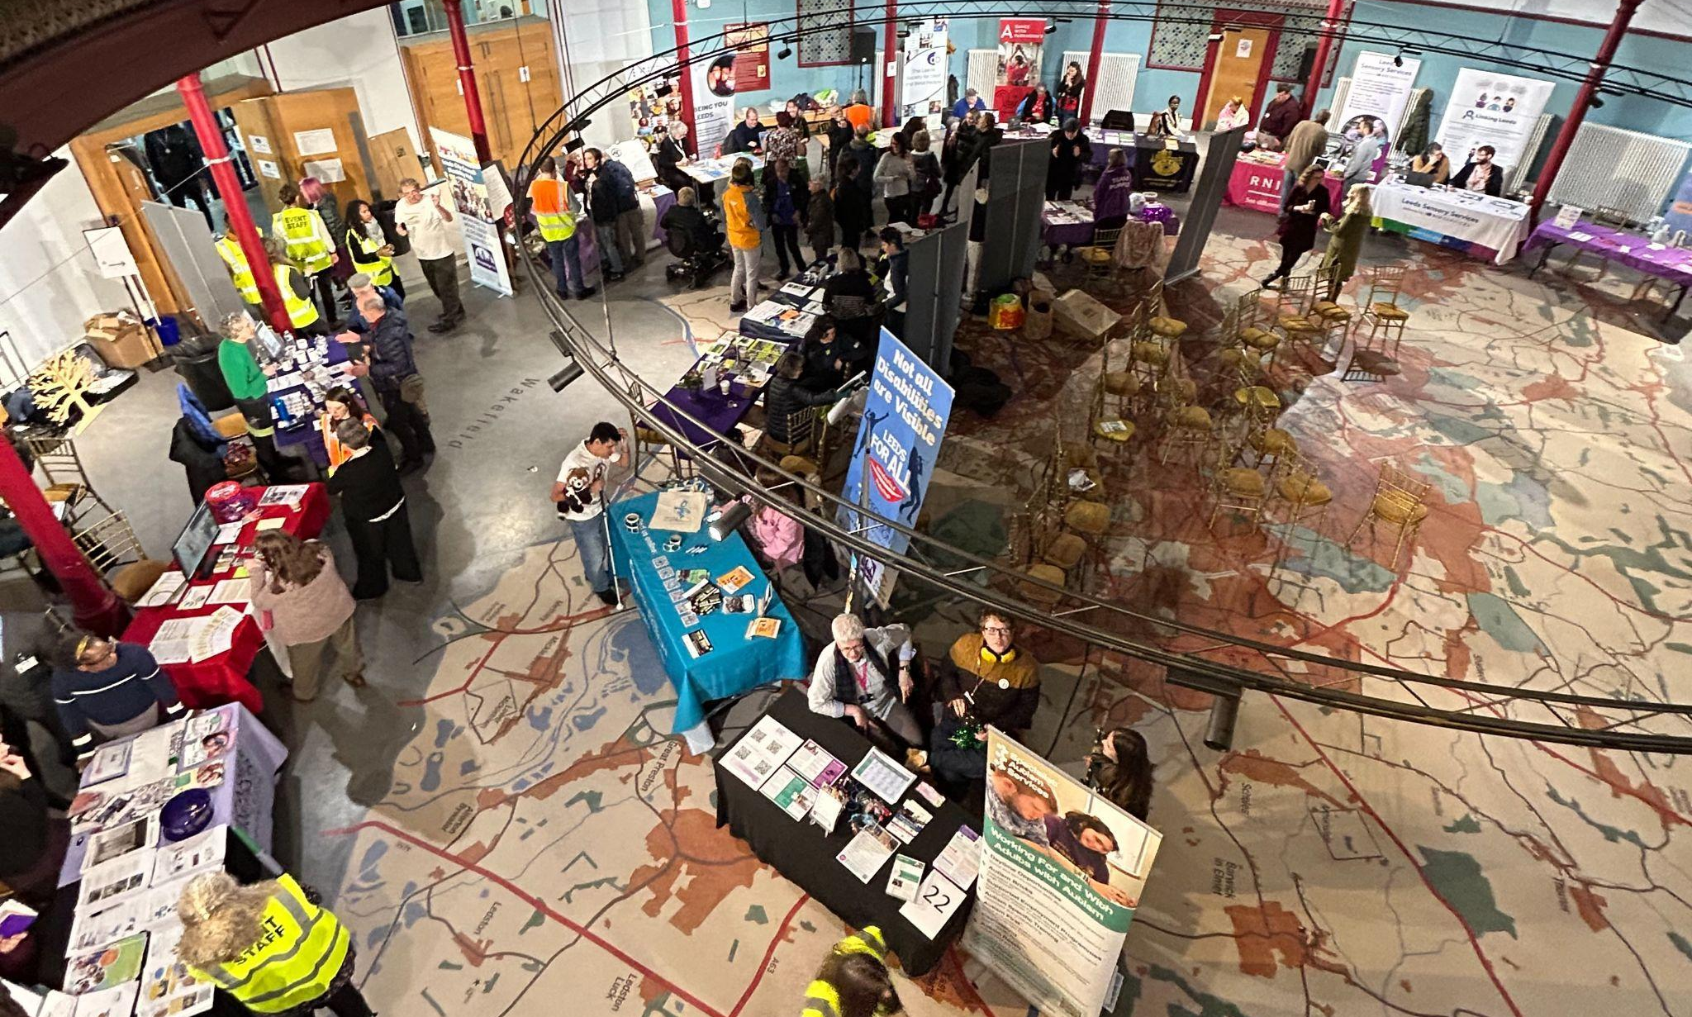

The Marketplace had 29 stalls and were hosted by organisations from the third and public sector. A full list of stallholders and information about their organisations can be found in Appendix 3. The demand from organisations requesting stalls was high this year and we had to operate a waiting list. There were 10 organisations on the list, but pleasantly, no organisations dropped out on the day of the event. The range of organisations ensured various disabilities could be represented and provided a variety of engagement opportunities, which gave the Marketplace a good buzz and ensured it was well attended throughout the day.

Stalls were planned out around the room and grouped together with a learning disability and a physical and sensory impairment theme to make the hall more accessible and to make it easier for organisations to network as well. This resulted in initial conversations and possible new partnerships being made. People were able to meet and share useful information about services, activities, groups, and support options that their organisations offer.

Interactive Stalls

This year’s theme also included innovation. Many stallholders provided interactive stalls. See examples below:

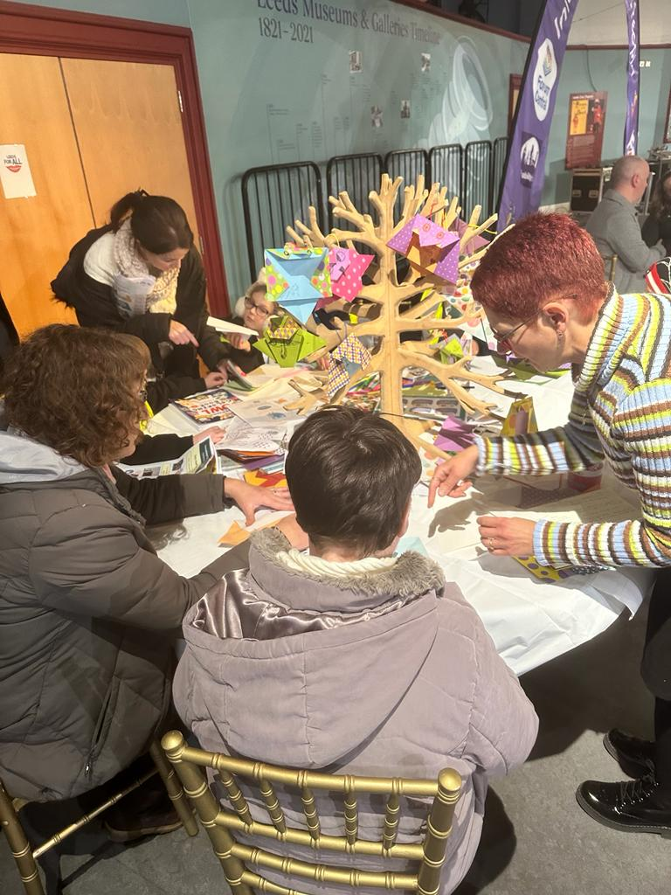MindWell’s Give a Hoot Campaign held a creative wellbeing station where people with disabilities made 36 owls with a focus on their hopes, dreams and expectations for the future of Leeds. The owls will be displayed during April and May at Leeds Playhouse as part of the Mindwell 1001 Stories event.
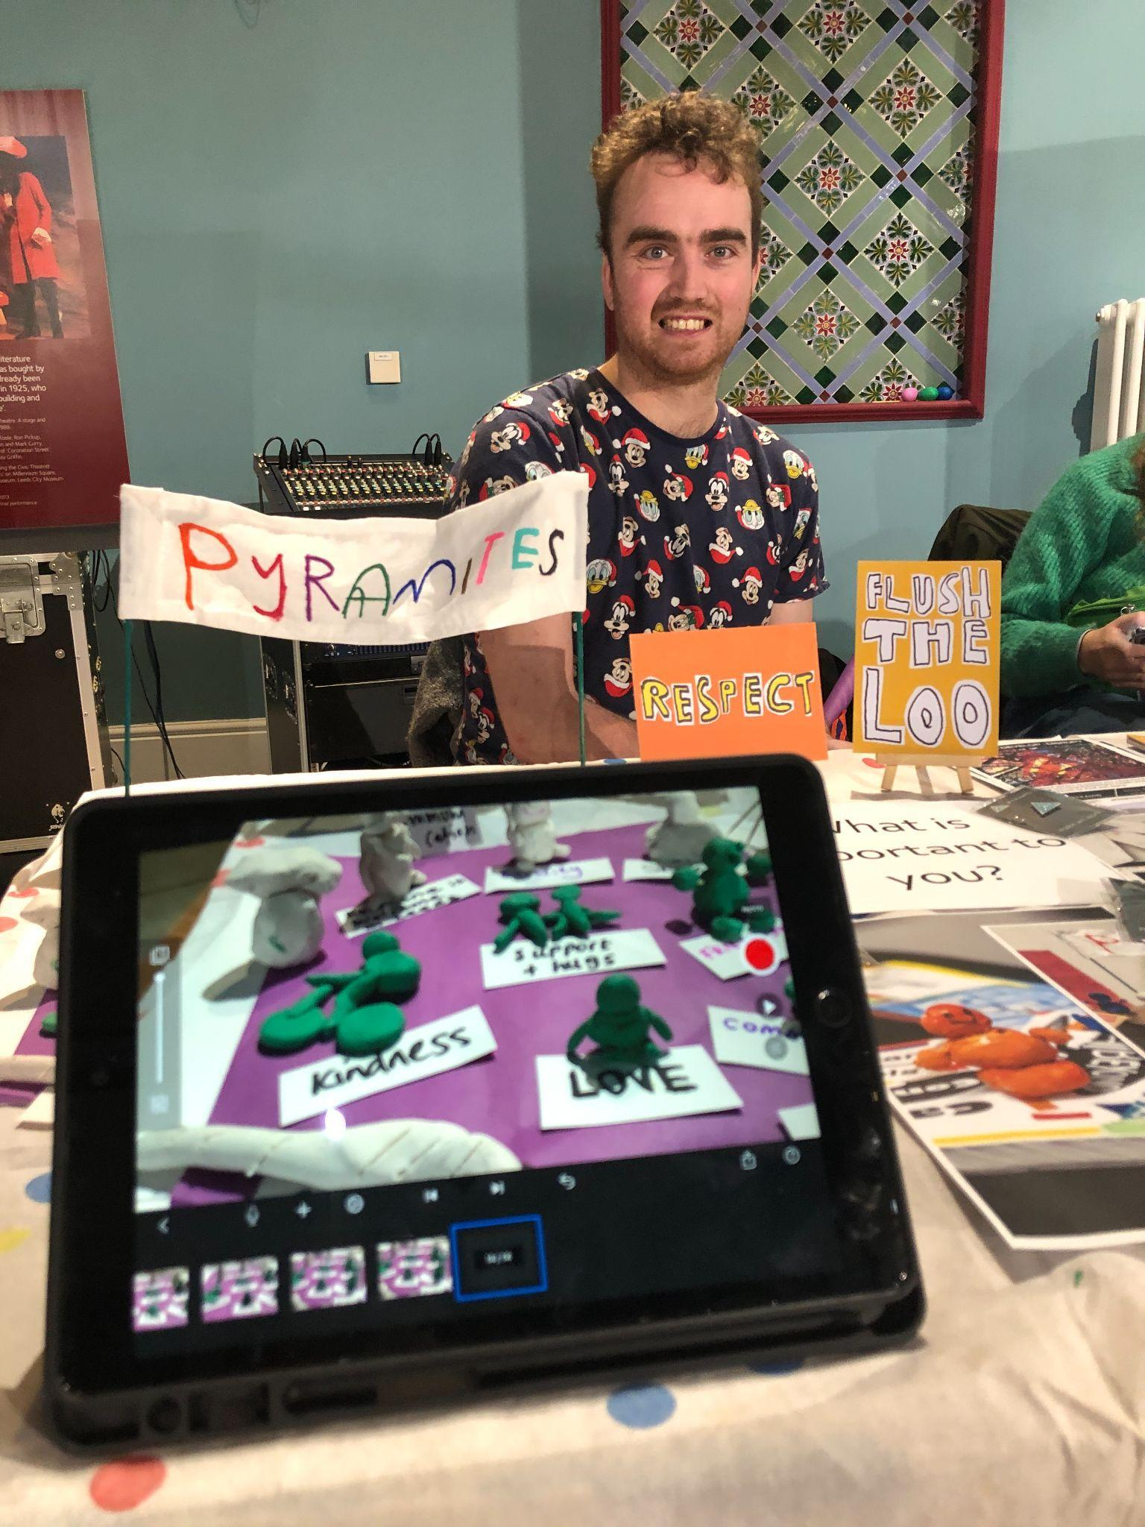
RNIB and Leeds BID had interactive equipment on their stalls for attendees to try out and experience which proved popular and aided conversation.

Pyramid of Arts also held an activity on their stall making ‘Pyramites’, which attracted high levels of participation. A stop motion video was produced from people’s figurine creations.

Illustrations

Tom Bailey, a Leeds artist, sketched 14 cartoons about the aims of people with lived experience when he asked individuals the question: ‘What is important to you?’ He then listened to them and drew the sketches on an iPad which connected as large scale visuals on the 3 ceiling mounted screens in the Broderick Hall Marketplace.

The results were impressive and gave people a chance to look at what others were saying in a visual format, more understandable and more immediate.

Topics that were important to people in their lives covered:

- Being employed and being able to work from home.
- Having BSL translation where and when needed.
- Having access to easily digested information.
- Being accepted and listened to - having a voice.
- Engaging in sport and being able to access paths and parks.
- Having friends and keeping pets.

For all of Tom’s illustrations, see Appendix 6.
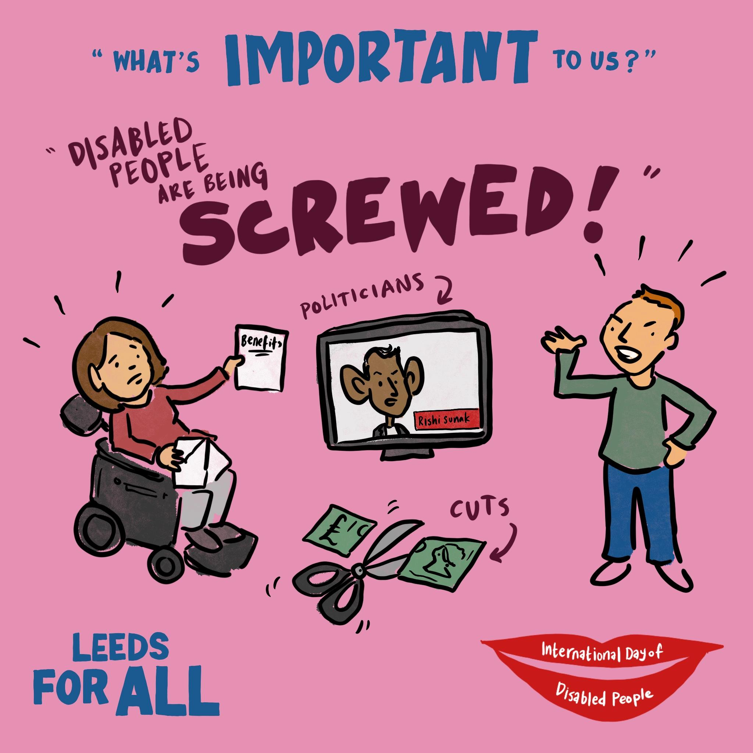

Being accepted in more inclusive communities and a more inclusive society were the takeaways. It was great for people to see this instant artwork as it built a visual account of the day for those with lived experience.

The sketches will be used in further event publicity and campaign work. Unfortunately, the sketches weren’t accessible to people with visual impairments at the event. An action for future events is to make any visuals accessible by audio means also.

SignHealth Wellbeing Workshop

A wellbeing workshop run by Sign Health for the Deaf community was held in the Marketplace area at lunchtime. It was delivered in BSL by Sarla Meisuria, founder of Deaf Options, and founder of the first Asian Women’s Deaf Association in 1992. The presentation covered mental health and self-care for the deaf community and was well-attended by 10 - 15 individuals with positive feedback. Watch Youtube video of participant feedback in BSL.

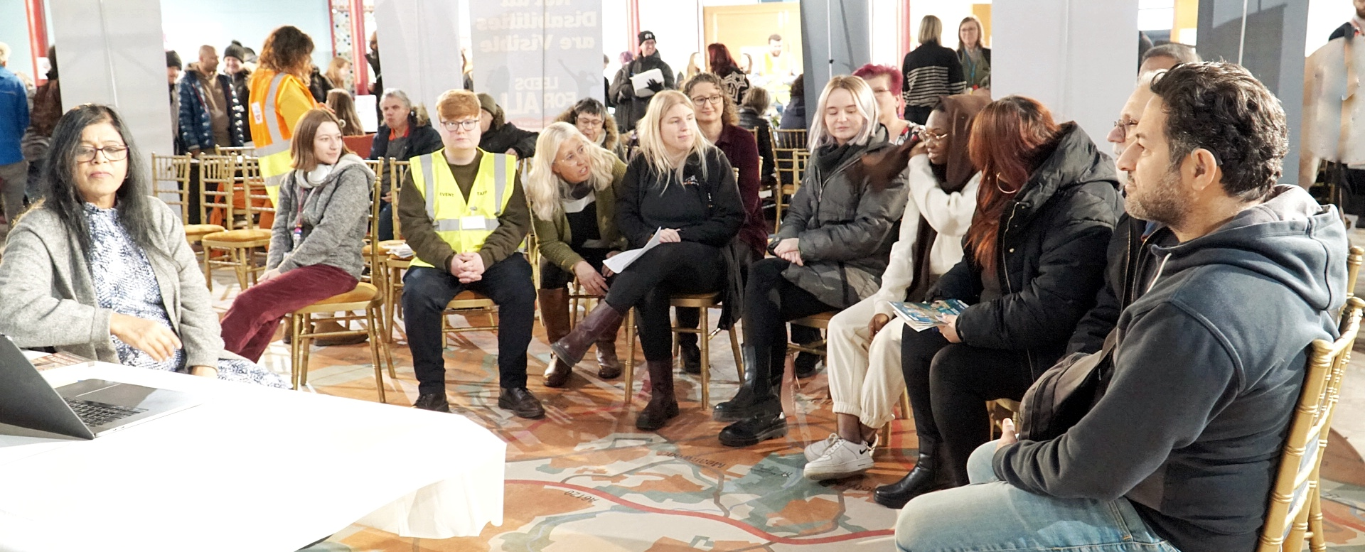
Photo credit: Cheryl Ferris-Stewart

Guest Speakers
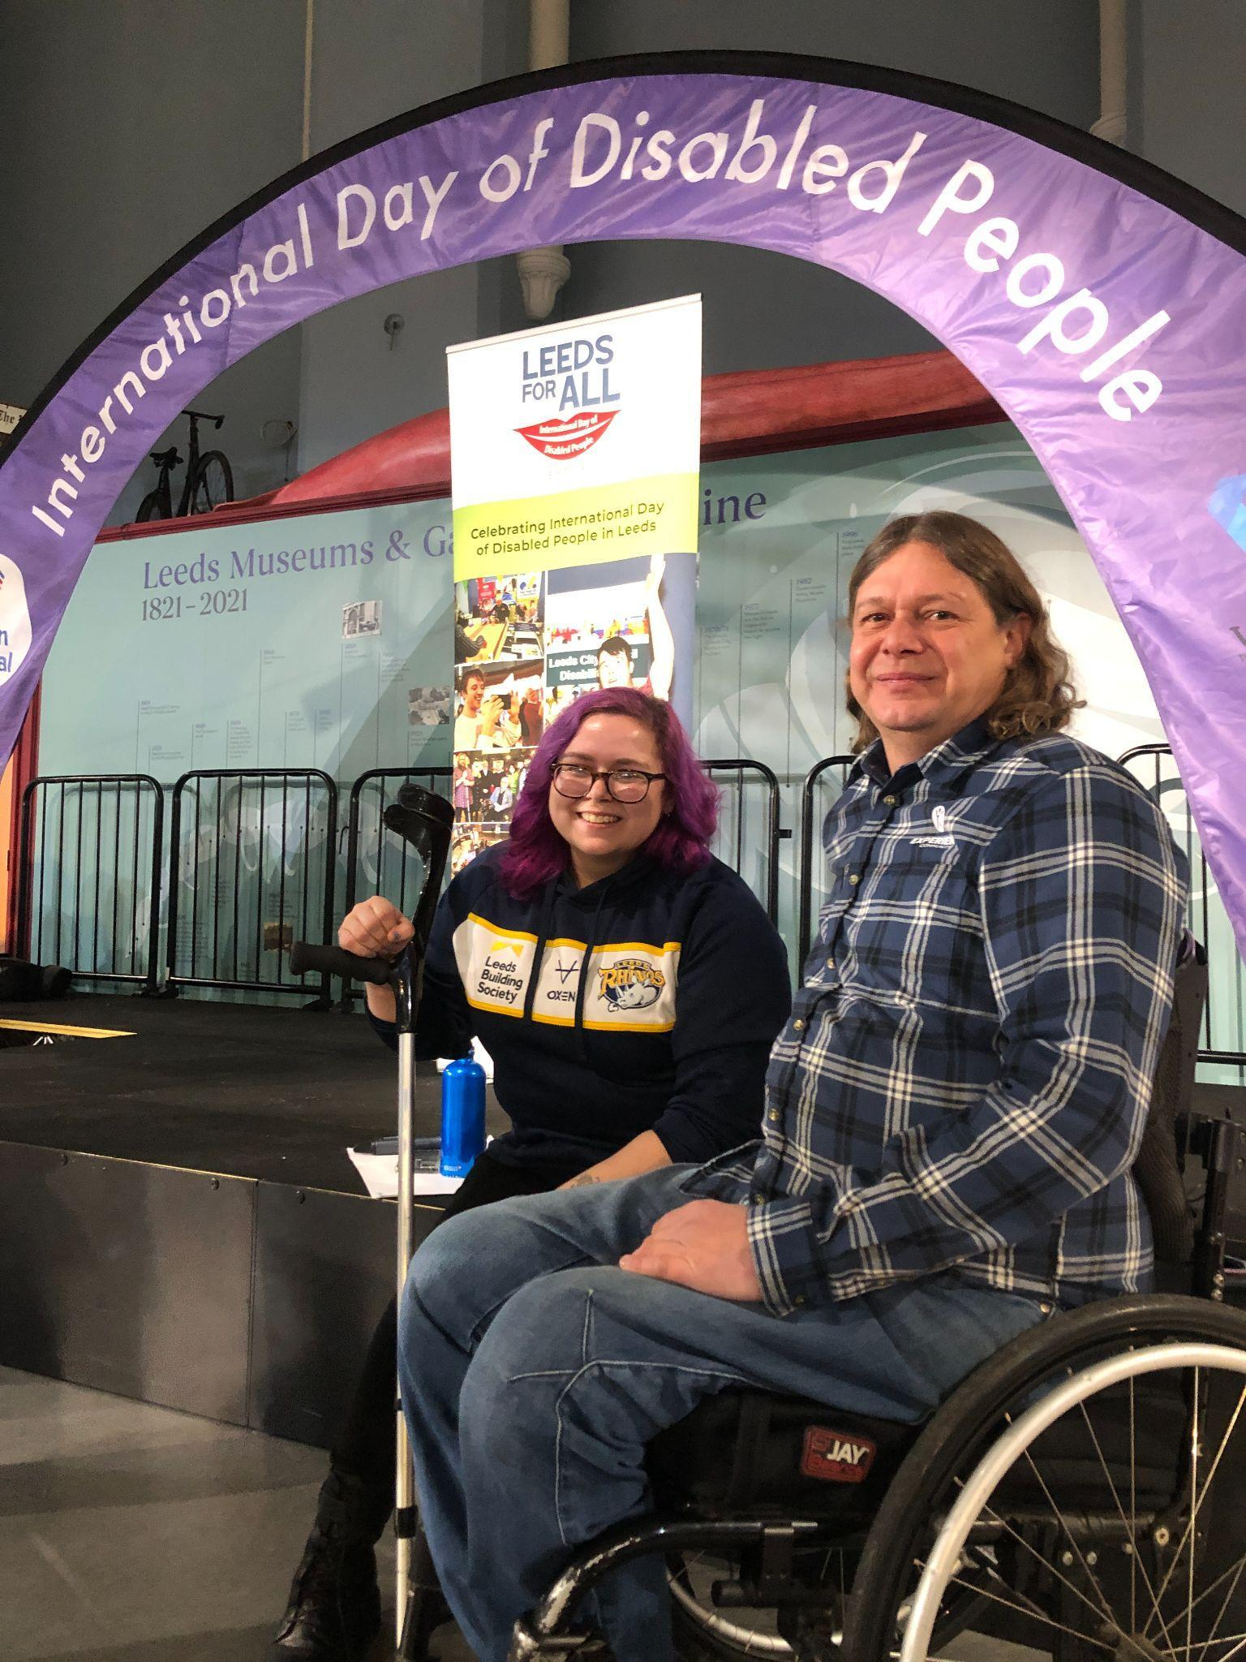
The event was officially opened by the Lord Mayor of Leeds, Al Garthwaite. Further to this, we had opening guest speeches from Geoff Turnbull, Equality, Diversity and Inclusion Manager from the Leeds City Council Equality Team, and Councillor Kevin Ritchie, Disability Champion and Lead member for the Leeds Disability Hub.

The event also had two motivational guest speakers with lived experience of physical disabilities this year who had championed themselves in local outdoor disability sports. They were Jodie Boyd Ward, Captain of Leeds Rhinos Wheelchair Rugby Team and Craig Crimes, Director of Experience Community CIC which enables wheelchair users to access the countryside and advocate for inclusive pathways.

Facilitated Activities

Activities were held in a large downstairs room in the Museum called the Thoresby Room and included drop-in sessions run by local organisations who specialise in facilitating adapted movement and sports. They were held by:

- Ross from Active Leeds - table ping-pong (21 attendees)
- Shakil from Yorkshire Cricket - table cricket (14 attendees)
- Ione from Yorkshire Dance - free movement (34 attendees)
- Jem from The Feel Good Circus - circus skills (28 attendees)

All activities were adapted to be accessible for disabled people. Each activity was popular and well attended. Anyone could attend any of the sessions, the only stipulation being that if you normally had a PA attend class with you, then people were asked to do the same for the activities at IDODP. People were notified in advance which worked well.

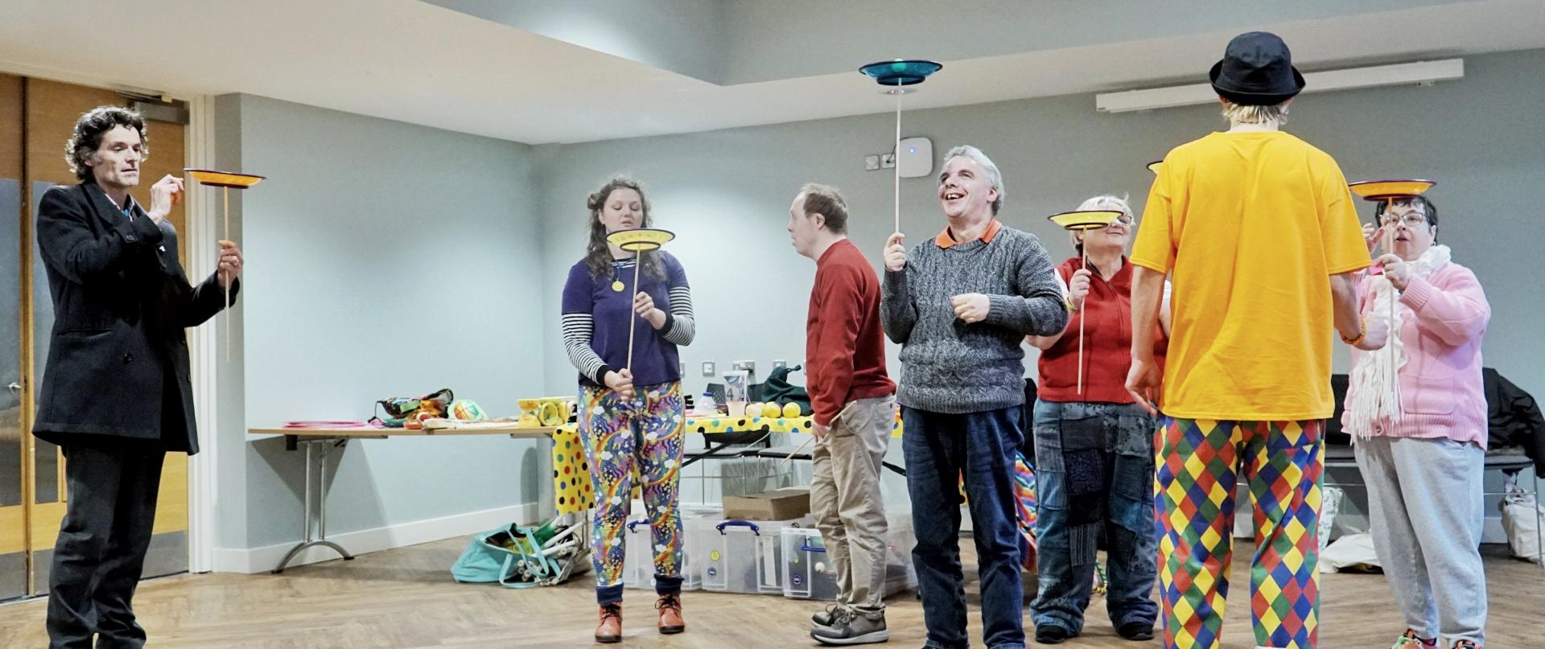

Sensory / Quiet Room

The sensory/quiet room was a space for anyone to use but was implemented after feedback from autistic people/organisations the previous year. The room was run by Leeds Autism Services and some of the sensory items were provided by Leeds City Museum, so that anyone requiring space and silence could go there and interact with the environment of coloured lights, a darkened room, and light censored toys. It was also well attended, it saw 35 people use the room throughout the day and its inclusion in the 2023 programme was based on attendee feedback from 2022.

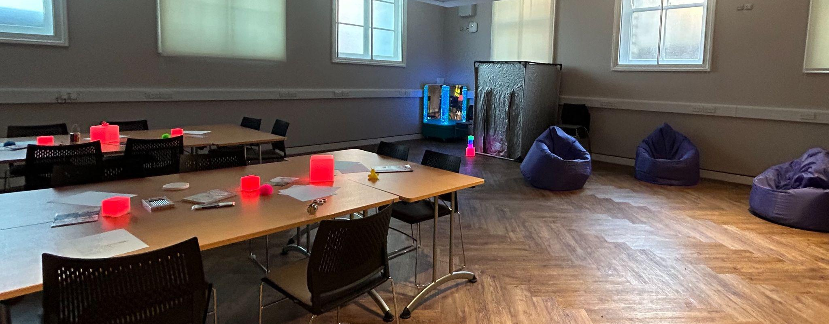

The Small Grants Programme

The small grants fund was run for the second year and featured returners from 2022 as well as new groups representing both people with Physical and Sensory Impairments and Learning Disabilities. Applicants were chosen by a panel (Forum Central and The Disability Hub) that kept their activities close to the theme of Transformation, Inclusion and Innovation. Applicants could apply for up to £350.

- Total number of applicants: 27
- Number of successful applicant organisations:12
- Total number of participants included over the whole of the 12 activities: 511

Advertising and Selection

The Small Grants Fund was advertised broadly across the sector throughout September 2023 using Forum Central and The Disability Hub’s websites and Forum Central Member Networks. A final deadline for receipt of applications was set for 8th October 2023. All completed applications went to the Disability Hub to be collated and the Grants Panel then met on 30th October 2023 to decide on which applications were successful in getting funding. Grants up to a max of £350 were allocated and the organisations were informed by the end of the first week in November 2023 as to whether they had been successful or not.

Successful organisations were chosen according to whether they fulfilled the IDODP 2023 themes of Transformation, Innovation and Inclusion.

Two of the Small Grant Funded Activities took part in the IDODP Marketplace Day. They were the Leeds Bereavement Forum Death Cafe in the museum cafe and DEX Ltd who had a marketplace stall with their Wheel of Fortune activity.
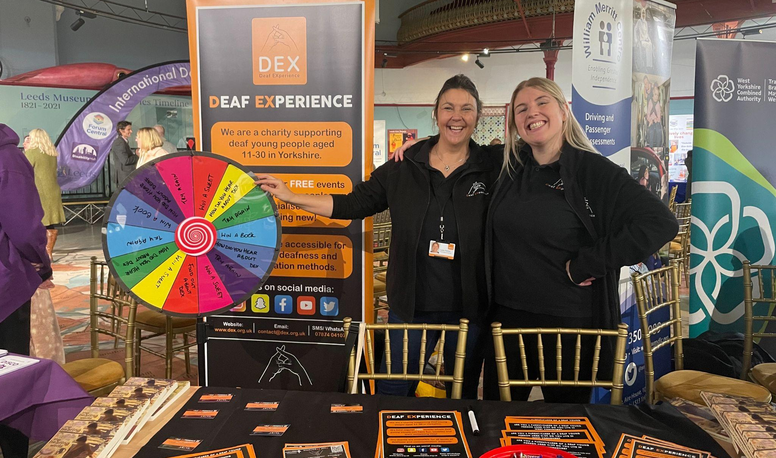

People in Action also held their Leeds Talent show after the IDODP event on that evening making it a full day of celebrations in Leeds. The Small Grants contribution provided BSL captioning on their Leeds Talent live stream video

Leeds Talent - Youtube video link

The majority of the other Grant Funded Activities were held throughout Leeds during December 2023 and January 2024 by organisations at their bases, with Forum Central or Leeds Disability Hub visiting to experience the activities and join in where possible.

Summary of Small Grant Funded Organisations

Canal Connections CIC
An inclusive social project, bringing nature and awareness of local waterways to communities and groups. Grant money spent on Happy Wednesdays Project.

This project aimed at people with learning difficulties and other disabilities: taking them out on a canal boat, offering them the chance to get out and about, combating social isolation and improving on valuable life skills. We also aim to provide and promote the chance to engage with the wider community and improve the health and wellbeing of participants.

Craft Conscious Café CIC
The group is for people with disabilities and chronic illness including those who want support with their mental health. Art and craft activities are used to improve wellbeing and provide a supportive and safe space to share lived experiences. They help people feel less isolated, learn about resources that can enhance physical and mental wellbeing and challenge any learned behaviour.

They had a hybrid meeting in January using art and craft activities and discussion to explore how disabilities and chronic illness have changed and affected their lives, and to discuss resources. Discussion was around ‘triggering activities’ in daily life and what changes people could implement. Hybrid meetings are good for people who don’t feel well enough to attend in person so they can join in the arts sessions without being seen by other members.

DEX Ltd.
Deaf Experience Limited is a charity that supports deaf young people between the ages of 11> 30 years to meet each other and share their deaf experience.

DEX bought a dry-wipe ‘wheel of fortune’, to initially use on their IDODP Marketplace Stall. Participants won prizes, DEX stickers and info leaflets in a recyclable paper bag. The interactive nature of the game acted as a quick ice-breaker and supported lots of attendees to have the confidence to come over to speak to facilitators.

Different relevant questions can be written on the board depending on the outreach activity, all questions will be related to the barriers deaf young people face and will ask for their input about how they can be overcome. Information will be collated using pictures, video clips and quotes to share during and after the event to celebrate the contributions of deaf young people.

GFS Community Enterprise
The Old Fire Station in Gipton is a thriving community hub. A space where people can come to access support, socialise and have fun. Providing opportunity for children and young people, adults and older people to maximise their potential to improve their well-being and quality of life under one roof.

Their Open Day which was held in January was an interactive and informative celebration of disabled people in East Leeds. It brought together local organisations that support those with additional needs, from fun adapted sports and crafts to practical everyday help. Communities took part in fun activities and raised awareness of services available to them in the area. There were speeches and refreshments too.

Harehills Park Bowling Club
In late December the club showcased their adapted equipment with demos for people with disabilities. But the main feature this year was to hold their newly invented Black-Out Bowls Tournament that provided an opportunity for people with visual impairments to play alongside other members. It proved to be a very successful initial event that the club is going to develop more widely around the national bowling circuit. Refreshments were provided by the club.

Leeds Bereavement Forum
This is a small charity, which works to develop and improve bereavement services in the city by signposting service users, providing training, information and events to support professional development and identifying any gaps in bereavement support. Leeds Bereavement Forum campaigns to help people talk more openly about dying, death and bereavement and to make end of life plans. It also works in partnership with Dying Matters.

They held a Death Café at the IDODP marketplace event where people gathered to eat cake, drink tea and discuss death. Death Cafés are an international movement dedicated to encouraging discussion about death and dying in a relaxed environment. It was a welcome opportunity to ask any awkward questions people wanted to ask.

Leeds United Foundation
Supports young people aged 8 – 16 years old with mixed disabilities including amputees, Cerebral Palsy, ADHD and Autism. Many of them can’t access basic mainstream football and some have had negative experiences with other teams. The group meet once a week for an hour-long football session where they can enjoy playing football in an inclusive environment without judgement or barriers.

The sessions were held at LU training grounds at Thorp Arch with current players showcasing skills in a coaching session demonstrating how consideration and innovation can make sport accessible for all. Children with disabilities from local schools and community groups were invited to train with players to encourage them and build confidence. There were little challenge stations to highlight the obstacles people with disabilities face daily. Players told real life stories to show the positive change to their confidence and ability since attending the sessions.

Macular Support Group Leeds
A small group local to Crossgates which gives social support and information about central vision loss for people 65+ years old. They meet on the 1st Monday of every month and invite guest speakers to give ideas and share innovation around the latest developments to help members with visual issues. It also helps prevent social isolation for older people with visual impairments.

The Christmas Macular Spectacular – a special Christmas social with seasonal refreshments was held in December. There was a demo of shopping and delivery robots by a local firm. There was also a Secret Santa with gifts and raffle for party goers, their carers and family members. Travel expenses were met for people coming to the event as transport costs can be the overriding issues for non-attendance.

People in Action
This is a charity supporting learning disabled and autistic people to live happy, healthy and well-connected lives. They offer one-to-one support, as well as learning courses and social groups.

The grant was spent on providing live captions for their show ‘Leeds Talent’ that took place on the Leeds for All IDODP Marketplace Celebrations Day. The captions made the livestream accessible to the live audience but was also available via a QR code.

Leeds Talent is an annual fixture in the learning disability and autism sector, and every year it gets a little bigger. In the past it has always been a part of Learning Disability Week, but in 2023 it was part of the city’s IDODP celebrations. Until now we have not had any specific support for people with sensory impairments. Including captions in the 2023 show helped us to improve its accessibility, making it something for everyone!

Spider-Y The Home Of Wheelchair Sports In Leeds
Spider-Y runs wheelchair basketball and other disability sports in Leeds and enables disabled young people, with their friends and relatives, to enjoy and to benefit from involvement in appropriate sports. It promotes opportunities for people with disabilities to enjoy participating in sport locally, nationally and internationally. Our wheelchair basketball team (Leeds Spiders) is based at Morley Leisure Centre and has helped people with disabilities in Leeds participate - in total more than 20 of our grassroots players have gone on to represent their country in disability sport.

In late November we hosted a 3-hour wheelchair basketball ‘try out’ session for new people. There was also a full wheelchair basketball game demo by Leeds Spiders Wheelchair Basketball Club. The club’s chairman gave a talk on the barriers people with disabilities face in daily life and provided advice for people with a disability to gain employment and stay in work.

Swarthmore Education Centre
Swarthmore is a centre for lifelong learning, who works with many different groups of people and strive to make education accessible for all. They hold regular workshops and courses in the centre and also deliver accredited courses here.

They delivered a 4 hour long print session which was open to all. It was held in their accessible café space (open to the public as well as Swarthmore users).
There was a variety of pre prepared lino blocks which participants used to make their own print, greetings card or gift tags. There were also easy safe print tiles on which people designed their own patterns and motifs. The session was drop in so anyone could leave at any point they wanted to or use the café facilities and come back.

As the event was held in the café there was space for people to freely move around, sit down and chat – so the session included a social element too, it also allowed time for prints to dry before taking home. Staff were on hand to chat to visitors and new people and talked to them about Swarthmore facilities and services too.

YAMSEN: SpeciallyMusic: Yorkshire Association for Music and Special Educational Needs
This charity provides and promotes high quality musical activities and tuition for adults and children with a wide range of additional needs. They recognise the contribution that music plays in people’s lives, especially for those with difficulties and disabilities.

They offer choirs for those with learning difficulties, deliver music and multisensory projects and organise CPD workshops for people who work with participants. Members belong to music organisations like Music Mark, MEC and Making Music. They work in partnership with Aspire CBS to ensure that their participants also have the opportunity to take part in musical activities. (45 regular Aspire customers each year).

The grant money was used to cover transport costs of minibuses and taxis to their 3 Christmas Choral Events. In 2023 the cost of minibuses increased significantly, and they weren’t able to cover transport costs for these 3 very popular events. The events gave opportunities for choir members to perform in public, transformative for them in raising self-esteem and confidence with excellent feedback from audiences. The events further supported inclusion in the community. This included the Christmas Fair at Hillside, the Christmas Tree Festival at St Matthews Church (Chapel Allerton) and the annual Christmas Concert at Pudsey Town Hall.

Evaluation of Small Grant Funded Activities

Each participating organisation was asked to fill in an individual Evaluation Form which was read by all partners at Leeds for All. They were asked about the following points:

- Lessons learned from holding the event.
- Steps they will take as a result of being part of the scheme.
- Whether or not they used Social Media.
- If they would like further connection with Forum Central (if not already).

A Summary Chart of Completed Activities was then drawn up in which organisations fed back on all four points listed above - see Appendix 7.

Feedback

People attending the Leeds for All IDODP 2023 event and stall holders had the opportunity to feed back formally in the following ways: in person posting of an Easy Read feedback form (Appendix 8a) and a digital version of the feedback form (Appendix 8b). Some people attending the event, including Forum Central member organisations and partner organisations chose to give feedback informally via email, after attending the event.

We received feedback formally from 36 attendees and 13 informally via email. Please see the data analysis below, for an overview of what went well and what could be better for future IDODP events.

Quantitative Data

The feedback form asked attendees, “did you enjoy the event today?”.
35 of the 36 respondents answered this question, with 85.7% responding with “yes, a lot”, 14.3% responding with “mostly” and none reporting “a little bit” or “no”.

Figure 1: Did you enjoy the event today?
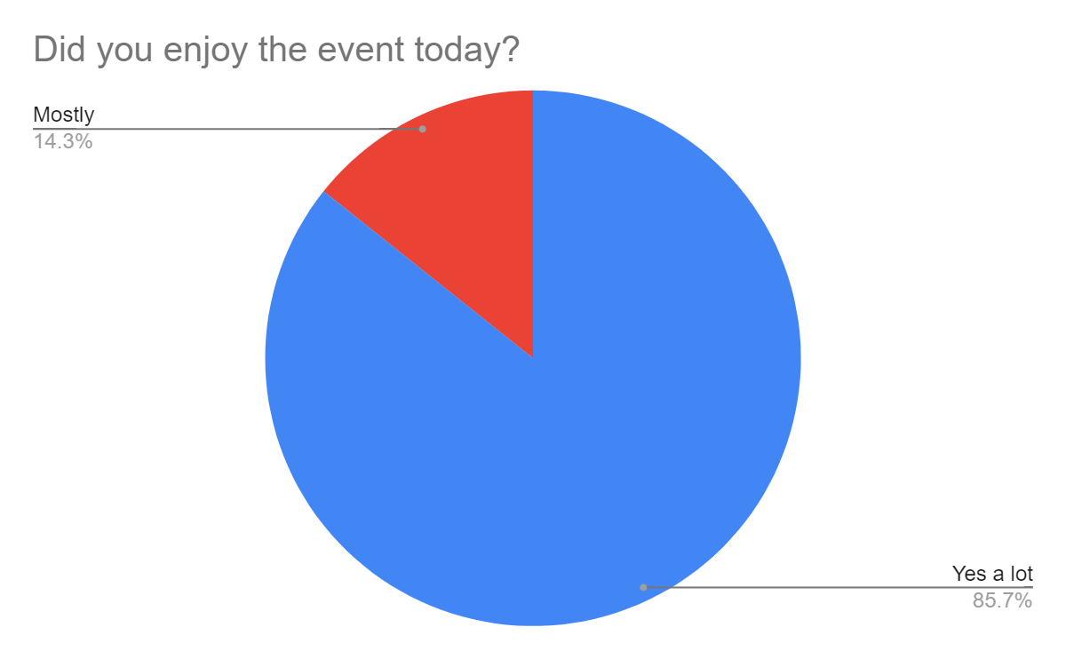

Attendees were asked “was the event accessible for you?”. 36 attendees answered this question and 100% said yes.

Figure 2: Was this event accessible for you.
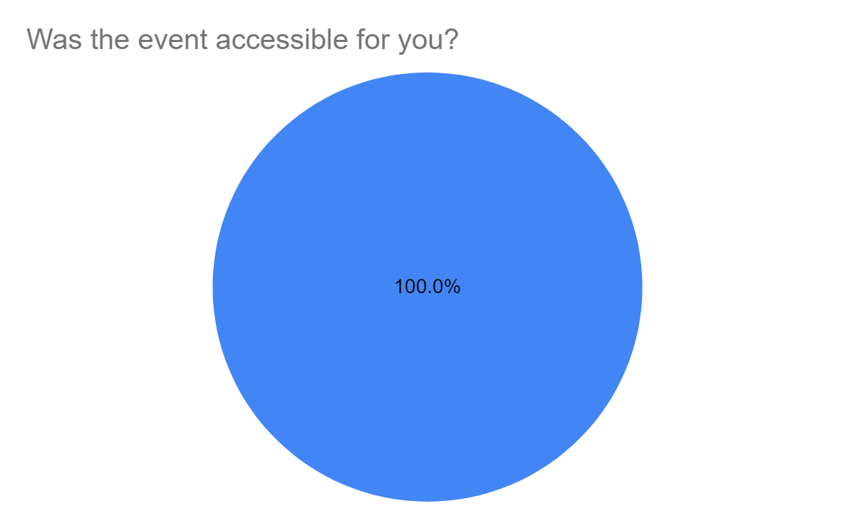
Attendees were asked in follow up to this question, “if no, please tell us what to improve”. After selecting yes, the attendee responded with: “but the steps could be a problem for many people”.

Attendees were asked “how did you find out about this event?”. 34 of the 36 respondents answered this question. The majority of attendees heard about the event via Forum Central (44.1%). 20.6% of attendees heard about it from another charity/organisation, 17.6% heard about it from Leeds City Council, 17.6% heard about it from someone talking about it and the following methods of recruitment were all averaged at 2.9%; social media, poster, email from equality department LCC, work (St Annes), google neurodiverse events, colleague, blank entry submitted, LCC, Leeds Sensory Service.

Figure 3: How did you find out about this event?
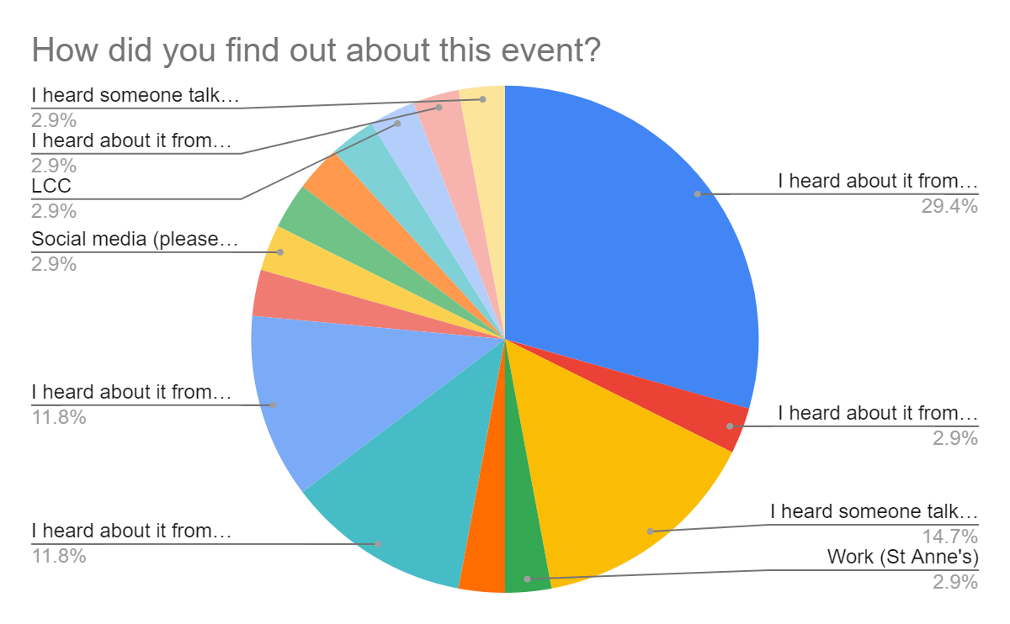

Attendees were asked “has this event made you think more about your wellbeing and how to connect with other groups?”. 32 of the 36 respondents answered this question. 93.8% of attendees responded with “yes” and 6.3% attendees responded with “no”.

Attendees were asked in a follow up question, to please expand on this answer. 21 attendees answered this question. The findings are included in the qualitative data section.

Figure 4: Has this event made you think more about your wellbeing and how to connect with other groups?”
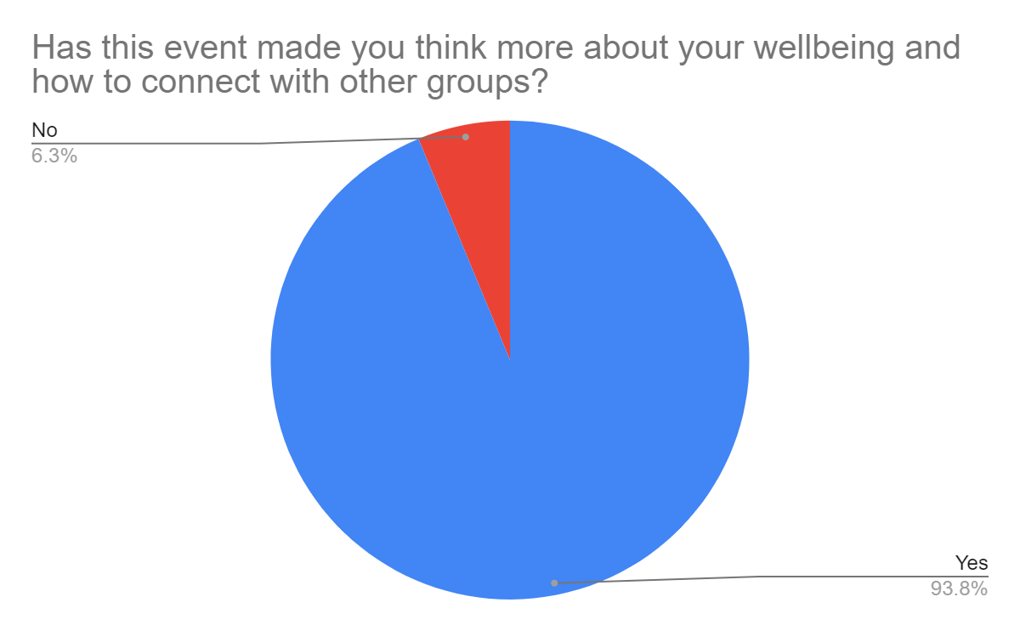

Qualitative Data

Attendees were asked “what did you like about Leeds for All 2023?”. 35 of the 36 attendees responded. Attendees reported that there was a range of activities, opportunities to network, well organised, the event was informative and brought the community together. The quotes below illustrate some of the examples. Attendees reported:

“This has developed so much since last year, very engaging!”

“It was a truly inclusive event that had a lot to offer the community of Leeds with options for using services and engagement. It also gave us the opportunity, as a charity, to share our services and make links to other charity groups who we could work with.”

“The variety of stallholders and the speeches. Great networking opportunities and felt very inclusive and like a community.”

“Lots of attendees throughout the day, we got a lot of enquiries. We also made some great connections with other stall holders.”

“The variety of services that were there, meeting a variety of different people and being able to network with other agencies.”

“Friendly people - well organised, lots of info!”

“Very informative! Really enjoyed the varied info and Mindwell making an origami owl :)”

Participants were asked “what did you not like about Leeds for All 2023?”. 25 of the 36 respondents answered this question. The feedback will be used to improve future Leeds for All events.

This feedback highlighted a gap, in particular around accessibility for those with a hearing and/or sight/sensory impairment. The Leeds for All planning team has highlighted this too and will aim to work more closely with organisations working with this community, to improve access for future years. Forum Central provided staff who were trained as ‘sight guides’ but better identification of those people is needed for future years. The Leeds for All planning team also provided two British Sign Language (BSL) interpreters for the entire day, but this was considered not sufficient, either due to the number of people who used BSL or the lack of signposting to available BSL interpreters/how to request translation.

The planning team has also highlighted, along with feedback from previous years, around the ‘echo’ that exists in the Broderick Hall, due to the shape of the room. This can be difficult for many people. The layout of the museum itself on multi floor levels does not benefit movement especially for wheelchair users or those with a visual impairment – a single level and more accessible location would be preferable for future events with a mixed/pan disability focus.

A final, key improvement for next year, will be to improve access to stalls. Some respondents noted that whilst the layout of the room was better than the previous years, there were still improvements to be made, to allow more space for people to look at stalls.

Please note, 5 of the respondents reported “nothing”. Attendees reported:

“Hard to navigate the stalls as sight impaired.”

“The venue is quite echoey.”

“Can be a bit difficult to access some stalls.”

“I hope to get more BSL interpreters next year”.

“Acoustics in the hall made it hard to hear the speeches.”

“Layout of the marketplace could have been a little more spread-out and less claustrophobic.”

“It was very echoey in parts and hard to hear the speeches being in the main hall with the stall holders.”

Attendees were also asked to expand on the following questions: Has this event made you think more about your wellbeing and how to connect with other groups? 21 of the 36 respondents answered this question. Attendees reported:

“We met lots of potential new groups, and were able to welcome new participants into our session.”

“Providing staff with resources to support patients.”

“Building on existing connections.”

“How to better support others and raised awareness of what’s available.”

“So much information available to help people connect.”

“10 for signposting people”

“Became more aware of groups I was unfamiliar with before.”

“Come to make contacts for our own events.”

“How we need to consider inclusion in everything we do”.

“Talking to different organisations helps signpost to patients.”

“I have made some really good links with people that came to see us on the stall and also other stall holders who would like to work together.”

“The event was great for networking with other organisations and threw up lots of potential opportunities for collaborative working.”

Attendees were also asked “do you have anything else you would like to tell us about the event today? For example, things that could be improved.” 16 of the 36 respondents answered this question. Attendees reported:

“Loved it”

“The one of multiple zones has been fab. We love the new format in the hall.”

“Advertise the event more.”

“Well organised. Friendly, supportive staff.”

“Really lovely and enjoyable event. Varied too!”

“It’s a good way for professionals to connect/network.”

“Really amazing, bringing together of people - thank you.”

“Speakers separate so can hear better.”

“I think the speeches were easier to hear last year as they took place at the entrance. This year people kept arriving during the speeches and the noise grew louder and louder.”

“More opportunities to be a guest speaker. More break out spaces for organisations.”

“Maybe put up a poster at the entrance telling people which workshops are on, where they are and at what time so that people know where to go. You may have had this and I did not see it.”

Finally, attendees were asked “do you want to be emailed with updates about IDODP 2024 or similar events? Write your email address below to sign up to the mailing list.” 15 attendees responded with their email address. Data for this question will not be provided in this report or the appendices, in order to adhere to GDPR.

If you’d like to see the entire redacted dataset please contact hello@forumcentral.org.uk

Email feedback

Further feedback arrived via emails (Appendix 9). A selection of these responses follows:

Royal Mencap’s ‘My Community’ project attended IDODP:

”We had a stall manned by one of our community connectors. At the event, Maisie met and spoke to Alex Toothill from Outside the Box, after finding out what they do, she arranged for us to meet. That meeting happened on 17 January, and we are now working on how we can connect up with their participants and potential combine on a project together.”

Involvement Co-ordinator at DEX Ltd:

“It made us realise that not a lot of other services are aware of us or that we are based in Leeds, the event definitely got us out there! We connected with Space2 at Gipton Fire Station with regards to doing an art project with our young people and we contacted Metro about their new Orange Wallet scheme for people with disabilities. We are now distributing the wallets to Deaf young people across Yorkshire who have a free bus pass. I have also contacted Mindwell about partnership work around deaf awareness and access.”

Information Officer - Through The Maze - Connect in The North:

“I had several conversations about easy read and accessible info at the event. These included discussions with people doing broad public engagement that wanted to start improving accessibility for people with a learning disability (eg. in relation to transport changes in Leeds) and a couple of health professionals starting research projects. One of the health professionals also linked me to another researcher at Leeds University, with whom I have had a discussion about inclusion in research she is proposing to develop guidelines on inclusive participation in medical research (again, her scope is very wide, and so I was able to help fly the flag for making sure people with a learning disability are included). Just today I have followed up with the researcher to link her to Purple Patch's Purple Research Group, which has prompted me to send this feedback.

On our stall, we spoke to 64 people. This led to us adding two or three entries to our website from links we made, as well as some signposting and a lot of promoting our service.

So, my headline feedback is that it was a great event, especially for reaching people we might not connect to in other parts of our work that have a narrower learning disability focus.”

Autism and Learning Disability Digital Inclusion Coordinator - Pyramid/100% Digital Leeds:

“I found the International day of disabled people a really vibrant and inclusive event where people with learning disabilities were able to have their voices heard while also finding out more about what is happening in the City of Leeds. It was wonderful that we were able to have a stall at the event, where one of our members led an activity to gain feedback from attendees with and without learning disabilities. Opportunities like this give our members confidence and show them that their work is valued.

As a professional, the event was wonderful as it gave me a chance to network and to make new connections. For example, I met members of the Leeds city council Highways and Transport team who are looking to make their work more inclusive for people with learning disabilities. The team have since joined the Autism and Learning Disabilities Digital Inclusion Network, and we are now looking at ways in which we can support one another moving forward. Joint working like this enables organisations to reach more people with learning disabilities in an efficient and accessible manner.”

In Conclusion

The 2023 IDODP Marketplace Event was a great day of celebration; far more extensive and wider reaching in terms of relationship and partnership building than its predecessors in 2020-22. This was not only because the Covid pandemic and lockdowns had effected and drastically reduced in-person contact in those years, but in 2023 because the Forum Central Learning Disability and Physical and Sensory Impairment Teams had worked on this as a collaborative and developmental project it resulted in a far greater reach.

The combination of the Celebrations Day and the Small Grant Funded Activities in 2023 also had a very beneficial spin off of creating new interest in Forum Central’s Specialist Networks. Within the Forum Central IDODP team itself more accessible formats and content have been produced, to include new audiences and more people with lived experience. This in turn will widen the scope of how Forum Central reshapes its view on accessibility for its future developmental work with organisations in Leeds.

Recommendations

- To hold a more community based IDODP Celebrations Event in future.
- To make the IDODP Small Grants Fund a central part of future plans.
- To consult earlier with the IDODP Steering Group over major decisions.
- To build stronger engagement with Hearing and Sight Impaired people.
- To have basic BSL training available pre-event for all Leeds for All staff.
- To further develop Leeds for All accessibility strategies.

Reflexive Statements

Helen Brand, PSI Development Worker (Volition, Forum Central): Working on the IDODP 23 Project as a team has really benefited the way we have been able to create what was a pan-disability programme this year. Everybody brought their creative skills to the table and I think we all feel proud of the way the event and the grant funded activities were received by organisations and local communities. The final report, easy read report and highlight videos show real allround collaborative quality.

Dominique Burley, Senior Development Worker - Learning Disability Network (Volition, Forum Central): It was great to co-produce International Day of Disabled People 2023 with a variety of Forum Central members, partner organisations and people with lived experience. This year’s event had a buzz in the air, with lots more stalls and activities. I felt that we built on the feedback from last year to make this year's event more accessible and engaging. I feel that for future years, we need to continue to build on feedback. To make a pan-disability event accessible, in an often inaccessible world can be challenging, but it is possible if we continue to co-produce future events and share learning and best practice.

Susan Morrell, Leeds CIL, spoke about her personal highlights of being a Steering Group member:
‘Interacting with people from different organisations, working in a mutually supportive atmosphere, the involvement and support of Forum Central and Disability Hub members who could carry out tasks and find resources to help ‘get things done’ and make the project a success.’

Max Conway, Admin and Communications Officer (Volition, Forum Central): I took part in the Mental Health workshop, presented entirely in BSL. As I do not have a hearing impairment, I required a BSL interpreter for this workshop. It was an incredibly eye-opening experience and showed how difficult it can be to follow multiple conversations with only one BSL interpreter.
It highlighted to me the importance of having a BSL interpreter present because without them, I wouldn’t have been able to take part. It also showed how we must try and not talk over one another or have multiple people talking at once in a meeting, as it is difficult for the interpreter to follow everyone at once.
I have also created the highlights videos for IDODP 2023. I was very keen to make sure these videos had an audio described version. Because how can we as the IDODP team advocate for the Disabled people of Leeds, if they are excluded from our content. We must go the extra mile to ensure all content is accessible to everyone.
Jenny Bull, Communications Manager (Volition, Forum Central): It would be fantastic if more people disabled people knew about this event and the support on offer which it showcases. This is an increasingly important annual city-wide event. More lead-in time and budget would enable us to promote it further. The reach seems to be growing year on year because word spreads - let’s keep up the great work. Producing materials in an accessible way does take more time and resource but that’s not an individual’s fault or problem - being able to receive and understand information is fundamental for independence and choice. Forum Central is advancing its learning of this so we can share best practice with colleagues and partners.

Appendices

Appendix 1: Leeds For All Logo

Appendix 2: Stall Holder Pack

The Stall Holder pack with was emailed to each stall holder in advance consisted of:
- Broderick Hall layout (below)
- Social Media Flyer
- PDF Poster
- Programme
- Event Access Guide (below)
- Stallholder Summary (Appendix 3)

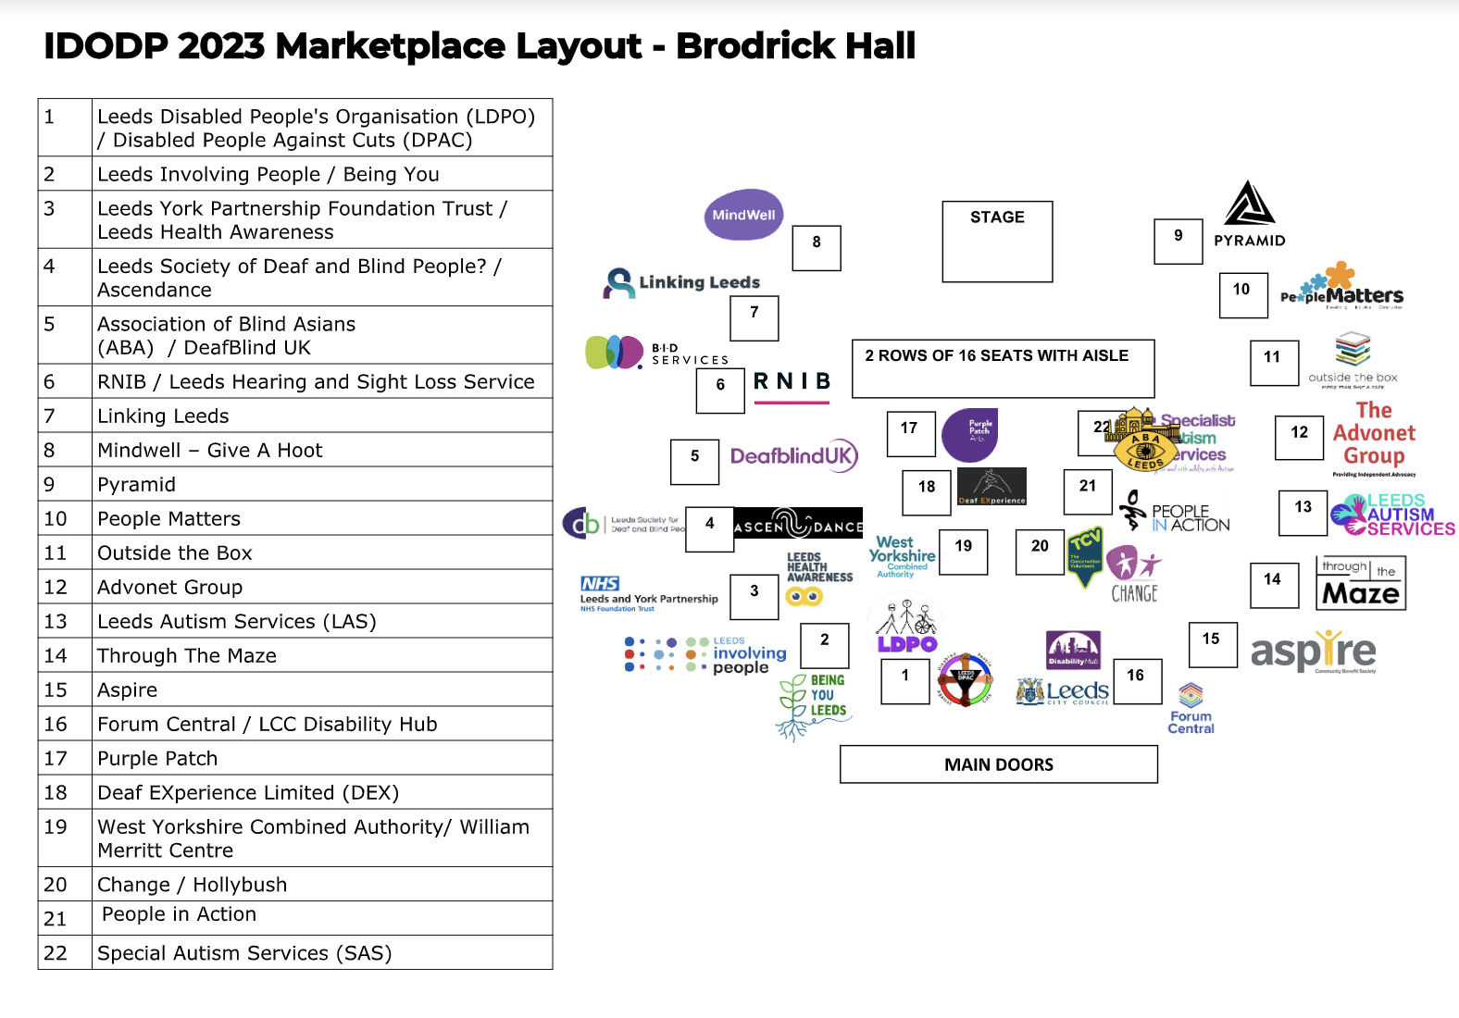

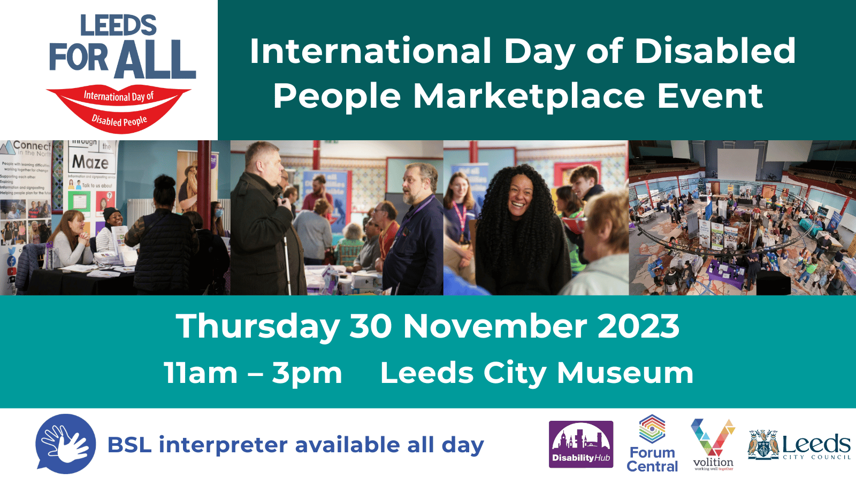

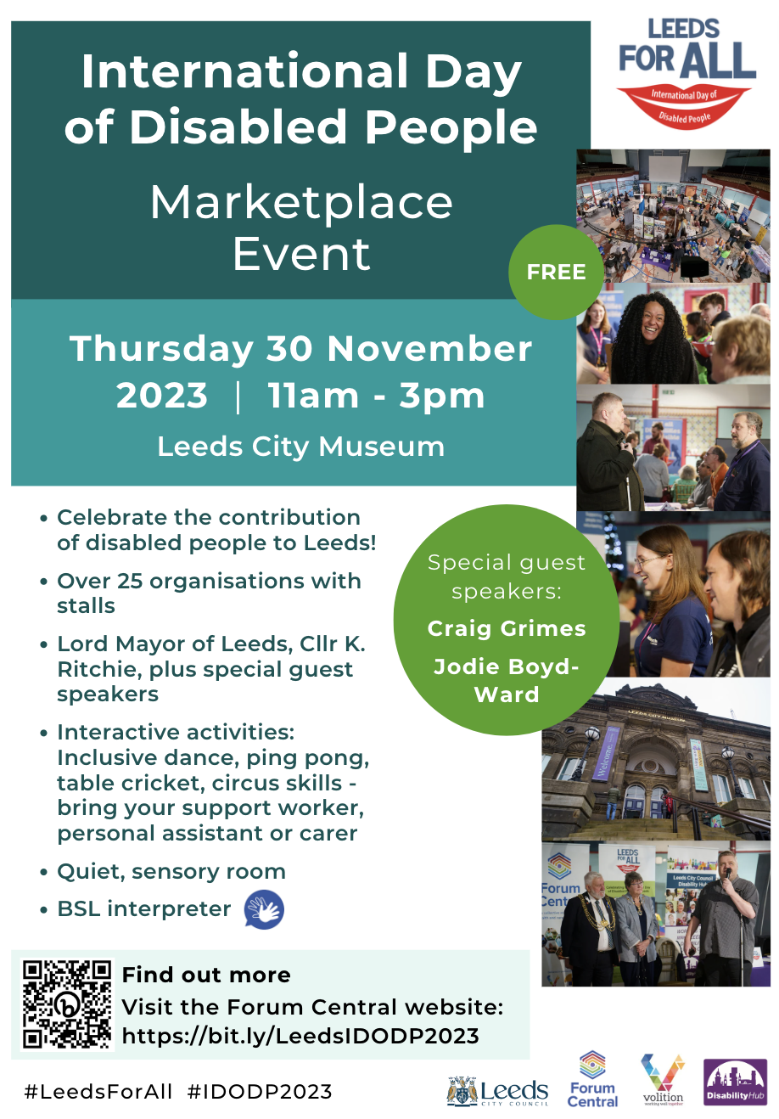
- 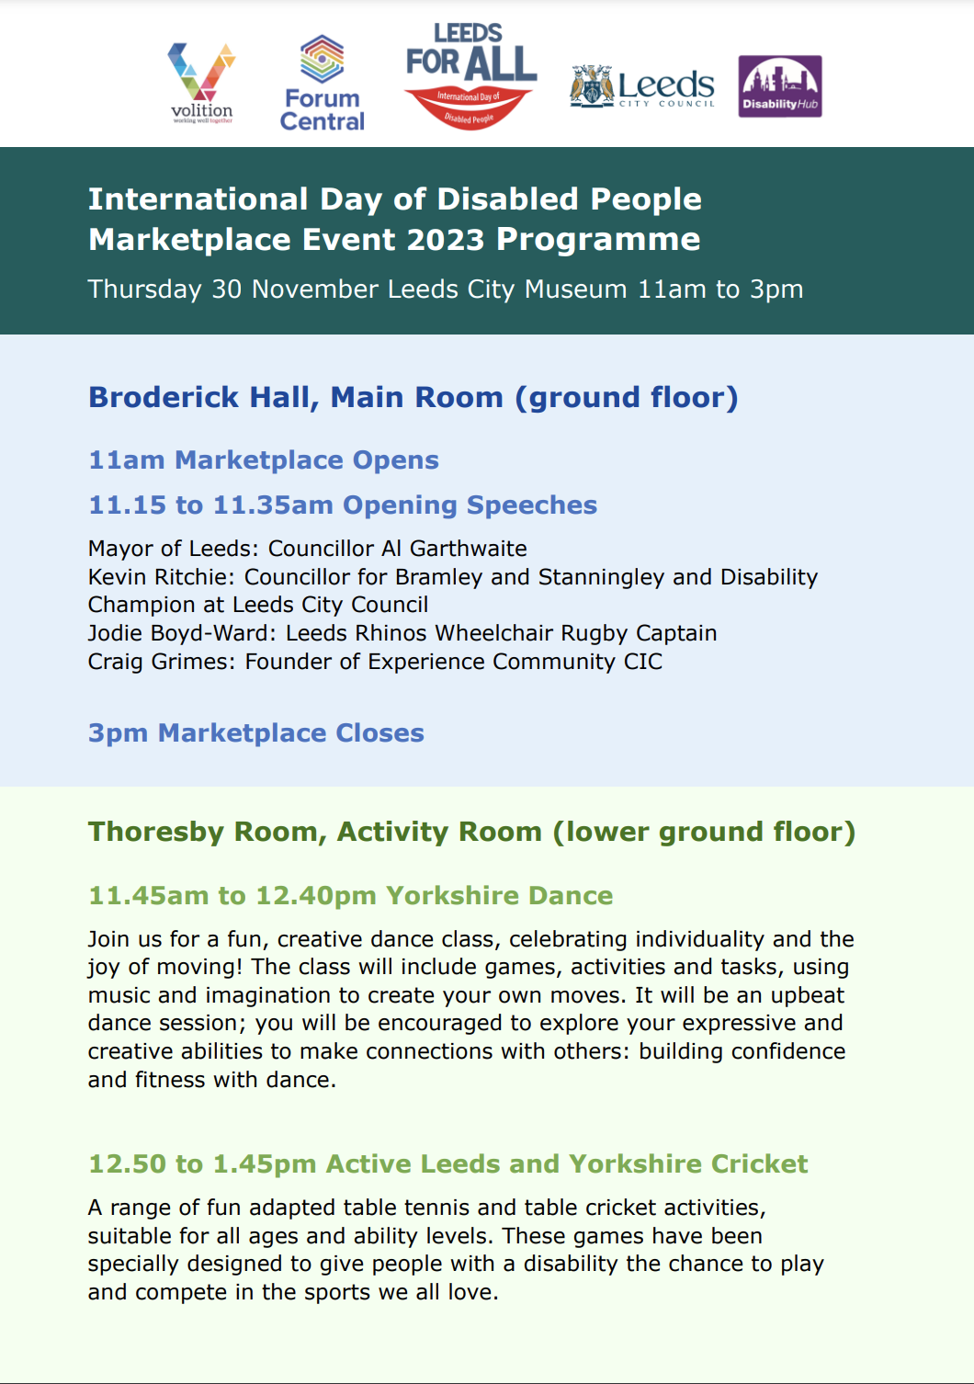
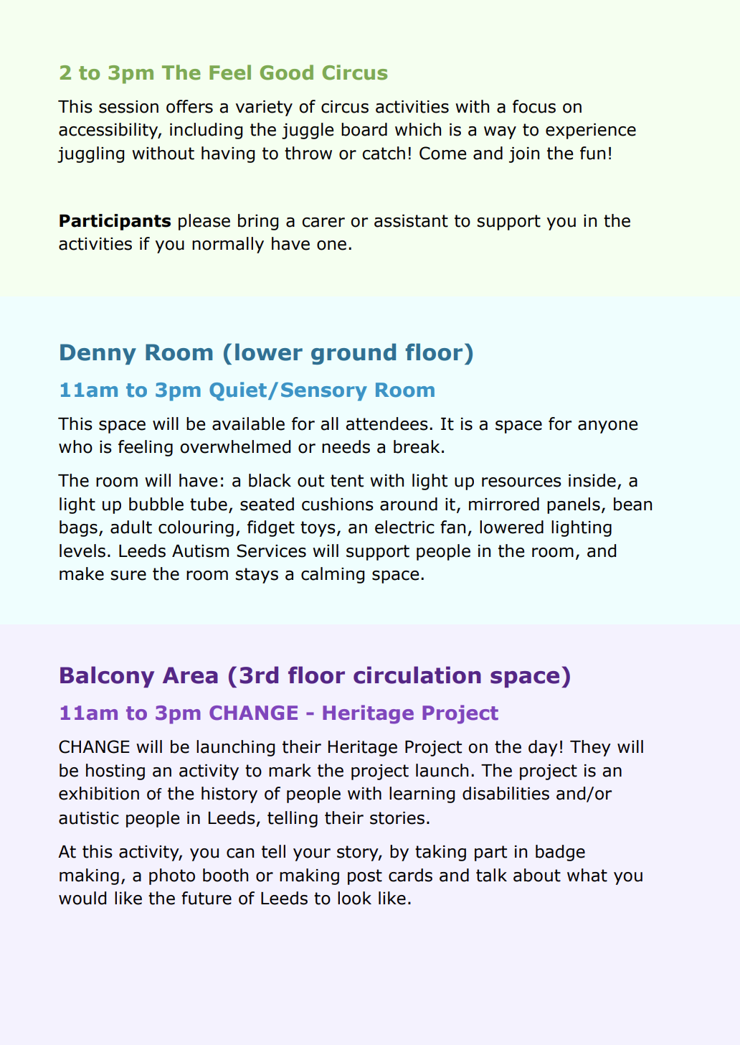
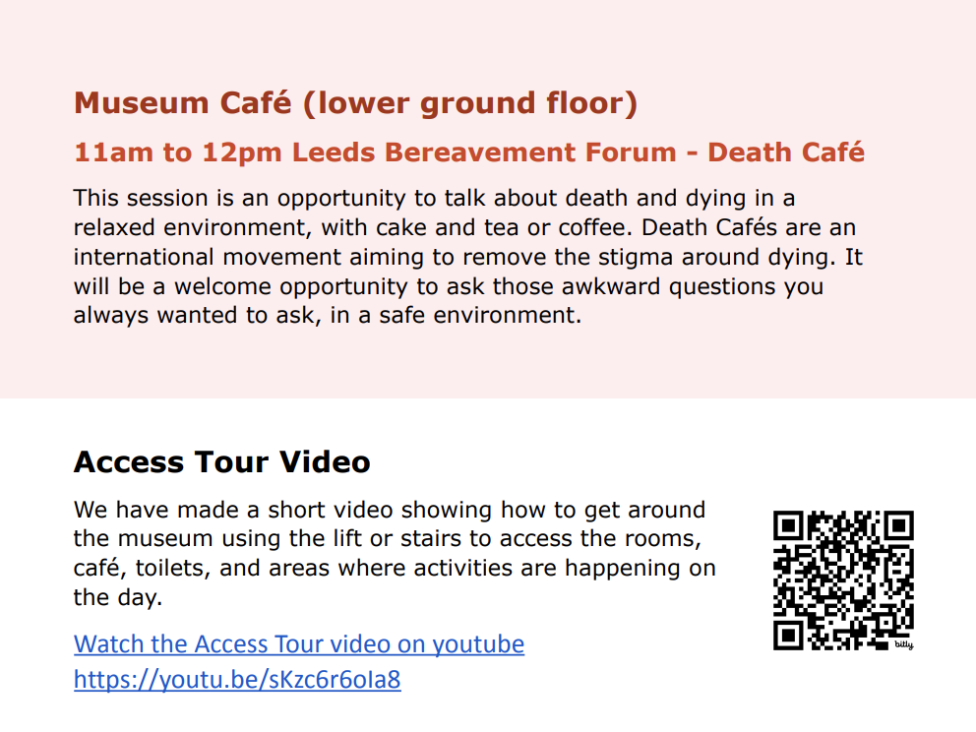

Event Access Guide (for stall holders)
- Arrival
This is a link to google maps which will help you to navigate to the City Museum if you are walking.
https://www.google.com/maps/dir//Leeds+City+Museum,+Millennium+Square,+Leeds+LS2+8BH,+UK/@53.8015511,-1.5490227,17z/data=!4m8!4m7!1m0!1m5!1m1!1s0x48795c1ce188d5c1:0x15d618c32f35e14!2m2!1d-1.546834!2d53.801548

1.2 Vehicle drop off points
The nearest vehicle drop-off point is at Cookridge Street close to the junction with Portland Crescent .This must be accessed via Portland Crescent as there is no vehicular access on the lower section of Cookridge St from Great George Street. This is due to a major development taking place on that section of Cookridge St. This also means that there is no access or parking on Rossington Street and Percival Street.
Taxis and private hire vehicles can turn right out of Portland Crescent into the cul de sac section of Cookridge Street for drop off. There is a dropped kerb near the ramped entrance to the Museum.
https://what3words.com/ is a location app which provides exact location points based on 3 metre squares. Every 3-metre square of the world has been given a unique combination of three words which can be shared with friends and family, emergency services and more to pinpoint locations easily.
What3 words reference for dropped kerb nearest to ramp - ///Keys.tunnel.wake
What3 words reference for the closest drop off point close to bottom of ramp near bollards with shallow kerb - ///Sector.month.fake
1.2 Parking
Three Blue Badge parking spaces are located on Portland Crescent along the side of the 02 Academy. There are also three spaces on the northern part of the street after the turn for Rose Bowl car park along the side of Civic.
Off-street car parking is available at the Rose Bowl carpark which is part of Leeds Beckett University City campus. This is accessed off Portland Crescent close to the junction with Woodhouse Lane. There is a surface carpark and an underground carpark with a lift.
1.3 Buses
The closest bus stop is on Woodhouse Lane cloe to the Hedley Verity pub.
Merrion stop A WY Metro - Your Next Bus only X84 to Ilkley
Merrion stop B WY Metro - Your Next Bus 14 routes heading northwards via Headingley including the city circular bus service
Merrion C WY Metro - Your Next Bus 16 routes heading southwards
This is an embedded pdf of the city centre map so will not meet everyone’s access needs. Metro has a journey planner app you can also use instead of this map.
2.00 Approach to entrance
The ramped access which is on the corner with Vernon Street has a central handrail and leads to a shared landing with the stepped approach off Millennium Square.
The steps are wide with a central handrails and tactile paving at bottom, at landings and at the top.
There are 2 double doors at the entrance, the door on the left hand side has power assistance so they can open easily for everyone.
3.00 Entrance lobby
Immediately inside these doors is a large landing which leads directly to steps up to the raised ground floor. These are wide steps with handrail on each side. There are two other sets of steps at each side of the main steps which leads down to the lower level. These have handrails on the right-hand side.
A lift is located to the left of the entrance doors in a lobby and it serves all floor levels. The lifts has tactile buttons and audio announcements inside the lift.
Take the lift up one level to get to the main marketplace event on 1st floor. You can also take it to the lower level Thorsesby room, toilets and café.
3.1 Hearing enhancement
The is a hearing loops in Thorsesby and Denny rooms on the lower level
3.11 BSL
We have a BSL interpreter for the day and they will be located in the main space. Please let us know if you need BSL support for discussions after the main speakers
4.0 Toilets
4.01 We have accessible toilets on Lower Ground and on 2nd and 3rd floors off the main circulation space. We also have gender toilets on the lower ground floor. We have baby changing on the lower ground and 2nd floor.
4.02 We have a changing places toilet on the third floor, turn left out of the lift to access this. This is accessed using a radar key. Staff working that that immediate area hold a key if you do not have one.
5.0 Assistance dogs
We welcome assistance dogs. There will be a water bowl for dogs in the foyer. Millennium Square is a large public pedestrian only space immediately to the front of the building which is suitable for exercising assistance dogs. There is also a grassed area outside Civic on Portland Crescent which also be used for this.
6.00 Refreshments
There will be refreshments in the hall
- Lunch
We are not providing lunch but there we have a café on the lower level which has soups and sandwiches. There is a choice of table sizes and chair types.

Appendix 3: Stallholder Summary

Organisation logo | Organisation name | Organisation description | Organisation website link
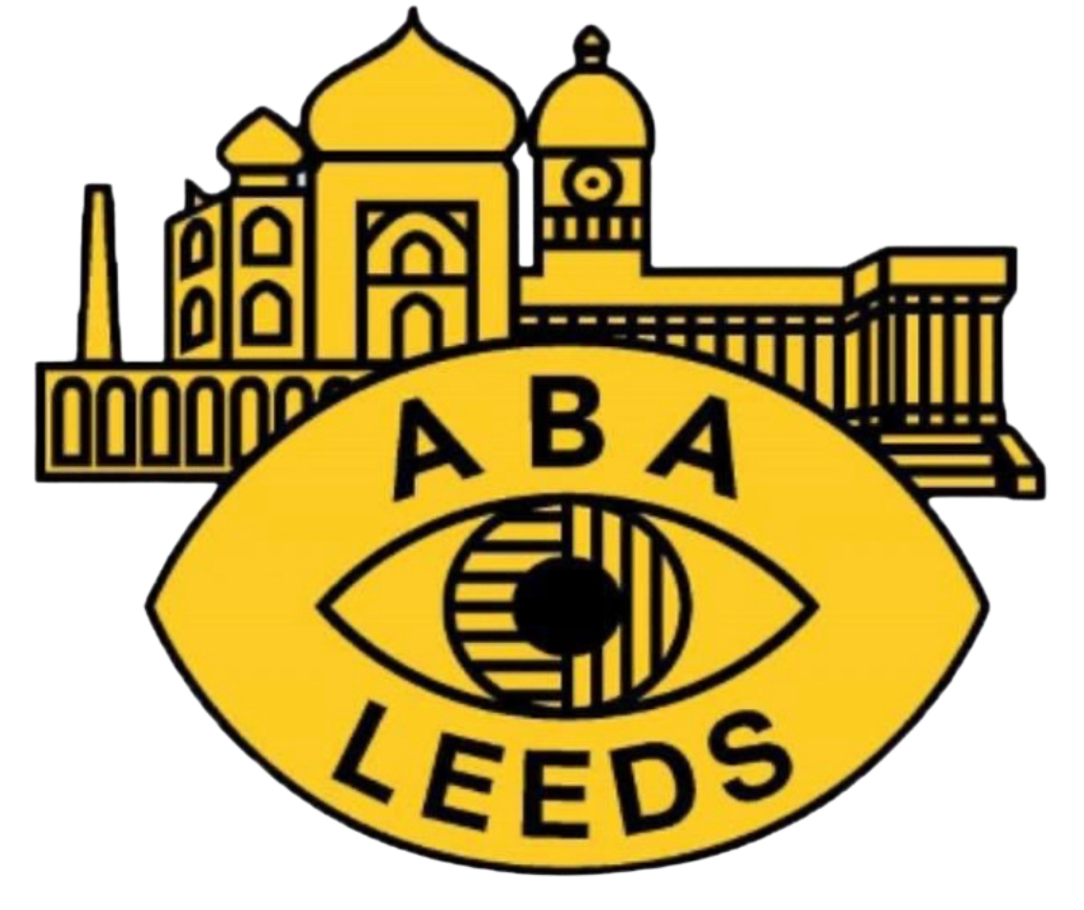 | Association of Blind Asians  (ABA) | Dedicated to providing advocacy and support for the blind BAME community | abaleeds.org.uk
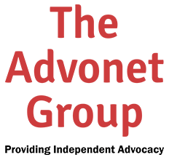 | Advonet | Providing statutory and community advocacy and related services that promote empowerment and inclusion | advonet.org.uk
 | Ascendance | A creative charity dedicated to health and well-being, offering dance classes and performance opportunities that are inclusive for all. | ascendance.org.uk
 | Aspire | The primary aim of the service is to reduce the duration of untreated psychosis and support recovery, positive mental health and wellbeing for all service users | aspire@commlinks.co.uk
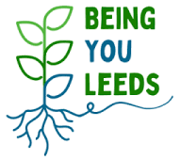 | Being You | Being You Leeds provides groups, activities and training and awareness sessions for community wellbeing across Leeds. | touchstonesupport.org.uk/being-you-leeds
 | CHANGE | CHANGE is a Learning Disability Rights charity and part of the Advonet Group, a leader in Advocacy services in Leeds | www.changepeople.org
 | DeafBlind UK | Deafblind UK helps people who are deafblind to live with their condition and to build their confidence and independence. | deafblind.org.uk
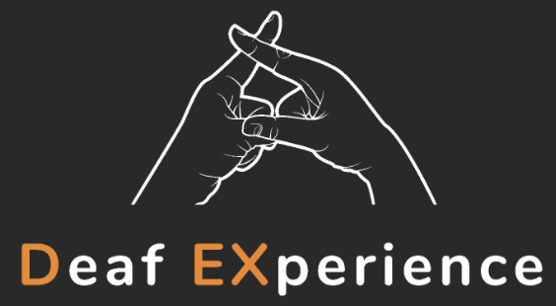 | Deaf EXperience (DEX) | DEX is a charity which campaigns nationally to improve access to education, wellbeing and quality of life for deaf and hard of hearing young people. | dex.org.uk
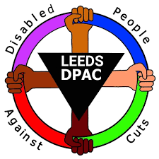 | Disabled People Against Cuts (DPAC) | DPAC is an organisation based in the United Kingdom for disabled people and allies to campaign against the impact of government spending cuts on the lives of disabled people. | www.facebook.com/DPACLeeds/
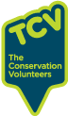 | Hollybush | Hollybush in Kirkstall is an environmental volunteering centre. Our volunteers help to manage green spaces across Leeds and beyond. We welcome people of all backgrounds and experience. | www.tcv.org.uk
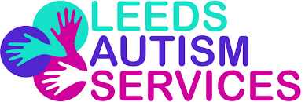 | Leeds Autism Services (LAS) | LAS is a charity dedicated to creating a more autism friendly society by promoting understanding and acceptance of autistic people. | www.leedsautism.org.uk
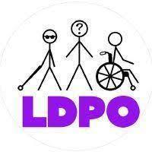 | Leeds Disabled People's Organisation (LDPO) | LDPO believes in striving to create a safe and accessible space that empowers and connects all disabled people to come together, to connect socially, discuss disabling social barriers and build connections with each other in the city of Leeds. | leedsforchange.org.uk/groups/leeds-disabled-peoples-organisation
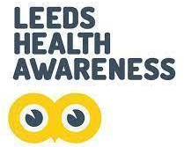 | Leeds Health Awareness | Leeds based community programme helping to raise awareness of and prevent long-term conditions across Leeds. | www.leedshealth.co.uk
 | Leeds Hearing and Sight Loss Service | Providing a comprehensive range of specialist support services for Leeds residents aged 16+ who are deaf, hard of hearing, sight impaired, severely sight impaired or deafblind. | www.bid.org.uk/leeds-local-services/leeds-local-services
 | Leeds Involving People (LIP) | LIP represents the independent voice of people through the promotion of effective involvement. We involve the community in the development of health, social care and community services by ensuring their opinions and concerns are at the centre of decision making processes. | www.leedsinvolvingpeople.org.uk
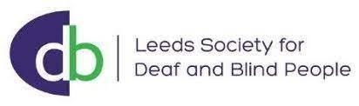 | Leeds Society of Deaf and Blind People | Our single objective has been to respond to the expressed needs and aspirations of Deaf, hard of hearing, DeafBlind, Blind and partially sighted people in Leeds. | www.lsdbp.org
 | Leeds York Partnership Foundation Trust (LYPFT) | Leeds and York Partnership NHS Foundation Trust is the main provider of specialist mental health and learning disability services in Leeds. We also provide specialist services across York, the Yorkshire and Humber region, and some highly specialised national services. | www.leedsandyorkpft.nhs.uk
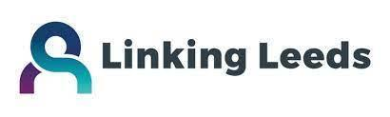 | Linking Leeds | The Linking Leeds Social Prescribing service operates out of Community Links with a consortium of local partners deliver the service. We work alongside Leeds City Council and Leeds GP Confederation. | linkingleeds.com
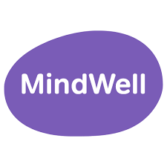 | Mindwell | MindWell is the mental health website for adults in Leeds. It’s funded to bring together information from the NHS, Leeds City Council and the third sector into one ‘go to’ place. | www.mindwell-leeds.org.uk
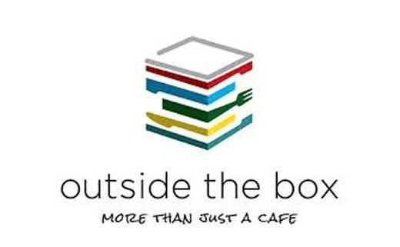 | Outside the Box | This charity is dedicated to community action, supporting people who have a learning disability and to re-investing any profits we make back into our local community. | www.outsidethebox.co.uk
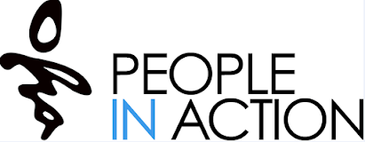 | People in Action | We work with learning disabled and autistic people to support happy, healthy and independent lives. | peopleinaction.org.uk
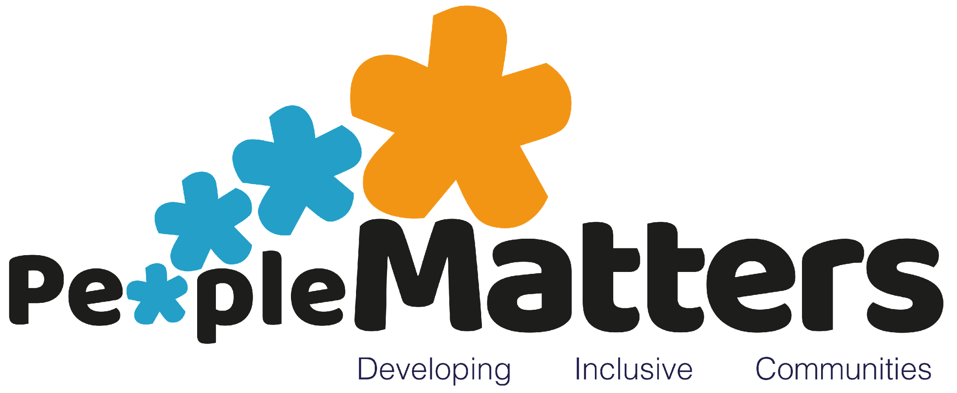 | People Matters | We create opportunities for people with learning disabilities and other hidden disabilities who experience disadvantage to be more independent and ensuring that each person’s needs are met | peoplemattersleeds.co.uk
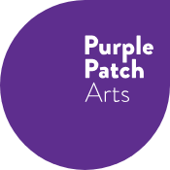 | Purple Patch Arts | We exist to provide innovative, inclusive, creative learning opportunities that improve the lives of learning-disabled and autistic adults by expanding their understanding and engagement with the world. | purplepatcharts.org
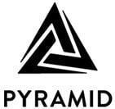 | Pyramid of Arts | Our goal is to help people with a learning disability to discover the arts and to develop their talents to become world-class artists. We also disrupt the social and institutional barriers that prevent them from being recognised, supported and celebrated. | pyramid.org.uk
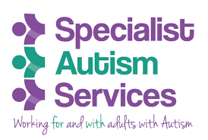 | Special Autism Services (SAS) | Specialist Autism Services delivers a strengths based Autism specific personalised learning programme, to develop social, communication and employment skills which empower our members to engage with new opportunities, make informed choices, achieve their goals, maximising independence and inclusion. | www.specialistautismservices.org
 | Royal National Institute for the Blind (RNIB) | We are leading the creation of an accessible world. A world where everyone can participate equally is a better world for everyone. | www.rnib.org.uk
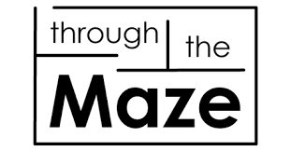 | Through the Maze | Through the Maze is an information and signposting service in Leeds for adults with learning disabilities, family carers and professionals. | www.through-the-maze.org.uk
 | West Yorkshire Combined Authority (YWCA) | We work across West Yorkshire to develop and deliver policies, programmes and services which directly benefit the people of West Yorkshire | www.westyorks-ca.gov.uk
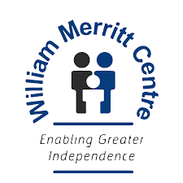 | William Merritt Centre | We offer impartial advice and assessments for people of all ages living with a disability or long-term condition to help them achieve greater independence and fulfilment. | wmdlc.org

Appendix 4: Easy Read Programme

Link to view the online pdf: Easy read programme IDODP 2023 (extract of 2 pages screenshot below)
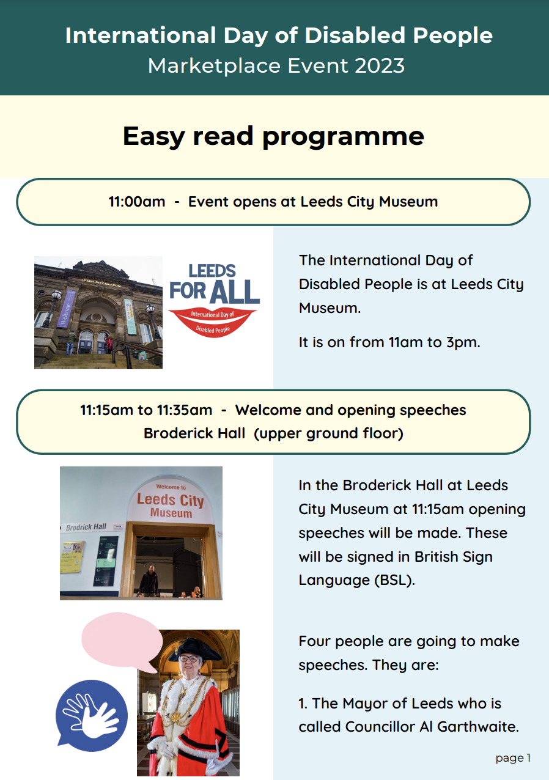
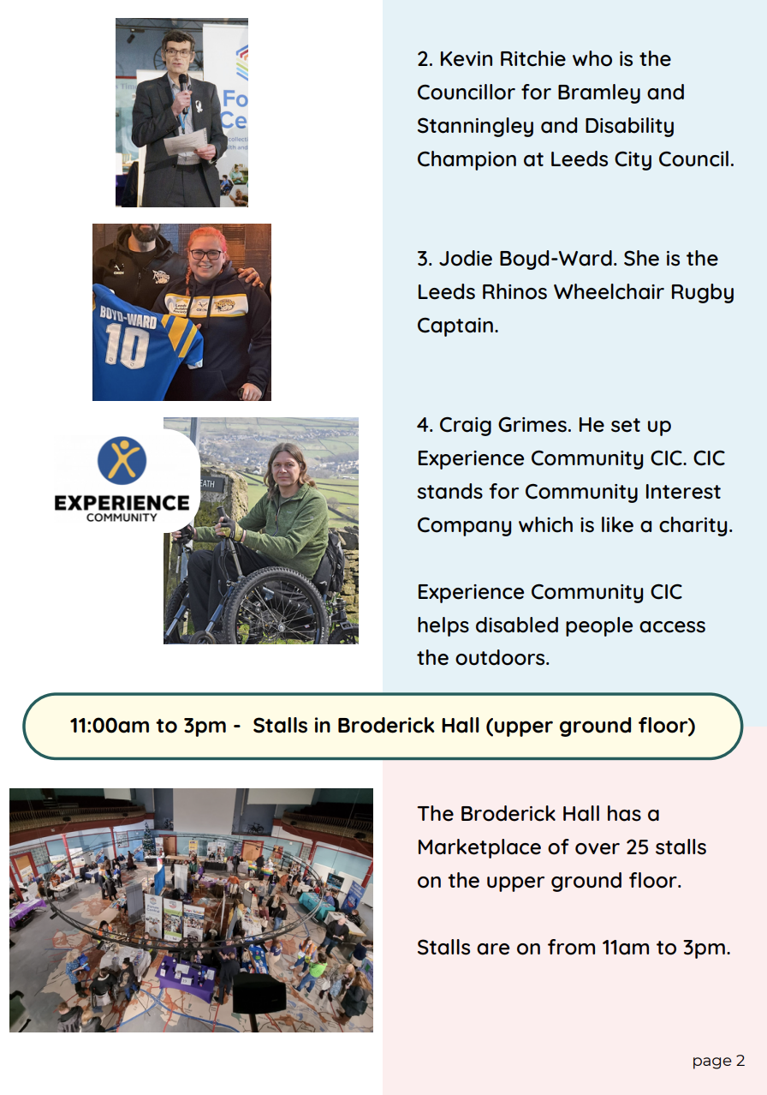

Appendix 5a: Press Release

International Day of Disabled People Celebration Event
2023’s theme is Transformation, Innovation and Inclusion

On Thursday 30 November at Leeds City Museum, a free interactive and inclusive event will be held to mark International Day of Disabled People 2023. The event is packed with things to do from 11am until 3pm and aims to highlight the contribution of disabled people to our city.

This annual Leeds celebration, now in its fifth year, brings guest speakers and activities together with stalls from over 25 organisations who support disabled people or promote self-advocacy. Visitors can expect a warm welcome at the marketplace. There will be lots of information about support and activities that take place in Leeds for a wide range of disabilities. MindWell will also be encouraging people to take part in their ‘Give a Hoot’ campaign.

Jodie Boyd-Ward, Leeds Rhinos Wheelchair Captain and Craig Grimes, Experience Community will be sharing their stories and speaking about their experiences in local disability sport. The Lord Mayor of Leeds and Councillor Kevin Ritchie will also make opening speeches, signed by BSL interpreters.

Activities on the day will be inclusive and fun. Yorkshire Dance is facilitating a Leap and Bounds session, you can play table cricket and ping pong with Active Leeds and Yorkshire Cricket or why not try out some circus skills with The Feel Good Circus!

Carers, Personal Assistants and Support Workers are invited to help with the activities. There will also be a quiet room with sensory items for anyone to use if they need a break or are overwhelmed.

Councillor Mary Harland, Leeds City Council’s executive member for communities, said: “This is a unique event where disabled people can feel welcome to be themselves, have fun, and connect with Leeds’ fantastic third sector and disability community.”

Pip Goff, director of Volition, a lead partner of Forum Central says “We are incredibly proud to host the International Day of Disabled People Marketplace alongside Leeds Disability Hub on behalf of our members. The fact that communities of people in Leeds can access valuable, person-centred support through our member organisations is something to celebrate.”

Helen Brand, Forum Central Physical and Sensory Impairment Network Development Worker says “This year promises to be better than ever! It is a fantastic opportunity to meet like-minded people and providers of community services. Come along, bring family and friends!”

It will be a space for celebration, reflection, connection, acceptance, and challenge. Join in and be part of the movement toward making Leeds a fair and safe ‘Leeds for All’.

For more information about the Leeds for All International Day of Disabled People (IDODP) Marketplace event, including a video access tour, visit the IDODP 2023 event page on ForumCentral.org.uk.

- ENDS -

(The press release was sent with contact details, information about the event organisers and steering group, and images and social media images with alt text.)

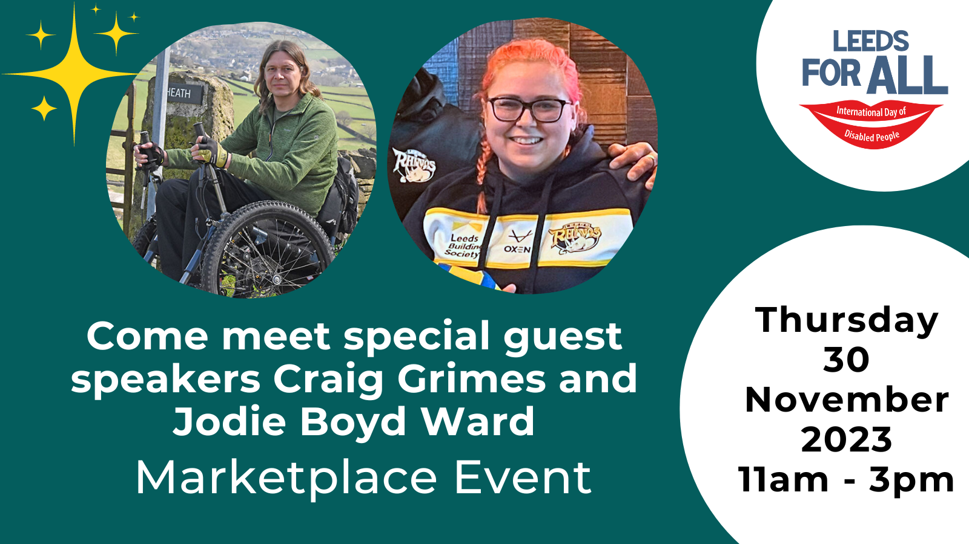
Appendix 5b: Selection of graphics

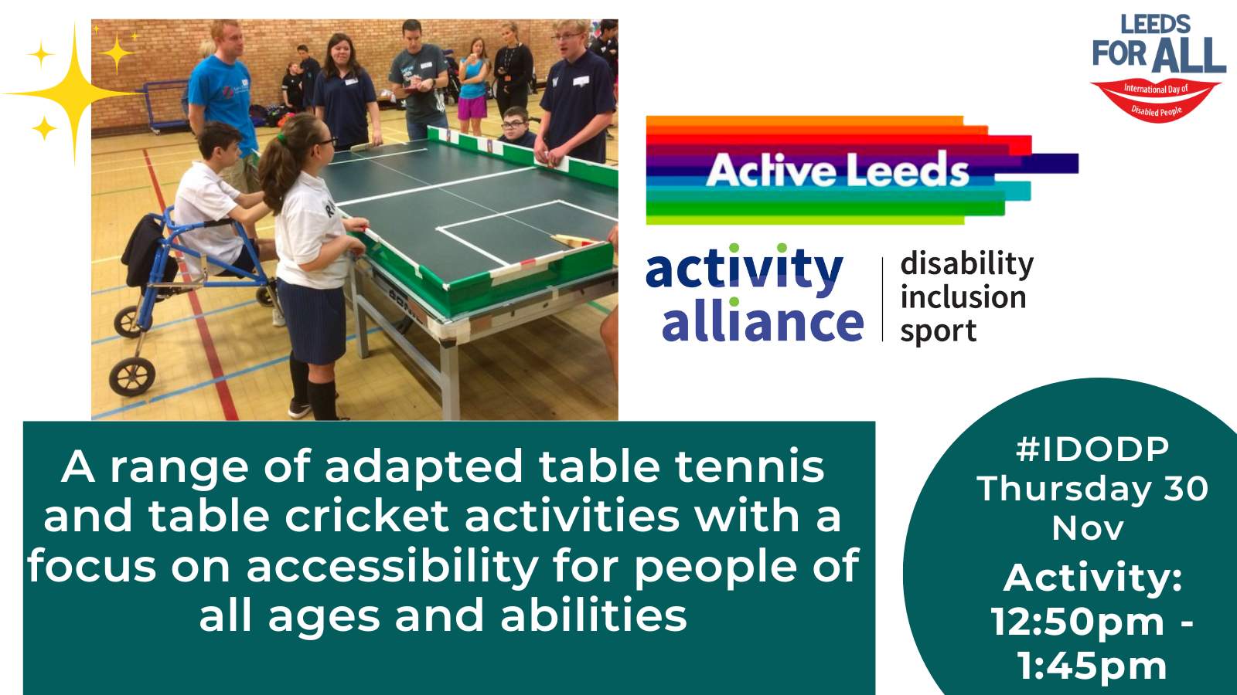
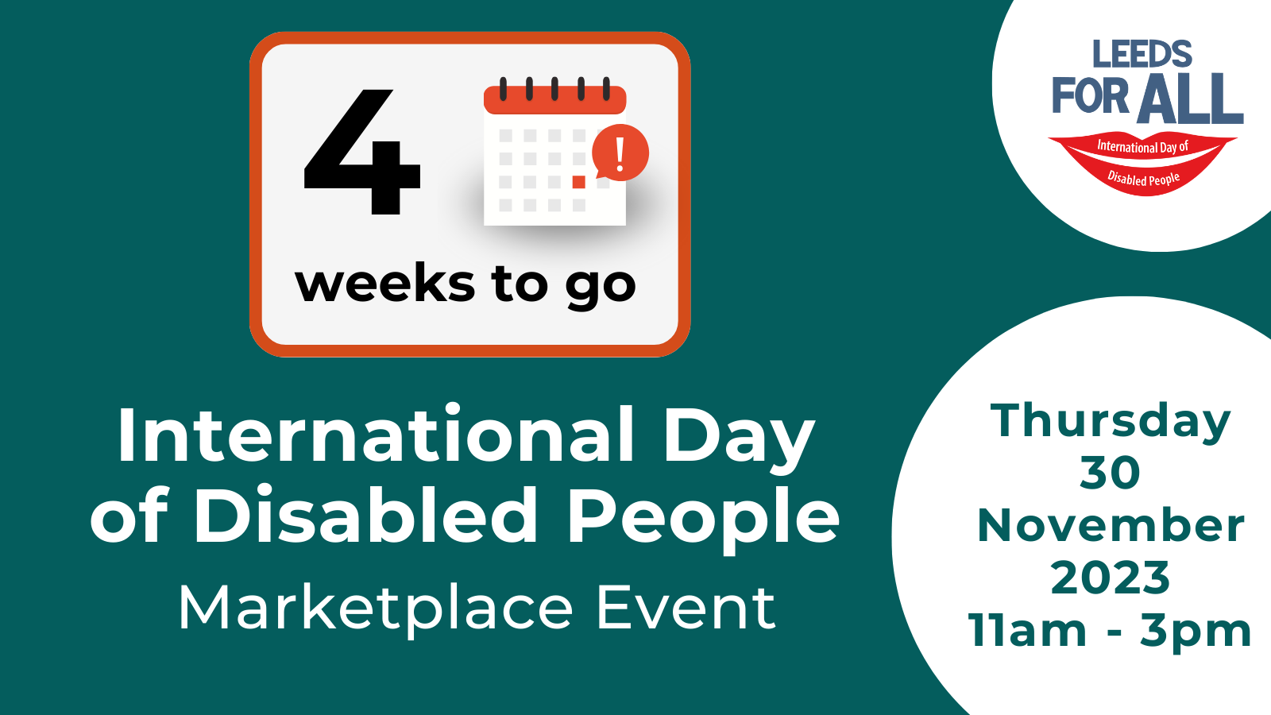
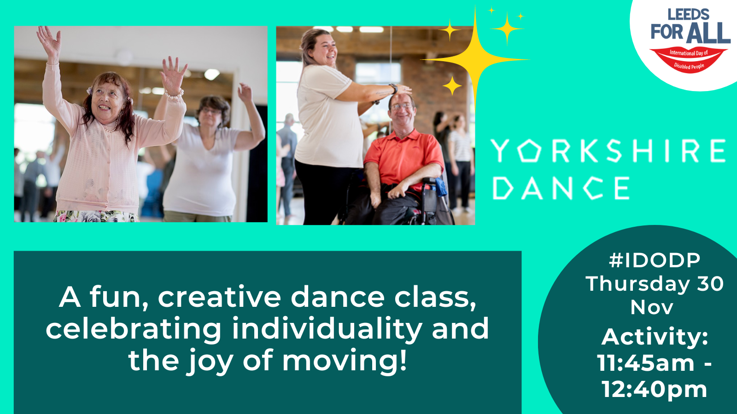
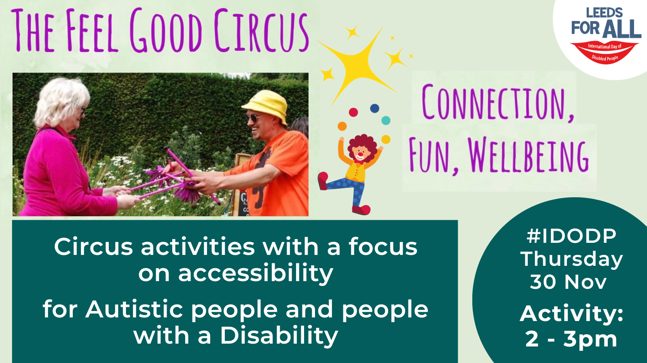

Small Grants fund:
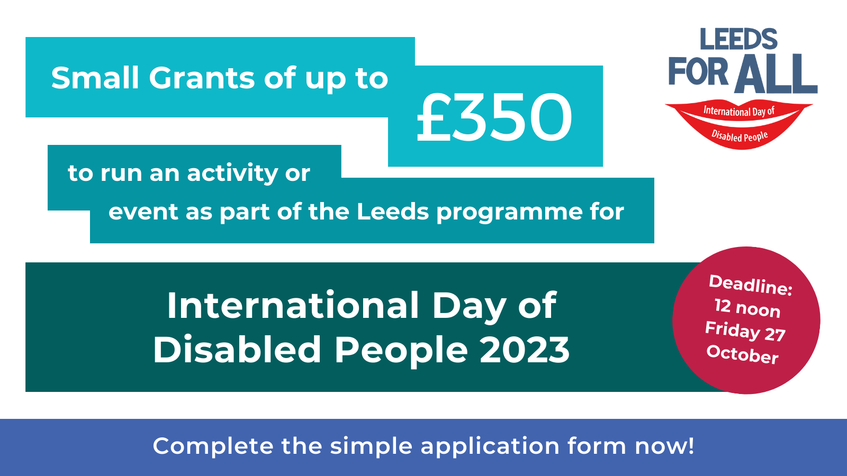

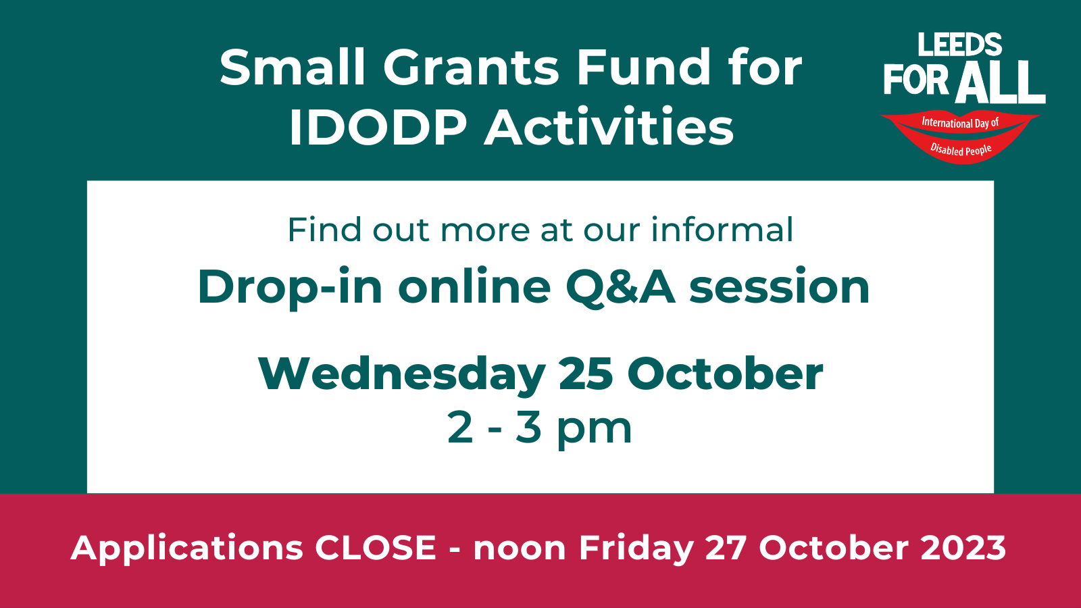

Email signature:
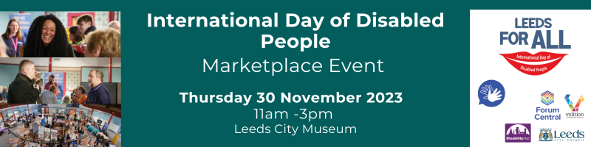

Appendix 6: Illustrations (link to folder containing all illustrations)

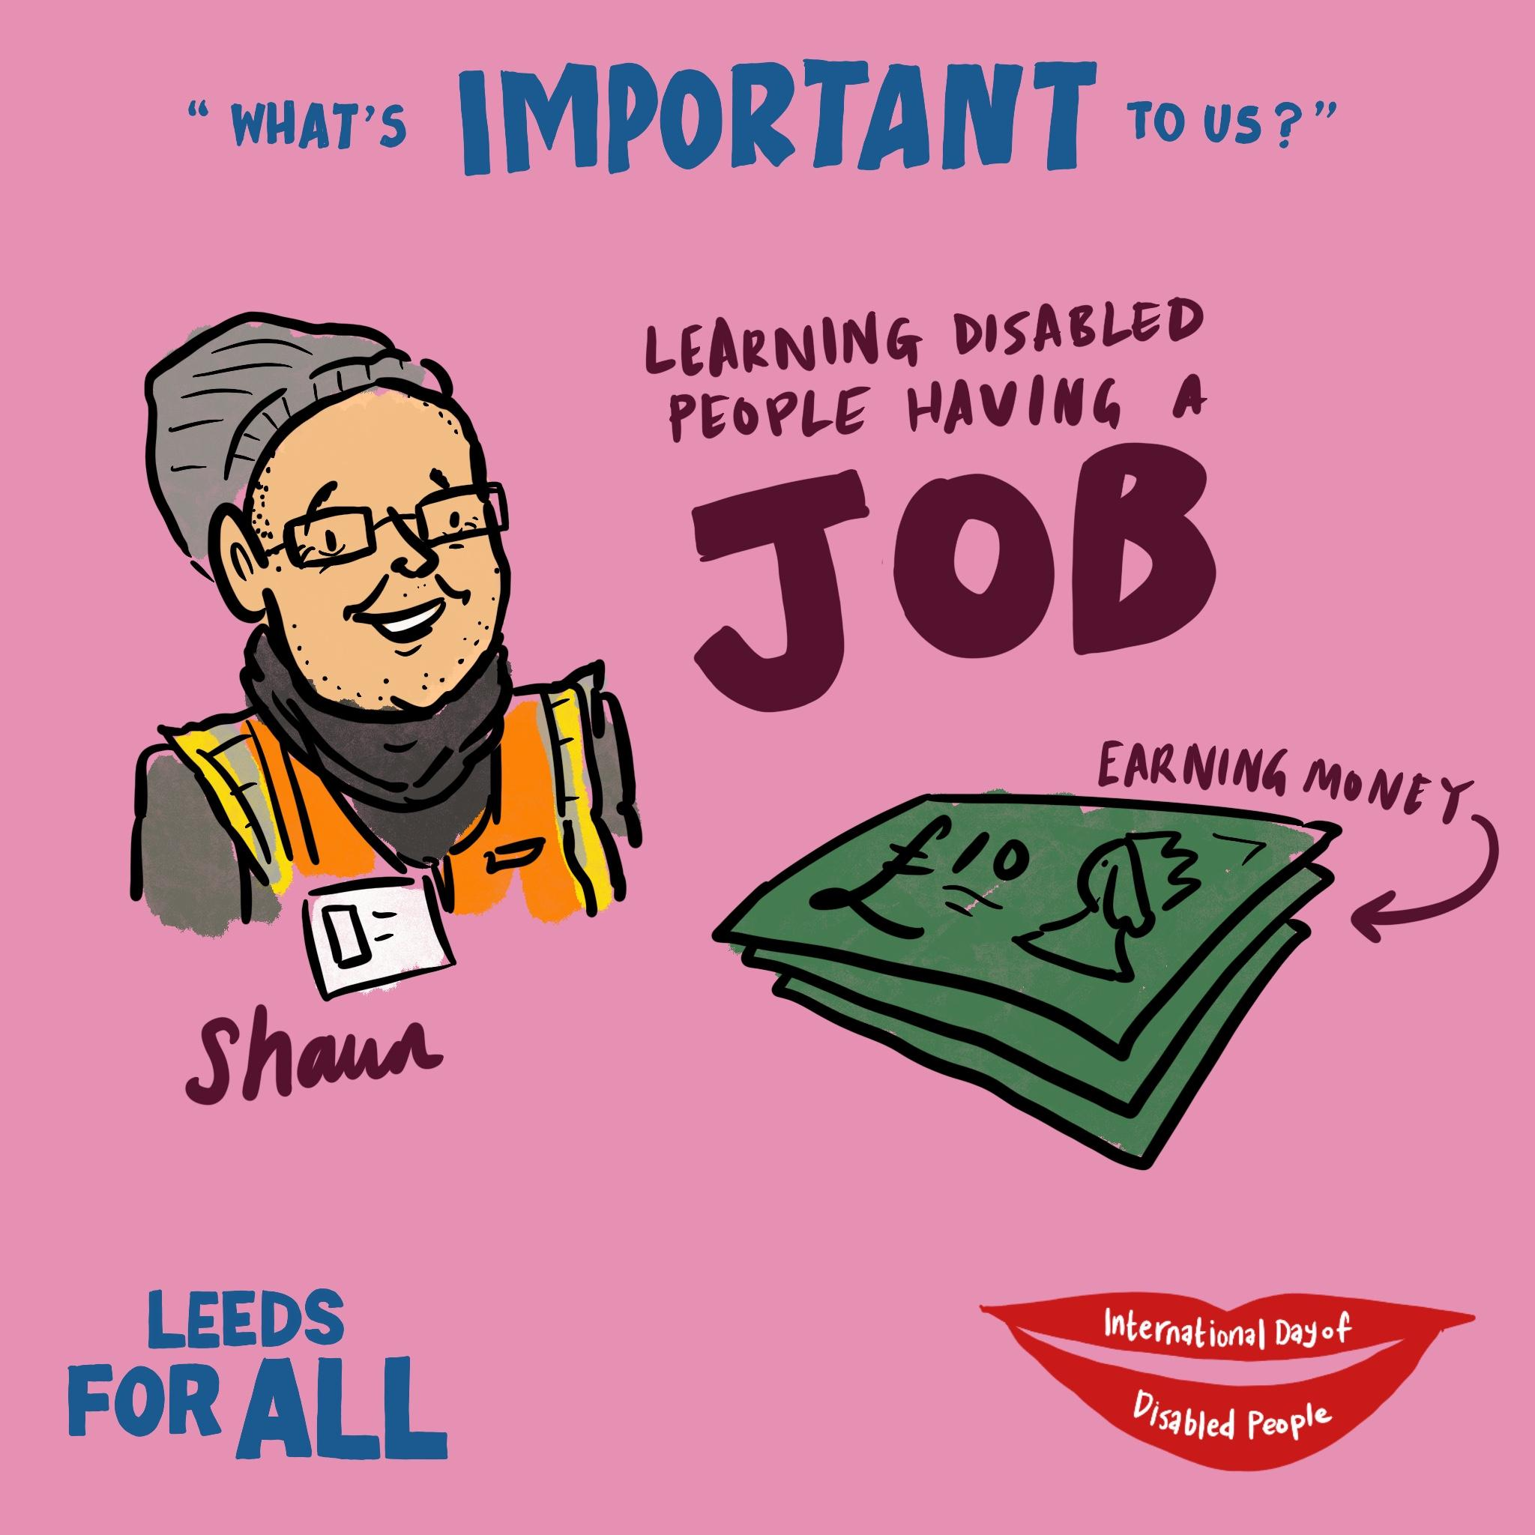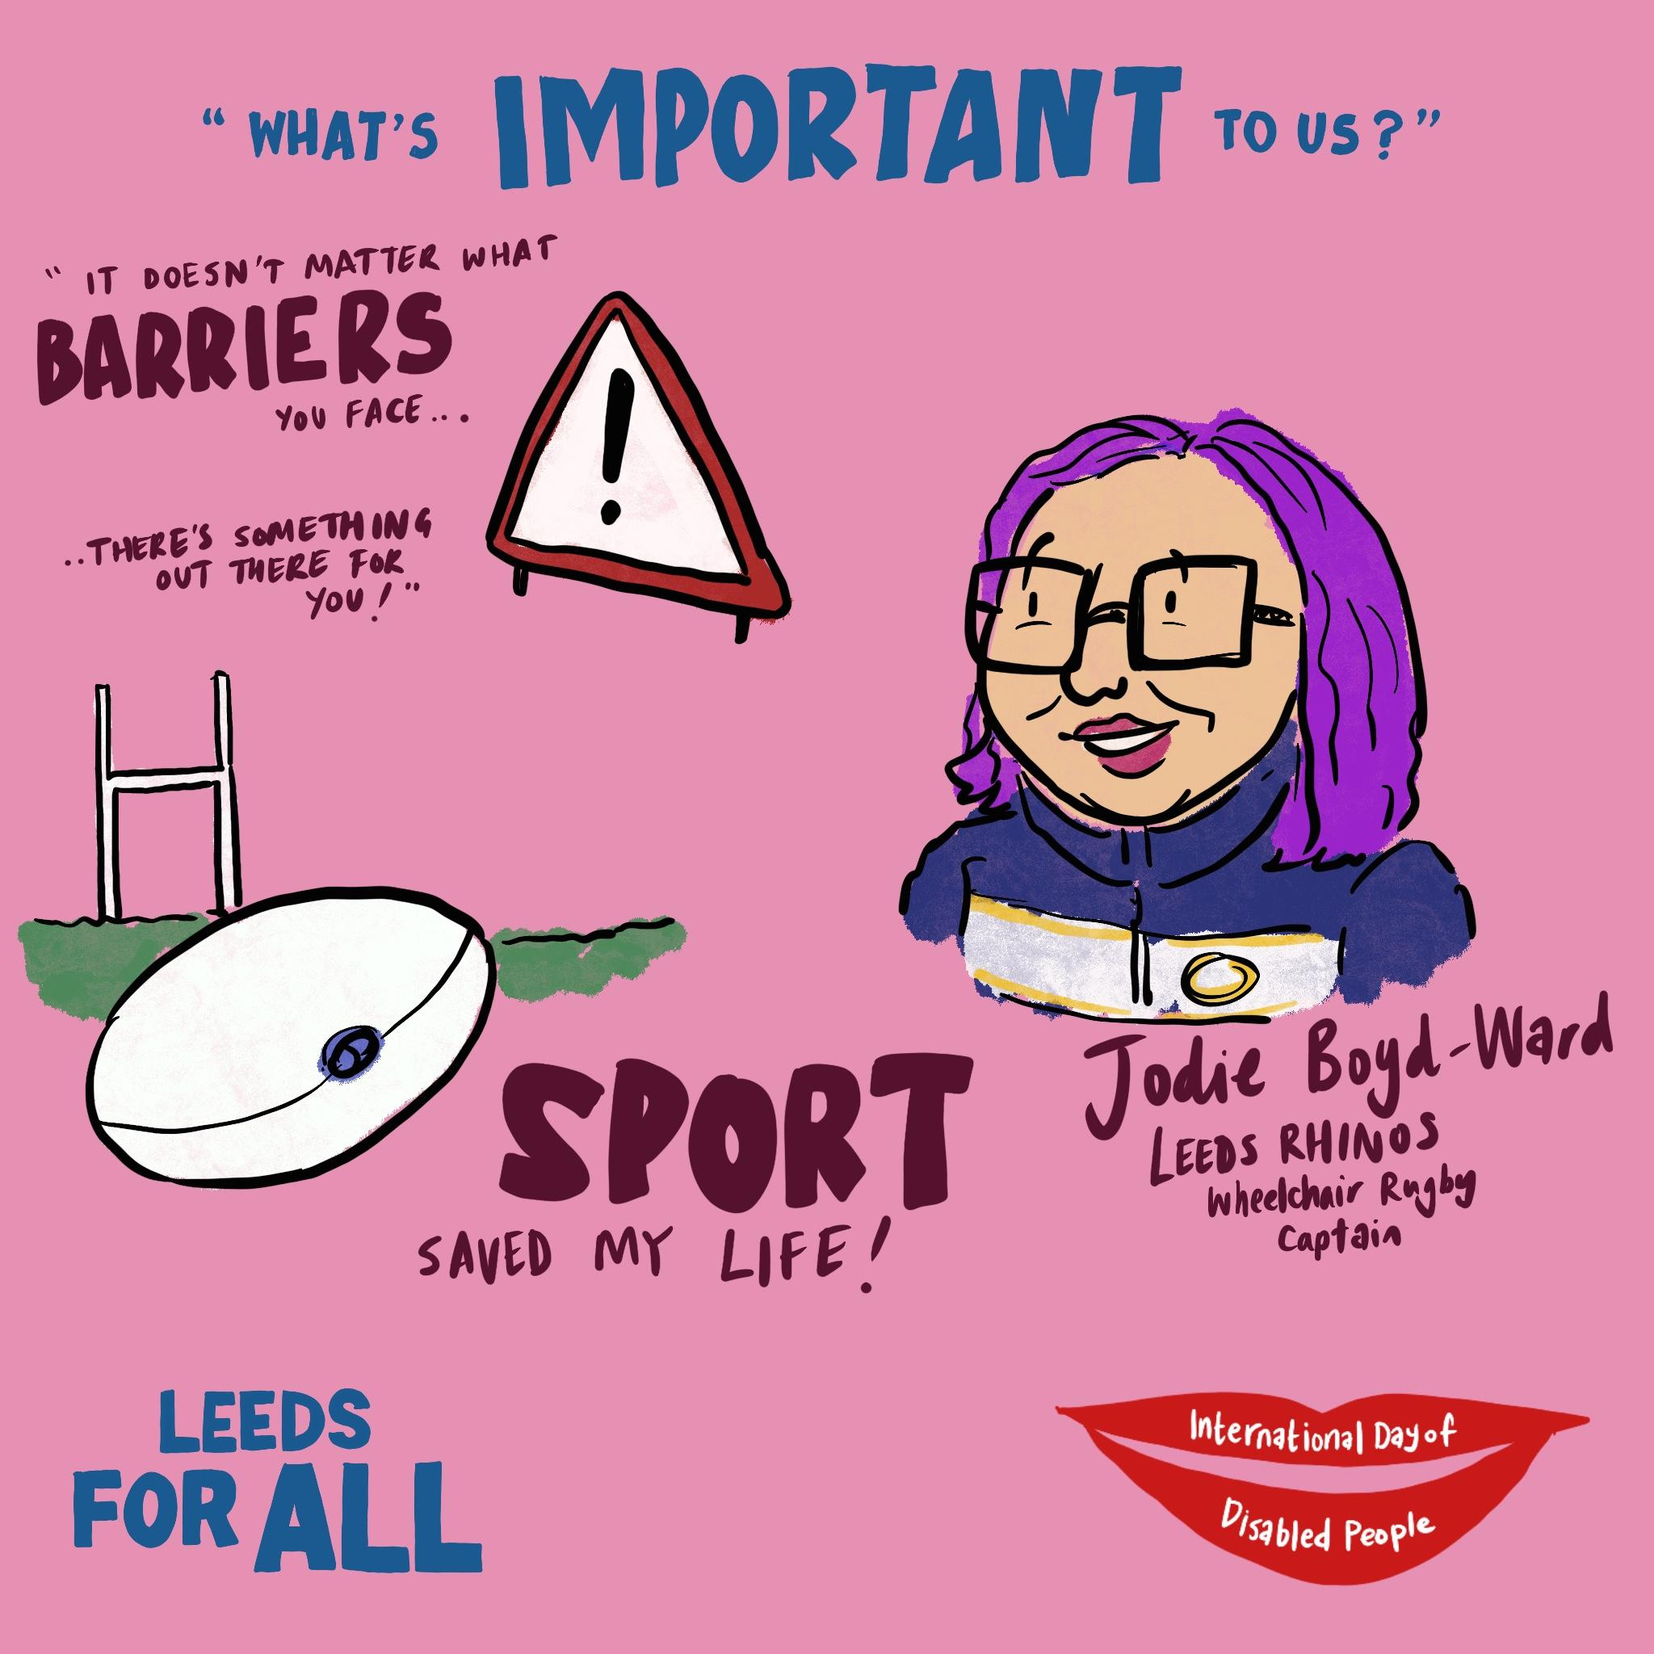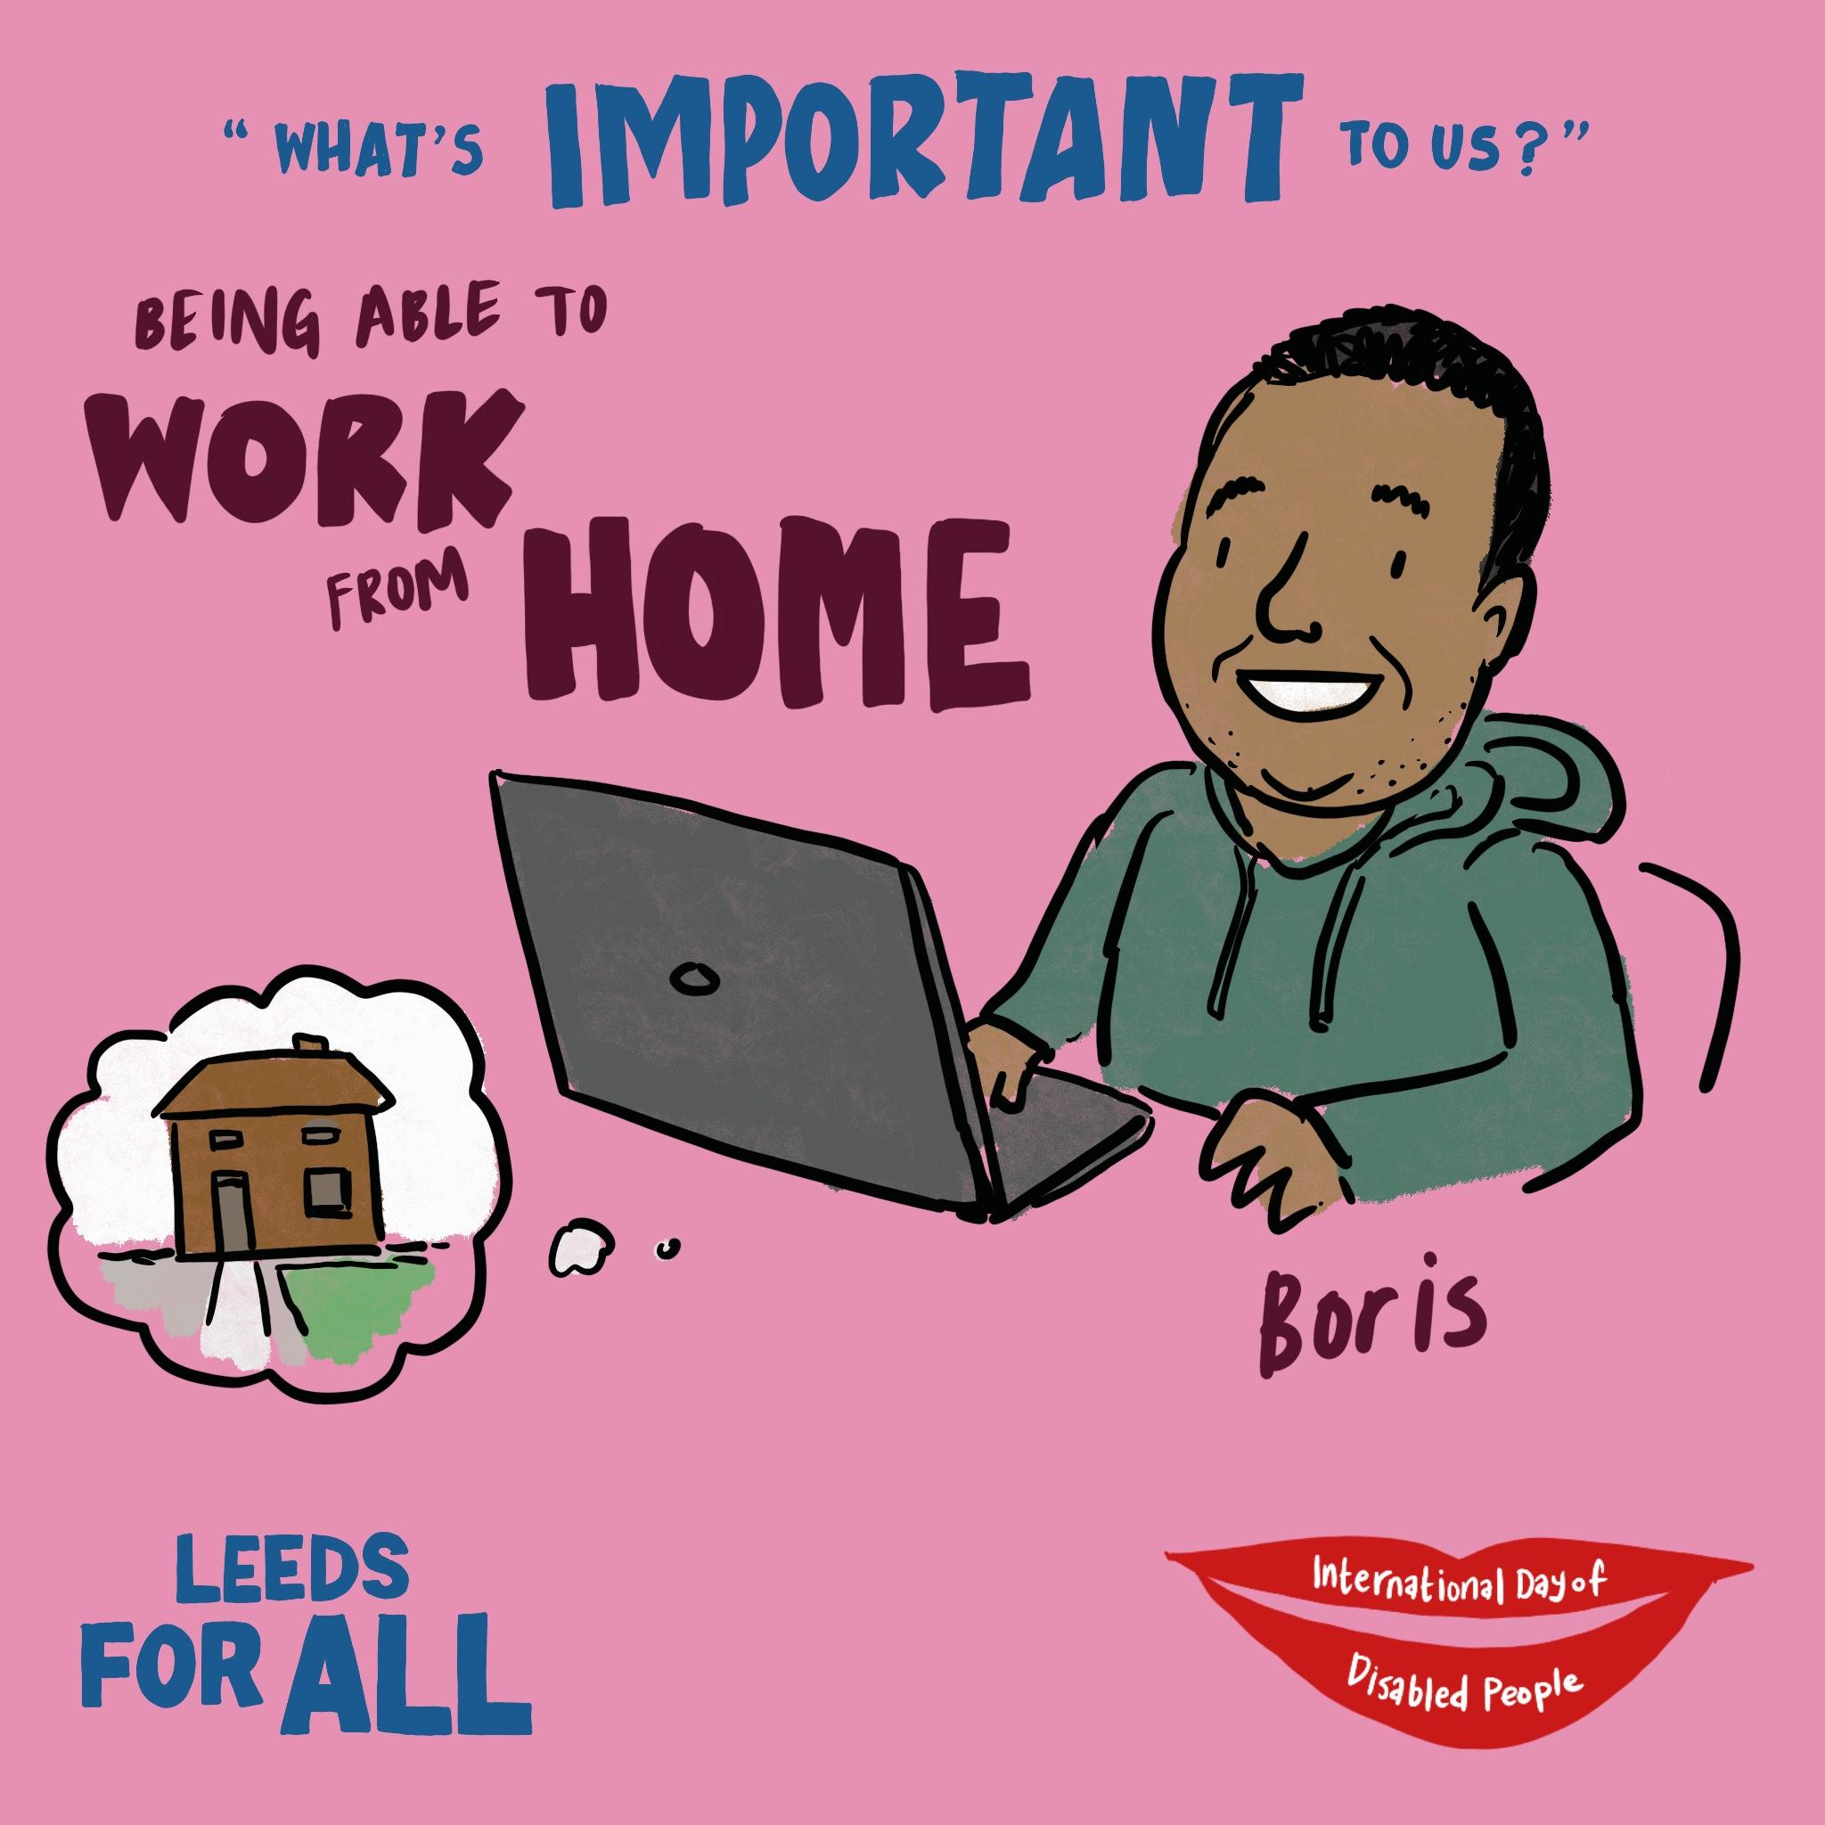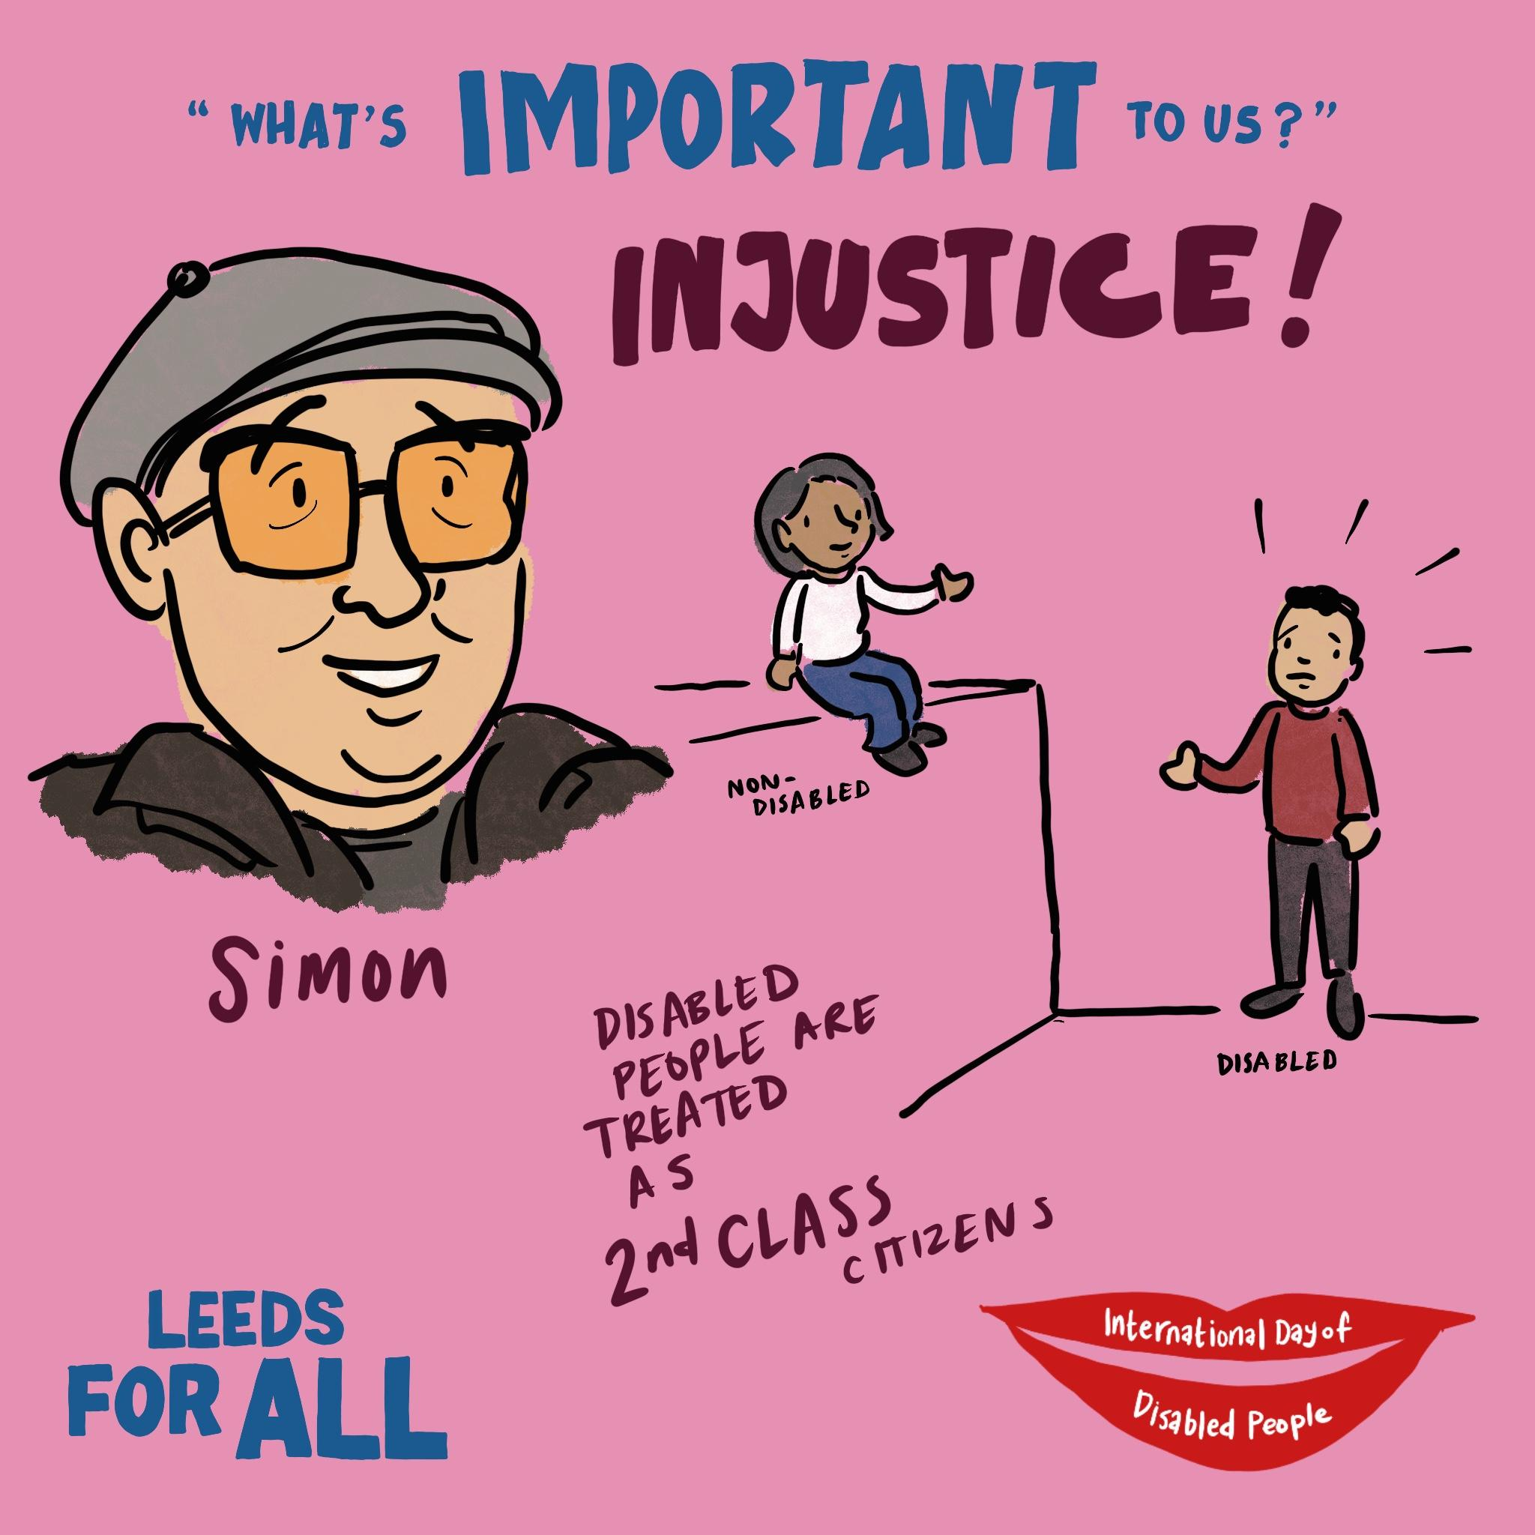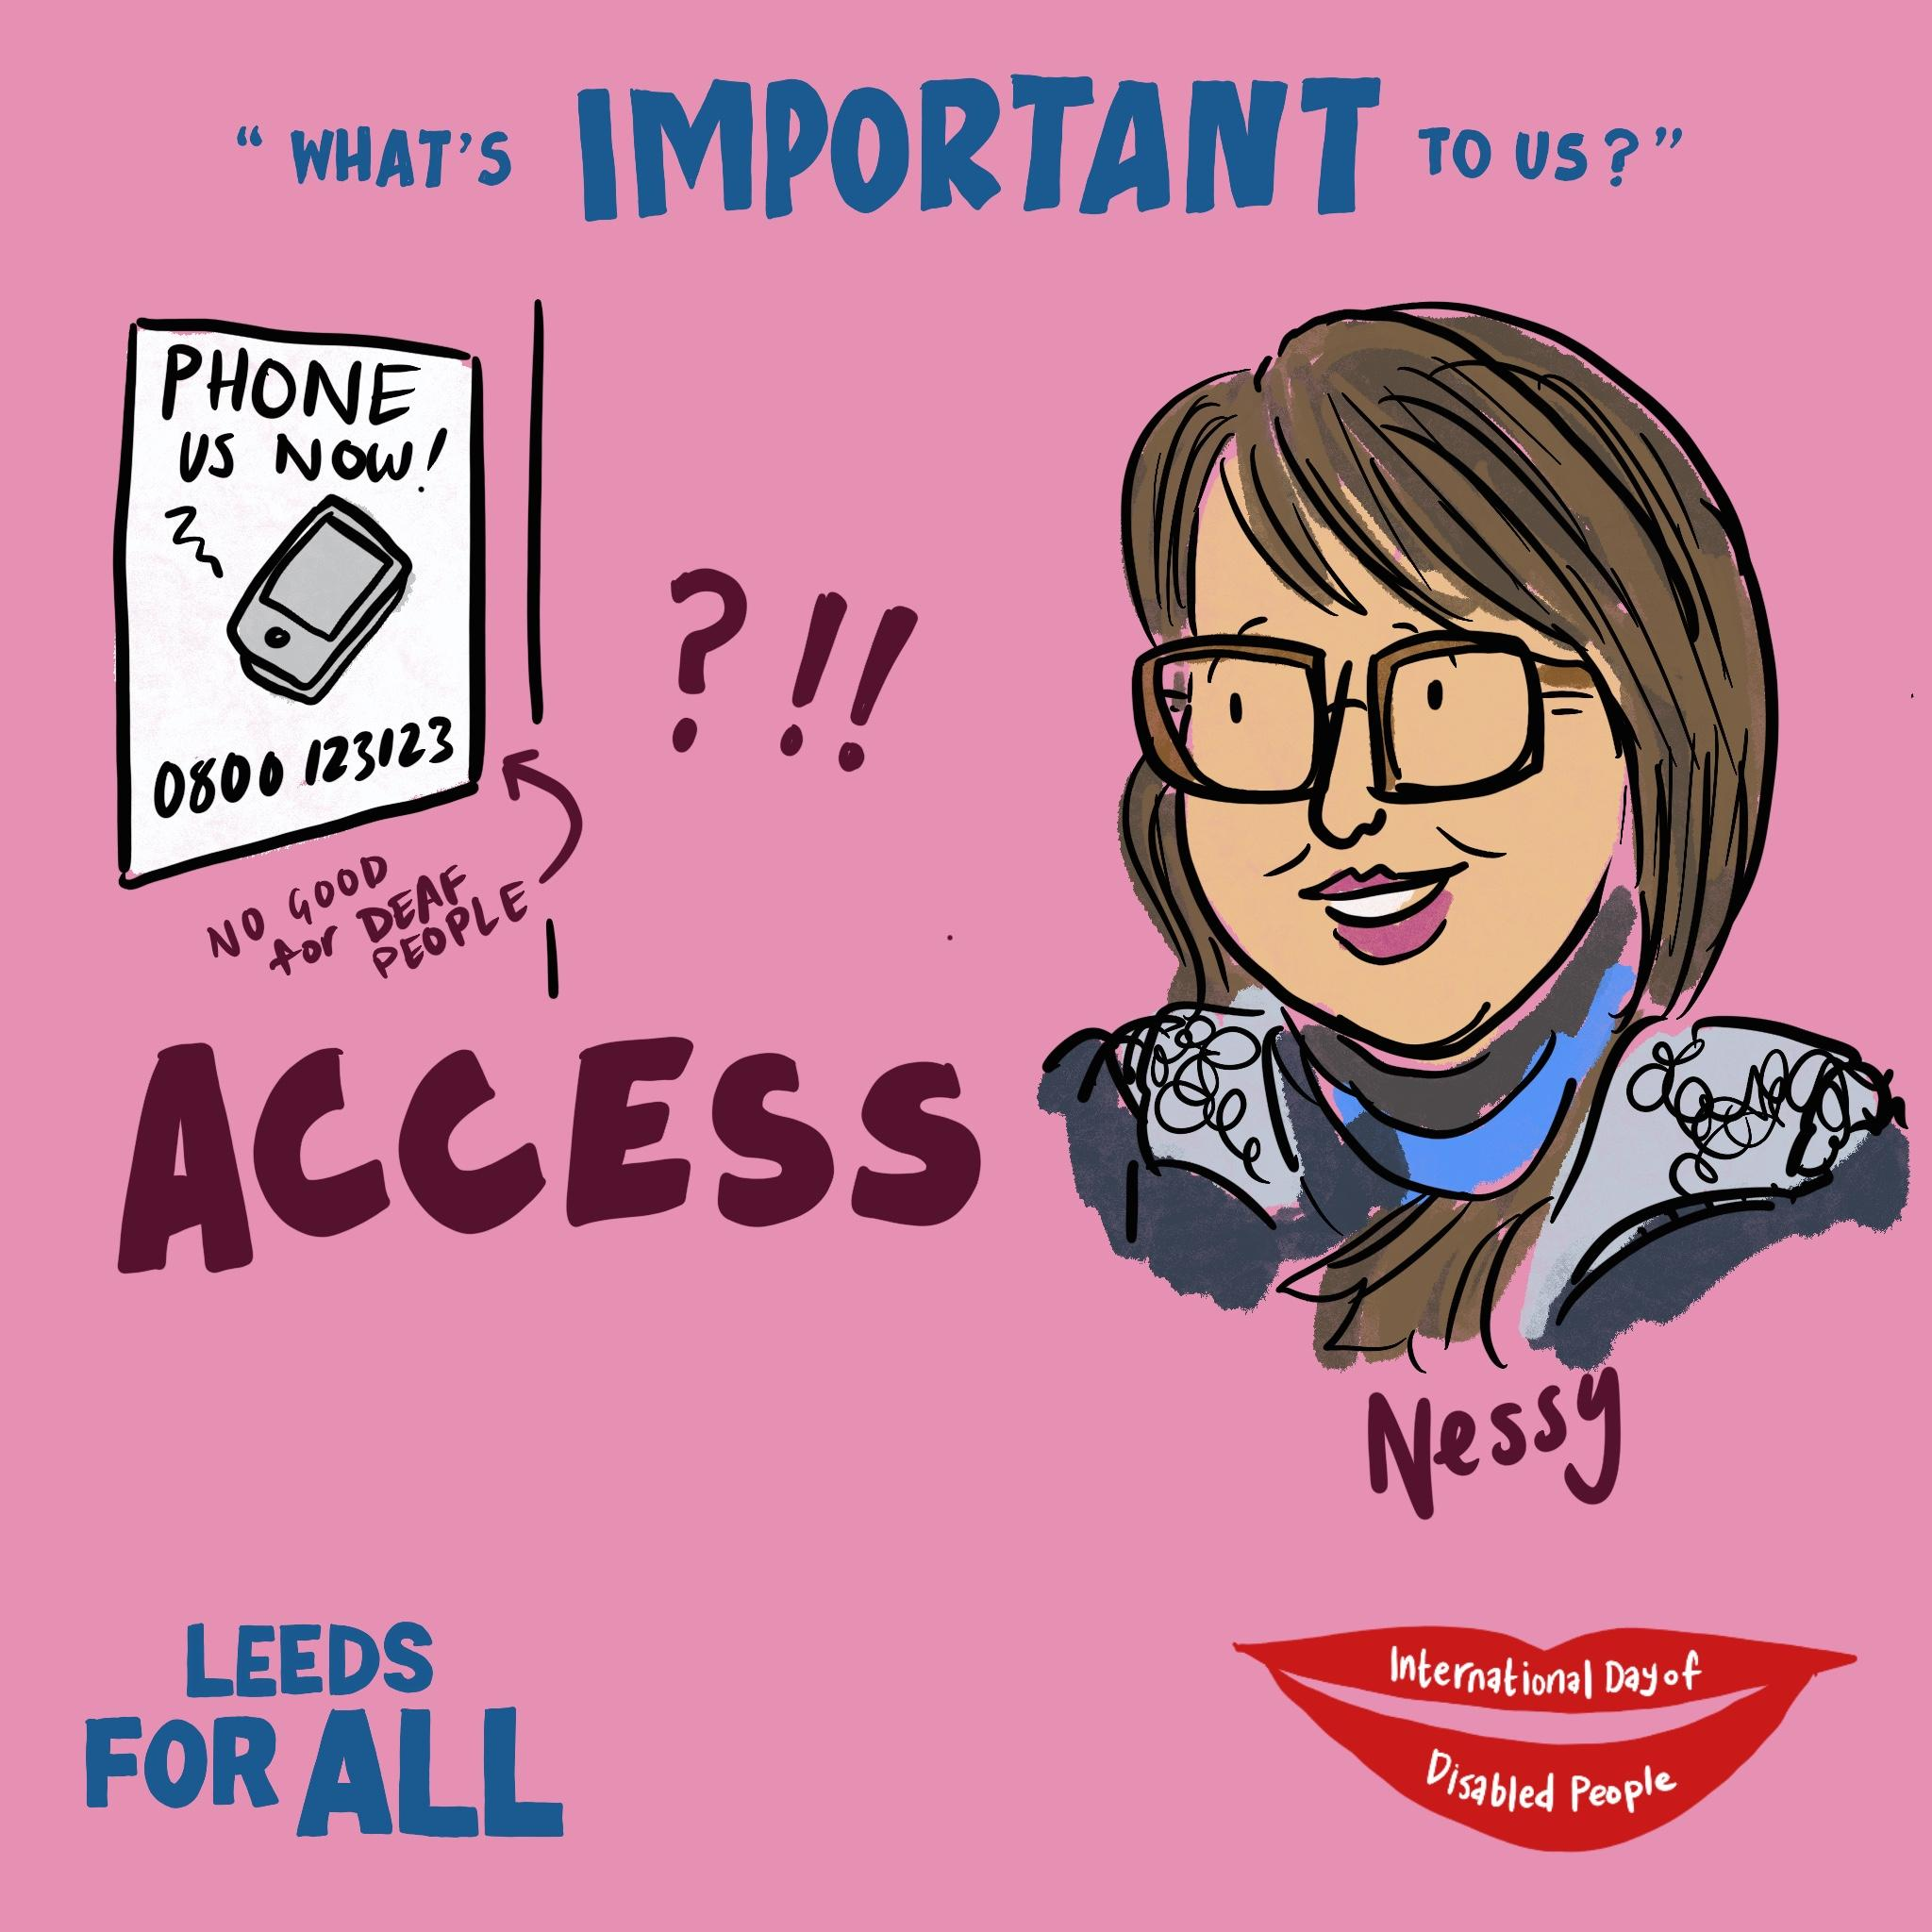

Appendix 7: Summary Chart of Completed Activities
Summary of Small Grants Evaluation Forms
Organisations | No of Attendees | Learning from each event | Results – what’s next? | Further involvement with Forum Central
Canal Connections | 4 | Weather was very poor and affected the numbers of people attending that day | Will use the remaining funding for similar events in spring and invite LD/PSI reps along | Yes, continuing correspondence
Craft Conscious Cafe | 8 | Community building location: People want to attend, but it can be tricky. We have decided to no longer offer the sessions in this way, due to the low number of people attending. Complex with unreliable funding and ad hoc ads | To run events with other organisations collaboratively, not sole responsibility. To  explore offering one off event sessions with a longer PR timeline, not as several sessions. | Yes, to FC PR for future events and networking
DEX Ltd | 35 | IDODP Stallholder – networking, info sharing – Wheel of Fortune good to get feedback and for future use | Raised staff confidence for events, attracted a new audience, raised charity profile | No immediate FC support needed
Gipton Fire Station | 112 | This event was very popular with local community, individuals and organisations to share their services. Stalls were filled quickly, those who couldn’t make it expressed interest to be involved in future events. We were overwhelmed with the volume of volunteers, many who had disabilities. Feedback: 36 people signed up to the mailing list. 94 responses - 86 rated the event as good/excellent, 8 rated it as ok. 54% considered themselves to have a disability. The information alongside fun activities helped raise awareness in a positive way. | This event or similar will become a more regular occurrence in GFS activity calendar. It was very busy with lots of wheelchairs so room capacity was reduced slightly. We would have struggled with space had many more turned up. We’ll look to do something in summer and utilise outside space. Links with new organisations for signposting increased so we’ll be able to better support people with disabilities at Gipton Fire Station. | Will continue as Forum central members
Harehills Park Bowling Club | 28 | We now have an annual trophy to be played for each year for IDODP which is brilliant, raising awareness and created a legacy.  Bar now set for bowling clubs and BCBA to make positive additions to bowling calendar on a much bigger scale.  HHPB club reputation is improved as our VI members spread good news, morale is lifted and VI players achievements in bowls are improved and abilities gap reduced. | Plan IDODP ’24 Blind Bowls Activity into HHBP calendar early, topic of AGM on 22.01.24  Either do activity nearer to 03.12 IDODP date or hold similar events during the summer. | They made new contacts with organisations at IDODP 30 Nov
Leeds Bereavement Forum | 2 | IDODP Small Grant Funded Event – minimal attendance – too far away from main room – didn’t quite fit in with IDODP Celebrations theme. The low turnout for the session was disappointing but the quality of the conversation had was excellent. | LBF will continue to run Death Cafes in 2024 until our organisation’s confirmed closure at the end of March. | No further support required
Leeds Mac Soc | 12 | Society is important for people who have VI and need a close local community – who would otherwise be isolated | Need more funding | Yes – through Disability Hub connections
LUF | 90 | Wider advertising, more public via different routes – attracted a new audience – Will start them up on a new event starting in Jan 24. It has expanded clientele plus club offer. | Yes – connected with IDODP event.  Now need to raise more awareness about club offer | Yes please – keep in the loop – member offer?
People in Action | 55 | We now know that it is difficult to book live or remote sign language interpreters to work at an evening event in Leeds We decided therefore to use live captioners to caption our live stream. We learned the tech know-how to get this done again next time in the future to improve it.  We have learned that this project is important to lots of our service users, both performers and spectators as well as friends, families and sector colleagues. We very much hope to keep it going as an annual event. | Now applying for funding to run the event again and to create other (ideally paid) performing opportunities for our pool of talent.  Already Invited the winners of this year’s show to perform at another event. Continue to create opportunities for talented people to hone their craft and show it off in public. | Re: funding for performing arts, and being put in contact with relevant partners who might like to be involved in future events
Spider-Y | 18 | We got lots of young people through the door who were either a family member of a member who had not had an opportunity to play before and wanted to play a sporting activity with their family member maybe for the first time using a wheelchair. Also involved an info session: Access to Work | Event timing to be improved for 2024. Short timeframe on fund award gave us limited time to book sports hall (Morley sports hall limited availability) Need LCC to be more involved with S-Y club as its v low on funds (it’s the only wheelchair basketball provider in Leeds) | PSI Connection to be made with Disability Hub (Cllr Ritchie regarding funding)
Swarthmore | 17 | Only a few of the people who attended had been to Swarthmore before, so it was nice to see new faces. All new attendees found the event on Eventbrite (listed as a free event) Also regulars dropped into the workshop – it got a bit crowded as there were wheelchair users and other people came back after lunch. Needed to have more tables set up. Very successful day all in all. The café location attracted more participants and was also close to accessible toilets. | To find funding to run similar events in future, to explore techniques/work with different facilitators. Themed events.  It’s a great opportunity to reach a new audience, explain about Swarthmore, and tell people about the subsidised courses they could join. | If there are any other funding opportunities coming up, it would be great to hear about these.  FC Members – Network?
Yamsen | 3 Xmas Choral events in Dec  60  40  30 | The grant went towards our Transport Fund. Active encouragement of members to perform in the Community. This gives purpose to our choir meetings – public performances build confidence!  The biggest barrier we face is transport to events, esp for members without 1:1 support. Many Centres struggle to get transport when/where they need it. | We now have an established Transport Fund to help involve more members in performing, knowing that we can get them to/from the venue.  We have other events that we plan to attend this year: Rothwell Music Festival in March, Learning Disabilty Day at Temple Newsam in June, Wharfedale Music Festival in Ilkley in July. All these events involve transport. We are looking for other opportunities for our members to perform just like any other choir. | We would like to keep in touch re any other community events/funding
 | Total: 511

Social media utilised: Eventbrite, Facebook, X, Tiktok, and Instagram to encourage people to register, participate, buy tickets, attend, and do follow up PR. People in Action made sting videos using the event and partners’ logos to get people’s attention and using footage from previous events to make PR videos and digital flyers to share.

Appendix 8a: Easy Read Feedback Form

Feedback Form
International Day of Disabled People Marketplace Event 2023
Thursday 30 November, Leeds City Museum 11am to 3pm

Please share your feedback to help us plan IDODP 2024. Thank you.

- Did you enjoy the event today? Please put a tick (✓) in the box to answer.
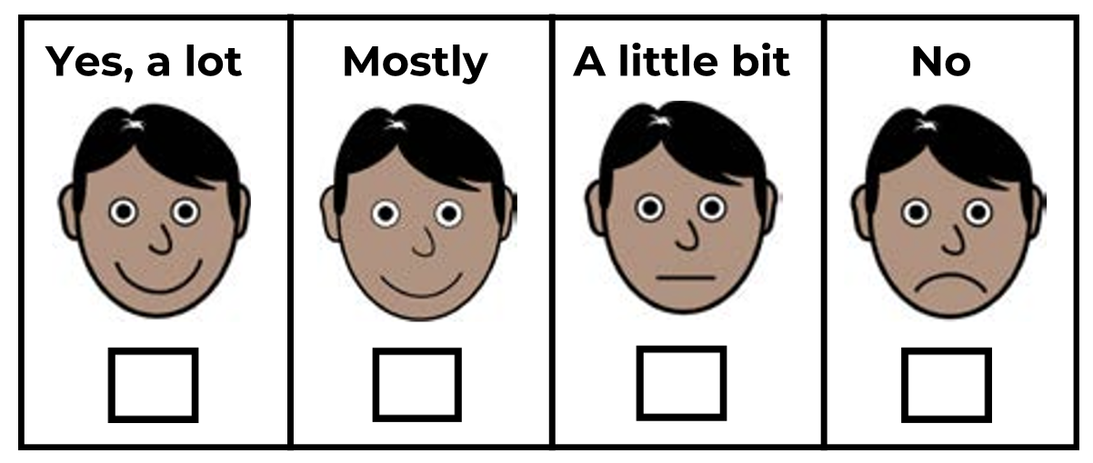

- What did you like about today?

__________________________________________________

- What did you not like about today?

__________________________________________________

- Was the event accessible for you? Please put a tick (✓) in the box next to your answer

⬜ Yes ✅ ⬜ No ❌
- How did you find out about this event? Please put a tick (✓) in the box next to your answer

⬜ social media (like Facebook, Instagram or Twitter)
⬜ Poster
⬜ I heard someone talk about it
⬜ I heard about it from Forum Central
⬜ I heard about it from Leeds City Council
⬜ I heard about it from another charity/organisation
⬜ I heard about it another way (please tell us on the line below):

__________________________________________________

- Has this event made you think more about your wellbeing and how to connect with other groups?

⬜ Yes ✅ ⬜ No ❌

Please tell us how on the lines below:

__________________________________________________

__________________________________________________

- Do you have anything else you would like to tell us about the event today? For example things that could be improved (please write on the lines below)

__________________________________________________

- Do you want to be emailed with updates about IDODP 2024 or similar events? Write your email address below to sign up to the mailing list

Thank you for taking the time to give us your feedback.

Appendix 8b: Digital Version of the Feedback Form

Appendix 9: Email Feedback

IDODP 2023 EVENT EMAIL FEEDBACK
Organisation /job role | What they said about the Celebrations Day……
Director of Leeds Church Institute | It was vibrant and informative, so well done to the team for pulling all those different aspects together.
Employment and Skills Manager (Finance & Professional Services)  Leeds City Council | A great event today, really well done. I spent ages wandering round talking to people and finding out more. It makes you realise just how much goes on in Leeds. Many congratulations.
Service User - Asking You! | Feedback on access video: I think that video is amazing great idea to show everybody where the lifts are before they get there where the ramp is and how to access everything before they get there, I think that’s brilliant!
Senior Commissioning Officer (PSI) Leeds City Council | It was a very bustling event, wasn’t it? Really well attended I was pleased to see.
Leeds Rhinos Wheelchair Rugby Captain | I really enjoyed the event! I don’t think in the 11 years I’ve been in Leeds that I have ever attended the museum, so it was interesting to see how accessible the venue was; I found it completely accessible, and the range of vendors was great. I think the programme worked really well too.
Transport Accessibility Coordinator  West Yorkshire Combined Authority | Leeds City Region Enterprise Partnership (the LEP) | What a great event last week! We had so much interest from attendees, some great conversations and I made some fantastic new contacts with other stallholders. Thanks for organising it.
Counselor for Bramley | I’m truly grateful for the Teams efforts delivering the day. I thought the day was excellent, the programme varied and interesting. The joy of the participants downstairs during the various activities was a pleasure to see. The range of stalls and quality of information was first class too.
Dance Facilitator, Yorkshire Dance | We loved being part of the IDODP activities. It was fantastic to see so many people getting involved and enjoying the dance session, exploring creativity and movement and most importantly, having fun! The support from the Forum central team was great and we can’t wait for next year’s event.
Director, Leeds Bereavement Forum | Thank you for giving us the opportunity to hold our event. IDODP felt the most ‘buzzy’ I think I’ve seen it this year, many congratulations to all involved organising it. I thought the number of clearly marked marshals on the day was excellent and everyone was very friendly and helpful.
Active Leeds Coordinator and Yorkshire Cricket Coordinator | My colleague and I thought the event was good, the space was an appropriate size- plenty of room for both our ping pong, Activity Alliance stall and the Yorkshire Cricket guys. We had a reasonably steady stream of people coming in to play the activities, we could have accommodated more people but its hit and miss how many will actually come along. I know some of your colleagues went to try and round up more participants and I think that helped boosting numbers. Overall it was good, no problems at all.
Information Officer - Through The Maze and Connect in The North | I had several conversations about easy read and accessible information at the event. These included discussions with people doing broad public engagement that wanted to start improving accessibility for people with a learning disability (eg. in relation to transport changes in Leeds) and a couple of health professionals starting research projects. One of them linked me to another researcher at Leeds University, I have had a discussion about inclusion in research and she is proposing to develop guidelines on inclusive participation in medical research ( I was able to help fly the flag for making sure people with a learning disability are included) Just today I have followed up with the researcher to link her to Purple Patch's Purple Research Group, which has prompted me to send this feedback.  On our stall, we spoke to 64 people. This led to us adding entries to our website from links made, as well as signposting and a lot of PR for our service.  My headline feedback is that it was a great event, especially for reaching people we might not connect to in other parts of our work that have a narrower learning disability focus.
Community Partner (Leeds) Royal Mencap | Royal Mencap’s ‘My Community’ project attended the IDODP event, we had a stall manned by one of our community connectors. At the meeting, Maisie met and spoke to Outside The Box, after finding out what they do, she arranged for us to meet. That meeting happened on 17 January, and we are now working on how we can connect up with their participants and potentially combine on a project together.
Autism and Learning Disability Digital Inclusion Coordinator - Pyramid/100% Digital Leeds | I found IDODP a really vibrant and inclusive event where people with learning disabilities were able to have their voices heard while also finding out more about what is happening in Leeds. It was wonderful to have a stall at the event, one of our members led an activity to gain feedback from attendees with and without learning disabilities. Opportunities like this give our members confidence and show them that their work is valued.  As a professional, the event was wonderful as it gave me a chance to network and to make new connections. For example, I met members of the Leeds City Council Highways and Transport team who want to make their work more inclusive for people with learning disabilities. The team have since joined the Autism and Learning Disabilities Digital Inclusion Network, and we are working on ways to support one another moving forward. Joint working like this enables organisations to reach more people with learning disabilities in an efficient and accessible manner.

