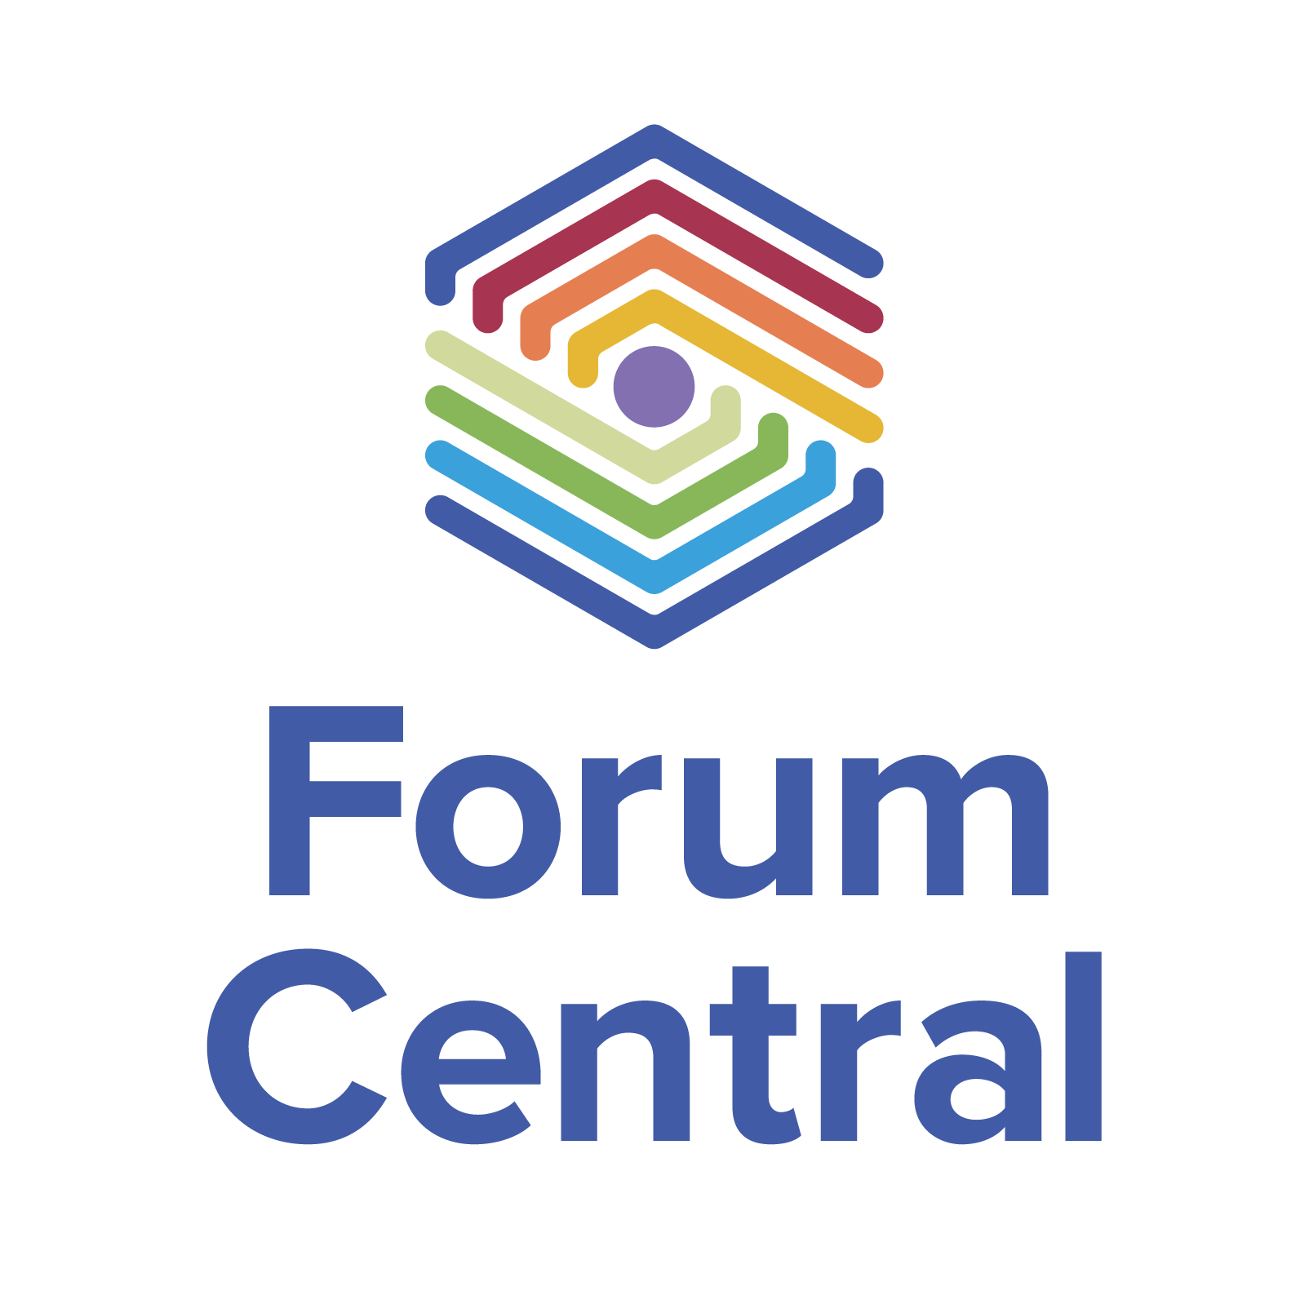
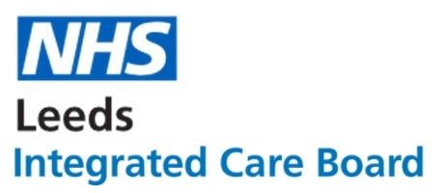

Forum Central Third Sector Representative - Health Protection Board

Role Description

Context
We are recruiting a new third sector representative to the Health Protection Board, which has recently been reconvened. The role was previously held by the late and greatly missed Heather Nelson.

The Health Protection Board is a Leeds-Wide Health and Care system board that feeds in to the Health and Wellbeing Board.

For background see: Leeds Health Protection Board Report 2022
(This year’s Leeds Health Protection Board report has been finalised and will be shared shortly)

The work of the board is led by Victoria Eaton, Director of Public Health, Leeds and their role is to ensure strong and robust Health Protection system leadership with effective outbreak management processes are in place to monitor disease, prevent harm and protect the health of the population of Leeds. The board is committed to a strong evidence base, a commitment to community engagement, and a strong emphasis on workforce development and collaborative working. It seeks to ensure that people are consulted, supported and cared for with compassion and kindness.

Director of Public Health, Leeds.

About the role
The Third Sector Representative is a full voting member of the board. The role entails championing the work of the Health Protection Board across the city and advocating for our diverse Third Sector within the board. The successful candidate will work with the Forum Central team in gathering and synthesising views from the sector to feed into the board, as well as feeding back from the board via Forum Central. It is an excellent opportunity to ensure that:
- The Third Sector is able to to influence high quality health and care support and services and to contribute to improving wellbeing in Leeds
- The Health Protection Board harnesses the power of the Third Sector to help deliver the city’s Health Protection work
- City partners receive the valued input and insight of the Third Sector and harness their contribution to Best City outcomes

Candidates for both roles must be able to provide time and capacity to commit to:
- Attending quarterly Health Protection Board meetings
- Attending the Forum Central Health & Care Leaders Network.
- Attending monthly Leeds Health and Care Partnership Development Third Sector Reference Group Meetings when possible.
- Maintaining contact with the Forum Central team to discuss input from the sector across the agenda and for ongoing support

Commitment
Health Protection Board meetings are held each year, each lasting 2 hours and requiring approximately 2 hours preparation/feedback time.

We aim to have the representative confirmed before the next Health Protection Board meeting on July 16th 1-3pm at Merrion House.

Knowledge, Skills and Abilities
Applicants should be able to demonstrate and give examples, evidencing skills and knowledge in the following areas:
- Be confident speaking on behalf of the sector, without a personal or organisational bias
- Have a commitment to people’s voices being at the heart of decision making in Leeds
- Be committed to reducing health inequalities and improving outcomes for people
- Understand key relevant concepts including wider determinants of health and intersectionality
- Have strong knowledge of the health and care system in Leeds and in particular the Third Sector, voluntary and community services and an understanding of the importance of place and asset based provision
- Understand the strategic context for health and care in Leeds and the issues facing Third Sector organisations delivering health and care outcomes in Leeds
- Good communication skills and the ability to be a confident strategic voice for our diverse Third Sector with a willingness to challenge constructively and hold the board to account
- Have experience of contributing to multi-agency meetings

Support to the role
The role is supported by a member of the team; the Forum Central Third Sector Advocates/Representatives Relationship Officer for the board, as well as the wider team who provide:

- An induction which will address any training and development needs and provide information and data about Leeds Third Sector, Forum Central and representation.
- Links and introductions to the Forum Central membership and wider partnerships
- Support for actions following meetings (e.g. accessing research, data, engagement with the wider sector) as required
- Access to simple feedback mechanisms
- Forum Central will communicate key messages arising from any board meetings to the wider sector (through the FC Website,network meetings, etc.)
- Support available to enable capacity if a lack of capacity is a barrier to you or your organisation.

Selection process
Interested parties should provide an expression of interest to reps@forumcentral.org.uk explaining how you meet the role criteria.

The expression of interest should be no longer than 400 words. Alternatively, you may submit a short video application explaining your suitability for the role.

Please express your interest by Wednesday 17 April 2024.
Please indicate in your application if you would be happy for us to contact you about further opportunities in third sector representation.

Contact
If you have any questions or would like more information on the roles please contact reps@forumcentral.org.uk.

