# 

# Household Support Fund Forum Central Report

Evaluation of Activity Jul 2023 - Feb 2024

*April 2024*

## Introduction and Overview

Through the Household Support Fund, Forum Central was awarded £650,000 to allocate in small grants to organisations in Leeds, to provide direct support to vulnerable households in Leeds. Central Government funding was made available via Leeds City Council to ensure that community groups and organisations could provide support to vulnerable and those on low incomes with the costs of energy, food and essential items and we have received strong feedback illustrating how the grants positively impacted individuals and families facing severe hardships, such as sanctions, lack of savings, and sudden crises. Stories provided often emphasised the emotional and practical impact of receiving timely help, like food vouchers or direct financial support. Whilst the work has had a significant impact, longer-term funding commitments are required to enhance stability and planning.

Forum Central is able to reach a broad range of different and diverse organisations and to ensure these organisations can also become linked in to other support and capacity building through membership and sharing of contacts, invites to events, links to Workforce and organisational governance resources etc.

Through social media and Forum Centrals multiple networks, organisations and small grassroots community groups were made aware of the funding. Networks included; Learning Disability groups, Local Care Partnerships, Trauma informed communities including those working with young people, Men’s Health Unlocked, Neighbourhood Networks, mental health and physical and sensory impairment.

A total of **£623,000** was awarded in grants of between £1000 and £5000 to 99 different third sector organisations between July 2023 date and February 2024. Grants were awarded to a diverse range of frontline delivery organisations across all areas of the city.

Organisations were asked to apply via an online application form and detail where they worked, who they would target, how they would meet that need and provide a financial breakdown. The panel of four staff members from Forum Central met monthly to assess applications and award funding.

Forum Central worked closely with Voluntary Action Leeds to ensure the grants were used to complement the work of the Leeds Community Anchor Network.

### Location of funding

The below map highlights the households the funding was able to support, with the red highlighting a higher number of households. The map evidences that organisations funded were able to provide support across the city.

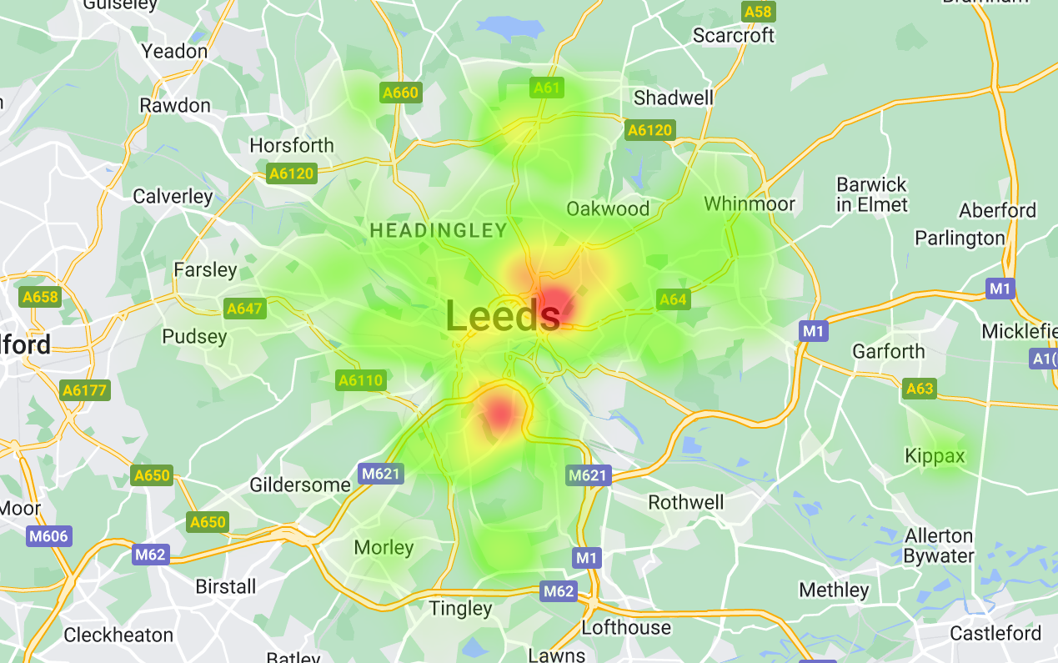

Half of the financial support was awarded to households with children: with the largest type of support provided being vouchers, with pension age disability and other households also mainly receiving vouchers. 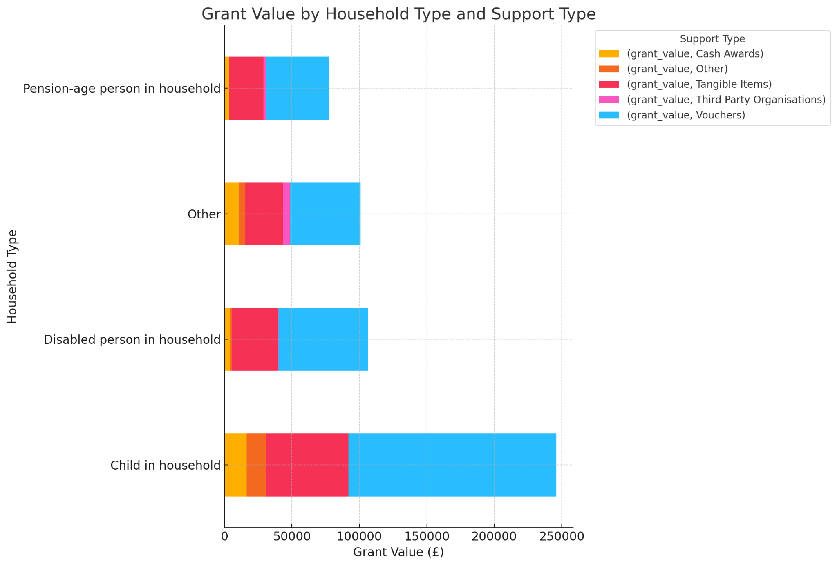

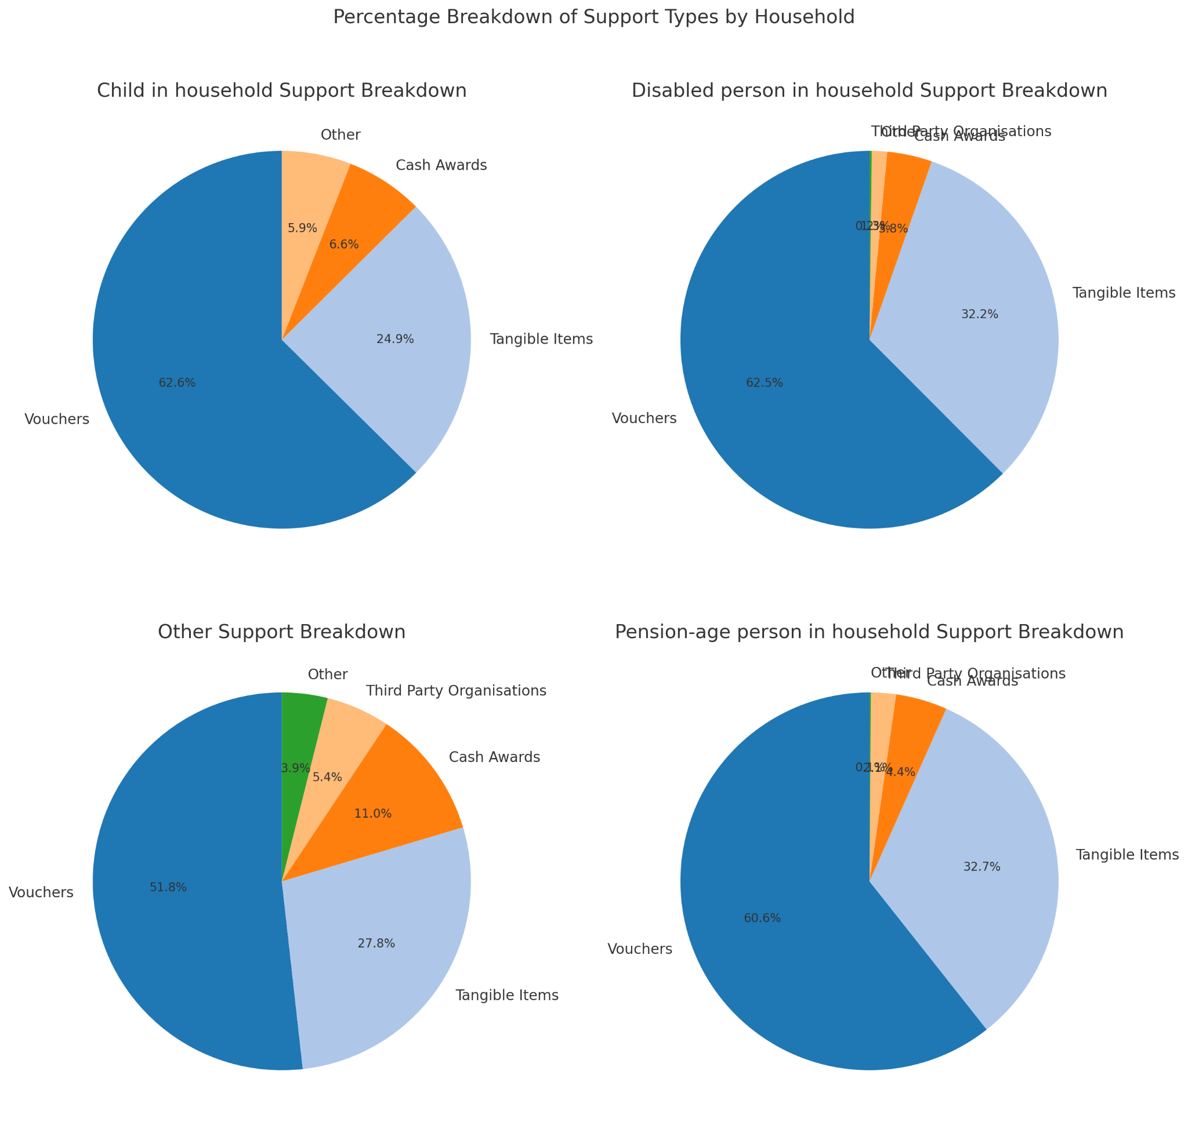

**Our figures evidence that a total of 9,799 awarded were given to households:**

| **Total volume of awards split by household composition** | | | | |
| --- | --- | --- | --- | --- |
| Households with children | Households with pensioners | Households with a disabled person | Other households | Total volume of awards (by household composition) |
| 4,542 | 1,605 | 1,128 | 2,524 | 9,799 |

| **Total volume of awards split by category** | | | | | | | |
| --- | --- | --- | --- | --- | --- | --- | --- |
| Food (excluding FSM support in the holidays) | Free School Meal support in the holidays | Energy and water | Essentials linked to energy and water | Wider essentials | Housing costs | Advice services | Total volume of awards (by category) |
| 7,911 | 34 | 691 | 123 | 903 | 137 | 0 | 9,799 |

**We asked all recipients to complete monitoring at the end of the grant, key feedback included:**

### What Worked Well

* Voucher systems were frequently mentioned as an effective method of providing immediate relief and maintaining dignity for recipients.
* Specific support for families and individuals in dire situations helped address immediate needs efficiently.
* Collaborative efforts with local community groups or services were able to build on previous relationships to provide additional community support.

### Challenges and Limitations

* Some efforts were less effective than hoped. For example, unexpected needs arose, such as the realisation that oil heaters could cause additional financial burdens.
* Increased sanctions and systemic issues hampered the effectiveness of the support.
* Increasing need from community members and that this emergency support is helpful but a short-term solution
* Administrative issues, such as delays in processing support or difficulty in reapplying for funding.
* The mismatch between the types of food available in hampers and the dietary needs or preferences of the recipients.

## Case Studies

Numerous stories were shared illustrating how the grants positively impacted individuals and families facing severe hardships, such as sanctions, lack of savings, and sudden crises. Stories provided often emphasised the emotional and practical impact of receiving timely help, like food vouchers or direct financial support.

“A single parent with four children recently faced significant financial distress when she was issued a utility bill of £1000, which she was unable to pay within the designated time frame. This brought about a decline in her mental health, and she sought advice and guidance to help her cope with the situation. Our organisation provided her with food vouchers which enabled her to allocate her own funds to pay a portion of the bill. Afterwards she agreed to pay the outstanding amount in instalments. Additionally we provided her with additional vouchers to purchase food for her family, as she had been struggling to meet their nutritional needs due to financial constraints. This assistance had a positive impact on her mental health and overall well-being.”

**Beetey Din**

“During a Stay Well This Winter drop-in session, a member attended the drop-in asking for help. They were scared to put the heating on at home due to cost and their house never went above 7 degrees. They had a disability and multiple health conditions. Our project manager signposted to some local support services including Greendoctor, and was also able to provide a £50 HSF supermarket voucher to alleviate some financial pressure and encouraged them to put the heating on to warm their house over the coldest days’.

**People in Action**

One family had already been struggling but an unexpected sudden death in the wider family put them under even greater strain. They were having to cope with the struggle of affording food, bereavement and supporting the wider family which resulted in additional expense. We were aware of their situation so delivered food and a voucher to them within a few days of their sad news. The mum said, "You guys don't know what this means to us. I knew Flourishing Families was gonna be there for us. I had nothing much in the cupboards and then you show up with food and a Tescos voucher. Thank you so much."

**Flourishing Families**

"We have a long term client that attended for a support appointment for an energy voucher via the grant program. Whilst at the appointment the support worker asked questions around the clients living situation, the client highlighted that they had not had a cooker for over a year and was mainly eating cereal. The client explained that they had a carer, who was aware of their lack of cooker and that they regularly use food banks, but could not cook the food they brought home. The team supported the client with a second grant for a cooker and raised the concerns as a safeguarding case with their provider, an investigation into the matter is underway."

**BHA Skyline**

"The Councillor referred a client in her 80's, who had COPD, no heating or hot water and was unable to fund a new Boiler and Green doctors advised that there would be an 8 week wait for funding. Asked if we could provide a heater. We bought and delivered a heater that evening and delivered a grocery shop the next day. We also topped up the electric metre with £60 pounds of credit to ensure she had sufficient energy to get her through the Christmas period. She appeared very grateful for the support that we had given."

**Leeds Irish Health and Homes**

### Case study from Imagine If theatre company

It is with great sadness that we have heard that Chesca Joy the CEO of Imagine If theatre company died on the 1st May 2024. Chesca was committed to supporting others, her compassionate and determined nature meant that she was able to support individuals with their immediate needs and provide hope for the future.

This is a case study Chesca provided to detail the great work she and the team provided utilising HSF funding (names changed):

“I met with Helen and her mum, Liz who have severe learning disabilities. They live together with Helen’s other young siblings and are struggling with some of their bills - rent, council tax, food, school uniform etc.

Liz ended up crying during our first meeting as she had been summoned to court by Leeds City Council due to the arrears she was in and she was extremely overwhelmed and confused at what she owed to which company and how she was going to pay it.

We worked with Helen and Liz over a three week period and offered them direct financial support with their bills and food, as well as practical support (going through their bills one by one with them and creating a spreadsheet with clear information for Helen and Liz to utilise) and emotional support.”

Liz said of our support: "It has helped me loads, especially being able to buy some shoes for my little boys means I'm not having sleepless nights anymore”. “The money has helped to lift weight off my shoulders as I am in a lot of debt. This has helped my mental health because I can now set up comfortable payment plans to maintain the rest of my debt”.

## Recommendations from grant holders:

* Longer-term funding commitment for HSF from central government to be distributed in grant form to community organisations, this would enhance stability and aid planning.
* Organisations highlighted that in future grants they would like the opportunity to seek to improve their monitoring and feedback mechanisms within the organisations to enhance the distribution and effectiveness of support.
* Further flexibility in the application processes for small groups and communities, such as applications via the telephone.
* Continued use of direct voucher systems for food which allow recipients to choose what they need most.

## The organisations involved in the distribution of grants:

1. Association of Blind Asians(ABA) Leeds
2. Age UK Leeds
3. All Community Connect CIC
4. Angels of Freedom
5. Angel of Youth
6. Ascendance Rep
7. BARCA
8. BHA Leeds Skyline
9. Basis Yorkshire
10. Beetey Din
11. Bridge Community Church
12. Chapeltown And Harehills Learning Project
13. CATCH Leeds
14. Crossgates and District Good Neighbours Scheme
15. Circles Of Life Voices Of Men
16. Circles Of Life Women Together
17. Complete Woman CIC
18. Calvary International Christian Centre
19. Canopy Housing
20. Care & Repair
21. Carers Leeds
22. Catholic Care
23. Chabad Lubavitch Leeds
24. Champions Community Sport and Health CIC
25. DASSI (SEN SUPPORT group for Black and Ethnically Diverse Mums)
26. Damasq
27. Disability Families Middleton
28. Eritrean Cultural Centre Leeds
29. Feel Good Factor
30. Flourishing Families Leeds
31. GGrassroots Enterprise for Social Inclusion and Poverty Relief
32. Getaway Girls
33. Getting Clean
34. Gipsil
35. Grandparents and Kinship support group
36. Health For All
37. Helping Hands UK
38. HOPE
39. Harehills Park Bowling Club
40. Hamwattan Centre
41. Happy Tears Foundation
42. Holbeck Moor FC
43. Home-Start Leeds
44. ISSE ltd
45. Imagine if theatre
46. Immolite Yorkshire CIC
47. Junior Sports Hub
48. KIPPAX Parish Council
49. Karma Dance CIC
50. Kidz Klub Leeds
51. LASSN - Leeds Asylum Seekers Support Network
52. Leeds Black Elders Association
53. Leeds Muslim Youth Forum
54. Leeds Grand Mosque Foodbank
55. Leeds Irish Health and Homes - LIHH
56. Leeds Jewish Welfare Board - LJWB
57. Leeds Sao Tome and Principe community group
58. Leeds Gate
59. Leeds Jewish Housing Association
60. Leeds Refugee Forum
61. Leeds Ukrainian community Association
62. Leeds Women's Aid
63. Light Up Black and African Heritage Calderdale
64. MHA Communities Horsforth
65. MHA Communities South Leeds
66. Morley Shed
67. New Wortley Community Association
68. Nigerian Yorkshire Communities Network UK CIC
69. Pafras
70. Paperworks (Harrogate) Limited
71. People In Action
72. People Matters
73. Pudsey Community Project
74. Reestablish
75. SARSVL
76. Sikh Elders Service
77. Shantona
78. SLATE
79. SLATE Charity Group
80. St Luke’s Cares
81. Sabhrang Health and Wellbeing Association
82. Soup & More
83. South Bank Sanctuary
84. St Paul's Ireland Wood
85. St Vincents Support Centre
86. Sunshine and Smiles
87. The Friendship Circle of Leeds
88. Delpha Alpha Delta (DAD)
89. The Gambia Welfare Society
90. The Market Place (Leeds)
91. Touchstone
92. URC Leeds
93. West Yorkshire Destitute Asylum Network - WYDAN
94. Women Arise
95. Women's Health Matters
96. Women's Whispers
97. Yorkshire and Humberside Maternity Stream of Sanctuary
98. Zarach
99. yum / Armley Action Team

## 