## International Day of Older People Image Reel: Photo Permission Form

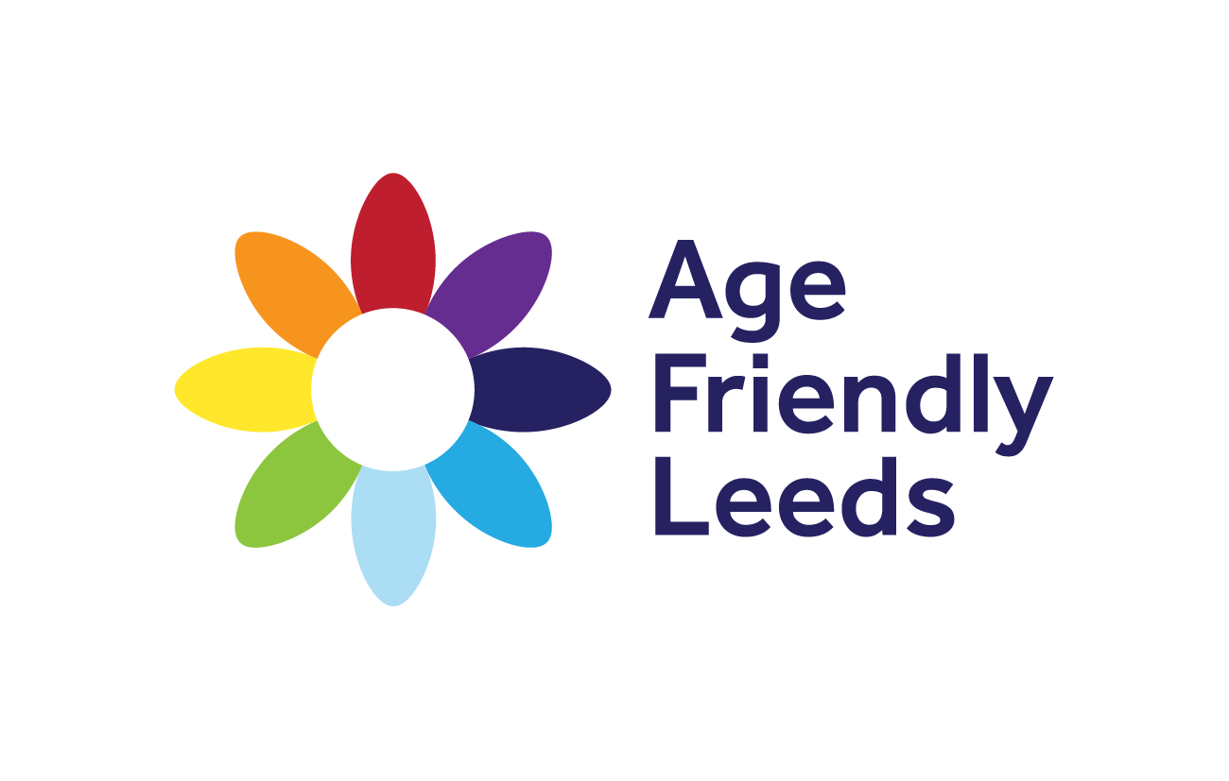

Thank you for agreeing to submit an image to the International Day of Older People Image Reel for the 1st October 2024. By filling in this form you are accepting that you are the owner of the image and have permissions by any persons included in the image to share at the event. The image will only be used on this reel and will not be used for any other purposes.

I consent for this/these images to be used at the International Day of Older People Image Reel on the 1st October at Headingley Stadium. The image will be used on a large screen display and will showcase dementia friendly work in Leeds .

**Name:**

**Project:**

**Signature:**

**Date:**

By signing this form, you agree: you will not expect or receive any payment from the image

If signing on behalf of a child or vulnerable person you confirm that you are their parent, legal guardian or authorised representative.

**Your rights**

You can ask Friendly Communities to not use the image up until the 23rd September and we will omit the image from the reel shown on the 1st October. We cannot guarantee we will have time to remove the image after this point.

**Contact details**

Elizabeth Griffin, Friendly Communities Officer

Leeds Older People’s Forum, 24C Josephs Well, Hanover Walk, Leeds LS3 1A

0113 244 1697

07871371819

elizabeth@opforum.org.uk