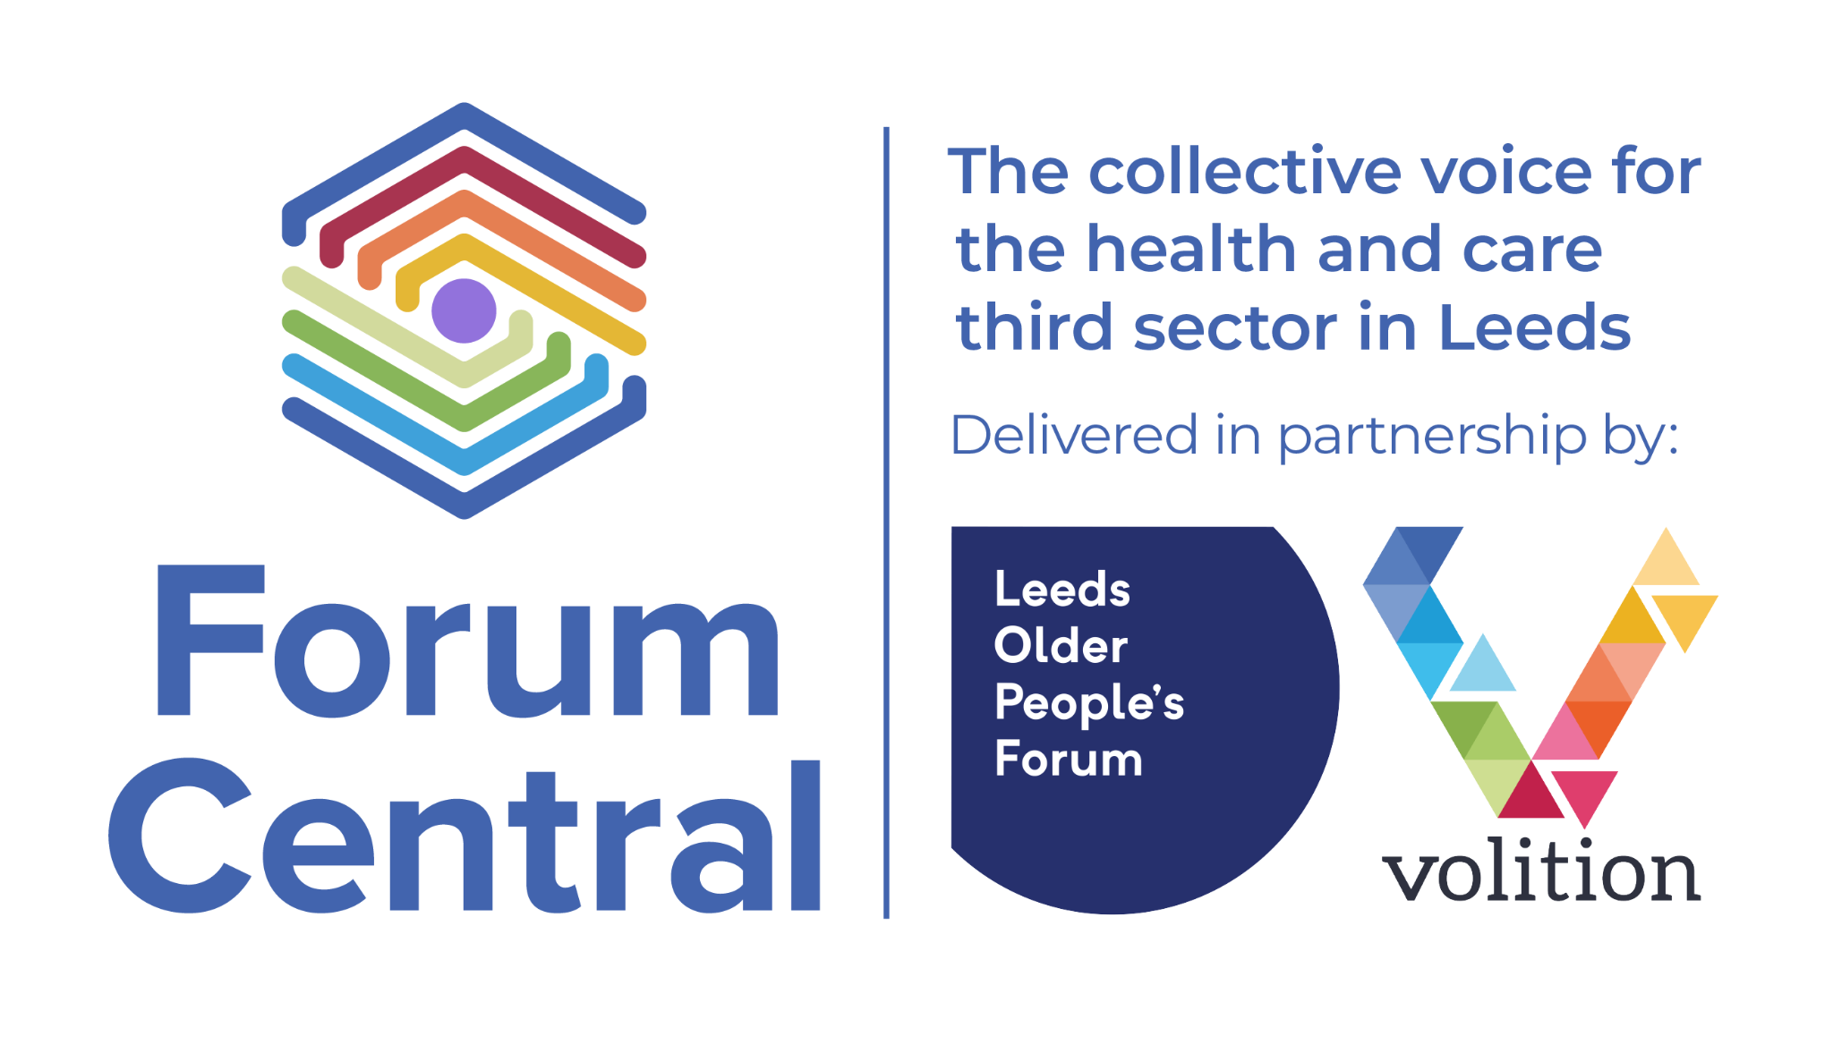

**Household Support Fund Leeds - cost of living grants**

The Household Support Fund (HSF) is a Central Government fund. Forum Central is administering grants for groups and organisations to distribute to the people they support, particularly communities including cultural diversity, mental health, young people, learning disabilities, physical and sensory impairment and older people.

Funding is distributed to organisations through grants of up to **£5,000** and is targeted at households in Leeds. We particularly welcome applications from small groups and organisations who wish to apply for less than £1,000.

Alongside Leeds Community Anchor Network and Leeds Food Aid Network Forum Central is distributing HSF funding to third sector partners to enable this support to reach those most vulnerable. The funding has to be used to support people who are facing hardship to have access to fuel and food.

**Which individuals are eligible for support?**

Government guidance states “*The Fund should be used to support households in the most need; particularly those who may not be eligible for the other support*”

It is to be aimed at a wide range of low income households in need “*including families with children of all ages, pensioners, unpaid carers, care leavers and disabled* people”.

The guidance also states that this funding can be used to provide ‘*a basic safety net to individuals regardless of their immigration status’*, so those with no recourse to public funds are officially able to access funding.

The funds administered by Forum Central aims to provide much needed support to individuals through community groups.

**Application process**

Third sector organisations in Leeds can apply for funding. We encourage applications from smaller and grassroots organisations including faith organisations.

The HSF7 grants round opens on Tuesday 27th May 2025 and **closes at 5 pm on Tuesday 24 June 2025.** Applications will be assessed in mid-July.

A second round of HSF7 funding will open in September and close in October 2025.

If your organisation received funding in July 2025 you are eligible to apply for the second round of funding in September provided you have allocated all the money to households and successfully completed your monitoring return by the application deadline.

**How to apply**

After reviewing suggestions from delivery partners in previous rounds we created a range of ways that groups and organisations can apply for a grant.

**Online:** To complete a short online application form please [click this link to take you to the Household Support Fund grant application page](https://form.jotform.com/LOPF/household-support-fund-application).

**Email:** Download the application form to your computer, type your answers, save it and email it to [grants@forumcentral.org.uk](mailto:grants@forumcentral.org.uk)

**Post:** Download the application form, print it, handwrite your answers and post to:

Grants team, Forum Central, Suite E1 Joseph’s Well, Hanover Walk, Leeds LS3 1AB

**Voice recorder:** Read the questions on the application form and speak your answers into a voice recorder app on your smartphone, then email this audio file to [grants@forumcentral.org.uk](mailto:grants@forumcentral.org.uk)

**Telephone:** Call Jenni at Forum Central on 07536 416 402 before the closing date to request a printed copy of the application form and guidance notes. Alternatively, ask Jenni to book an appointment slot so that someone from Forum Central can call you back to complete your application form over the phone.

If you are awarded funding, we will send you a grant agreement form which must be signed and returned back to us in order for us to release funds.

The fund will run until the end of March 2026 and all funding must be allocated by Friday 20 March 2026.

**Who else is delivering the fund in my area?**

We will share a list with all organisations who have received the grant including those supported by Leeds Food Aid Network and Leeds Community Anchor Network and are also working with the Local Care Partnerships team. We will consider delivery by ward or area order, though some will cover more than one ward. There will undoubtedly be a crossover between communities of interest and communities of place but we aim to ensure that delivery on a local level will complement provision city-wide.

**What can it be spent on?**

Your group doesn't need to be constituted but if your application is successful the funding must be paid into an organisation’s bank account, not an individual person’s bank account.

The funding can be used to help people with fuel costs and/or provide food or food vouchers. The grant can also be spent on other wider essentials and essential items including energy saving goods, housing costs and travel in exceptional circumstances.

Because additional funding has been allocated to the Food Aid Network and the Community Anchor Network, Forum Central will prioritise funding which supports people with issues of fuel poverty.

**How much can we claim for our overheads?**

The official government guidance states that ‘reasonable cost’ should be taken for overheads. Leeds City Council has asked that that overheads of groups and organisations must be below 15% of the amount requested.

**What are the monitoring requirements?**

You will be expected to return the monitoring by **Friday 27 March 2026.**

You will need to provide Forum Central with a brief end of grant monitoring report and a completed spreadsheet which records how and where the funding was spent. A template will be provided. We request that this monitoring is submitted as soon as possible after all funds have been allocated to households - there is no need to wait until the deadline.

Your completed monitoring spreadsheet must add up to the total value of the grant and evidence the expenditure of the grant per household.

The monitoring spreadsheet records the following information:

* Overall spend
* Categories of types of support (Food, fuel, wider essentials etc.)
* Household composition of beneficiaries (Household with children/with pensioners/ disabled people/other)

The end of grant monitoring report is a very short online form which asks for a brief overview of the way in which you distributed the grants and for you to upload your completed monitoring spreadsheet. There is also space for you to share a brief story, case study or quote to tell Forum Central about the difference that HSF funding made to a household you support. This is, however, optional. The most important part of the monitoring return is an accurately completed spreadsheet as this enables Forum Central to report to Leeds City Council.

This is trust-based funding, awarded on the basis you are best placed to meet the needs of the communities you work with. No further proof of spend will be requested, but you are expected to maintain a record as would be required via your own internal processes.

If you have any questions about the grant application process please email [grants@forumcentral.org.uk](mailto:grants@forumcentral.org.uk) or call 07536 416 402. To read the [Household Support Fund Impact Report please visit the Forum Central website](https://forumcentral.org.uk/household-support-fund-forum-central-impact-report/).