**International Day of Disabled People 2024**

# Evaluation Report

Published May 2025. V4.

(Word document version with photos and appendix)

## collage of photos from IDODP 2024 featuring performers, speakers and stallholders.

Photo Credit: Cheryl Ferris-Stewart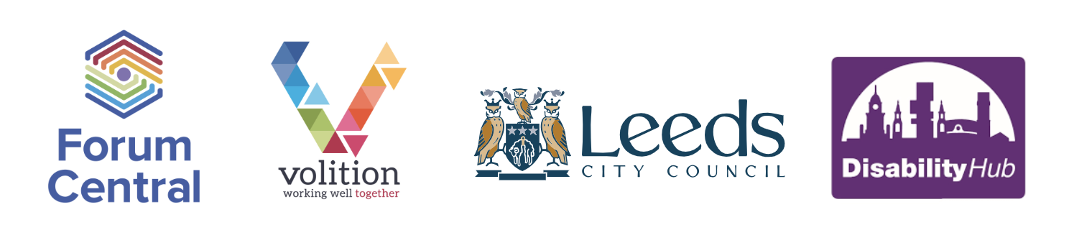

# Contents

**Page 2 Background**

**Page 2 Executive Summary**

Event Summary

Coordination

**Page 6 Event Preparation and Delivery**

Stallholder Information

Accessibility

Further considerations

Communications and Marketing

**Page 12 The Marketplace Event Activity**

Stalls and Interactive stalls

Wishing Tree

Guest Speakers

Art Zone

Quiet Sensory Room

**Page 9 Feedback**

Quantitative data

Qualitative data

**Page 25 In Conclusion**

Recommendations

Reflexive Statements

#### 

#### Appendices

**Page 28 Appendix 1** - Leeds for All logo

**Page 28 Appendix 2** – Stallholder Information Pack (Layout, flyer, programme, Stallholder Summary)

**Page 38 Appendix 3** – Easy Read Programme

**Page 39 Appendix 4** – Press Release

**Page 40 Appendix 5** - Promotional graphics

**Page 42 Appendix 6** – Illustrations (from 2023)

**Page 43 Appendix 7** – Feedback Form - document and digital form

# Background

International Day of Disabled People (IDODP) is a Global Day of Recognition created by The United Nations which takes place every year on 3 December. The annual observance of this day aims to promote an understanding of disability issues and mobilise support for dignity, rights and wellbeing of disabled people.

It was launched in 2019 to coincide with the [United Nations Disability Inclusion Strategy](https://www.un.org/en/content/disabilitystrategy/) that came into being in June that year.

[IDODP](https://disabilityunit.blog.gov.uk/2020/12/03/international-day-of-people-with-disabilities/) is recognised by the British Government as an important part of our UK Disability Policy, although the role of Minister of State for Disabled People, Health and Work no longer exists. The appropriate role is now held by Rt Hon Sir Stephen Timms MP and is the current Minister of State for Social Security and Disability. The principles of IDODP are Celebration, Learning, Optimism and Action.

Since 2019, Forum Central has worked in partnership with The Disability Hub at Leeds City Council to host the ‘Leeds for All – International Day of Disabled People’. 2024 saw the event being hosted for its 6th year.

You can read more about the [history of Leeds for All on our website](https://forumcentral.org.uk/international-day-of-disabled-people-leeds-for-all/).

**The theme for 2024 was ‘Advocating for Accessibility’.**

*“International Day of Disabled People is a really lively event, and it is wonderful to see people with learning disabilities, carers, and people working in the sector coming together to share good practice and have fun! I always meet new people when attending and this has led to exciting new collaborations and projects. The event is well organised and feels really inclusive and friendly.”* – Nicky Lines, Pyramid of Arts.

# Executive Summary

An overall figure of approximately 520 people attended the IDODP Celebrations Day on Tuesday 3 December 2024, not discounting the stallholders and their volunteers. A wide variety of people attended with different lived experiences from those with learning disabilities, physical and sensory impairments and autistic people, plus organisations which support these communities and individuals. It was a great success.

The event was opened by the following guest speakers: The Lord Mayor of Leeds - Abigail Marshall Katung, Councillor Kevin Ritchie - Lead Member for Disability at Leeds City Council, Rob Moriarty - Businessman, Entrepreneur and Self Advocate, Anne Marie Davies - Volunteer and Advocate.

The marketplace hosted 27 stallholders, which were local organisations, in the Brodrick Hall, as well as various performances coordinated by People in Action: 7 Singers, Dance, Rap, and Performance Poetry. Leeds Older People’s Forum were also present, hosting a stall on ‘Let's Talk Transport’ an opportunity for discussion hosted by Travel Connections at Leeds Older People's Forum. BSL interpreters were available throughout the day in the marketplace.

There was also an Art Zone hosted by Pyramid of Arts that saw 72 people attend. Leeds Autism Services also hosted a quiet sensory room that had 40 people make use of this calming space.

We had a Wishing Tree in the main room where people could write comments about what they ‘wished’ to see change in Leeds in 2025. These statements are listed on page 16 of this report and cover a wide range of themes.

People were welcomed to join the day and make new connections, meet up with friends, share ideas and celebrate!

IDODP continues to promote the ambitions of the Better Lives Strategy to *‘support every person to live in a place they call home with people and things they love, in communities that look out for one another, doing the things they love’.* Without advocacy and self-advocacy, many historical disability rights movements would not have taken place. IDODP provides a space for community engagement, collaboration and innovation, sparking initiatives that can ensure people’s voices are heard and influence change.

[Watch the short video of IDODP 2024 highlights on YouTube](https://youtube.com/shorts/aVIihHu-5rg).

#### Partnership in Practice

It is with gratitude that we give thanks to all who work in our partnership to make this event a success each year. The IDODP event is run in partnership under the brand name ‘Leeds for All’. It includes Forum Central, Leeds City Council Equality Team, Forum Central members, and the IDODP Reference Group.

The annual IDODP Marketplace Event has a large reach and is an important place outside of The Disability Hub meetings where direct engagement can happen between the Council’s Equality Team and disabled people. The Disability Hub works with organisations and speaks directly with disabled people to get their views on how the Council can keep moving towards making Leeds a more inclusive city across all aspects of their services.

IDODP promotes and supports the work of VCSE and Third Sector organisations, facilitating such key annual events is a priority of the Equality team and something which they seek to do across all protected characteristics. IDODP also promotes the ambitions of key Leeds City Council strategies such as the Best City Ambition, Better Lives Strategy, and increases public awareness of contributions by Leeds City Council to the city’s disabled support infrastructure.

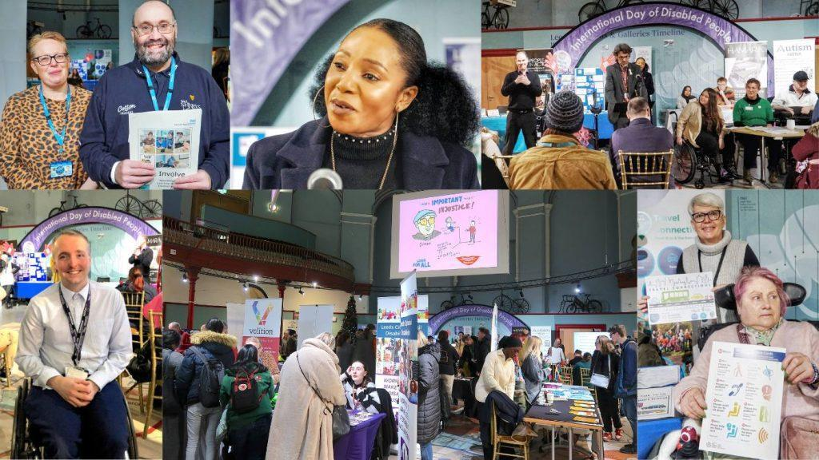

**Co-Production and Advocating for Accessibility**

The ethos of the Leeds for All team and Reference Group in 2024 was to advocate for accessibility. Co-design was central to our project planning and while we feel this improves year on year, there is always more that we can learn and so seek to continue to make improvements for future IDODP events.

## Event Summary: IDODP 2024 ‘Advocating for Accessibility’

This was the sixth IDODP event, which is now a well-established programme, held annually at Leeds City Museum. Based on feedback from 2023, we chose to change the room layout slightly so that fewer stallholders shared tables, making use of more table space and keeping more free space to move between stalls so people could visit stallholders more easily. Feedback also showed that people enjoyed hands-on activities in 2023 so we chose to include an Art Zone, which hosted various activities people could get involved in throughout the day. 2023 also saw the introduction of a quiet sensory room and this was kept for 2024’s event, as the room was well utilised and had positive feedback. The sensory room was hosted by Leeds Autism Services again with some equipment provided by Leeds City Museum.

People were free to attend IDODP for as long or little as they liked, giving it the feel of a ‘drop in’. People used the space for networking, socialising and learning about new organisations. Each year, we seek to take an intersectional approach, ensuring that our event is as diverse as the communities we work with, this proves to be one of the highlights that is enjoyed by most attendees but can cause some challenges in organising a big event in one main room.

## Coordination of the Event

#### Leeds City Council Contributions

The Council kindly organise the booking of the venue each year and also the booking of the BSL interpreters who are so important to the smooth running of the day for the deaf community who are both stallholders and attendees.

This year we also experimented with a rolling script on a large screen at the back of the Brodrick Hall, next to the BSL interpreters for those who do not use BSL and/or do not lip read. This script was kindly run by the Equality Team with museum tech to help us cover speeches and lyrics from the performers’ songs.

#### Forum Central Contributions

Volition - Forum Central oversaw project management, planning, administration, design and coordination, promotion and marketing of the IDODP event.

#### The Disability Hub Contributions

The Disability Hub is one of Leeds City Council’s Equality Hubs. It supports the Council’s engagement with a wide range of Leeds citizens so they can feed into decision making. Leeds City Council’s Equality Team staff members contributed to the preparations and promotion of the event, as well as offering support on the day.

# Event Preparation and Delivery

**Reference Group**

The Leeds for All team recruited volunteers to become part of the Reference Group, by inviting a range of organisations, each with a focus on a different impairment or condition. Reference group meetings took place once a month from August to November, for 1-2 hours.

The Reference Group had 8 members made up of third sector organisations and Leeds City Council representatives:

* Leeds City Council – Access, Equality, and Special Services Departments
* Leeds Autism Services
* Leeds CIL (Leeds Centre for Integrated Living)
* DeafEXperience (DEX)
* REMAP
* People in Action
* Harehills Park Bowling Club
* Volition, Forum Central.

Reference Group members contributed their ideas on activities, performers, room layout, accessibility and helped to promote the event. IDODP utilises a cross-sector and pan-disability approach with organisations representing support and activities, offered by and for people with both visible and invisible disabilities, people with learning disabilities and/or autistic people.

## Stallholder Information

#### 

#### Stallholder Virtual Information Session

An information session for stall holders was held 18 days before the event so that information regarding the room layout, arrival/departure times and other necessary information could be given to those hosting stalls on the day. It included a Q&A session where stallholders could clarify anything they needed to, this resulted in a problem free set up and smooth running of the marketplace on the day. 12 stallholders attended the briefing session.

#### Stallholder Information Pack (Appendix 2)

The stallholder information pack was emailed to all stallholders following the information session. They were also asked if they would promote our event using the materials provided in the pack. It included the following documents:

* Brodrick Hall Stalls layout
* Promotional materials - flyer / poster
* Programme
* YouTube Access Video
* Stallholder Summary

## Accessibility

#### 

#### Venue Access Tour Video

Following the positive feedback around last year’s accessibility video, we created an updated version for the 2024 event. The Volition - Forum Central team and a volunteer from Leeds Autism Services visited Leeds City Museum on a quiet day to create the accessibility video with captions. The video shows where the various entry and exit points were to the building, where activities would be located, how to use the lift, and where accessible and changing places toilets were located.

The video can be viewed on YouTube: [IDODP 2024 Access Tour of Leeds City Museum](https://youtu.be/n0KwN-WQqsU). It received 81 views and 1 like (as of March 2025). Although the previous year’s view count was higher (153), we still had positive feedback and it is something we will look to continue to produce in future.

This was an important communications aid for people before the event - it set expectations, gave information about the event and its timings and the accessibility of the venue. We know from feedback that videos like this help ease anxieties because it shows people exactly what to expect on the day, and gives a visual guide of the layout, which especially helps anyone who struggles with theory of mind.

The video was also shared on social media, LinkedIn and Facebook, which received high engagement. Receiving 127 impressions, 141 views and 5 clicks, with an engagement rate of 3.94%.

#### 

#### Sight Guides

Forum Central held a training session prior to the 2023 event ensuring sight guides were available. At the 2024 event, we continued to have sight guides, but due to staff changes, we will now be looking at ensuring more staff are trained to be sight guides. All staff members and volunteers of the IDODP event had attended an in-house information session and a health and safety talk at Forum Central as part of their training.

As a follow up, Forum Central staff also attended a refresher RNIB Visual Awareness course in March 2025 and a similar deaf awareness session by DEX and Leeds Society for Deaf and Blind People is also planned for summer 2025.

**The Quiet Sensory Room**

The quiet sensory room was hosted in The Denny Room. The room featured sensory items such as colour changing boxes, a light bubbler, beanbags and promoted a calming environment. Leeds Autism Services provided some of the equipment for the room and also offered their skills, to support anyone on the day if they needed any help or someone to speak to. The Leeds City Museum also provided some of the equipment for the quiet sensory room. It is with thanks to these organisations for creating a calming space.

#### 

#### BSL Interpreters

The 2024 marketplace event and activities had 2 interpreters from Leeds City Council who provided support for the Opening Speeches and for any individual requests in support for networking. The BSL Interpreters were identified to people at the start of the event and were visible throughout the day to support the deaf community.

#### Welcome table with Programmes: Easy Read and plain text document (on coloured background).

An Easy Read Programme was produced and shared to give an overview of what was happening at the event, including who the speakers were and where and when activities were taking place. Hardcopies of the Easy Read Programme were available for attendees who needed them at the joint Forum Central and Leeds Disability Hub Welcome Table. We also provided handouts and leaflets from disability led organisations on health, transport, and employment initiatives.

* [Programme IDODP 2024 word document (link to google docs)](https://docs.google.com/document/d/1-WSSjkZLFkV_x0qwe8Z-QgIyvikQcxr6/edit?usp=sharing&ouid=105181143019795271484&rtpof=true&sd=true) (file can be downloaded as a Microsoft Word document)
* [Easy Read programme IDODP 2024 V2 (PDF 6MB)](https://forumcentral.org.uk/wp-content/uploads/2024/10/Easy-read-programme-IDODP-2024-V2.pdf)

## Further Considerations

#### Risk Assessment

A thorough risk assessment of all activities and stall holders was collated for the museum, which clarified to organisers details of the layout in the main hall and illustrated what stallholders were intending to do on the day.

**Room Layout – Map**

There were 3 large scale A3 printouts of the Brodrick Hall layout (appendix 2a) showing where each organisation’s stall was located for people to refer to.

#### Feedback Post box

A red and gold post box (cardboard) was placed by the Forum Central Welcome Table in Brodrick Hall and captured valuable feedback from attendees. We asked what people thought about the day, its activities, their interactions with organisations and if the event had inspired them or influenced them to connect with new organisations. People who attended were also asked if the event inspired or enabled them to try something new to add to their daily routines or changed their outlook on improving their wellbeing advocacy knowledge, skills and social connections.

Further information about feedback from the event can be found in the data analysis section of this report.

#### Signage

The museum is a multi-level venue with steps and every attempt was made to make accessing the different activities in the museum as easy as possible. Large arrows and directions were posted at strategic points and museum Visitor Assistants and Forum Central Volunteer Staff were located along corridors, at entry and exit points, on lower-level floors and in the main hall.

## Communications and Marketing

**Brand Development**

2024 IDODP branding was largely kept the same for consistency, and only slight changes were made to show the difference in theme. For example, the inclusion of a purple banner on the posters title. The branding has continued to see the continuation of the teal colour, as it's a combination of the Forum Central specialism colours of cyan for Learning Disability and green for Physical Sensory Impairment (PSI) this reflects the cross-specialism approach of this event. It is also part of Leeds City Council’s colour palette.

#### 

#### Promotion

The event was promoted widely by Forum Central and Leeds Disability Hub through direct email, online via social media (Facebook, LinkedIn and X (formerly Twitter) and on the websites of Forum Central, Doing Good Leeds, Eventbrite, [Leeds Inspired](https://www.leedsinspired.co.uk/events/international-day-disabled-people-marketplace-2024) and Leeds City Museum. Posters were displayed at venues and workplaces around the city centre. The Forum Central team shared IDODP updates by direct email, word of mouth at Network Meetings and with external contacts, as did the Disability Hub at the Council. Stallholder organisations were also encouraged to promote the event to their service users, volunteers and people they support and work with.

The official and community guest speakers, performers and activities were a fantastic promotional tool and are continually highlighted as key reasons for people to attend the IDODP event.

This event brings organisations, members of the public, partners, commissioners and funders together as a leading community event and was promoted as such.

The following was produced and shared as part of a communications plan:

* Press release (*appendix 4*) circulated to local and regional media contacts.
* Double sided flyer/poster printed as A5, A4 and A3 (*appendix 2b*) and taken to key, relevant locations around the city, for example day centres, and it was available for organisations to download for display in their offices and venues.
* Social media graphic of the poster.
* A short promo video collating images from last year’s event and highlighting reasons to come along. (screenshots, *appendix 5*)
* Email signature (*appendix 5*) added to all Forum Central staff members' email signatures to ensure the event's recognition by member and partner organisations.

**Facebook Activity**

Several posts were shared on facebook about the event, on the Forum Central account and from stall holders, and afterwards, notably, from Councillor Kevin Ritchie. The ‘Happy IDODP’ post on the day reached approx 1.8k accounts and received 18 interactions (likes and shares) - this is one of our most highest reaching posts to date.

The main promotional post in the lead up was shared one month before the event and was the poster and link to the event page on our Forum Central’s website, this received 771 views, and 8 interactions.

A short [IDODP promo video](https://fb.watch/zsj9Fx7g-F/) featuring photos from last year’s event was created as a promotional tool which received 1,892 views and 30 interactions (likes, shares, comments). The access tour video was also shared but didn’t receive as much engagement with a reach of just 54 and 4 interactions.

**X Activity**

X (formerly Twitter) was a core social media channel for Forum Central (@MyForumCentral) at the time of the event but we have since moved away from X due to the negativity on the platform and its owner and our audience moving away from there. Our audience there consisted of mainly third sector organisations and statutory partners.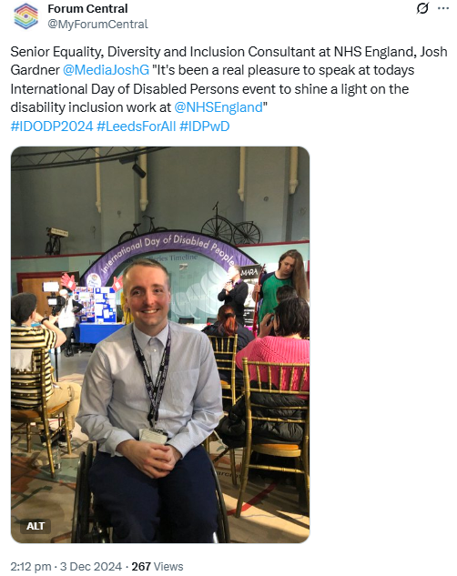

We pinned a post about the IDODP event on 8 November which linked to the press release on the Yorkshire Evening Post but this only received 107 views, 4 likes and 1 repost. The Leeds Disability Hub (@leeds_hub) was not posting on X account at the time of promotion or the event.

We made 3 posts on the day showcasing the event. These received a combined total of 964 views, 52 likes and 15 reposts. These included photos of the event and quotes from attendees:

“Senior Equality, Diversity and Inclusion Consultant at NHS England, Josh Gardner @MediaJoshG "It's been a real pleasure to speak at today's International Day of Disabled Persons event to shine a light on the disability inclusion work at @NHSEngland”

“Executive Member for Equality, Health and Wellbeing at Leeds City Council, Councillor @FionaVenner "It's wonderful to see such a diversity of organisations, performers with disabilities and the event being led by people with disabilities."

**LinkedIn Activity**

We shared four IDODP posts on LinkedIn between November to December and once in September to share that stall applications were open.

The post on the day of the event and marking the awareness day itself “Happy International Day of Disabled People 2024!” received the highest engagement with 284 impressions and 46 clicks, giving it an engagement rate of 16.2% (3.5% as a benchmark is considered good). The main post announcing the event in November received a high number of impressions:277 but only 8 clicks, engagement rate for The Access Tour video received 127 impressions, 141 views and 5 clicks, with an engagement rate of 3.94%.

**Instagram Activity**

The poster and short [IDODP reel](https://www.instagram.com/p/DC85zhuq-HR/) were the main promotional posts leading up to the event. The video reached of 214 accounts (bearing in mind we had approx 300 followers) and received 14 interactions.

On the day we shared ten instagram stories of videos: 6 of the performances and 4 from the art zone. It was great to be able to have this immediate outlet for publishing what was happening at the event. These stories were each viewed between 42 and 28 times.

# The Marketplace Event Activity

“A huge thank you to everyone who made this event possible, the organisers, volunteers, speakers, performers, the 26+ organisations, and all who attended. Your dedication and hard work made it a meaningful and fun day for many in different ways. The rise in attendance from 380 in 2023 to over 520 in 2024 shows the growing impact and demand for events like this. The personal stories shared were a powerful reminder of the ongoing work needed to achieve true equity, equality, and accessibility for all. For me it’s great to see how, together, we are doing our best to support, empower, and enable disabled people in Leeds.”

*Councillor Kevin Ritchie – Councillor for Bramley & Stanningley Ward and Lead Member for Disability at Leeds City Council.*

#### Stalls

The Marketplace had 27 stallholder organisations from the VCSE sector and public sectors. A full list of stallholders and information about their organisations can be found in appendix 2d. The demand from organisations requesting stalls was high, as it is every year, and we had to operate a waiting list. There were 8 organisations on the waiting list, but very pleasantly, no organisations dropped out on the day of the event. The range of organisations ensured various disabilities could be represented and provided a variety of engagement opportunities, which gave a ‘good buzz’ to the Marketplace and ensured it was well attended throughout the day. An extra 200 people attended in comparison to 2023.

Stalls were planned out around Brodrick Hall with groupings of learning disability, autism and physical and sensory impairment themes to make the hall more accessible and to make it easier for individuals and organisations to network and find information. As a result, many conversations took place, possible new partnerships were made and people found new services they wanted to attend. People were able to meet and share useful information about services, activities, groups, and support options that their organisations offer.

#### 

#### Interactive Stalls

This year’s theme was Advocating for Accessibility. Some stallholders provided opportunities for discussion or other table-top activities. See examples below:

Leeds Older People’s Forum hosted a stall to focus on their Travel Connections project, which seeks to boost confidence of those who are struggling to travel independently. The project helps people to take a journey they want to be able to do themselves, whether that’s by foot, by bus or by taxi. Many disabled people raise concerns around travel and its inaccessibility, so an interactive stall was hosted to gather feedback from people and use this to continue to advocate for much needed changes, to make travel more accessible for disabled people.

There were many other interactive stalls on the day, two examples are RNIB showcasing their Interactive Visual Awareness Kits and Experience Community CIC showcasing their fleet of mobility equipment, including but not limited to, off-road wheelchairs, adapted cycles and much more.

#### Illustrations

At the 2023 IDODP event, we were lucky to have Tom Bailey, a Leeds artist, sketch 14 cartoons about the aims and wishes of people with lived experience, he asked individuals the question: ‘What is important to you?’. The illustrations were popular and well received, therefore we decided to project these illustrations again at the 2024 event as large-scale visuals on the 3 ceiling mounted screens in the Brodrick Hall Marketplace.

For all of Tom’s illustrations, see appendix 6.

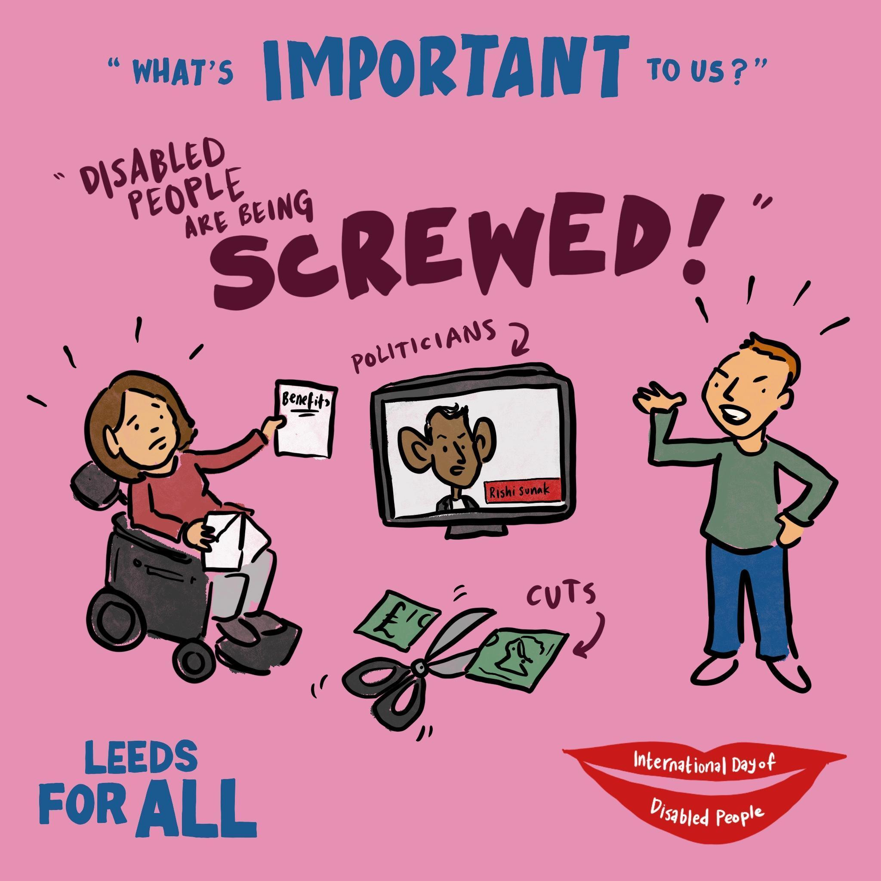

The sketches will continue to be used in further events publicity and campaign work. Unfortunately, the sketches weren’t accessible to people with visual impairments at the event. Another action for future events is to make any visuals accessible by audio means.

If you are interested in using these illustrations for your work, please contact: hello@forumcentral.org.uk.

#### Wishing Tree

A table was set up with a ‘wishing tree’ which people could contribute their thoughts and wishes for the future of Leeds, in the context of this event.

#### Statements from the Wishing Tree:

* Authority corruption free.
* More partnership and better communications from Leeds City Council.
* Secure Funding.
* More events linked to IDODP event to make disabled people feel more included and heard – events where a range of people can participate.
* More accessibility and more safe spaces.
* Accessible pavements everywhere.
* Better transport links around Leeds and cheaper train fares – less card only services in places.
* Less roadworks.
* More transport accessibility for people.
* Spread more awareness about how to accommodate people with disabilities – how to make areas less overstimulating.
* Designated quiet spaces around the city centre.
* Doctors to listen more and understand reasonable adjustments.
* More people learn to sign so deaf community can be included more.
* Free BSL giving chance for people in Leeds to learn BSL and more use of basic BSL signs like ‘Hello’ and ‘Thank You’.
* More respect for disabled people.
* People treated as all people should be – listened to and wishes honoured.
* Listen, Learn and Take Action!

#### Guest Speakers

The event was officially opened by a very well received speech from the Lord Mayor of Leeds, Abigail Marshall Katung and Councillor Kevin Ritchie, Lead Member for Disability at Leeds City Council.

The event also had two community based motivational guest speakers with lived experience of physical disabilities who had championed themselves advocates for accessibility. They were Rob Moriarty, Businessman, Entrepreneur and Self Advocate, Anne Marie Davies, Volunteer and Advocate.

#### Art Zone

The Art Zone was held in a large downstairs room in the Museum called the Thoresby Room and included a drop-in session run by local organisation Pyramid of Arts who specialise in facilitating all things arty and creative. The Art Zone saw 72 people attend throughout the day.

The activities were designed to be accessible for disabled people, and they were popular and well attended. Anyone could attend the sessions throughout the day, for as long or as little time as they liked. The only stipulation being that if you normally had a PA attend class with you then people were asked to do the same for the activities at IDODP. People were notified of this in advance which worked well.

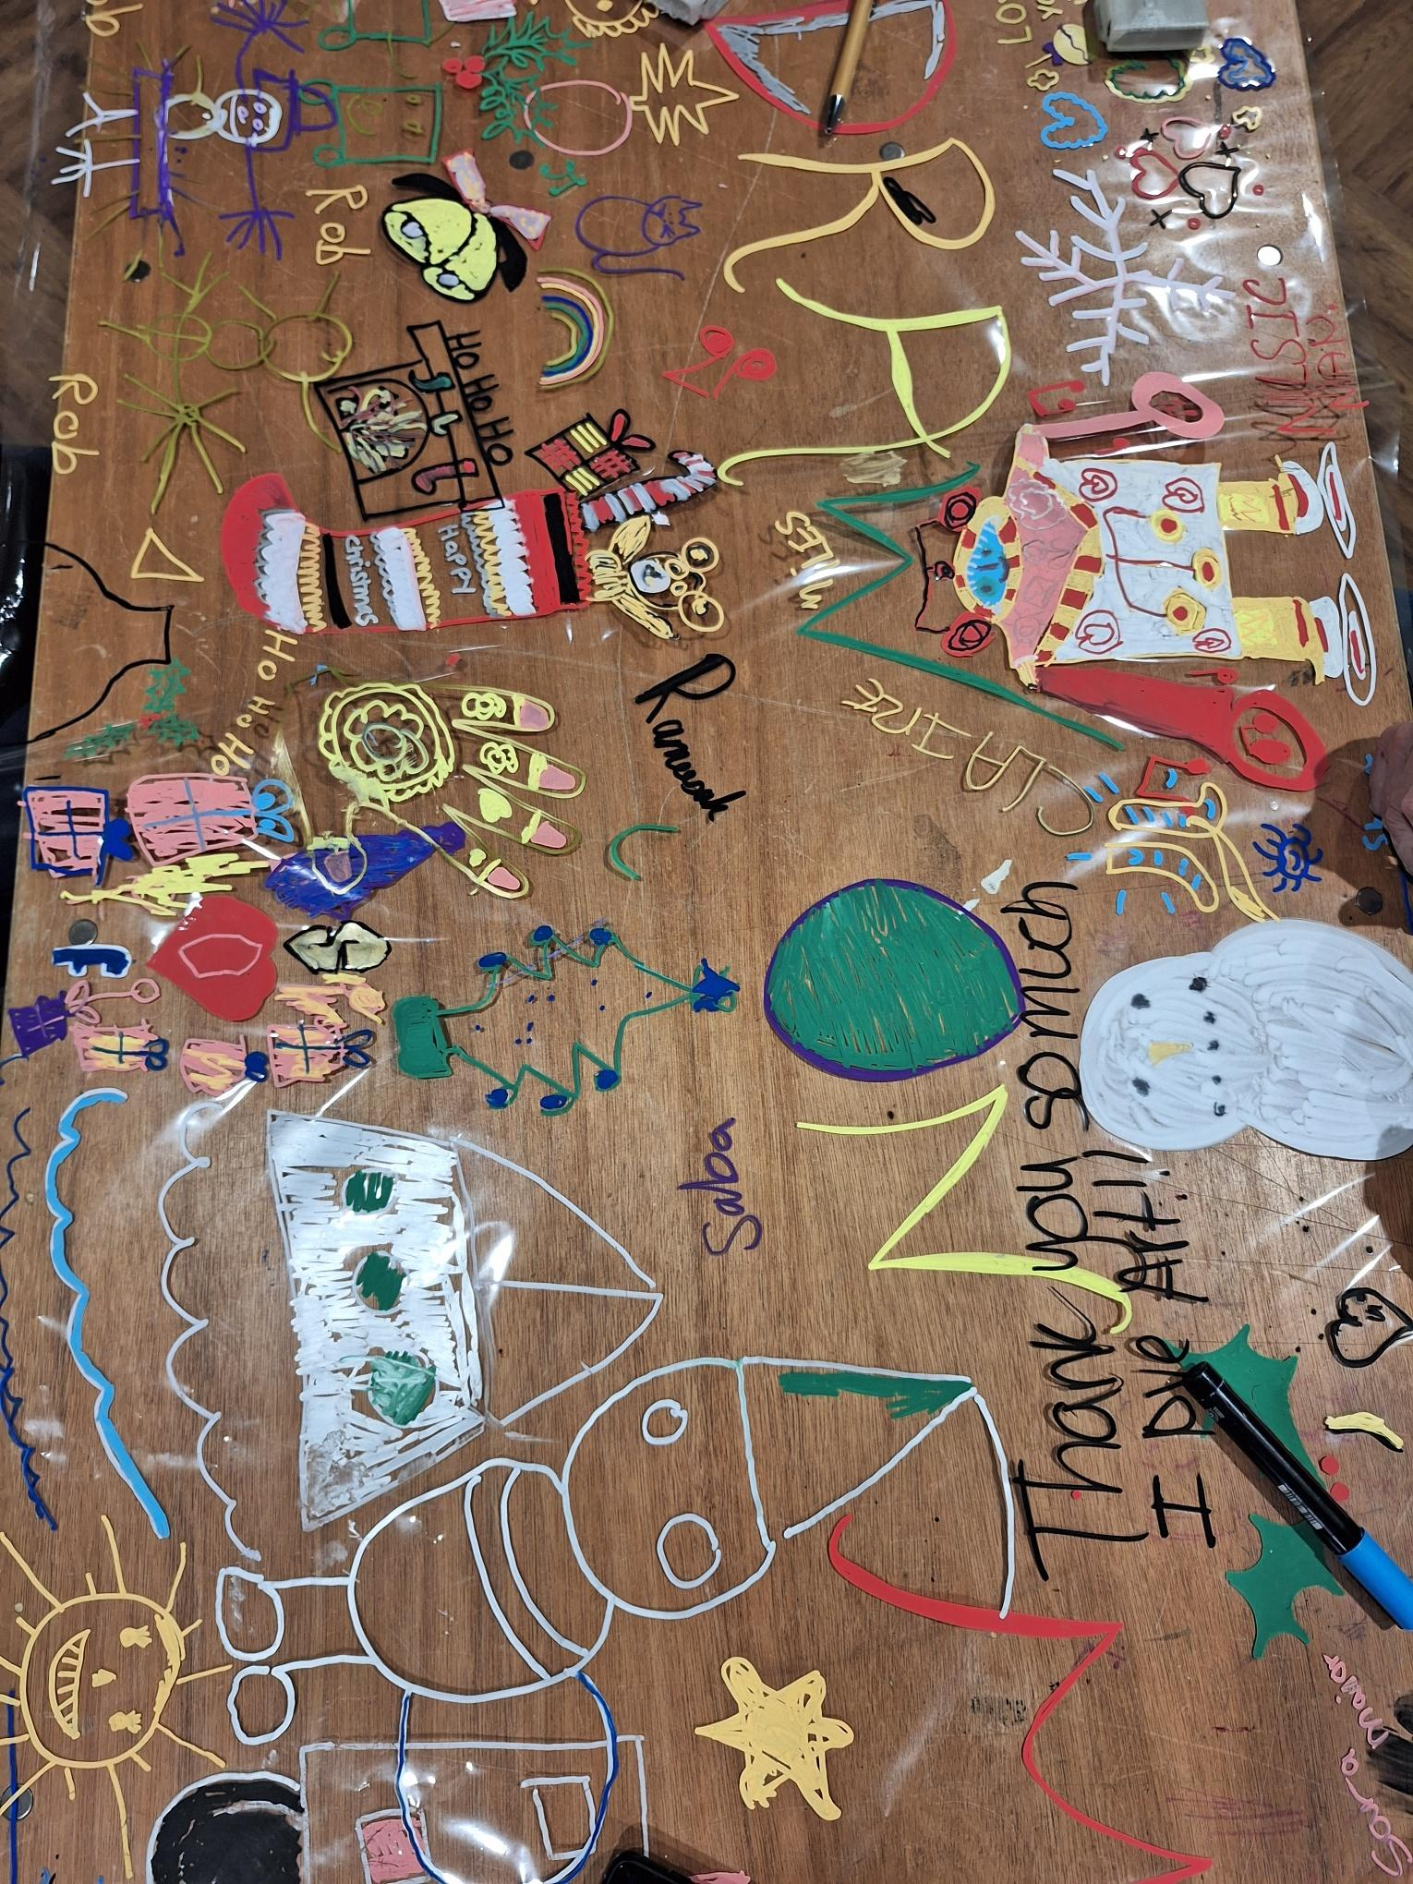

#### Quiet Sensory Room

The quiet sensory room was a space for anyone to use and was implemented after feedback in 2022, from autistic people/organisations. The room was run by Leeds Autism Services and some of the sensory items were provided by Leeds City Museum, so that anyone requiring space and quietness could go there and interact with the environment of coloured lights, a darkened room, and sensory toys. It was well attended and saw 40 people use the room throughout the day.

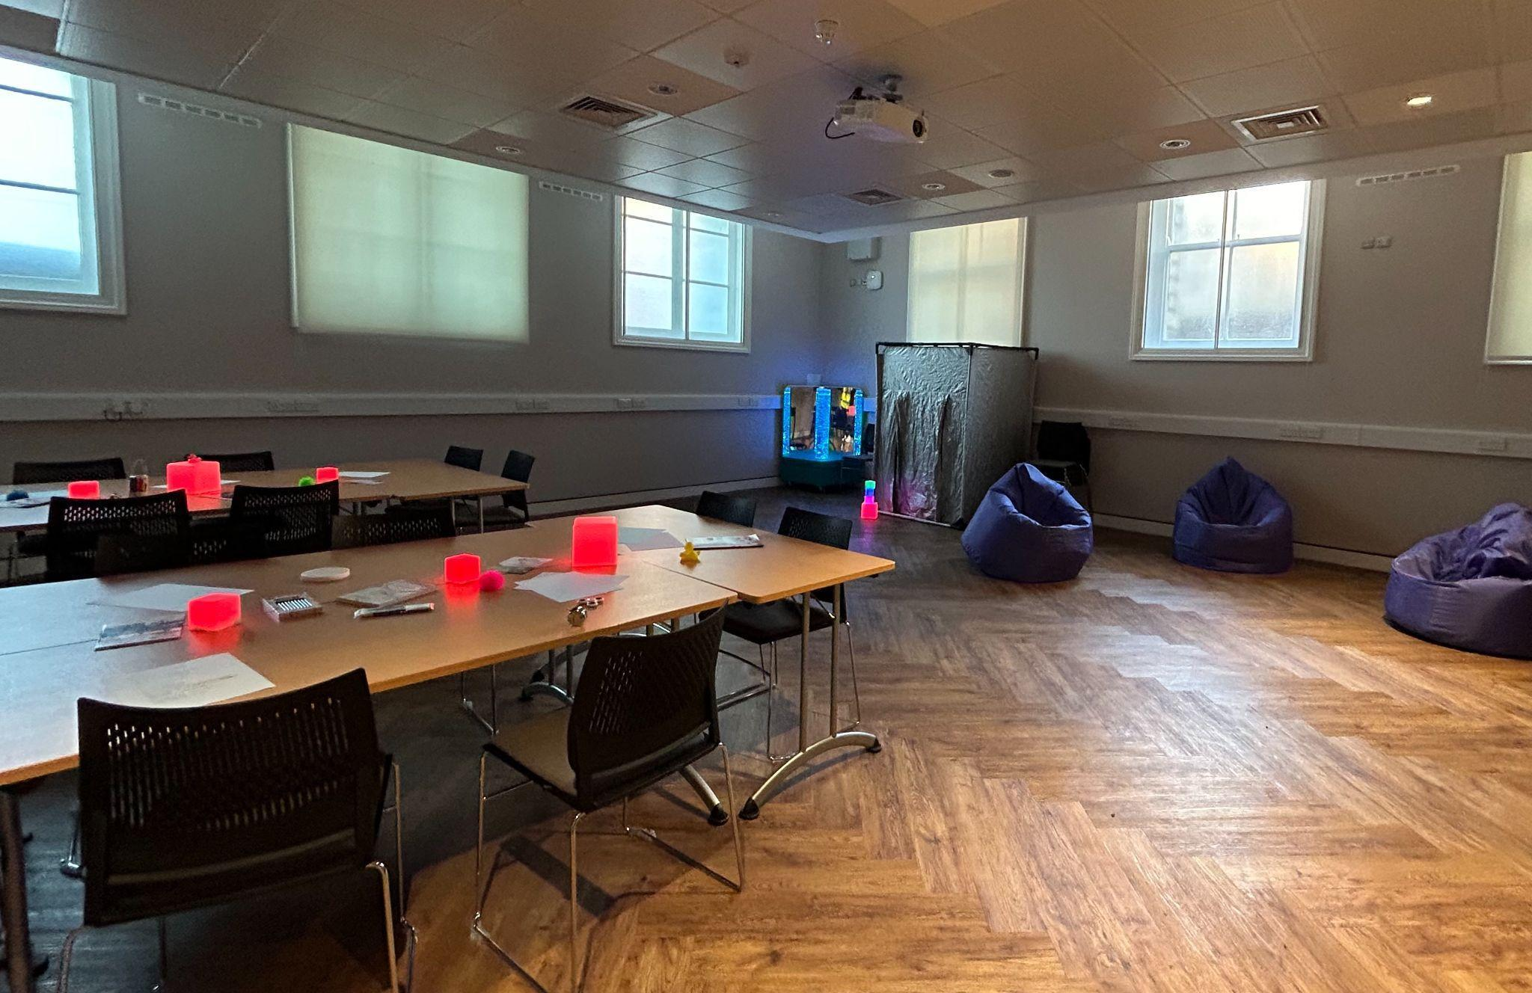

# Feedback

Attendees and stallholders at the Leeds for All IDODP 2024 event had the opportunity to feedback in the following ways: in person posting of a [Simple feedback form](https://docs.google.com/document/d/1jdafcNvwdt29iaQnsdjiCUly4DLtbclQ/edit?usp=sharing&ouid=105181143019795271484&rtpof=true&sd=true) (appendix 7) and a [digital version](https://docs.google.com/forms/d/e/1FAIpQLSdSKiS0PHtstJ4SnavgF5NiNE-b5e-UmYaMudfu-IuqQ84fiQ/viewform). Some people attending the event, including Forum Central member organisations and partner organisations chose to give helpful and constructive feedback informally via email, after the event

We received feedback formally from 10 attendees, and from 5 stallholders via the form, and 5 informally via email.

Please see a couple of quotes extracted below, followed by analysis of the data highlighting what went well and suggestions for improving future IDODP events.

**Gerry VanHee - Chair of REMAP Leeds**

*“At the Market Day itself, I think the inclusion of the performing arts sessions was very good and was a good focus point. On reflection, perhaps if it were possible to provide a small full-access stage to improve visibility of the artists and their performances. Also to provide electricity to the stands. This would let stand holders present more interesting displays and catch people’s attention more. Obviously I understand the nature and possible restrictions of the hall.’’*

**Leeds Society of Deaf and Blind People and DeX**

*“We felt that support for deaf people wasn't to a standard we expected. There were interpreters, but they couldn't interpret the performances. Captioning for the speeches wasn't very good as they didn't keep up with the speakers and they froze so deaf people couldn't keep up.*

*Captioning needs to be live and in tune with the speakers and performers and on the big screens so everyone can see. Interpreters need to be higher so if you are at the back of the audience you can see them clearly without people walking in front of you.’*

*There needs to be a larger space for performers to perform and for the audience to be seated. It felt very cramped and when the performers were on it was very difficult for people to continue moving around the room.”*

## Quantitative Data

**Attendee Feedback**

There were 10 feedback responses from those who attended the event.

The feedback form asked attendees, **“did you enjoy the event today?”**.

80% of the respondents answered this question with “yes, a lot” and 20% responded with “mostly” and none reporting “a little bit” or “no”.

***Figure 1: Did you enjoy the event today?***

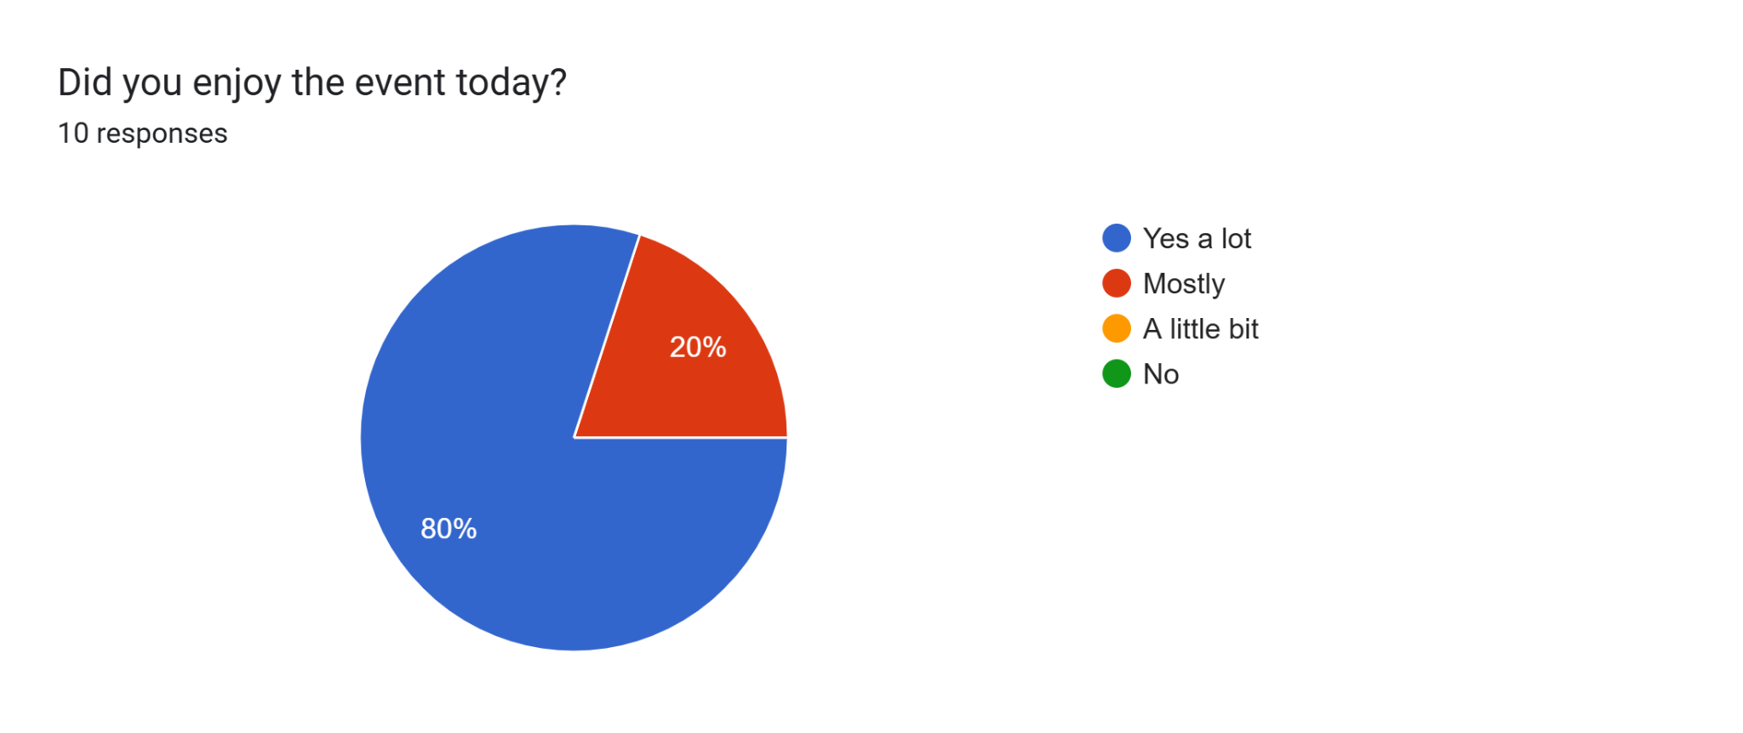

Attendees were asked **“was the event accessible for you?”**. 9 attendees answered this question and 100% said yes.

***Figure 2: Was this event accessible for you.***

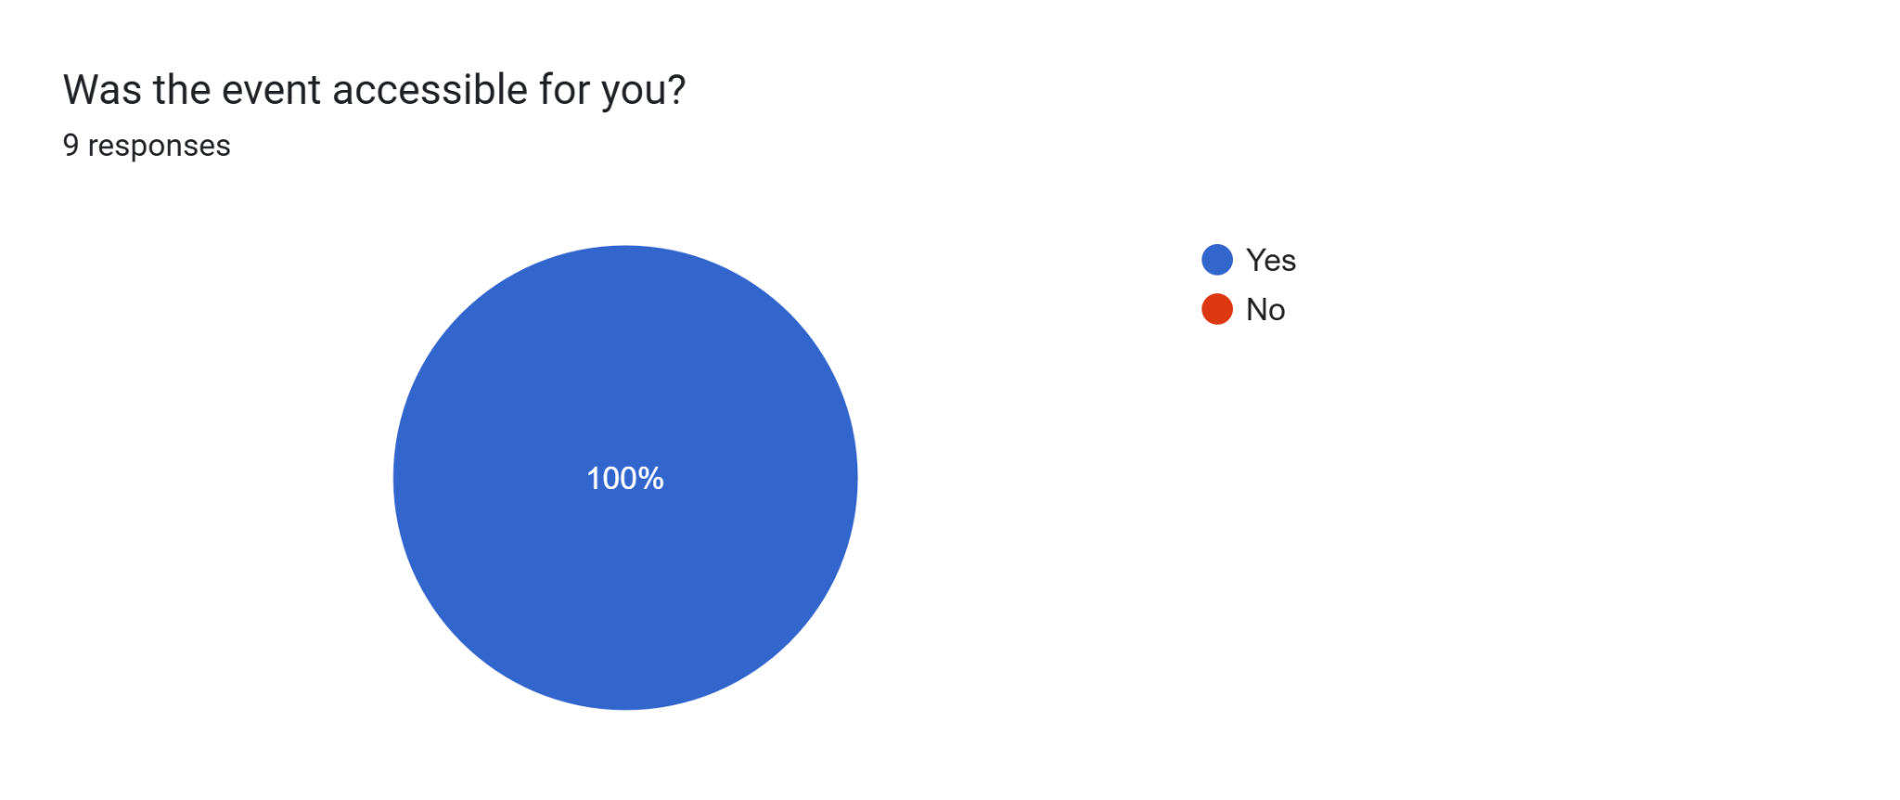

Attendees were asked in follow up to this question, “if no, please tell us what to improve”. People reported:

*“Yes – but noise levels were hard at times, poor acoustics for miked performances”*

Attendees were asked **“how did you find out about this event?”**. 9 attendees responded. The majority of attendees heard about the event via Forum Central (66.7%). 33.3% heard about it from Leeds City Council, and 22.2% heard about it from social media.

***Figure 3: How did you find out about this event?***

Forms response chart. Question title: How did you find out about this event?
. Number of responses: 9 responses.

Attendees were asked **“Has this event made you think more about how you might advocate for accessibility - for yourself or other people?”.** 8 attendees responded. 62.5% of attendees responded with “yes” and 25% attendees responded with “no” and 12.5% responded with “other”.

Attendees were asked in a follow up question, to please expand on this answer. 6attendees answered this question. The findings are included in the qualitative data section.

***Figure 4:* Has this event made you think more about how you might advocate for accessibility - for yourself or other people?**

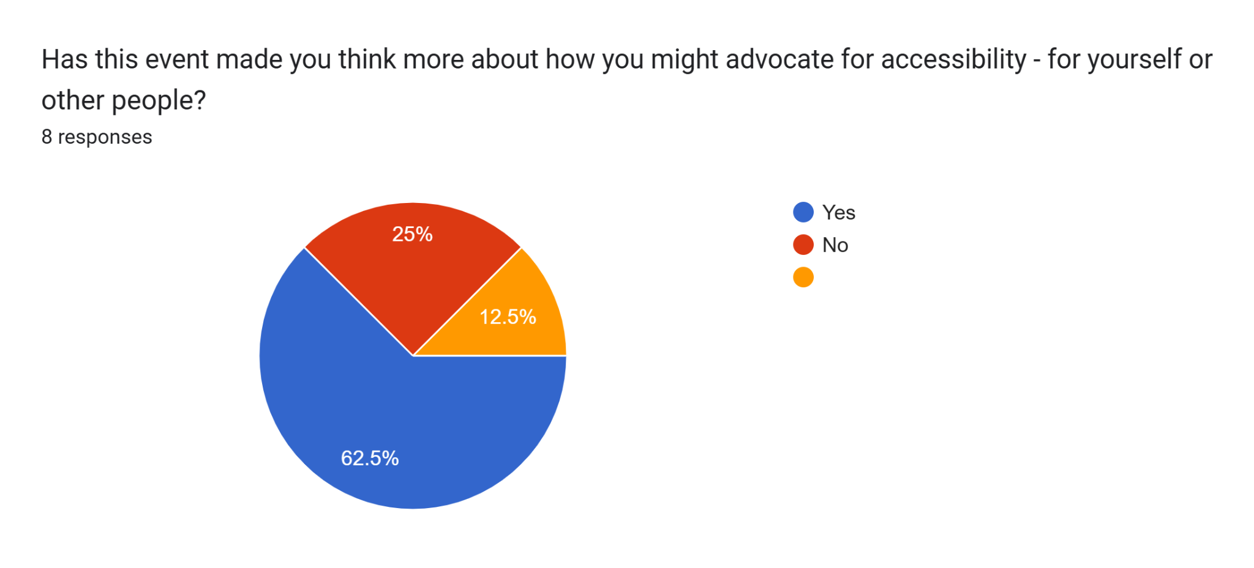

## Qualitative Data

**Attendee Feedback**

Attendees were asked **“what did you like about the Leeds for All event 2024?”**. 10 responses were received. Attendees reported that there were a variety of stalls and lots of opportunities to connect with different organisations, giving the event an intersectional approach. Attendees reported:

*“Meeting people to explain things better”*

*“Making new connections and being part of something intersectional”*

*“The whole event was great, well put together and a great variety of people. - Wonderful day!”*

*“Good atmosphere”*

*“A time of celebration. The performances were brilliant!”*

*“The vibe”*

*“Good how of people across the stalls. Good performances and a different room - quite bad.”*

*“The variety of stalls”*

*“The fact there were so many organisations in one place, nice to speak to and find out more under one roof.”*

*“Lovely atmosphere and great chance to meet people”*

Participants were asked **“what did you not like about Leeds for All 2024?”.** 10 responses were received but only 5 included any negative feedback, the others were ‘n/a’ or ‘nothing’. Feedback in this question will be used to improve future Leeds for All events.

Attendees spoke about how performances were great, but being in the same room as the stalls made it difficult for both stallholders and performers due to noise levels. Performers were reintroduced to the main hall, based on feedback from previous years, of wanting the event to have performers to create a celebratory feel. However, the acoustics of the room make this very difficult. Some people also spoke about the event being too long in running time. The event is a 4 hour drop in event to ensure accessibility for those who might find it hard to attend in a morning or an afternoon, or may have difficulties with transport or a longer distance to travel.

As above, the event is a drop in and visitors are free to leave at any time. Teams of stallholders had to attend for the entirety, as members of the public may have travelled especially to see them. It was also reported how there was a strong presence of organisations who support autistic people and/or people with a learning disability. The number of stall applications we receive from these organisations is significantly higher than those who work with others. We welcome applications from all and will aim to improve the balance in future. Attendees reported:

*“N/A*

*“Nothing”*

*“It was all great”*

*“Hard to run a stall while performances are on – noisy! Also unfair on the performers. It’d be a shame not to have performers somewhere*

*so much going on, and when performances were on people coming round stalls oblivious to this and wanted to talk.”*

*“Think it stretched out a bit too long”*

*“So much going on, and when performances were on people coming round stalls oblivious to this and wanted to talk.”*

*“It was focussed on LD and Autism. Could be more focused on other disability.”*

*“Acoustics of the venue made talking to people difficult at times when performances were on, people coming round stalls were oblivious to this and wanted to talk.”*

Attendees were also asked to expand on the following questions: **Has this event made you think more about your wellbeing and how to connect with other groups?**

6 attendees answered this question. Attendees spoke about how they either learnt something new, would implement it in their work and that even if they didn’t learn anything new, they found the event valuable. Attendees reported:

*“All the leaflets, I collected it. I am going to read them and implement them in my work.”*

*“No – no new or different thinking but lots of valuable info sharing and networking”*

*“It covered subjects I am passionate about already”*

*“Different peoples' needs. Small improvements.”*

*“Running some event ourselves on inclusion practices for employers, and lots of connections made.”*

*“We have improved promo material to make it more accessible based on feedback from last year’s event, for example.”*

Attendees were also asked **“do you have anything else you would like to tell us about the event today? For example, things that could be improved.”** 5 attendees answered this question. Attendees reported:

*“N/A. But if you could keep it up.”*

*“The drop-in format of the event means the Health & Safety briefing will have been missed by a lot of visitors (not sure if a different way to do this) Speeches required a long pause in drop-in activity. Could speeches be recorded and played on a loop so people could drop in/out of a screening room? was a bit chilly but that might have been where we were in front of main open doors lol”*

*“Great networking event, lots of info gathered and connections made.”*

*“More spacious venue. Tea/Coffee”*

Finally, attendees were asked **“do you want to be emailed with updates about IDODP 2024 or similar events? Write your email address below to sign up to the mailing list.”** 5 attendees responded with their email address.

## Email feedback

Further feedback arrived via email. Those who provided it were happy for this to be shared, as follows:

**Nicky Lines: Pyramid of Arts - Autism and Learning Disability Digital Inclusion Coordinator**

*"International Day of Disabled People is a really lively event and it is wonderful to see people with learning disabilities, carers, and people working in the sector coming together to share good practice and have fun! I always meet new people when attending and this has led to exciting new collaborations and projects. The event is well organised and feels really inclusive and friendly."*

**Alice Clayden: Pyramid of Arts - Creative Programme Coordinator**

*"We were really pleased that people who were interested in becoming members at Pyramid used the event as an opportunity to bring in their sketchbooks and artwork to show us. Having the designated art zone allowed us to have really meaningful 1:1 conversations with people about how they could get involved with Pyramid. Hopefully the people we met at the event will be joining us to make more art in the Pyramid Studio soon!'.*

**Ian Graham, Aspire**

*“The first IDODP event I went to a few years ago seemed to just be professionals networking with each other. It’s been much better since an effort was made to make it a more inviting event for people who actually use the services we’re all providing.”*

**Craig Asquith - Leeds Autism Services**

*“We wanted to say thank you to you and the team for organising and running the quiet/sensory room at IDODP! It was great, so calming! The video and sound for the background was really nice too. I hope you enjoyed the day. Thank you again. And to Michael especially for helping us get over 500 attendees!”*

# In Conclusion

The 2024 IDODP Marketplace Event was a great day of celebration; increasing its attendance by more than 200 people than the previous year.

It has a significant ability to encourage and provide opportunities for relationship and partnership building than its predecessors. Many opportunities for ‘in-person’ interactions have been lost since Covid-19 pandemic and lockdowns, reducing people’s opportunities to connect informally in a welcoming environment. The Forum Central Learning Disability and Physical and Sensory Impairment Teams worked with partners as a collaborative and as a developmental project, which resulted in a greater reach.

The IDODP event helps spark new interest in Forum Central’s Specialist Networks, of which IDODP is promoted as an event Network Members would benefit from attending. Forum Central’s IDODP team will continue to work towards becoming more accessible in producing formats and content to be more inclusive/accessible, to enable us to reach new audiences and those with lived experience.

Broadening our range of audience will continue to help reshape Forum Central’s accessibility and future developmental work with organisations in Leeds. Including how we organise in-person or hybrid meetings and live events.

### Recommendations

* To reintroduce the IDODP Small Grants Fund as a central part of future plans.
* A different venue is needed for this event, which is larger and more accessible for all.
* To build stronger engagement with Hearing and Sight Impaired people.
* To have basic BSL and sight guide training available pre-event for all Leeds for All staff.
* To use Plain English and continue to develop and produce information in a variety of accessible formats.
* To further develop Leeds for All accessibility strategies.
* Future IDODP events must be more intentional in their priorities, to achieve strategic objectives in improving outcomes for disabled people.

## 

## Reflective Statements

**Helen Brand, PSI Development Worker (Volition, Forum Central):**

*“The initial model of organising the pan disability IDODP event in 2023 was continued for this 2024 event, but we adopted a different room layout in order to create more space between stalls. However, this year it became very evident that people have very different accessibility needs and one room just isn’t big enough to accommodate accessibility for all! Having said that, the event had a great buzz and the marketplace was very busy all day. Speeches and performances definitely need a separate space at future events and we need to encompass accessibility for the sensory impaired community as an on-going priority for 2025. Overall, the main feel of the event was positive with lots of new learning and new connections being made along the way.”*

**Dominique Burley, Senior Development Worker - Learning Disability Network (Volition, Forum Central):**

*“International Day of Disabled People is a fantastic event which brings people together, to network, encourage new partnerships and celebrate the achievements of disabled people. The event increased in both applications from stallholders and attendees, but we need to work more on encouraging other organisations so we have a wider range of organisations, as it was mentioned the event seemed focussed on organisations which support people with a learning disability and/or autistic people. To create an event which is accessible for everyone can be challenging - everyone is different, we all have different needs. And often what works for some people, is the opposite of what another person needs.*

*I learn something new every year about accessibility and there’s still always room for improvement. Another reflection is the feedback of the event being too long - I find the event is not too long, as people have different needs. Not everyone can get to any event before 12pm, 2pm and so on, or not everyone can stay later into the afternoons. Transport can be a huge issue for many people, whether that is a long distance to travel or often transport does not show up/is delayed and people can worry about missing out on events. 4 hours is not a long time in the grand scheme of things. Many people travel to events like ours, to see specific organisations or as an opportunity to be connected and meet new people”*

**Gerry Van Hee, Remap Leeds:**

*“I found this year very interesting and motivating to learn about organisations acting in Leeds to support people with different needs. The range of stalls organised by Leeds for All for the IDODP Market Day and the fact that there was a waiting list is testament to the value the groups place on being at the event.*

*For REMAP, it made a number of areas VISIBLE where we can focus our efforts to improve awareness of our offer and generate more opportunities to support physically disabled people lead a better quality of life. This will be a primary focus for us in 2025.”*

**Jenny Bull, Communications Manager (Volition, Forum Central):**

*“As always, this was a fantastic event but it needs secure funding to take it to the next level. If we could secure the date and a venue with better acoustics earlier in the year we could start promotion and circulating information about it much earlier, which would help widen its reach to people who are perhaps not already connected with services or the third sector. I think the format worked well this year but appreciate that the performances were difficult to talk over. I think one solution for this could be having stall holders come away from their stalls to sit in the audience, or by having performances in a connected but separate space. I think it would be good to build on the 2024 event theme ‘advocating for accessibility’ and incorporate activity which responds to some of the most commonly reported barriers, such as transport, digital and workplace and engage with businesses, leaders and experts by experience around these topics, either with a panel discussion or dedicated sessions.*

**Appendices**

## 

## Appendix 1: Leeds For All Logo



## 

## Appendix 2: Stall Holder Pack

The Stall Holder pack with was emailed to each stall holder in advance consisted of:

1. Brodrick Hall layout (*appendix 2a*)
2. Promotional poster / flyer (*appendix 2b*)
3. Programme (*appendix 2c*)
4. Stallholder Summary (*appendix 2d*)

## Appendix 2a: Brodrick Hall Layout

[Museum Marketplace Layout 25 Trestle No Stage.docx](https://docs.google.com/document/d/1-YYZ_TdDS3qDZaQ5EF47zGChSJ6Unud5/edit?usp=sharing&ouid=105181143019795271484&rtpof=true&sd=true)

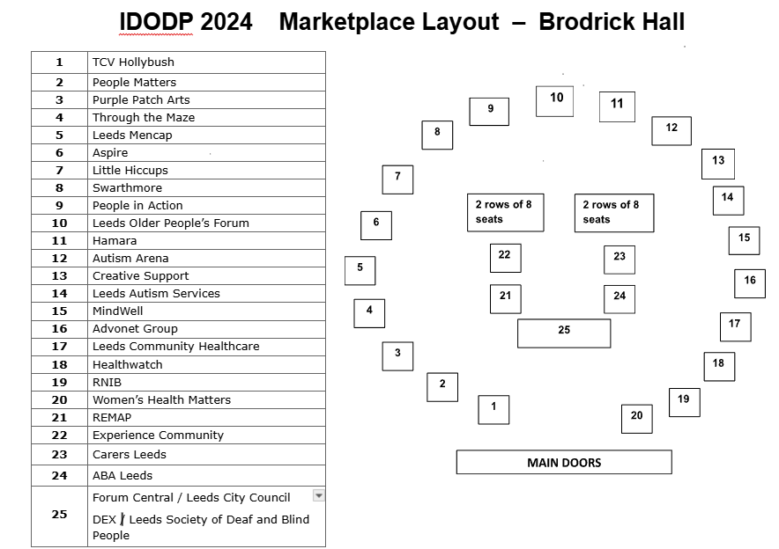

## Appendix 2b: Promotional materials - Poster / flyer

[Flyer Leeds IDODP 2024 V5.pdf](https://drive.google.com/file/d/13jxgX_5np7qb1DTTPMXErlt1BQMR5bp6/view?usp=drive_link)

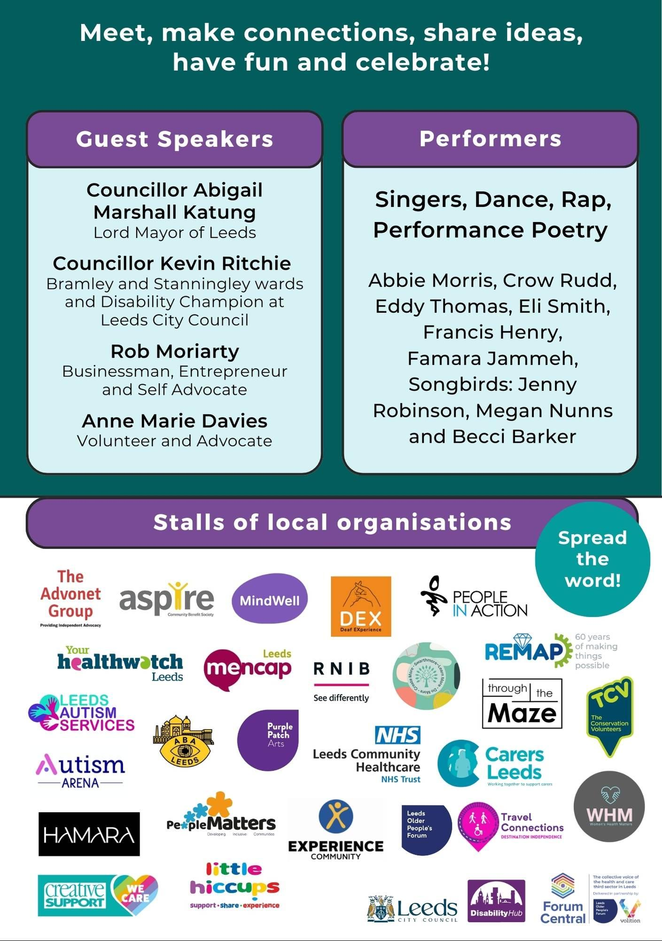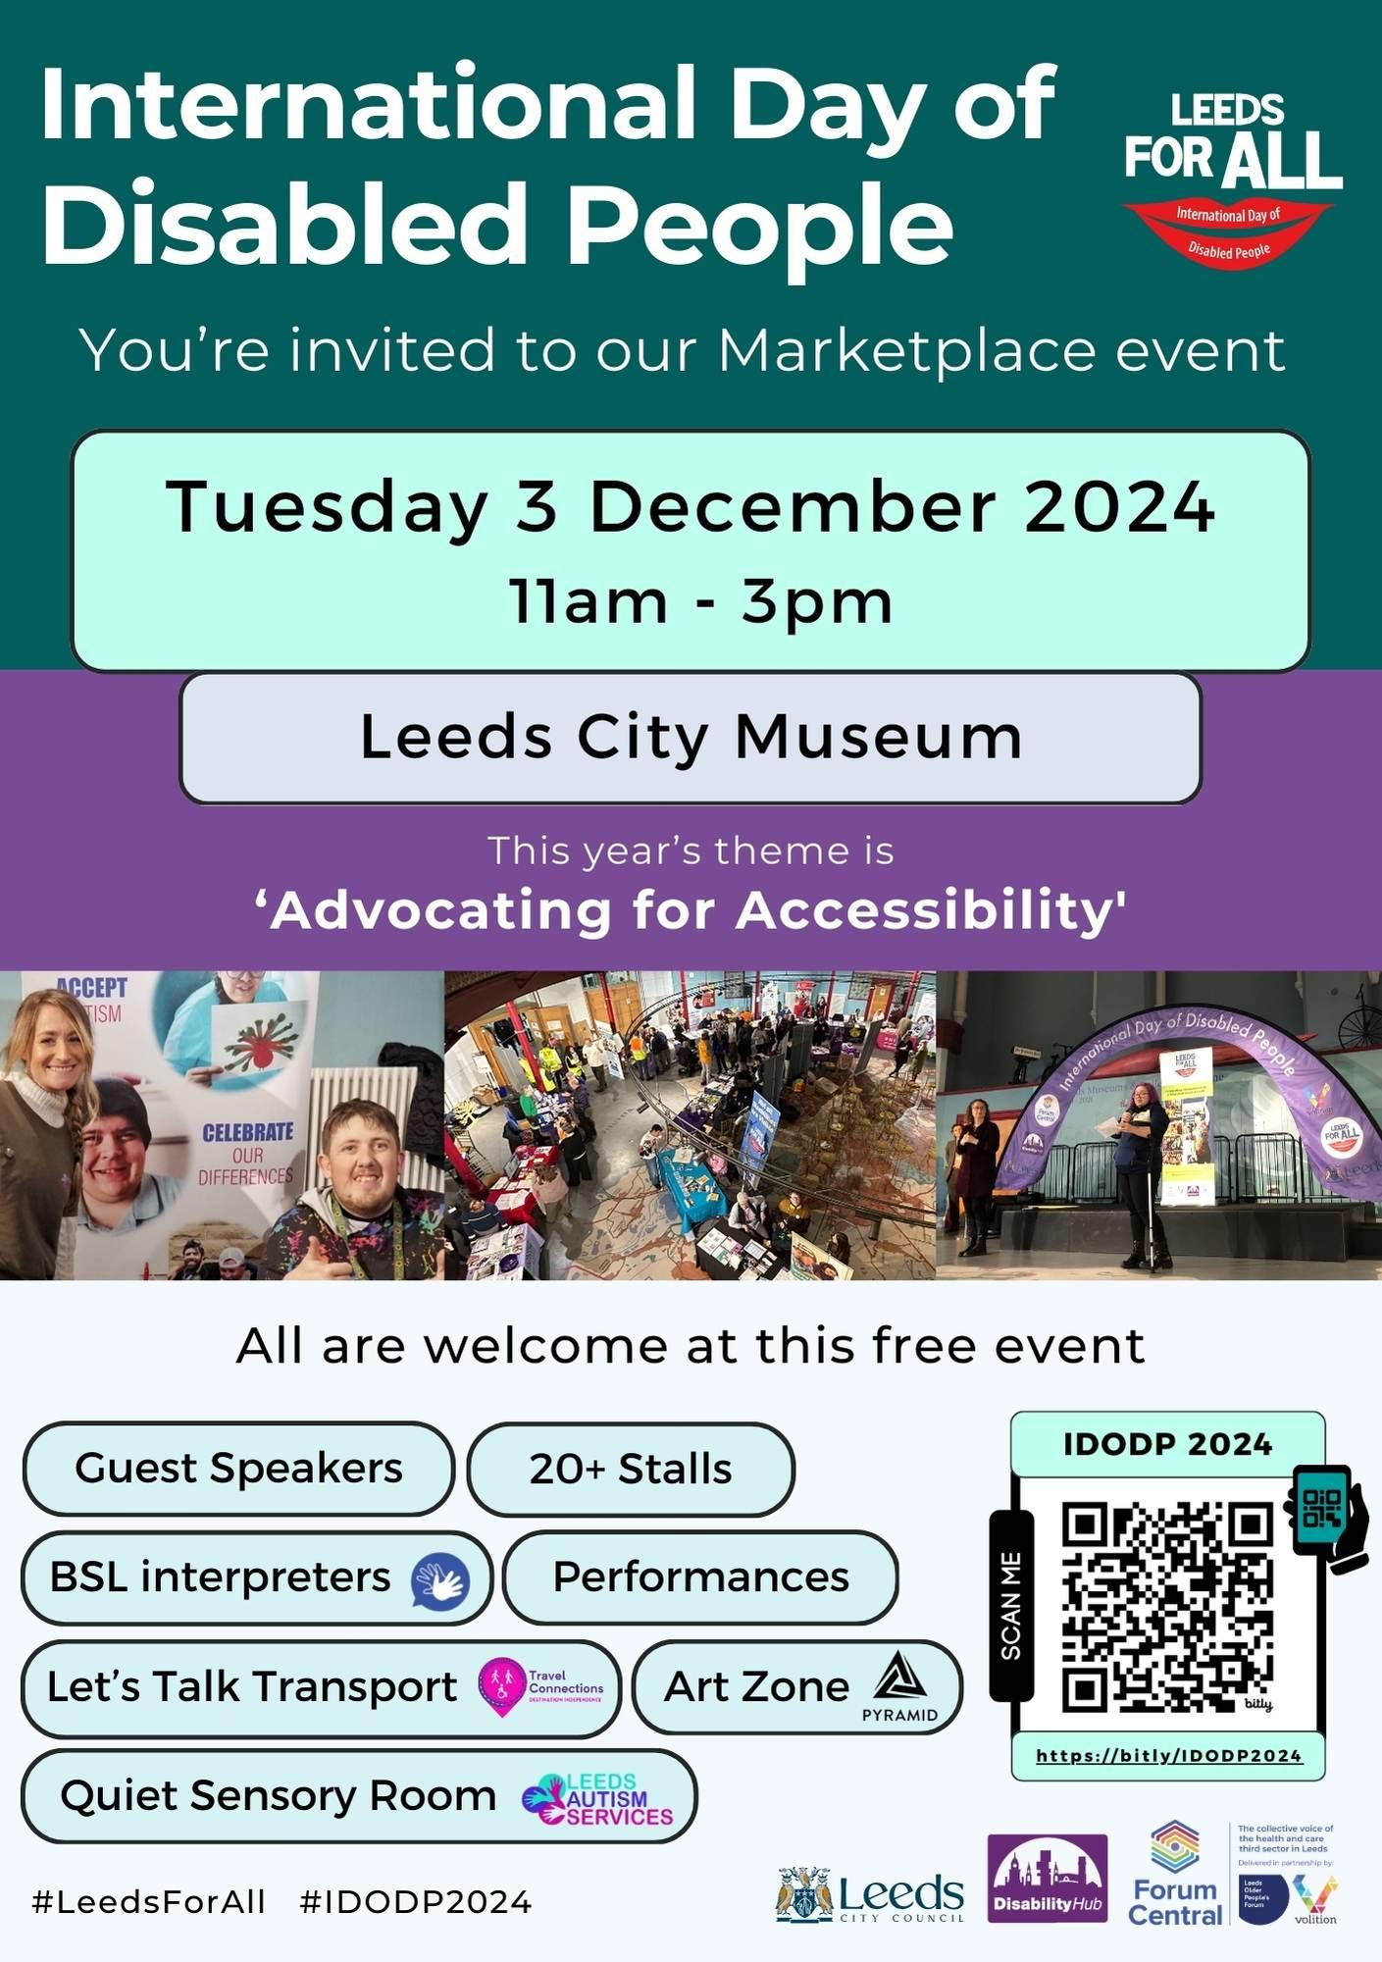

## Appendix 2c: Programme

[Programme IDODP 2024_V3.docx](https://docs.google.com/document/d/1-WSSjkZLFkV_x0qwe8Z-QgIyvikQcxr6/edit?usp=drive_link&ouid=105181143019795271484&rtpof=true&sd=true)

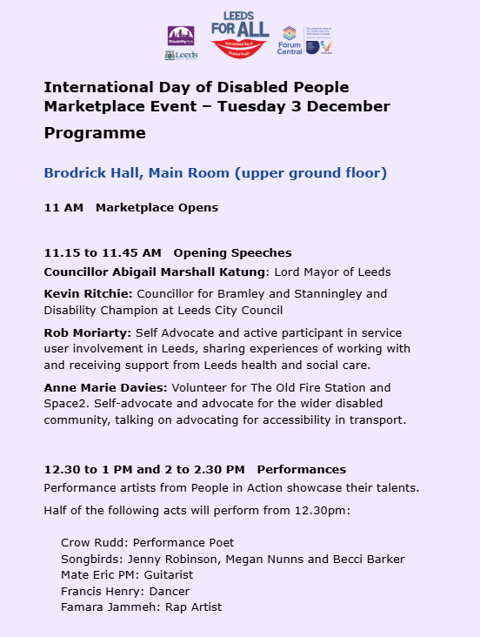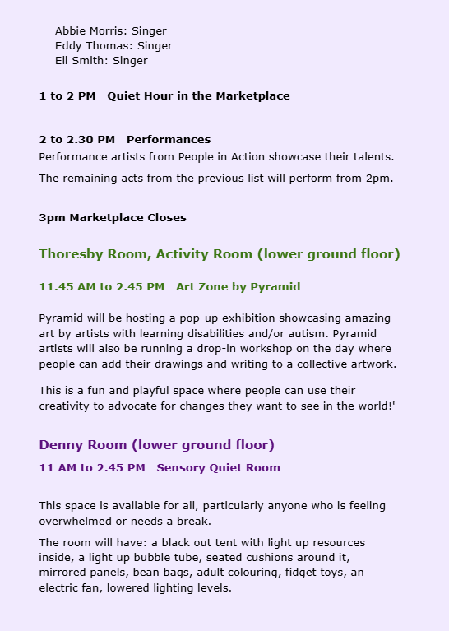

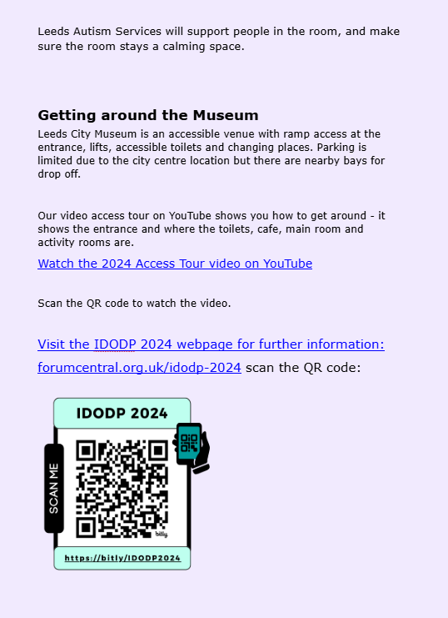

## Appendix 2d: Stallholder Summary

[Stallholder Biopic_colour images_V1 2024.docx](https://docs.google.com/document/d/1RTPpTEfLjErHeg_evThY7lm8ci11OPm_/edit?usp=sharing&ouid=105181143019795271484&rtpof=true&sd=true)

| **Organisation Logo** | **Organisation Name** | **Organisation Description** | **Organisation Website** |
| --- | --- | --- | --- |
| Association of Blind Asian's logo | Association of Blind Asians  (ABA) | Dedicated to providing advocacy and support for the blind BAME community | [abaleeds.org.uk](https://abaleeds.org.uk/) |
|  | The Advonet Group | Providing statutory and community advocacy and related services that promote empowerment and inclusion. The group includes: Advonet, Asking You! CHANGE, LEEP1, Leeds Autism AIM. | [advonet.org.uk](https://advonet.org.uk/) |
| Aspire CBS (@AspireCBS) / X | Aspire | Aspire Community Benefit Society supports people with learning disabilities to have better lives through the provision of high-quality, person-centred, care and support services. | <https://www.aspirecbs.org.uk/> |
|  | Autism Arena | Embracing Neurodivergence! A non-profit community interest company that relies on funding to help parent carers of autistic children navigate health & social care, education and leisure. | <https://autismarena.org.uk/> |
|  | Carers Leeds | The home of support for all unpaid carers in Leeds Are you helping a friend or family member due to their illness, disability, mental health issue or a substance misuse problem? Yes? – Then you are one of 74,000 unpaid carers in Leeds and we are here to support you. | <https://www.carersleeds.org.uk/> |
|  | Creative Support | Creative Support is a not for profit provider of person centred care and support Creative Support is a not-for-profit organisation promoting the independence, inclusion and wellbeing of people with care and support needs.  We do this by working with the people we support, their families and partner agencies to deliver innovative, high-quality services to meet individual needs and aspirations. | <https://www.creativesupport.co.uk/> |
|  | Deaf EXperience (DEX) | DEX is a charity which campaigns nationally to improve access to education, wellbeing and quality of life for deaf and hard of hearing young people. | [dex.org.uk](https://dex.org.uk/) |
|  | Experience Community | Experience Community is a not-for-profit Community Interest Company that helps disabled people access the outdoors through a range of inclusive walking, cycling, conservation and arts activities.  We’re interested in building communities of like-minded people, so we provide group sessions so that people can make new friends and learn from each others’ experiences. | <https://www.experiencecommunity.co.uk/> |
|  | Hamara | Hamara has grown to be the largest ethnic minority organisation in the voluntary and community sector in Leeds.  Working within the community sector and now employing over 20 staff, Hamara currently delivers several different strands of work including: Health Promotion, Youth Activities, Older People’s Services, Saturday Supplementary School, Learning Disabilities, Education and Employment & Training Programmes. | <https://www.hamara.org.uk/> |
|  | Healthwatch Leeds | Welcome to Your Healthwatch Leeds Your independent watchdog ensuring people’s voices are at the heart of shaping health and care services in Leeds. | <https://healthwatchleeds.co.uk/> |
| TCV logo | TCV Hollybush | Hollybush in Kirkstall is an environmental volunteering centre. Our volunteers help to manage green spaces across Leeds and beyond. We welcome people of all backgrounds and experience. | [www.tcv.org.uk](https://www.tcv.org.uk/) |
| Leeds Autism Services careers - hireful. | Leeds Autism Services (LAS) | LAS is a charity dedicated to creating a more autism friendly society by promoting understanding and acceptance of autistic people. | [www.leedsautism.org.uk](https://www.leedsautism.org.uk/) |
|  | Leeds Mencap | Leeds Mencap is a completely independent charity, started by and for those with learning disabilities. They directly help more than 570 families and individuals on their journey with learning disabilities and autism. Indirectly, they support hundreds more who use the specialist equipment and facilities in our centre.  Not only do they offer important services to people with learning disabilities and autistic people, they also recognise the needs of the whole family. They’re on hand to provide advice, support, and long-term help to all those they work with. | <https://www.leedsmencap.org.uk/> |
| Leeds Society For Deaf and Blind People | Leeds Society of Deaf and Blind People | Their single objective has been to respond to the expressed needs and aspirations of Deaf, hard of hearing, DeafBlind, Blind and partially sighted people in Leeds. | [www.lsdbp.org](https://www.lsdbp.org/) |
|  | Leeds Older People’s Forum | Leeds Older People’s Forum is a network of third sector organisations working with and for older people.  We want to ensure older people have the opportunities, choices and support they need to live the life they want. LOPF is a registered charity. | https://www.opforum.org.uk/ |
|  | Leeds Community Healthcare | Leeds Community Healthcare NHS Trust (LCH), serving the public in Leeds and providing health services to patients. | <https://www.leedscommunityhealthcare.nhs.uk/> |
|  | Little Hiccups | Little Hiccups is a Leeds based, award winning support group that has been set up by parents who have children with additional needs and disabilities. | https://www.littlehiccups.co.uk/ |
| Home - MindWell | Mindwell | MindWell is the mental health website for adults in Leeds. It’s funded to bring together information from the NHS, Leeds City Council and the third sector into one ‘go to’ place. | [www.mindwell-leeds.org.uk](https://www.mindwell-leeds.org.uk/) |
|  | People in Action | We work with learning disabled and autistic people to support happy, healthy and independent lives. | [peopleinaction.org.uk](https://peopleinaction.org.uk/) |
| People Matters Leeds | People Matters | We create opportunities for people with learning disabilities and other hidden disabilities who experience disadvantage to be more independent and ensuring that each person’s needs are met | [peoplemattersleeds.co.uk](https://peoplemattersleeds.co.uk/home/) |
| Home - Purple Patch Arts | Purple Patch Arts | We exist to provide innovative, inclusive, creative learning opportunities that improve the lives of learning-disabled and autistic adults by expanding their understanding and engagement with the world. | [purplepatcharts.org](https://purplepatcharts.org/) |
| Pyramid of Arts | Pyramid of Arts (Stall in the Thoresby Room) | Our goal is to help people with a learning disability to discover the arts and to develop their talents to become world-class artists. We also disrupt the social and institutional barriers that prevent them from being recognised, supported and celebrated. | [pyramid.org.uk](https://pyramid.org.uk/) |
|  | REMAP | REMAP’s mission is to improve the quality of life for people who experience short or long-term disability through infirmity, illness, or ageing. We do this by making and adapting equipment to meet the unique needs of individuals at no cost to them.  The equipment, produced by our team of dedicated volunteers, can help with day-to-day tasks such as mobility, personal care or eating. Or it can enable the client to pursue a hobby or ambition, such as participating in a sport or art activity. | <https://remap.org.uk/> |
| RNIB (@RNIB) / X | Royal National Institute for the Blind (RNIB) | We are leading the creation of an accessible world. A world where everyone can participate equally is a better world for everyone. | [www.rnib.org.uk](https://www.rnib.org.uk/) |
|  | Swarthmore | Swarthmore is a centre for lifelong learning. Our main aim is to encourage people who want to learn but might not feel comfortable in more formal educational institutions.  We offer a wide range of courses and workshops, run community projects, have regular exhibitions, offer room hire at competitive rates, and have an onsite cafe. | <https://www.swarthmore.org.uk/> |
| Home - Through the Maze | Through the Maze | Through the Maze is an information and signposting service in Leeds for adults with learning disabilities, family carers and professionals. | [www.through-the-maze.org.uk](https://www.through-the-maze.org.uk/) |
|  | Womens Health Matters | Supporting disadvantaged and marginalised women and girls to have a fair chance at a better life. | <https://www.womenshealthmatters.org.uk/> |

## 

## Appendix 3: Easy Read Programme

Link to view the online pdf: [Easy read programme IDODP 2024](https://forumcentral.org.uk/wp-content/uploads/2024/10/Easy-read-programme-IDODP-2024-V2.pdf) (extract of 2 pages screenshot below)

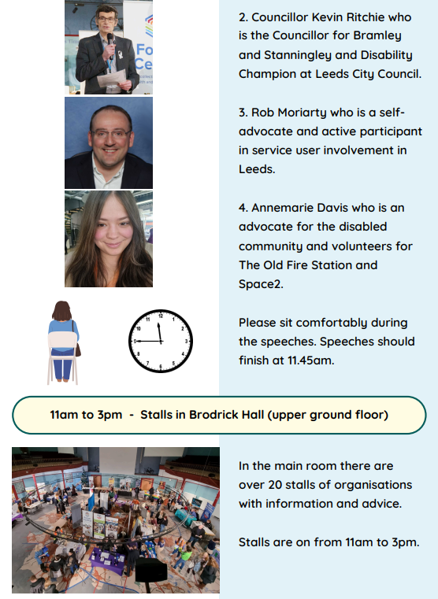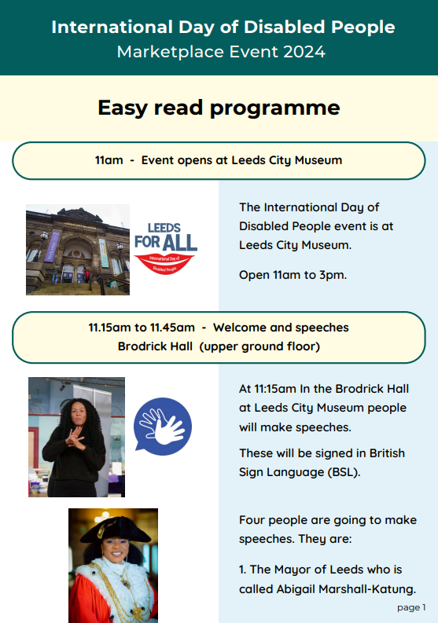 

## Appendix 4: Press Release

**International Day of Disabled People Marketplace 2024**

You're invited!

Leeds is delighted to be celebrating International Day of Disabled People for the sixth year in Leeds. The theme this year is ‘Advocating for Accessibility’.

The free and inclusive event will feature a marketplace with over 20 stalls showcasing local disability support organisations. It promises to be a great day with: performances, guest speakers, an opportunity to discuss transport, an art zone, quiet sensory room and BSL interpreters.

Visit [Leeds IDODP 2024 Marketplace Event on the Forum Central website](https://forumcentral.org.uk/idodp-2024/)

The full programme will be available on the event website shared as an easy read document shortly and includes:

* Guest speakers: The Lord Mayor of Leeds, Abigail Marshall Katung, Councillor Kevin Ritchie, Lead member for Disability at Leeds City Council, Rob Moriarty, businessman, entrepreneur and Self Advocate, Anne Marie Davies, Volunteer and Advocate.
* 24 Stalls of local organisations.
* Performances coordinated by People in Action: 7 Singers, Dance, Rap, and Performance Poetry.
* Let's Talk Transport: opportunity for discussion hosted by Travel Connections, Leeds Older People's Forum.
* Art Zone coordinated by Pyramid of Arts.
* Quiet Sensory Room hosted by Leeds Autism Services.
* BSL interpreters

Join us, make new connections, meet up with friends, share ideas and celebrate!

IDODP Leeds is organised by Leeds For All: Leeds City Council’s Equality Team and their Disability Hub, and Volition, Forum Central.

The venue is accessible with ramp access at the entrance, lifts, accessible toilets and changing places. Parking is limited due to the city centre location but there are nearby bays for drop off. [Get full details about Leeds City Museum Access information here](https://museumsandgalleries.leeds.gov.uk/leeds-city-museum/visit-leeds-city-museum/#access).

Volunteers wearing hi vis will be available to help you navigate the museum on the day.

Don't forget to share on social media using the hashtags #LeedsForAll and #IDODP2024.

* ENDS -

(The press release was sent with contact details, information about the event organisers and steering group, and images and social media images with alt text.)

## 

## Appendix 5: Promotional graphics

**Selection of screenshots from the short video:**

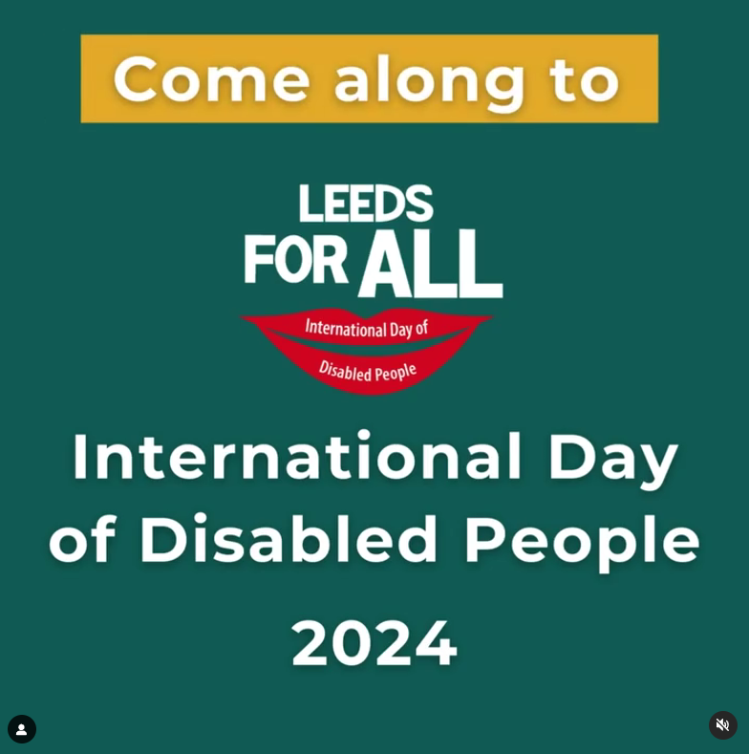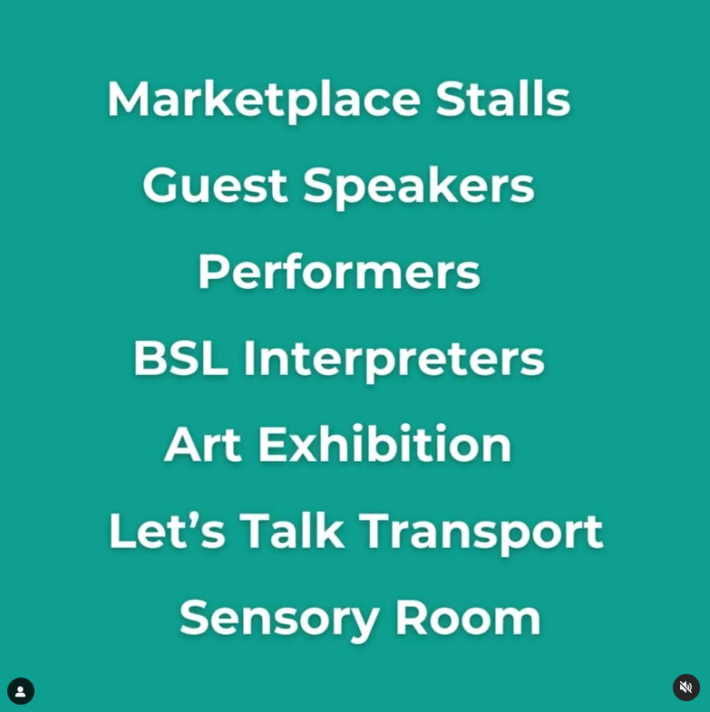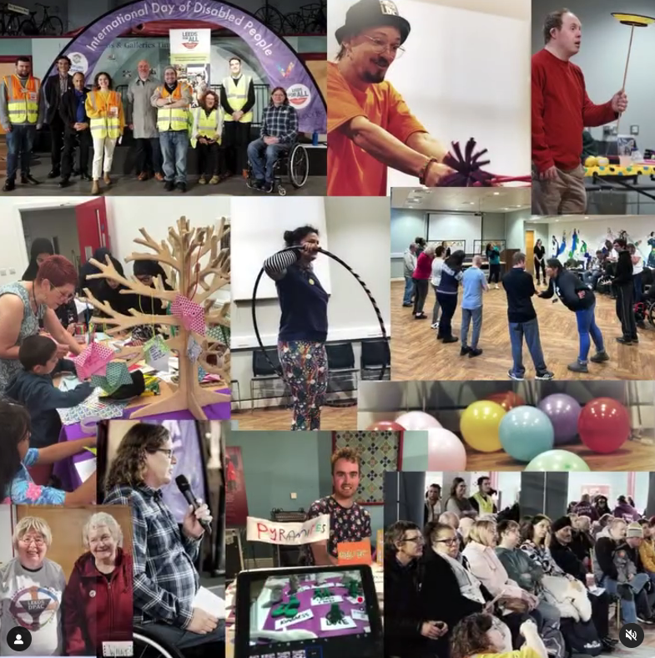

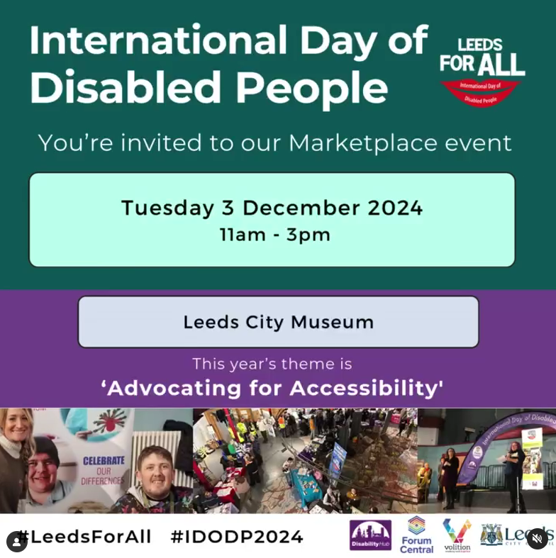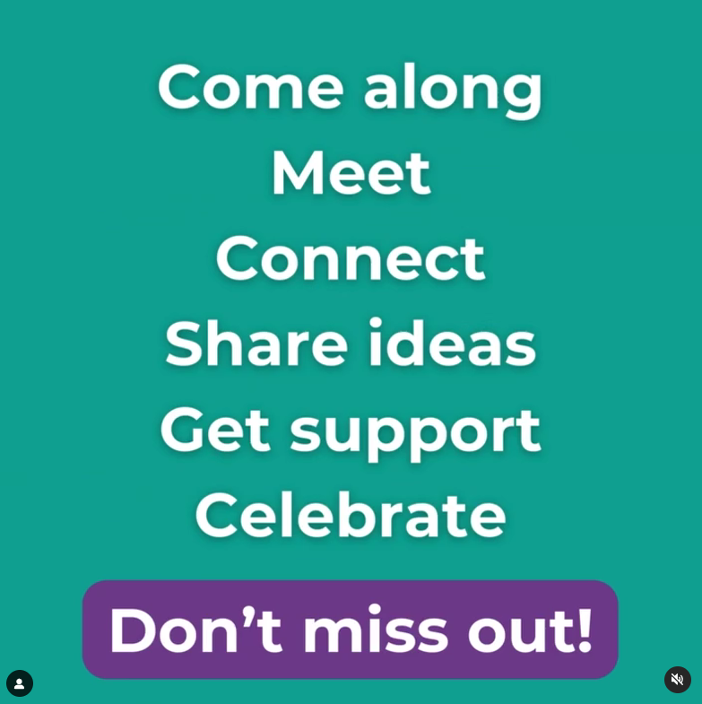

**Email signature:**

## 

[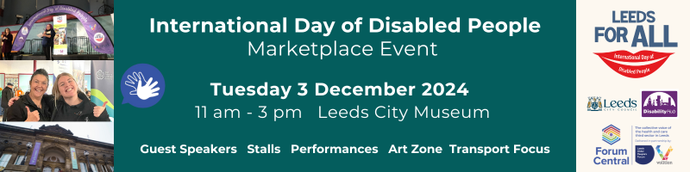](https://forumcentral.org.uk/idodp-2024/)

## Appendix 6: Illustrations from 2023 event

| illustration about what's important to us. Learning disabled people having a job | illustration about what's important to us. disabled people being screwed by the government |
| --- | --- |
| illustration about what's important to us. no barriers to what you want to do. Sport saved my life says Jodie Boyd-Ward | illustration about what's important to us. being able to work from home |
| illustration about what's important to us. injustice, disabled people are treated as second class citizens | illustration about what's important to us. accessibility of communications |

## Appendix 7: Feedback Form

[Digital version of the IDODP Leeds for All 2024 Attendee Feedback Form](https://docs.google.com/forms/d/e/1FAIpQLSdSKiS0PHtstJ4SnavgF5NiNE-b5e-UmYaMudfu-IuqQ84fiQ/viewform)

