About Scope

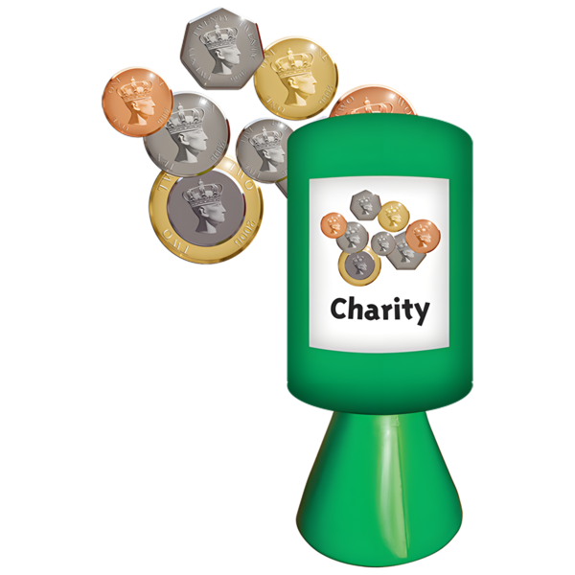
Scope is a charity.



We work in England and Wales.


We support disabled people and their families.

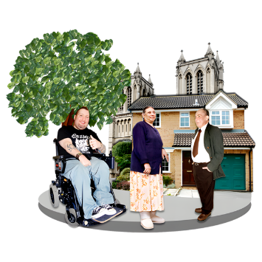
We want a fairer society for everyone.


Our goals
We have 3 main goals:
- Change how society thinks about disability


- Reduce extra costs for disabled people
- Help more disabled people get jobs

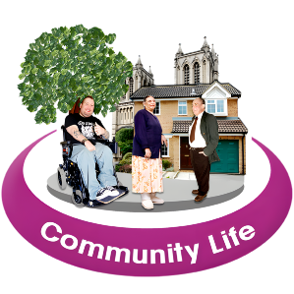
Scope in Leeds

Scope has a Community Hub in Leeds.


We use the Hub to:
- Run activities


- Hold events

- Work with disabled people and local organisations


We want to hear your ideas.
Your answers will help us use the Community Hub in the best way.

Survey and Focus Group Questions

1. Helping disabled people get jobs

Which activities would you take part in?
(You can choose more than one)
- Campaign
- Donate money
- Fundraise
- Volunteer
- Become a Community Supporter to hear about local events
- Share your story with Scope
- None of these
- Other (please tell us)


2. Other ideas about jobs
Do you have any other ideas for activities or events
that could help disabled people get jobs?

3. Reducing the cost of living

Which activities would you take part in to help reduce
the cost of living for disabled people?
(You can choose more than one)
- Campaign
- Donate money
- Fundraise
- Volunteer
- Become a Community Supporter to hear about local events
- Share your story with Scope
- None of these


4. Other ideas about costs
Do you have any other ideas for activities or events
to reduce the cost of living for disabled people?

5. Activities at the Leeds Hub
What kinds of activities would you like to come to
at Scope’s Leeds Community Hub?


6. Spreading the word
How do you think Scope can help people and organisations
understand and support our work?

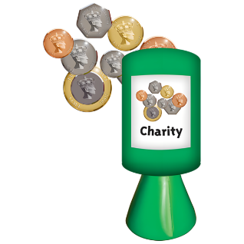
7. Organisations
Are you linked to an organisation or charity?
- Yes (please tell us which one)
- No


8. Staying in touch
How would you like us to contact you about future events?
- Phone and email
- Email only
- Phone only
- I do not want to be contacted
Email: __________________
Phone: __________________


9. Prize draw
You can enter a £40 prize draw for completing this survey.
Please enter your email address below.
We will not contact you for any other reason.
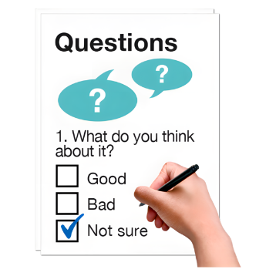

10. Diversity survey
After finishing this survey,
please complete our anonymous diversity monitoring survey.

