Diversity Monitoring Form
(Easy Read)

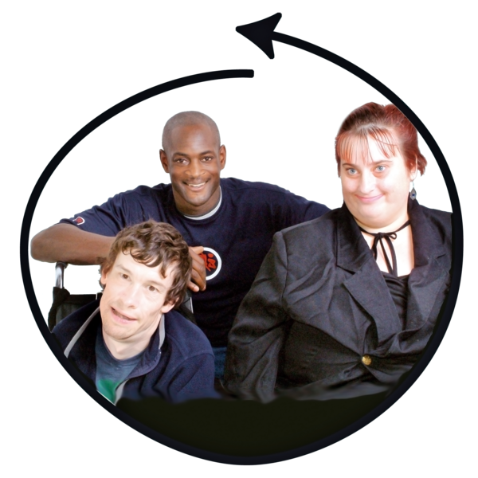
Scope wants to make sure we are fair and inclusive.


We will ask some questions about who you are.



This helps us understand who we support.


- Your answers are private and safe.

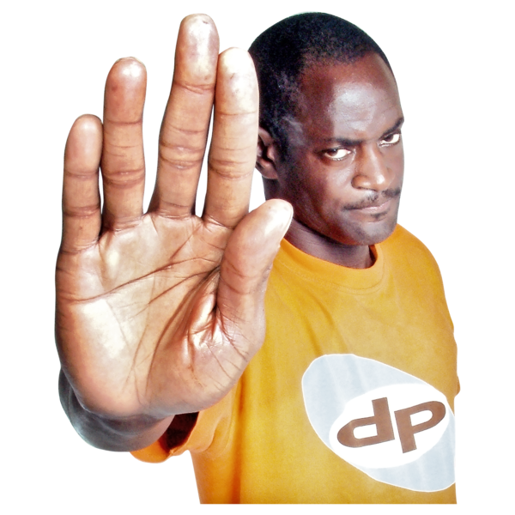
- You do not have to answer any question.


- You can ask us to delete your information at any time.


Read our privacy policy:
https://www.scope.org.uk/privacy


☐ I agree that Scope can collect this information

Questions

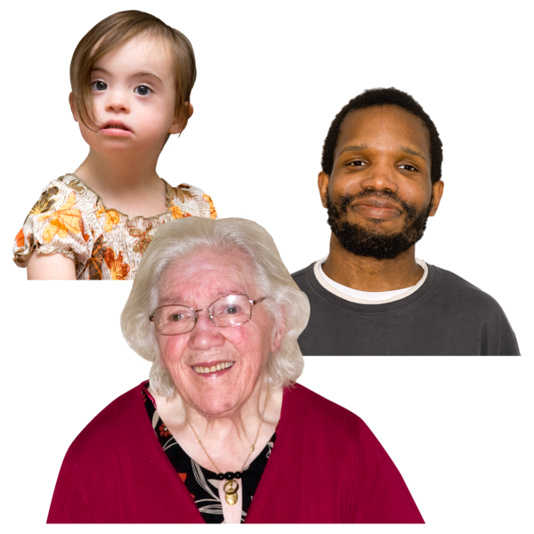
1.What age group are you in?
☐ 18–25
☐ 26–35
☐ 36–45
☐ 46–55
☐ 56–65
☐ Over 65
☐ Prefer not to say


2. What is your gender?
☐ Man
☐ Woman
☐ Non-binary
☐ Another word (write here) __________
☐ Prefer not to say

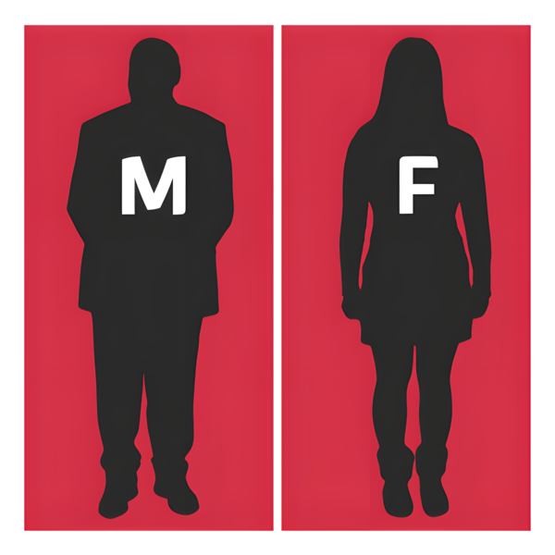
3. Is this the same as the sex you were registered as at birth?
☐ Yes
☐ No
☐ Prefer not to say

4. What is your ethnic group?
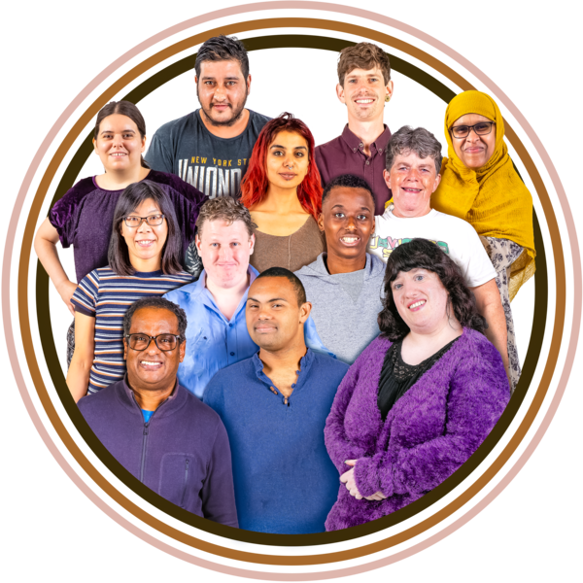
☐ White
☐ Mixed or multiple ethnic groups
☐ Asian or Asian British
☐ Black, Black British, Caribbean or African
☐ Arab or Middle Eastern / North African
☐ Another ethnic group (write here) __________
☐ Prefer not to say

5. What is your religion or belief?

☐ No religion
☐ Christian
☐ Muslim
☐ Hindu
☐ Jewish
☐ Sikh
☐ Buddhist
☐ Another religion (write here) __________
☐ Prefer not to say


6. Are you disabled or do you have an access need?
☐ Yes
☐ No
☐ Prefer not to say

7. What kind of condition or access need do you have?

(You can choose more than one.)
☐ Physical or mobility
☐ Hearing
☐ Vision
☐ Learning or understanding
☐ Mental health
☐ Neurodivergent (for example autism or ADHD)
☐ Long-term illness or pain
☐ Something else (write here) __________
☐ Prefer not to say

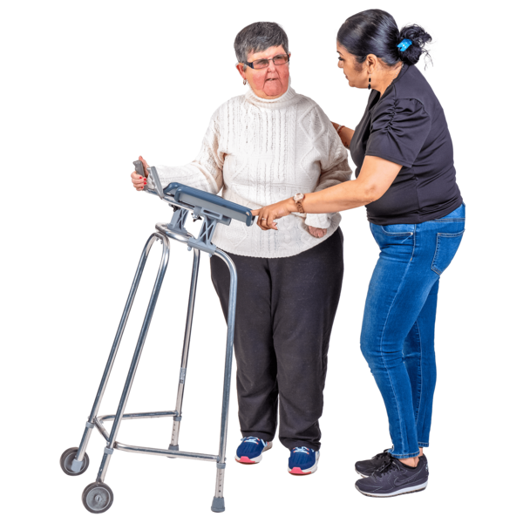
8. Are you a carer?
A carer is someone who looks after a family member or friend without pay.
☐ Yes
☐ No
☐ Prefer not to say

9. What is your sexual orientation?
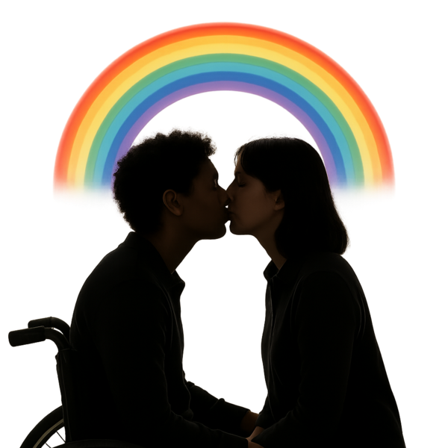
☐ Straight
☐ Gay or lesbian
☐ Bisexual
☐ Asexual
☐ Pansexual
☐ Another word (write here) __________
☐ Prefer not to say



Thank you for your time

