Neighbourhood Health

Executive Summary
Neighbourhood health will become our way of working, building on existing work already underway across Leeds, including community-based and integrated care models. We will work to better connect and optimise shared resource across the city. This links directly to the Leeds Ambitions and our aims for reducing health inequalities.
The transition will not happen all at once. Instead:
- Some elements are already in place, while others will develop over time
- Multiple change programmes (e.g. intermediate care, proactive care, community mental health) will collectively deliver the shift
- Progress will be shaped by evidence, insight and continuous learning
- Everyone working across the Leeds Health and Care Partnership has apart to play in redesigning the way we work to improve integration, coordination and communication.
The role everyone plays
Neighbourhood health cannot be delivered by any single organisation—it depends on collective ownership across the system.
Everyone has a role to play:
- People and communities will shape services through engagement and co-production, ensuring solutions reflect real needs and experiences
- The workforce will help design and deliver new ways of working, bringing their expertise and insight to making change practical and sustainable
- Partners across health, care, and the VCSE sector will work together as equal contributors, breaking down organisational boundaries
- System leaders will champion the vision, model collaboration, and enable shared decision-making
This is as much a cultural change as a structural one. It requires:
- Trust and transparency
- Shared accountability
- A shift from organisational priorities to collective outcomes
By working together in this way, Leeds can create a system that is more responsive, more equitable, and more sustainable for the future.

Why neighbourhood health matters in Leeds?

Leeds is a thriving and diverse city with a strong economy, but not everyone benefits equally. Significant health inequalities persist, with people living in the most deprived areas experiencing more years in poor health and dying around 12 years earlier than those in the most affluent parts of the city.
Around 80% of our health is shaped by the conditions in which we are born, grow, live, work and age - often referred to as the ‘social determinants’ or ‘building blocks’ of health. These include factors such as good-quality housing, financial security and access to leisure opportunities. Ensuring people are connected to these essentials is critical to improving health outcomes.
Without this, people - particularly those in more disadvantaged communities where access is often limited - remain at greater risk of developing long-term and complex health conditions earlier in life.
This is why a neighbourhood health approach must extend beyond traditional health and care services. It requires stronger collaboration with a wider range of partners who can support people to maintain their health and wellbeing for longer. This means shifting towards a more preventative, proactive model, with a focus on early intervention and addressing the whole needs of individuals.
By taking this approach, we can support the city’s wider ambitions, reduce health inequalities, and help delay the onset of ill-health - ultimately easing demand on health and care services.
In Leeds, there are significant health inequalities. For example,
a baby born in Harewood can expect to live 12.1 years (female) or 11.7 years (male) longer than a baby born in Hunslet.

What is Neighbourhood Health?

Neighbourhood Health aims to bring about radical change to the way health and care systems work together in Leeds, supporting delivery of the city’s ambitions and most specifically reducing health inequalities. The Neighbourhood Health framework operates across three tiers — Prevention, Proactive Care and Reactive Care whilst also considering the wider determinants of health.
In a neighbourhood health model, people will experience simpler, more coordinated care. Services will feel connected rather than fragmented, with fewer hand-offs and less repetition. Individuals, particularly those with complex needs, will receive continuous, holistic support built around what matters to them.
Neighbourhood health aims to coordinate NHS, social care, public health and voluntary services alongside broader services such as housing to improve health and wellbeing at the community level.
We can only achieve this through radical change to the way that health and care organisations, services, teams and colleagues work together; and importantly we work in coordination with broader services that affect people’s wellbeing, such as housing, education, community safety and financial management.
Together we can create healthier communities, helping people of all ages live healthy, active and independent lives for as long as possible while improving their experience of health and social care, and increasing their agency in managing their own care. This will be achieved by building on work already happening in Leeds to better connect and optimise shared resource across the city and links directly to the Leeds Ambitions.

In Leeds, Neighbourhood Health will contribute to the four city-wide ambitions:
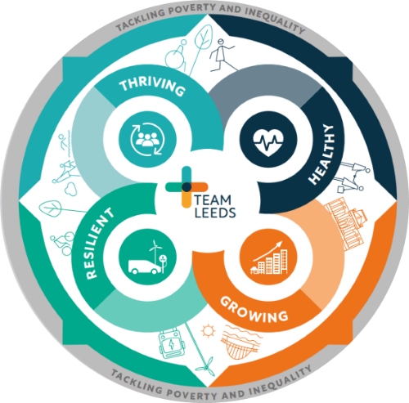
Healthy: Promote health and wellbeing for all residents by embedding proactive care and prevention in every neighbourhood.
Growing: Support inclusive economic growth by enabling people to stay well, remain independent,
and participate fully in work and community life.

Resilient: Create sustainable health and care models that help Leeds become a net-zero, nature-positive city.
Thriving: Build strong, safe, and connected communities through local partnerships that put people first and respond to what matters most.


Overview of the Neighbourhood Health Approach in UK
Rooted in the NHS 10 Year Health Plan and the national public service reform agenda, the approach recognises that good health originates within communities and requires a shift in care provision, technology adoption, and a stronger emphasis on prevention.

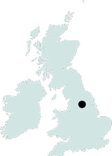
The Leeds Approach to Neighbourhood Health
– supporting our Leeds ambition
Our ambition: To make Leeds the best city for health and care, where neighbourhoods work together to reduce health inequalities, improve quality of life, and deliver integrated, person-centred care close to home.

Where the people of Leeds can say:
"I live in a thriving community, where I feel safe and truly cared for. There are
green spaces where I exercise regularly with social groups. When I need care
it is joined-up care and understands me, not just my condition – I am supported
to live a healthy life"

We will achieve this through Team Leeds collaboration, community empowerment, and proactive health and care models. Wrapping care around communities, not institutions.

Our vision of how it will feel for people and staff

We know that our patients, the people of Leeds and our staff are seeing and experiencing gaps in coordination because they’ve told us. This affects the quality-of-care people receive and, ultimately, their health outcomes. It also means we aren’t being as efficient as we should be as a system. We need to take what we’ve learnt from the past ten years and drive forward an ambitious plan of further integration and coordination.

This is how we want it to feel for people in Leeds…

Living well in my community

I know where to go for support with my health and wellbeing, and I feel confident accessing help before things reach crisis.

I feel part of my community and know where to go for help if something isn’t working.

I feel listened to and supported to focus on what matters to me, and I’m involved in decisions about my care.

I’m supported to live independently and safely at home, with the right help when I need it.

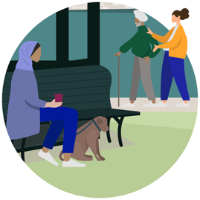
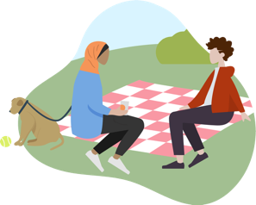

I don’t have to repeat my story – services share information and work as one team.
Different professionals work together as a “team of teams” to help me stay well – including health, care and community support.

I’m supported to build confidence, manage my health, and stay connected to my community.
Support is proactive, not just reactive, and adapts as my needs change.
The team around me knows my story, works together, and supports me in a joined-up way.
Working with my neighbourhood team



We work as one neighbourhood team across health, care, council and the voluntary and community sector.
We are empowered to work differently, share responsibility and improve outcomes together.

We focus on prevention, early intervention and addressing the wider factors that affect health and wellbeing.
We build trusted relationships with people and communities and respond flexibly to local priorities.

We use local data and insight to understand need and target support where it will have the greatest impact.
Working in the neighbourhood team

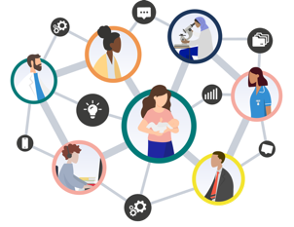
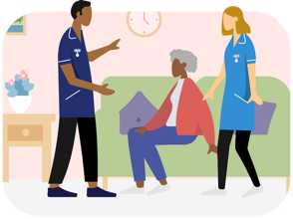

Strong neighbourhood working reduces pressure on hospitals by supporting people earlier and closer to home.
Neighbourhood teams are connected to wider specialist services when people need them.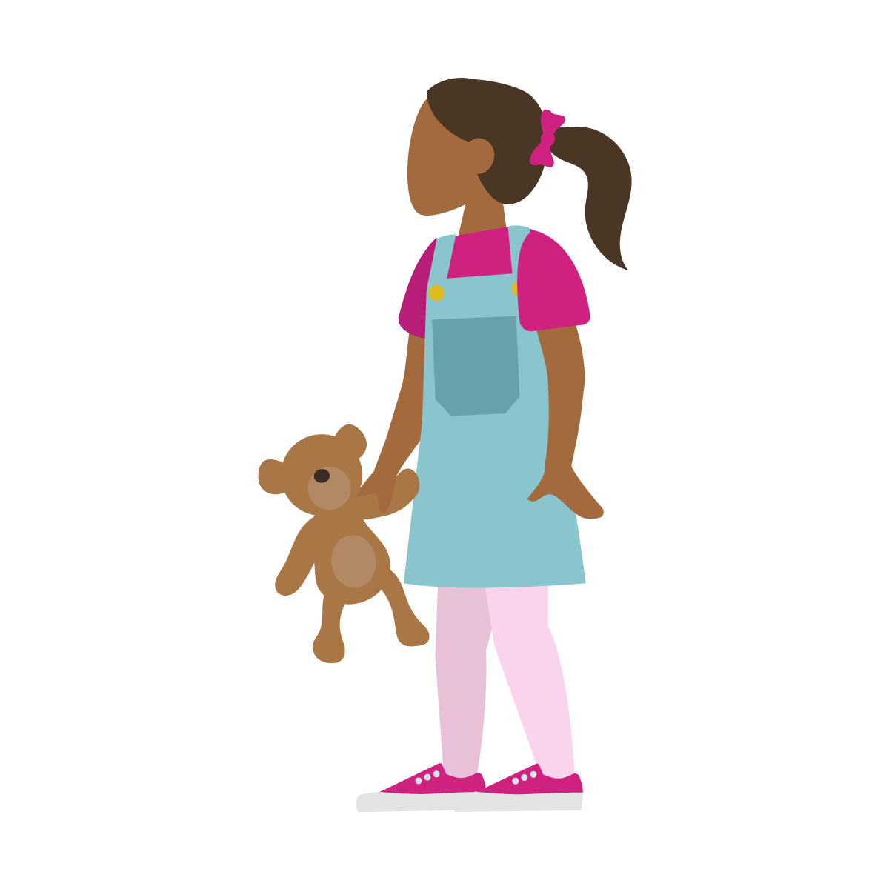
Learning from neighbourhoods helps shape services and improve quality across Leeds.
Care is coordinated across neighbourhood, place and system levels, so people get the right support at the right time.
Connecting into the health, care and wider system

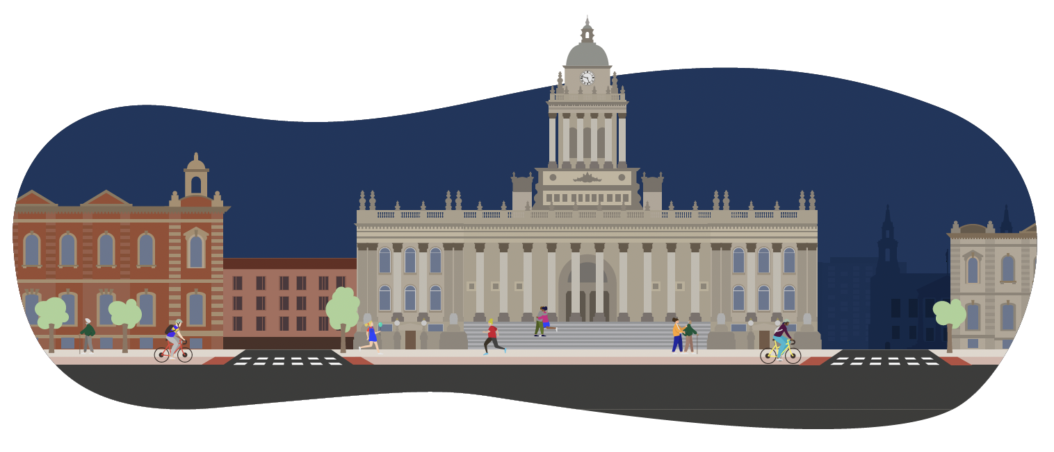
The neighbourhood health way of working isn’t new for Leeds

Leeds is building on local successes we have already had from working in multidisciplinary networked teams over a number of years. This involves expanding our existing work with our 15 Local care Partnerships (LCPs), integrating health services at the local level, linking health with housing, debt advice, and fitness initiatives, and promoting proactive, patient-centred care.

Continuous journey to neighbourhood health in Leeds…
LCC Community Hubs

Proactive Care Framework

Leeds Anchor Network
Leeds Mental Wellbeing Service

Primary Care Networks

Virtual Wards

School clusters
Linking Leeds
ABCD pathfinders – community connectors

Local Care Partnerships

HomeFirst
Leeds Community Anchor Network

Agree MNH footprints

Women's Health Hub

2017
2018
2019
2020
2021
2024
2023
2022
2026
2025
2016
and before

Leeds Provider Partnership Shadow form

Leeds NH Networks incl. Community Connectors

Hospital Discharge Team
0-19 PH Integrated Nursing Service

Community Champions

Specialised community nursing

Integrated Neighbourhood Teams

Working together to improve health and wellbeing in Leeds

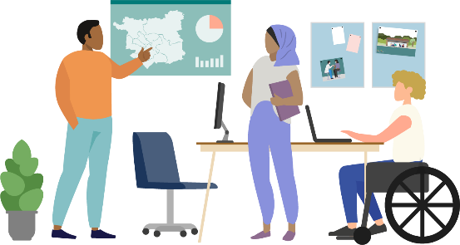
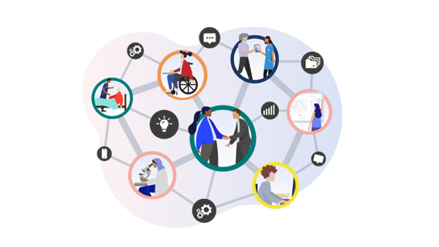
Central ambition – More care closer to home to improve wellbeing and reduce inequalities
Person centred approach – Joined up, easy to navigate, and delivered locally
Neighbourhood model – Flexible, locally led and based on community needs and strengths
Population health – data driven targeting to support earlier identification and reduce inequalities
Team of teams – Integrated MDTs and targeted support across health, care, VCSE and partners
Better experience – Simpler access, less duplication,
more preventative and personalised care
What matters to people – People in Leeds have told us that what matters to them is communication, compassion and coordination in health and care (the 3Cs). We will use the insight we already have to shape our approach and continue to listen to and engage with local communities as neighbourhood health develops in Leeds. We will build on what is already working well and support communities to embed strong, sustainable models of co-design
Neighbourhood Health Aims


Improve outcomes for children, young people and families.

Implement person-centred multidisciplinary care approaches.

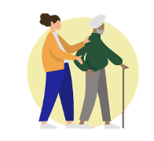
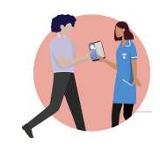
Ensure people can access the right help, at the right time, in the right place within the local community

Promote early diagnosis and prevent avoidable illnesses in the first place.

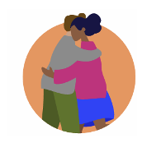

To embed the 3Cs, communication, coordination and compassion, across neighbourhood health, using people’s experiences to improve how services work together and feel to those who use them.

Support people of all ages with self-care and managing long term conditions.

Delivering Neighbourhood Health in 2026/27
Our neighbourhood approach in
Leeds is about joining up local services, strengthening community connections and building on local strengths so that people and communities can thrive.
15 neighbourhoods

Our ambition is for Neighbourhood Health Centres to become a hub
within communities that co-locate services and foster integrated working – a place that reflects the needs of the local neighbourhood and supports community empowerment.
3 Multi-neighbourhoods

We have worked across the partnership to agree clear neighbourhood footprints
for Leeds, comprising 15 neighbourhoods and 3 multi-neighbourhoods

These footprints give teams a shared understanding of populations, responsibilities and how they work together across organisations, providing consistent geography to build trusted relationships, organise integrated teams, target need using data, and connect neighbourhood delivery with specialist support at scale.
Clear footprints enable a stronger focus on prevention and early intervention, reducing duplication and unnecessary escalation, and ensuring people receive the right support, from the right team, at the right level, closer to home.

Multi-neighbourhoods provide the scale needed to deliver functions that are not viable at a single neighbourhood level, supporting capacity, consistency, resilience and access to specialist expertise, while maintaining strong local delivery within neighbourhoods.

Together, these layers create a joined-up system, organising care around people rather than organisations, and enabling Leeds to deliver more preventative, coordinated and locally responsive health and care.

Neighbourhood Health priorities for 2026–27
In 2026, the priority is to establish the foundations for Neighbourhood Health and move from design into delivery. This includes embedding neighbourhood governance and leadership for the agreed neighbourhood footprints, and standardising and scaling the Neighbourhood Proactive Care model, through neighbourhood MDTs, shared care processes and agreed target cohorts. Enabling work will focus on developing sustainable financial flows and contracting through shadow arrangements, progressing early Neighbourhood Health Hubs, and supporting workforce and organisational development.
In 2027, the focus shifts to scaling and embedding. Proactive Care will expand to larger populations, specialist support will be integrated into neighbourhood teams, and shadow financial arrangements will transition into formal neighbourhood and multi-neighbourhood contracts. Neighbourhood Health Hubs will move into wider delivery, workforce models will mature into business-as-usual, and consistent outcome measurement will demonstrate system impact, including reduced hospital use and progress on health inequalities.
Neighbourhood health will be enabled and supported by the Leeds Provider Partnership which will continue to develop over this period, establishing governance and financial flows which will make this way of working sustainable.
The merger of LYPFT and LCH will also contribute to integration across the city.

Neighbourhood Health Portfolio 2026/27

Leeds is putting in place a Neighbourhood Health Portfolio approach to organise how transformation happens across the system.
This brings together key programmes, including HomeFirst and other priorities identified through data and insight, into one joined-up approach. Instead of working as separate programmes, activity across prevention, proactive and reactive care, mental health, children’s services and the wider determinants of health are coordinated through a single framework aligned to shared city ambitions.
Delivery is supported through a matrix ‘Integrator+’ model, where people from different organisations work together as one team, with shared responsibility and clearer roles. Important support areas such as workforce, digital, estates and data are treated as shared system assets, helping everyone deliver consistently.

Essential components for neighbourhood health success
As part of this portfolio we have some jointly agreed elements that have been identified as essential components to the success of a Neighbourhood health. They are;
- Workforce partnership organisational development (planning, deployment and communications)
- Digital and data sharing (inc Shared Care Plans)
- Finance and incentive based contracting
- Neighbourhood health centres
- Communications and people voice involvement

